ASSIGNMENT-16.1
Name:M.Priyadarshini
H NO:2303A510B3
Batch-14
Task 1 – Student Information System Schema Task:
Design a database schema for a Student Information System and generate queries using AI.
Instructions:
- Tables: Students, Courses, Enrollments.
- Define primary keys, foreign keys, and relationships.
- Generate queries:
o Insert a new student record. o Fetch all courses enrolled by a student. o Count number of students in each course.
Expected Output:
• SQL CREATE TABLE statements and queries for student– course relationships.
Definitions:
Primary Key: A Primary Key uniquely identifies each record in a table.
Foreign Key: A Foreign Key is used to link tables together.
3. Relationships Between Tables Type of Relationship:
Many-to-Many (M:N) between Students and Courses
- One student can enroll in many courses
- One course can have many students

- Generate queries:
o Insert a new student record. o Fetch all courses enrolled by a student. o Count number of students in each course.
Query:
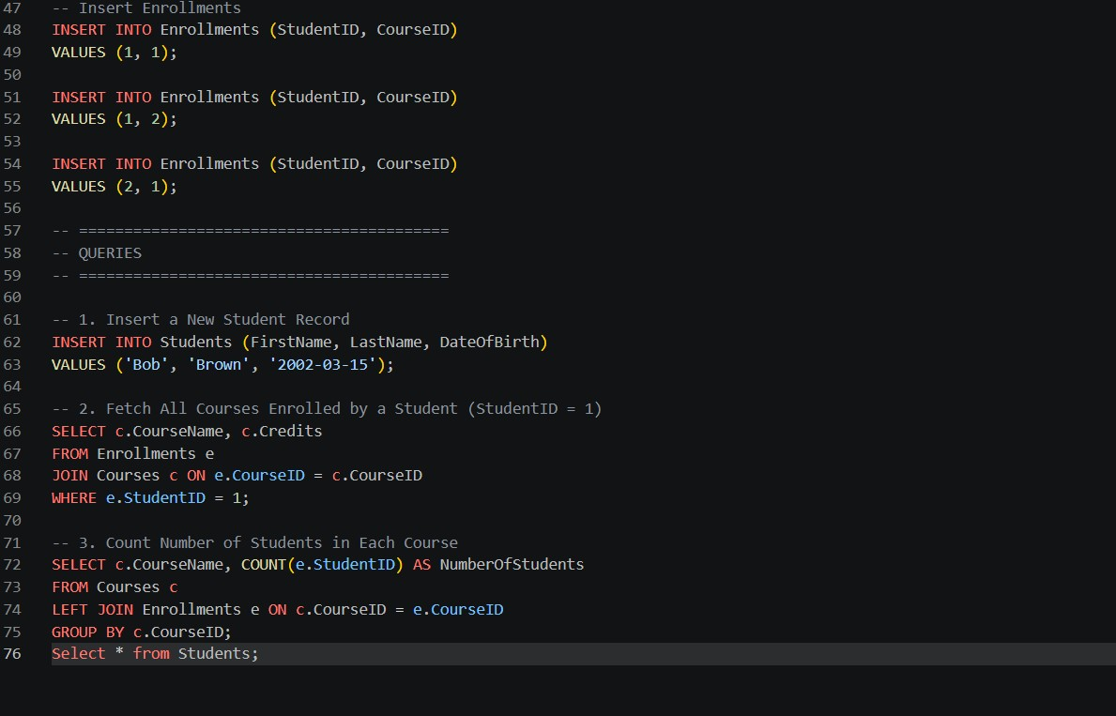
Output:
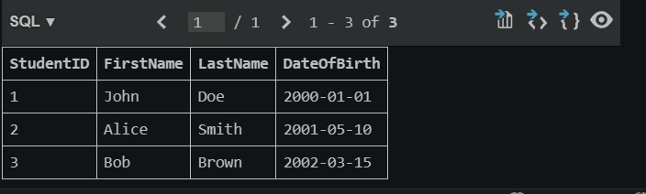
Justification:The relationship between the Students and Courses tables is a many-to-many relationship, because a single student can enroll in multiple courses, and each course can have multiple students. This relationship cannot be represented directly in a single table, so it is implemented using the Enrollments table, which acts as a junction table.
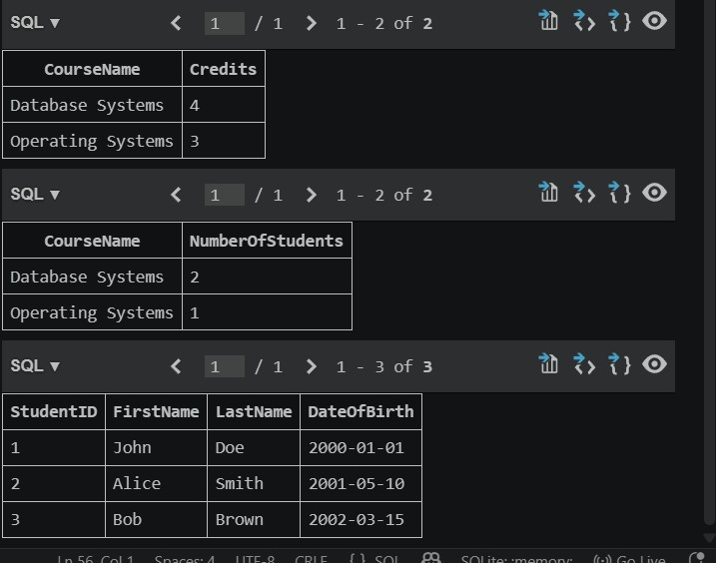
Task 2 – Hospital Management Database Task:
Create schema and queries for a Hospital Management System.
Instructions:
- Tables: Doctors, Patients, Appointments.
- Use AI to define constraints (unique IDs, valid dates).
- Generate queries:
- List all appointments for a specific doctor.
- Retrieve patient history by patient ID. o Count total patients treated by each doctor.
Expected Output:
- Normalized schema and SQL queries with joins.
Queries
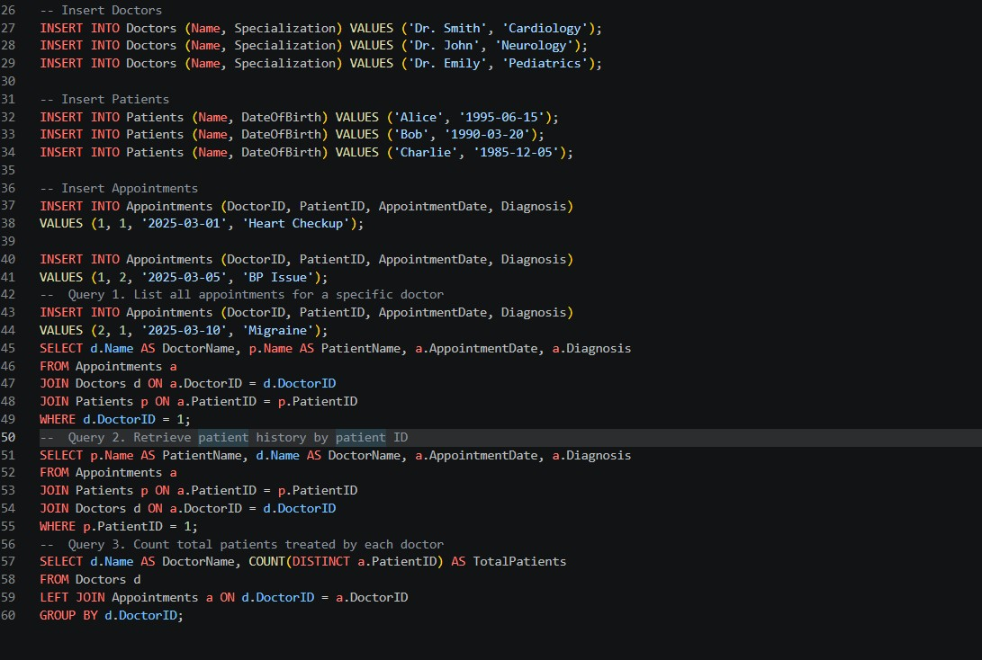
Output:
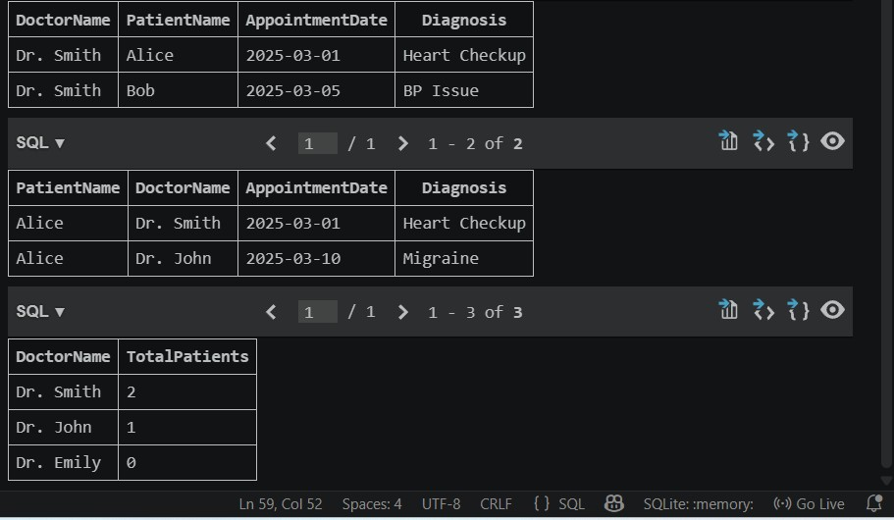
Justification: The Appointments table links doctors and patients via foreign key. Constraints like NOT NULL, UNIQUE, and valid date checks ensure data integrity, enabling efficient storage, retrieval, and querying of hospital data.
Task 3 – Library Database Task:
Design schema for a Library Management System.
Instructions:
- Tables: Books, Members, Loans.
- Use AI to suggest indexing strategy for faster queries.
- Generate queries:
- Retrieve all books currently issued. o Find overdue books (loan date > 30 days).
- Count number of books loaned by each member.
Expected Output:
- Schema + SQL queries demonstrating joins and conditions. Queries
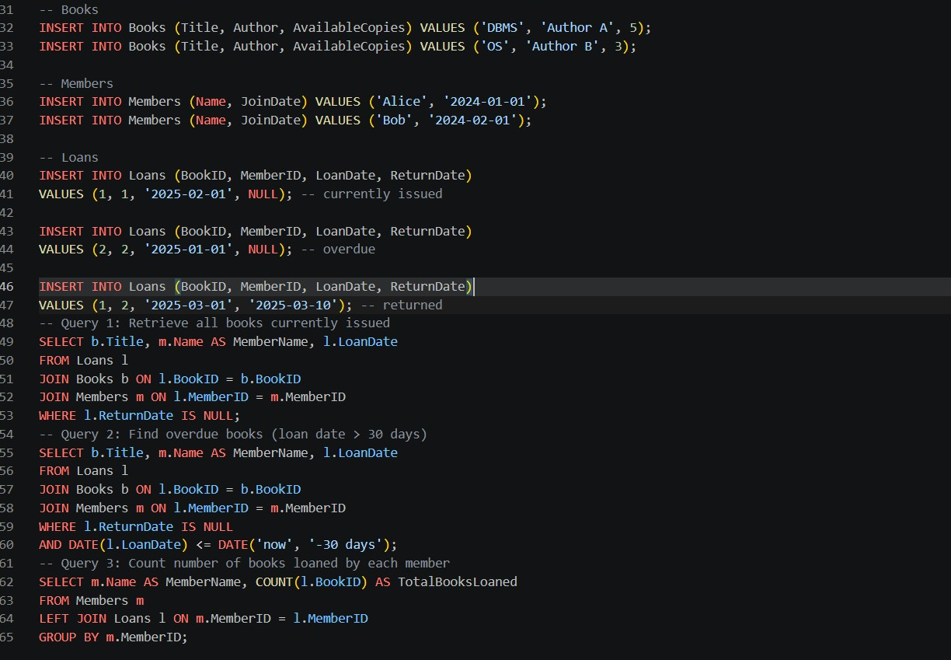

Output
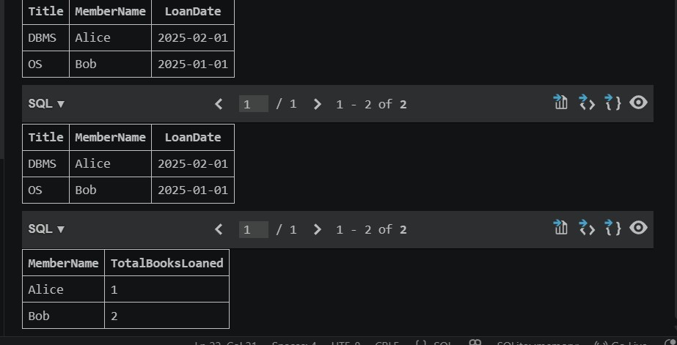
Justification: The library database is designed using three normalized tables: Books, Members, and Loans. Each table has a primary key to uniquely identify records, while the Loans table uses foreign keys to establish relationships between books and members.
Task 4 – Real-Time Application: Online Shopping Database Scenario:
Design a database for an E-commerce platform.
Requirements:
- Tables: Users, Products, Orders, OrderDetails.
- Generate queries to:
- Retrieve all orders by a user.
- Find the most purchased product.
- Calculate total revenue in a given month.
- AI should also suggest normalization improvements and query optimization.
Expected Output:
- Complete schema with relationships + SQL queries for analytics.
Queries
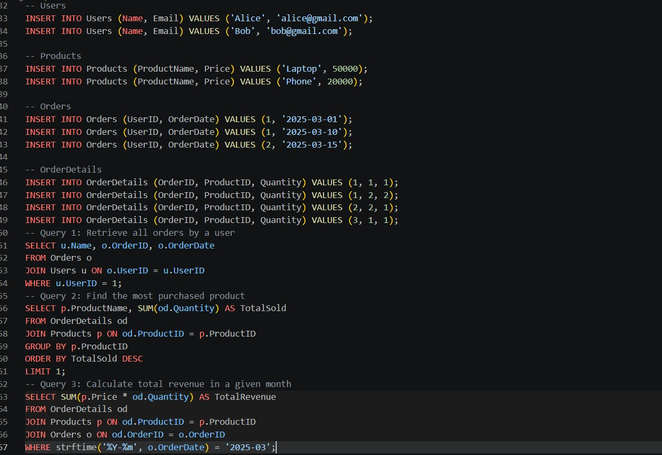
Output
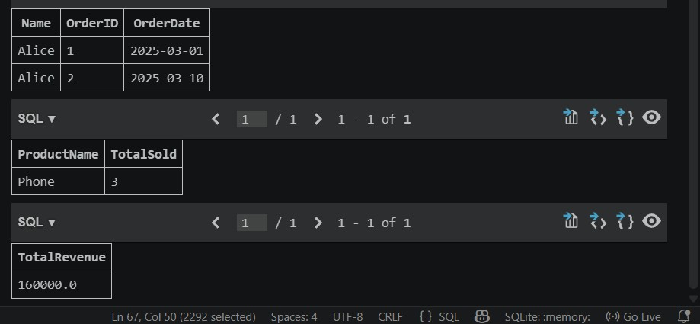
Justification: The database is structured in a normalized form to eliminate redundancy and ensure data integrity. The Users table stores customer details, while the Products table maintains product information independently. Orders are separated into a different table to record each transaction, and
OrderDetails acts as a junction table to handle the many-to-many relationship between orders and products.
Task 5 – University Examination Database
Design a database schema for a University Examination System and generate SQL queries using AI.
Instructions:
- Tables: Students, Subjects, Exams, Results.
- Define primary keys, foreign keys, and referential integrity constraints.
- Generate queries:
o Insert examination results for a student. o Retrieve subject-wise marks for a student. o Calculate average marks for each subject.
Expected Output:
• Normalized schema and SQL queries involving aggregation and joins.

Queries
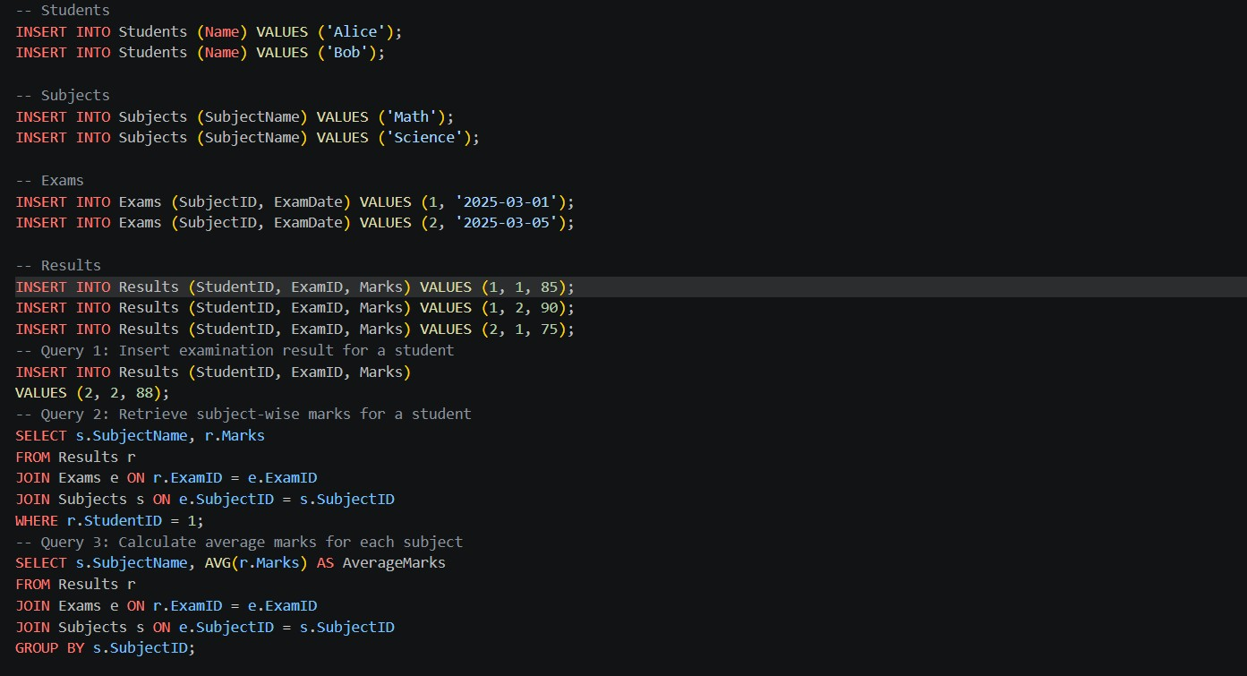
Output:
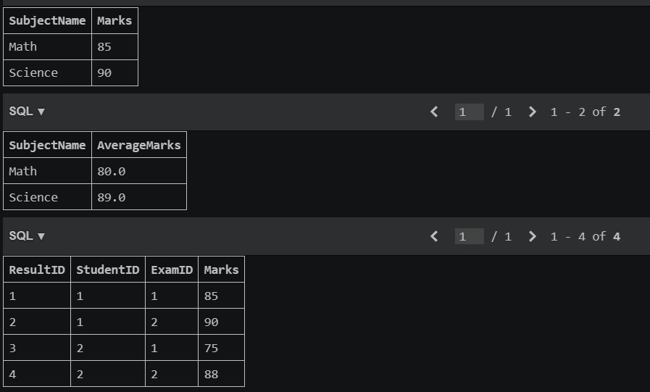
Justification: The database is designed using four normalized tables: Students, Subjects, Exams, and Results. Each table has a primary key to uniquely identify records, while foreign keys establish relationships between them. The Exams table links subjects with exam dates, and the Results table acts as a junction table connecting students and exams, enabling a many-to-many relationship. Referential integrity is maintained through foreign key constraints, ensuring that results cannot exist without valid students and exams.

