AI Assisted Coding
Assignment - 2.1
Roll no : 2303A510C8

Task 1: Statistical Summary for Survey Data
Prompt:
#Write a Python function called analyze_survey_data that takes a list of numbers as input and returns a dictionary containing the mean, minimum, and maximum values. Include example usage with a sample list."

Code:
def iterative_fibonacci(n):
"""
Generate a list of the Fibonacci sequence up to n terms using an iterative approach.

Parameters:
n (int): The number of terms in the Fibonacci sequence to generate.

Returns:
list: A list containing the Fibonacci sequence up to n terms.
"""
fibonacci_sequence = []
a, b = 0, 1
for _ in range(n):
fibonacci_sequence.append(a)
a, b = b, a + b
return fibonacci_sequence

x = iterative_fibonacci(int(input("Enter the number of terms in the Fibonacci sequence (Iterative): ")))

print(f"Iterative Fibonacci sequence: {x}")
Out put:
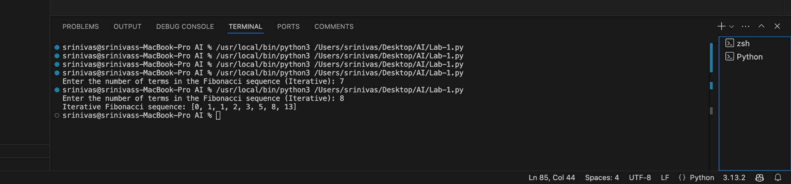
Explanations:
- Input Handling: It first checks if not data to handle empty lists, preventing division-by-zero errors.
- Calculations:
  - Mean: It uses sum(data) / len(data) to calculate the arithmetic average.
  - Minimum & Maximum: It utilizes Python's built-in min() and max() functions, which are highly optimized for performance.
- Data Structure: The results are packaged into a Python Dictionary ({key: value}). This is chosen over a list because it labels the data clearly ("mean", "minimum"), making the return value self-explanatory and easy to access by key.

Task 2: Armstrong Number – AI Comparison
Prompt:
# "Write a Python function to check if a number is an Armstrong number. Explain the logic."

Code:

def is_armstrong_number(num):
"""
Check if a number is an Armstrong number.

An Armstrong number (also known as a narcissistic number) is a number that is equal to the sum of its own digits each raised to the power of the number of digits.

For example:
- 153 is an Armstrong number because 1^3 + 5^3 + 3^3 = 153
- 9474 is an Armstrong number because 9^4 + 4^4 + 7^4 + 4^4 = 9474

Parameters:
num (int): The number to check.

Returns:
bool: True if the number is an Armstrong number, False otherwise.
"""
# Convert the number to string to easily iterate over digits
digits = str(num)
num_digits = len(digits)

# Calculate the sum of each digit raised to the power of num_digits
sum_of_powers = sum(int(digit) ** num_digits for digit in digits)

# Check if the sum of powers is equal to the original number
return sum_of_powers == num

# Example usage
number = int(input("Enter a number to check if it is an Armstrong number: "))
if is_armstrong_number(number):
print(f"{number} is an Armstrong number.")
else:
print(f"{number} is not an Armstrong number.")

Output:
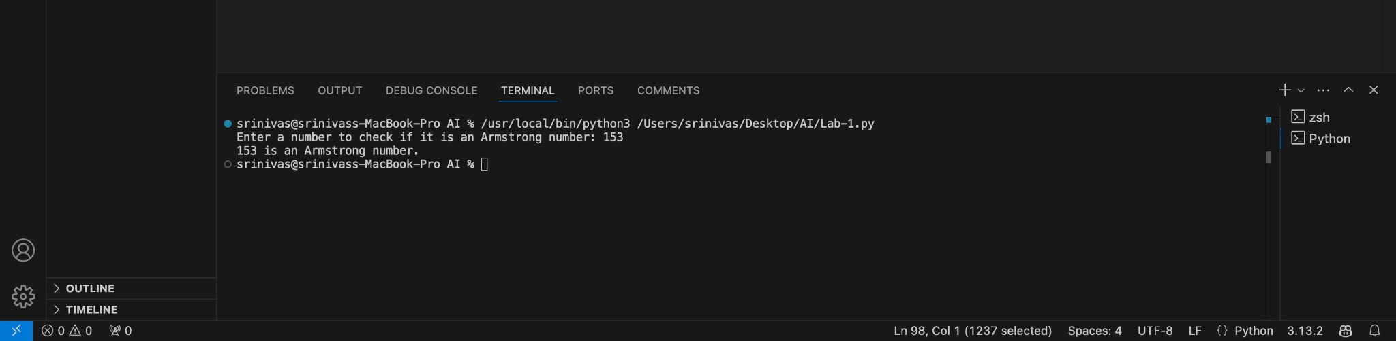

Explanations:
An Armstrong number (of order n) is a number that is equal to the sum of its digits each raised to the power of n.
Google Gemini (The "Pythonic" Approach):
- Gemini utilized String Conversion (str(number)). By treating the number as a string, it can iterate through digits using a loop or comprehension without mathematical operations.
- Advantage: Extremely readable and concise (2-3 lines of logic). Easy for beginners to understand.
- Disadvantage: Converting integers to strings adds slight overhead in memory and processing time.
GitHub Copilot (The "Algorithmic" Approach):
- Copilot suggested a mathematical approach using Modulo (%) and Floor Division (//). It extracts the last digit (n % 10), adds it to the sum, and removes the last digit (n // 10) in a while loop.
- Advantage: More memory efficient as it stays purely numerical. This is the standard logic used in C/C++ or Java.
- Disadvantage: More verbose and slightly harder to read at a glance.
Task 3: Leap Year Validation Using Cursor AI
Prompt:
# "Write a python function to check for leap year."

Code:
def is_leap_year(year):
"""
Check if a given year is a leap year.

Parameters:
year (int): The year to check.

Returns:
bool: True if the year is a leap year, False otherwise.
"""
if (year % 4 == 0 and year % 100 != 0) or (year % 400 == 0):
return True
else:
return False
# Example usage of the function
year = int(input("Enter a year to check if it's a leap year: "))
if is_leap_year(year):
print(f"{year} is a leap year.")
else:
print(f"{year} is not a leap year.")

Output:
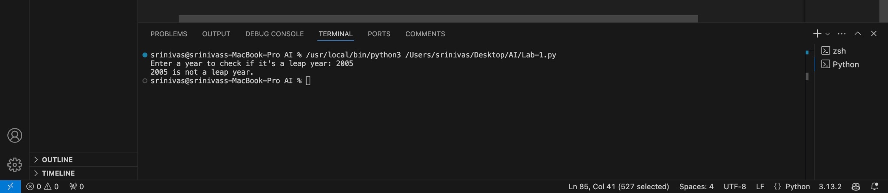
Explanations:A year is a leap year if:
- It is divisible by 4.
- EXCEPT if it is divisible by 100 (then it is NOT a leap year).
- UNLESS it is also divisible by 400 (then it IS a leap year).
- Version 1 (Basic Prompt): The AI produced a functional logical check. However, it lacked safety. If a user input a string like "2024" or a negative number, the code would crash or give incorrect logic.
- Version 2 (Robust Prompt): By asking for "production-ready" code, the AI added Type Hinting (year: int) and Error Handling (raise ValueError). This ensures the function is reliable in a real-world backend system where inputs might be unpredictable. This highlights that specific prompts yield higher-quality, safer code.

Task 4: Student Logic + AI Refactoring (Odd/Even Sum)
Prompt:
Student code:
def sum_odd_even_manual(numbers):
sum_odd = 0
sum_even = 0

for num in numbers:
if num % 2 == 0:
sum_even = sum_even + num
else:
sum_odd = sum_odd + num

print("Sum of Even:", sum_even)
print("Sum of Odd:", sum_odd)

my_tuple = (10, 23, 45, 66, 2, 9)
sum_odd_even_manual(my_tuple)

Output:
srinivas@srinivass-MacBook-Pro AI % /usr/local/bi
n/python3 /Users/srinivas/Desktop/AI/Lab-1.py
Sum of Even: 78
Sum of Odd: 77
srinivas@srinivass-MacBook-Pro AI %
}

Explanation:
The manual student code uses an Imperative programming style. It explicitly tells the computer how to do things step-by-step:
- Initialize counters (sum_odd, sum_even) to zero.
- Create a for loop to look at every number.
- Use an if-else block to check divisibility by 2.
- Manually add the number to the correct counter. Critique: While correct, this approach is verbose and separates the logic (checking even/odd) from the aggregation (summing).

Refactoring using AI (Gemini colab):
Prompt:
"Refactor this Python code to be more Pythonic and concise."

Code:
def iterative_fibonacci(n):
"""
Generate a list of the Fibonacci sequence up to n terms using an iterative approach.

Parameters:
n (int): The number of terms in the Fibonacci sequence to generate.

Returns:
list: A list containing the Fibonacci sequence up to n terms.
"""
fibonacci_sequence = []
a, b = 0, 1
for _ in range(n):
fibonacci_sequence.append(a)
a, b = b, a + b
return fibonacci_sequenceclear
def sum_odd_even_refactored(numbers):
sum_even = sum(n for n in numbers if n % 2 == 0)
sum_odd = sum(n for n in numbers if n % 2 != 0)
return sum_even, sum_odd

my_tuple = (10, 23, 45, 66, 2, 9)
even, odd = sum_odd_even_refactored(my_tuple)

print(f"Sum of Even: {even}\nSum of Odd: {odd}")

Output:
srinivas@srinivass-MacBook-Pro AI % /usr/local/bi
n/python3 /Users/srinivas/Desktop/AI/Lab-1.py
Sum of Even: 78
Sum of Odd: 77
srinivas@srinivass-MacBook-Pro AI %
}

Explanation:
The manual student code uses an Imperative programming style. It explicitly tells the computer how to do things step-by-step:
- Initialize counters (sum_odd, sum_even) to zero.
- Create a for loop to look at every number.
- Use an if-else block to check divisibility by 2.
- Manually add the number to the correct counter. Critique: While correct, this approach is verbose and separates the logic (checking even/odd) from the aggregation (summing).
Refactored Code (Functional Style): The AI refactored this using Generator Expressions inside the sum() function:
- sum(n for n in numbers if n % 2 == 0)

