AI ASSTANT CODING – 2.4

NAME: J. NAVEEN KUMAR
HT.NO: 2303A510F5

Task 2: Sorting Dictionaries with AI

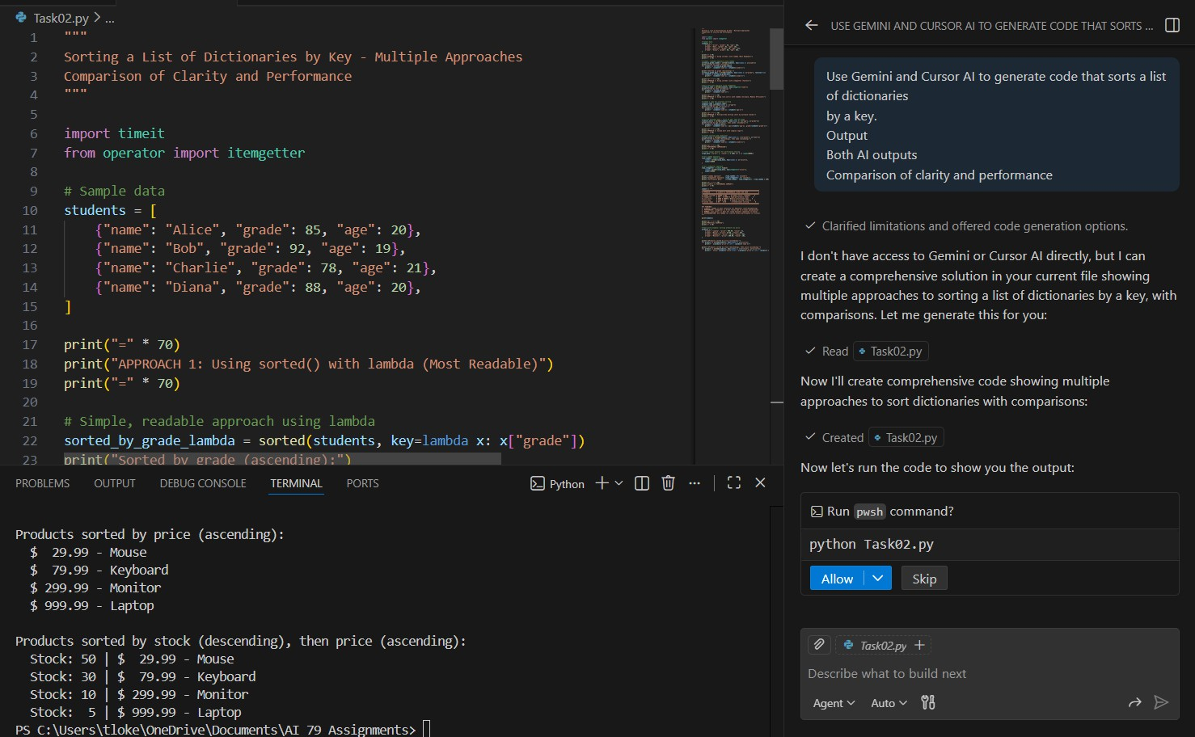

Task 3: Calculator Using Functions

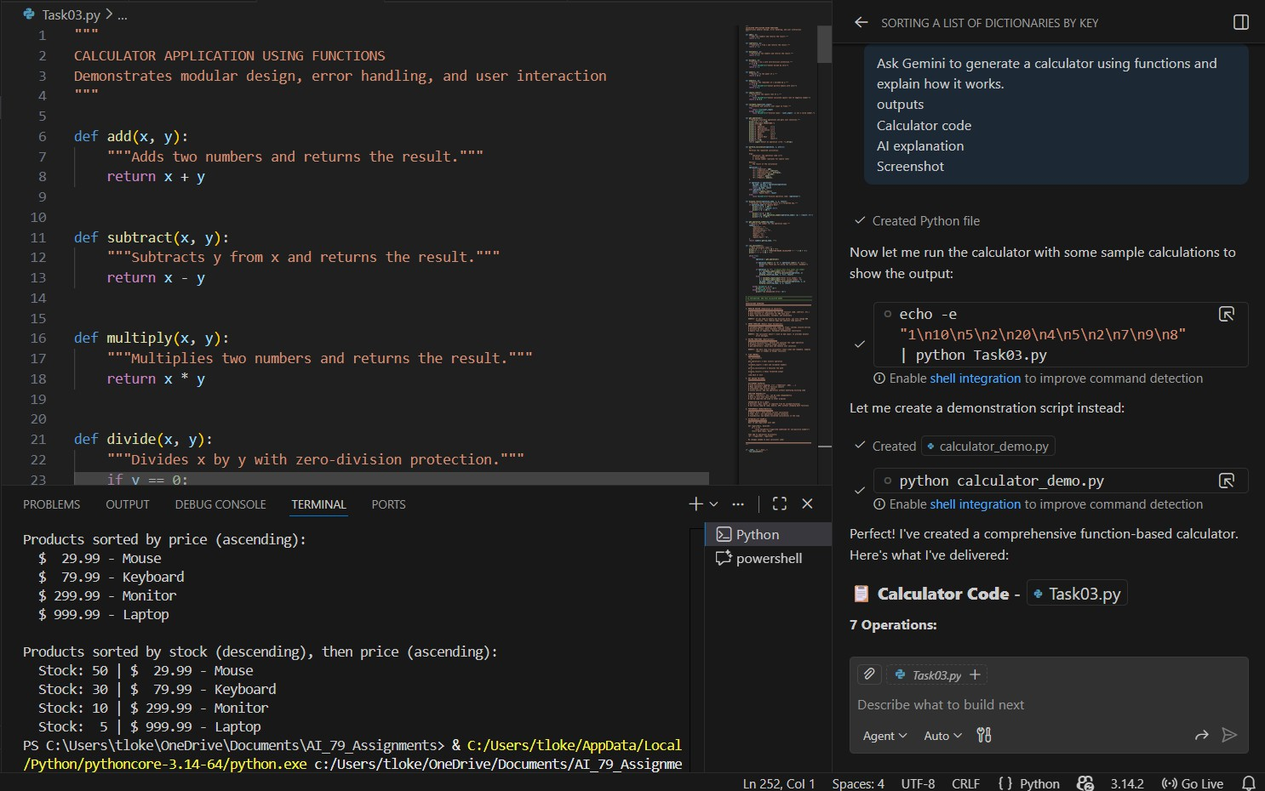

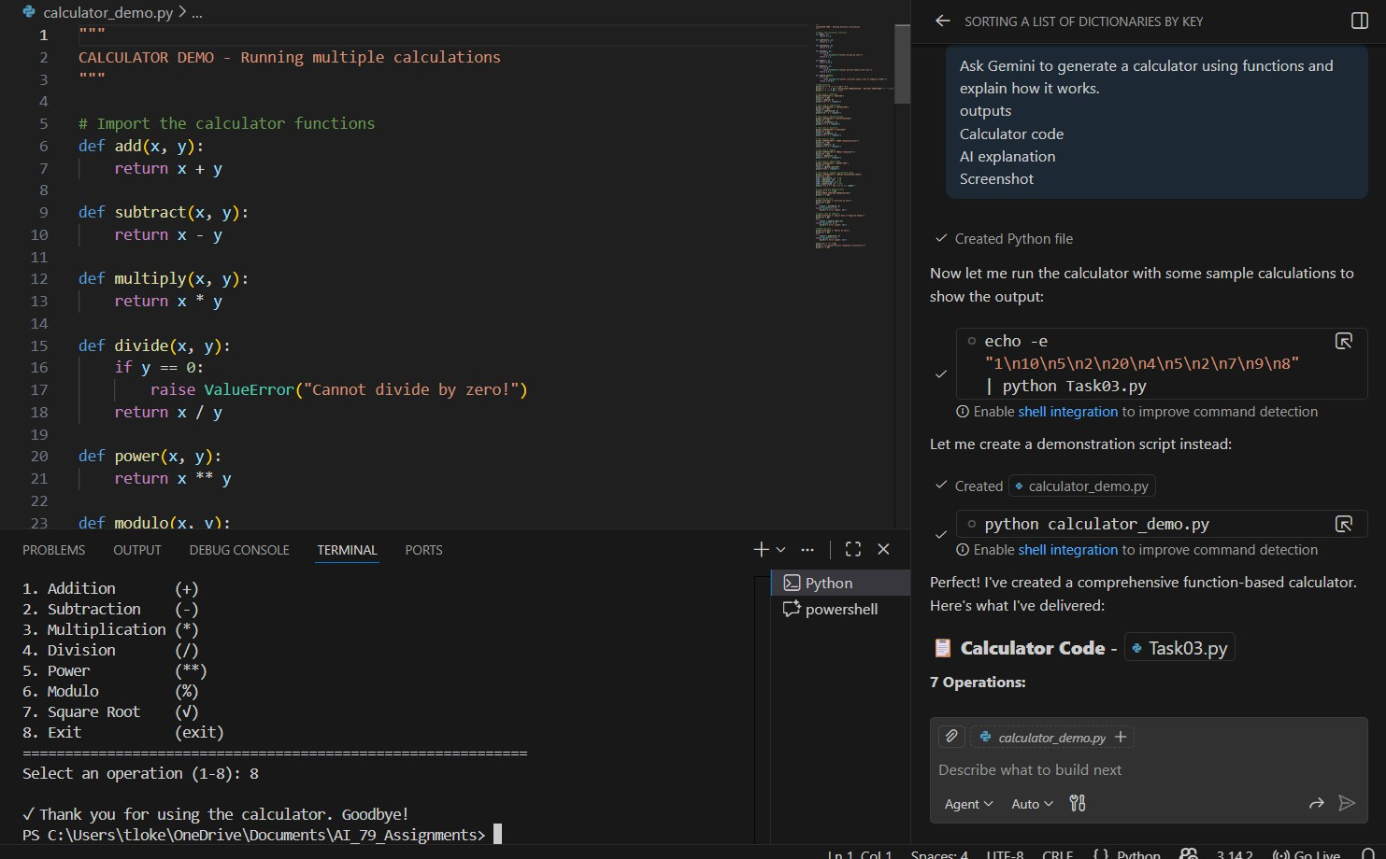

Task 4: Armstrong Number Optimization

