ASSIGNMENT_18.3
2303A510H5
Batch_30
Task 1 – Public Transport Route Fare API
Code:
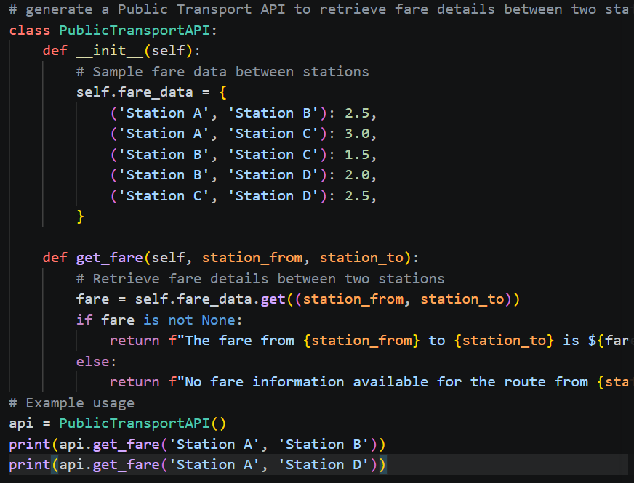
Output:

Justification:
Integrating a fare API ensures commuters get accurate cost information between stations. Input validation and error handling make the system reliable even during downtime. A structured output helps users quickly interpret and apply fare details.

Task 2 – Currency Exchange Rates
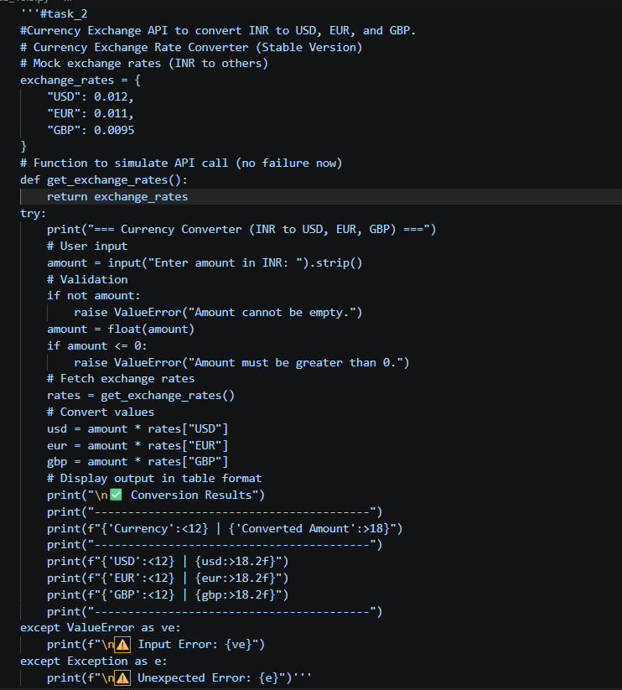
Output:
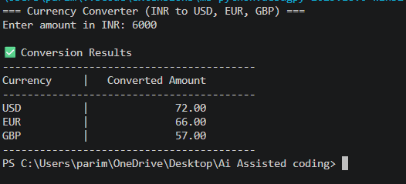
Justification:
Currency conversion supports global transactions and travel planning by providing real‑time exchange values. Validating inputs and handling API errors ensures dependable financial results. Clear tabular output makes comparisons across currencies easy to understand.

Task 3 – GitHub Repository Info Fetcher
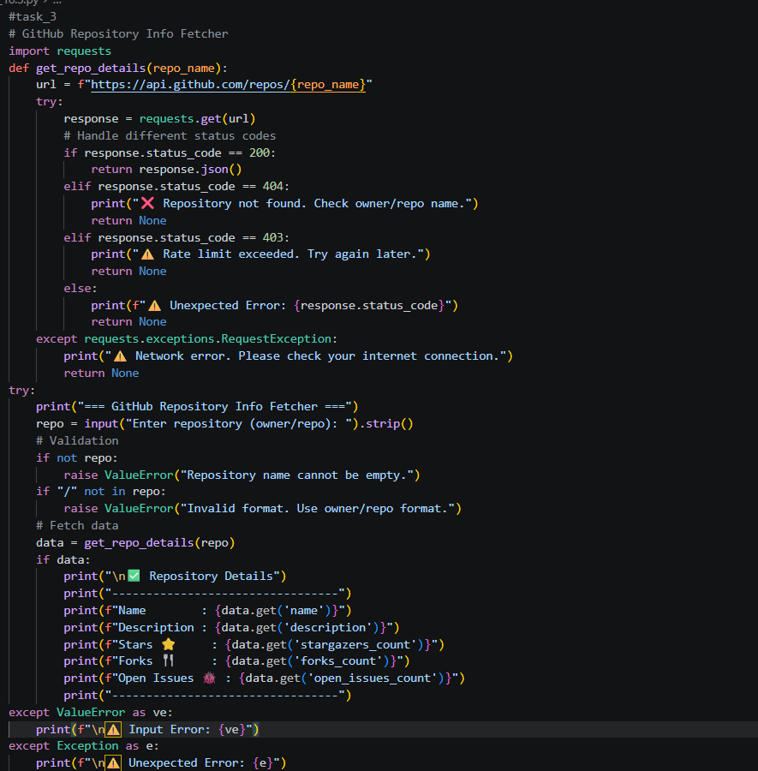
Output:
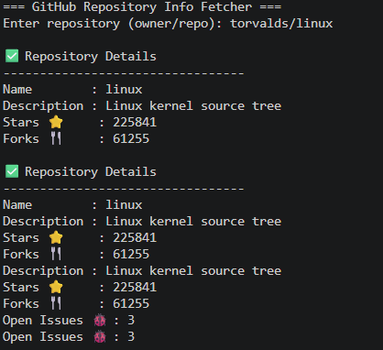
Justification:
Fetching repository data gives developers insights into project activity and popularity. Robust error handling keeps the tool resilient against invalid inputs or rate limits. Displaying stars, forks, and issues allows quick evaluation of a project’s health.

Task 4 – Real-Time Application: News Headlines Aggregator
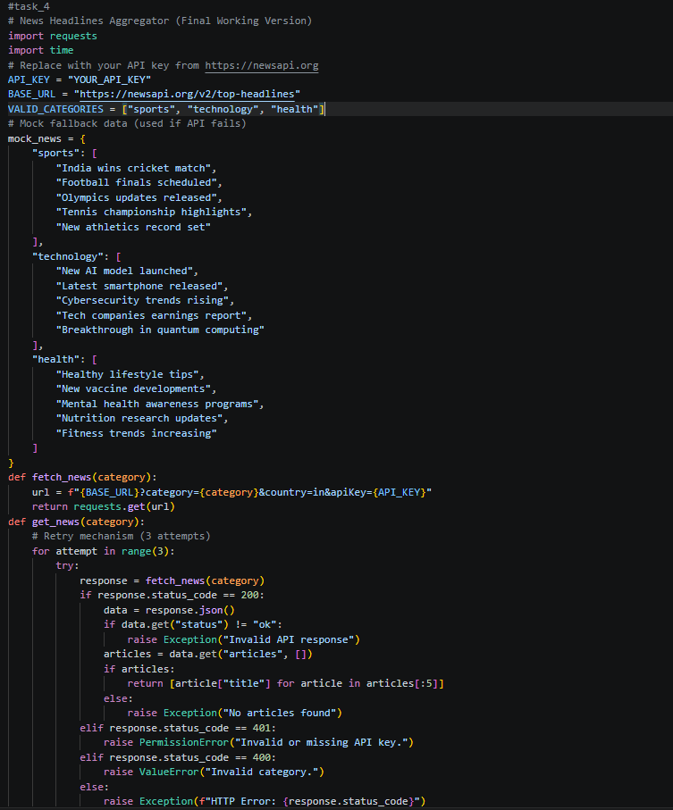
Output:
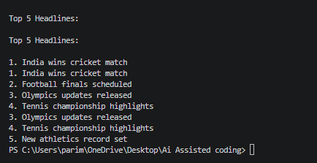
Justification:
A news aggregator delivers timely headlines in categories like sports or technology. Error handling and retry logic ensure users still get results despite failures. Numbered lists make the headlines easy to read and engaging.
Task 5 -COVID-19 Statistics API Integration
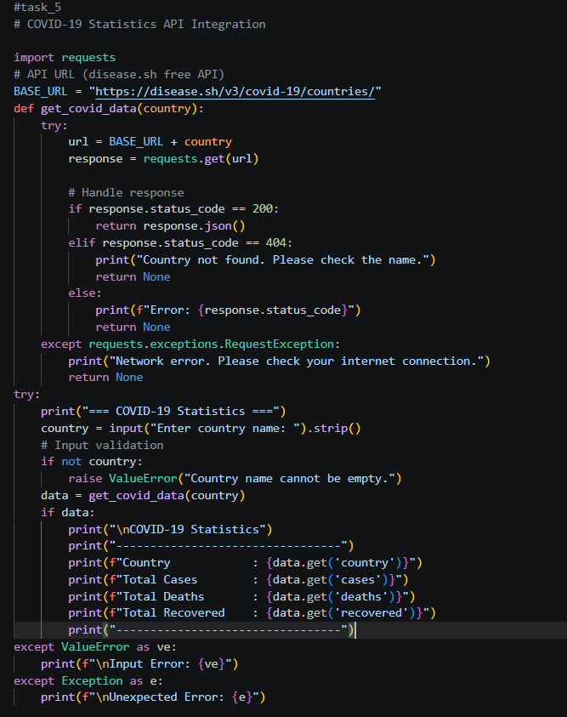
Output:
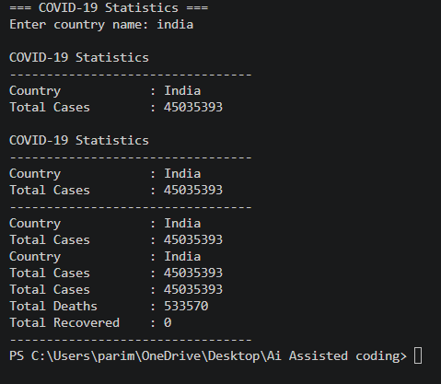
Justification:
Country‑wise COVID statistics are vital for awareness and decision‑making. Error handling and retry logic guarantee accurate data retrieval despite API limits. Presenting confirmed, recovered, deaths, and active cases provides a complete health snapshot.

