ASSIGNMENT_11.5
Batch_30
2303A510H5
Task Description #1 – Stack Implementation
Task: Use AI to generate a Stack class with push, pop, peek, and is_empty
methods.
Code & output:
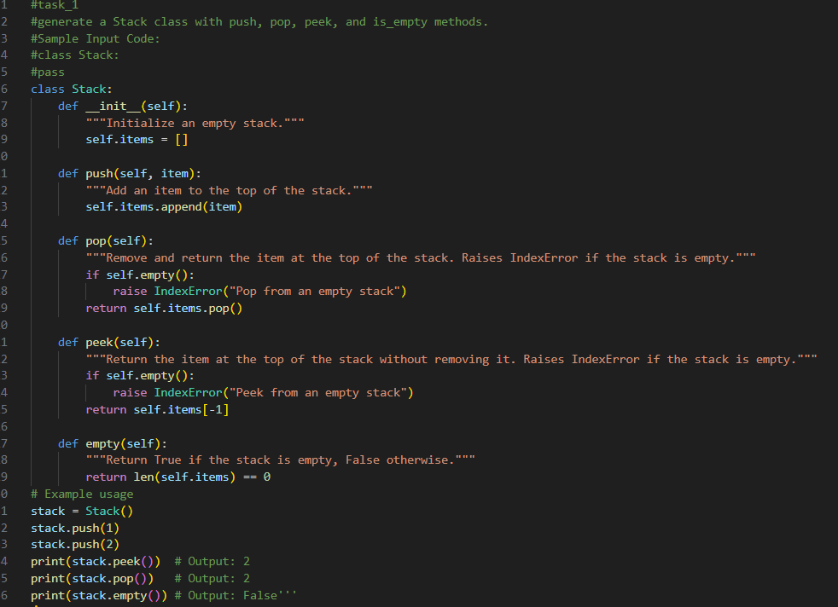
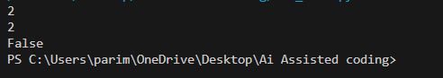

Task Description #2 – Queue Implementation
Task: Use AI to implement a Queue using Python lists.
Code & output:
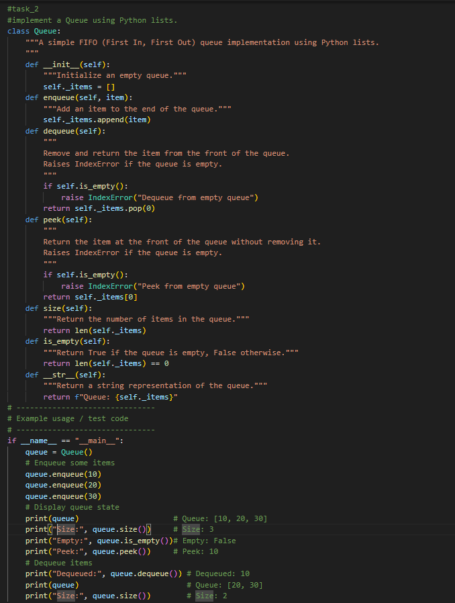
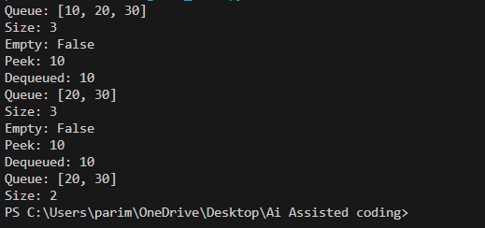
Task Description #3 – Linked List
Task: Use AI to generate a Singly Linked List with insert and display
Methods.
Code & output:
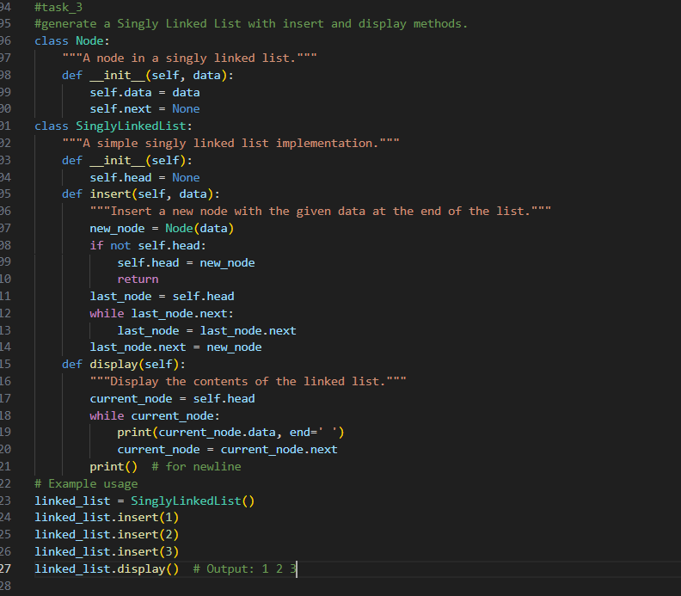
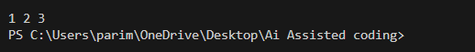
Task Description #4 – Hash Table
Task: Use AI to implement a hash table with basic insert, search, and
delete methods.
Code & output:
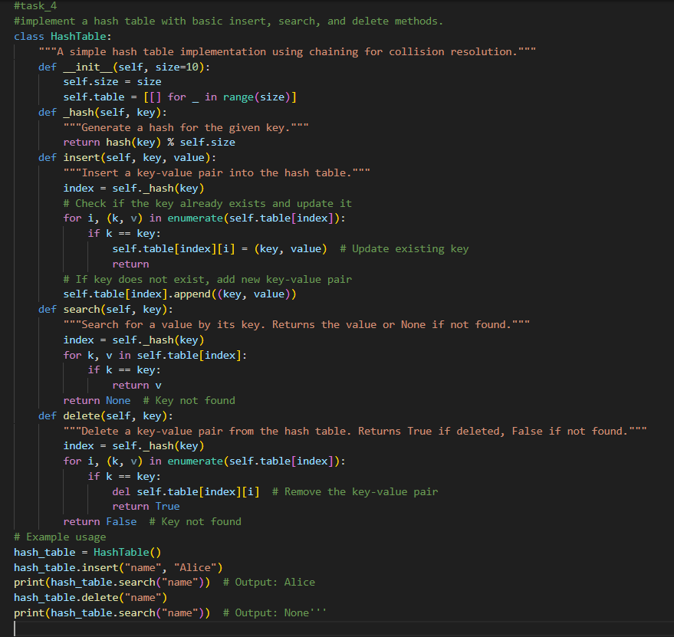
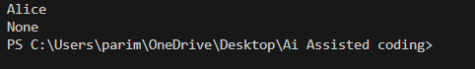

Task Description #5 – Graph Representation
Task: Use AI to implement a graph using an adjacency list.
Code & output:
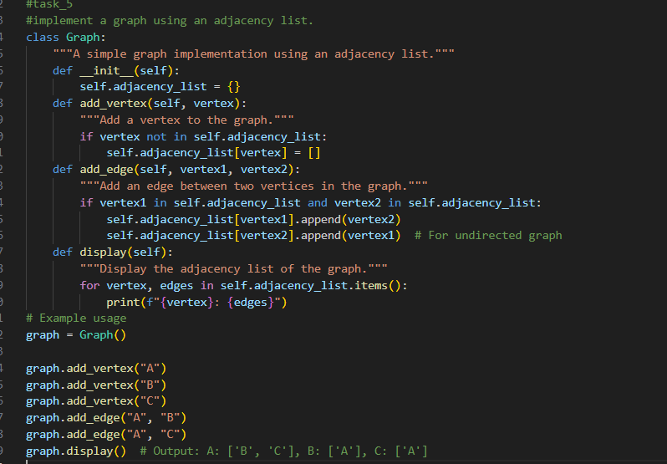
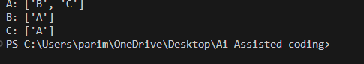

Task Description #6: Smart Hospital Management System – Data
Structure Selection.
Code & output:

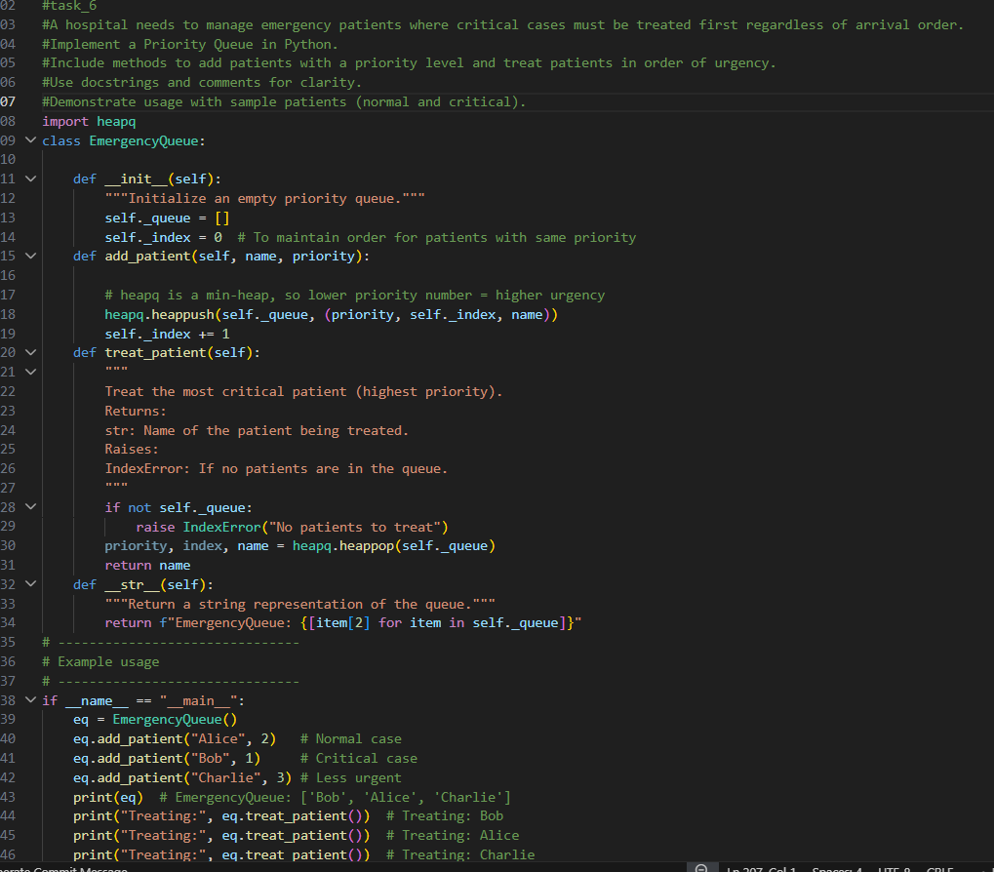
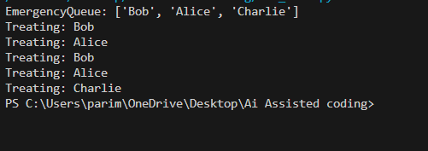

Task Description #7: Smart City Traffic Control System
Code & prompt:

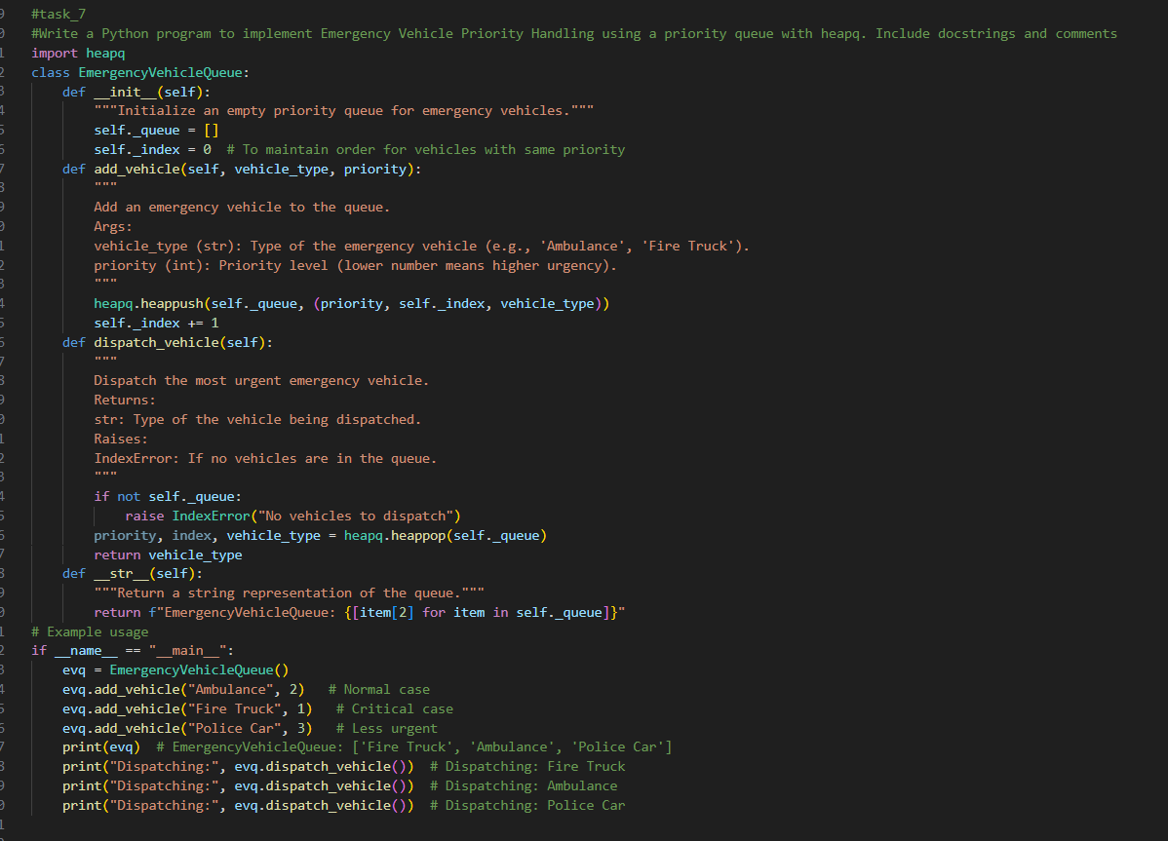
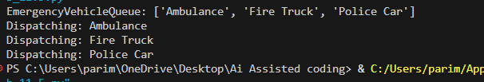

Task Description #8: Smart E-Commerce Platform – Data Structure
Challenge.
Code & output:
