ASSIGNMENT_11.2
Batch_30
2303A510H5
Task Description -1 – (Stack Using AI Guidance)
• Task: With the help of AI, design and implement a Stack data
structure supporting basic stack operations.
Code and output:
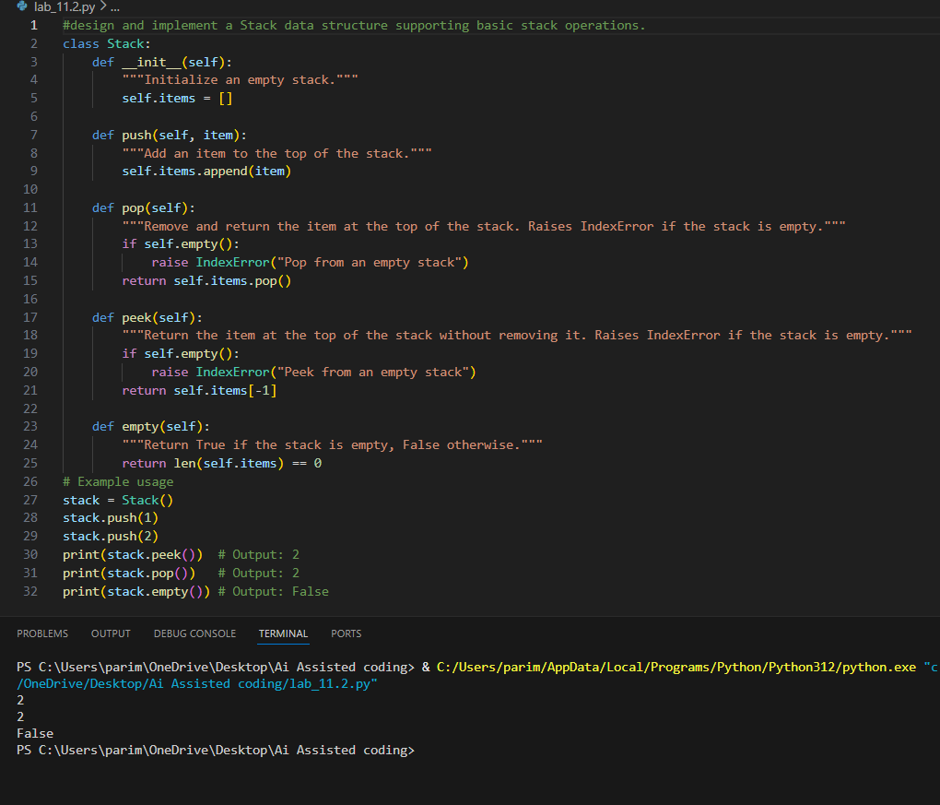
Justification:
The stack data structure is used to store elements following the LIFO (Last In First Out) principle. In this task, a stack was implemented using Python with basic operations like push, pop, peek, and is_empty. This implementation correctly demonstrates how elements are added and removed from the top of the stack.

Task Description -2 – (Queue Design)
• Task:Use AI assistance to create a Queue data structure
following FIFO principles

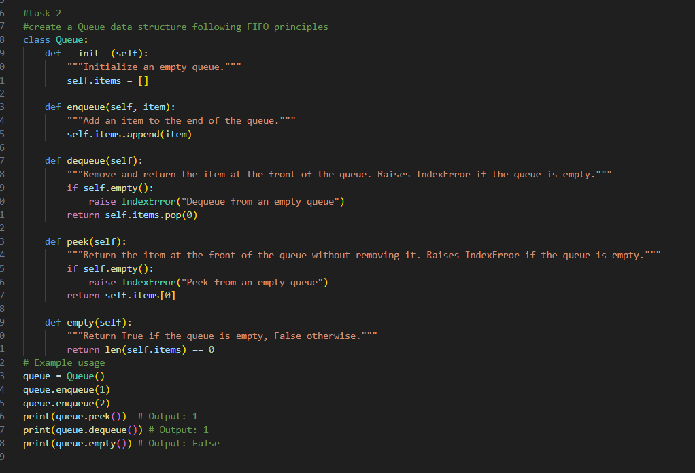
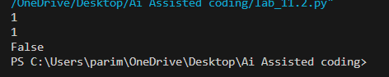
Justification:
A queue follows the FIFO (First In First Out) principle. The queue implemented in Python supports enqueue, dequeue, front, and size operations. This ensures that elements are inserted at the rear and removed from the front, which correctly represents the behavior of a queue.

Task Description -3 –(Singly Linked List Construction)
• Task: Utilize AI to build a singly linked list supporting insertion
and traversal.
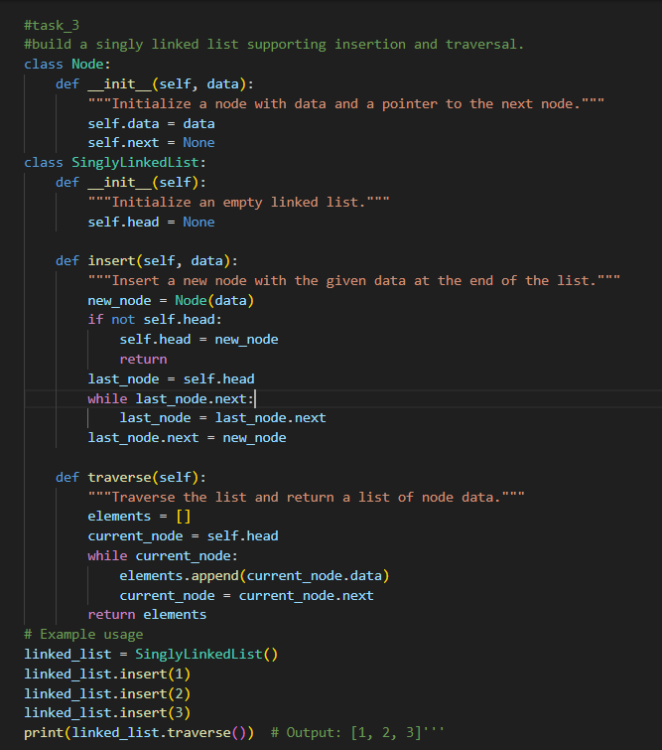
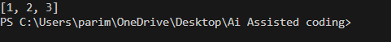
Justification:
A singly linked list is used to store data in nodes where each node points to the next node. In this task, nodes were created and linked together to form a list. The program supports insertion and traversal, which demonstrates how linked lists store and display elements dynamically.

Task Description -4 – (Binary Search Tree Operations)
• Task: Implement a Binary Search Tree with AI support focusing
on insertion and traversal.
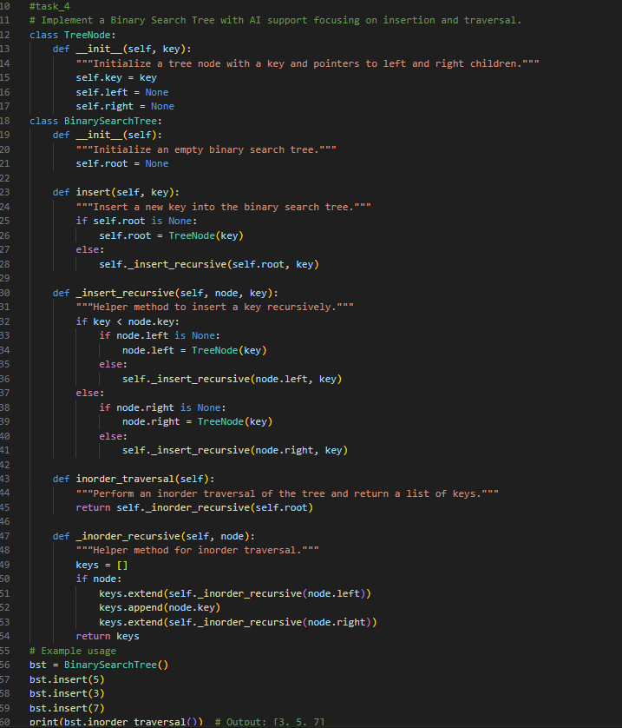
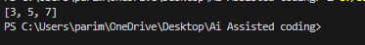
Justification:
A Binary Search Tree stores data in a hierarchical structure where left child values are smaller and right child values are greater than the root. The program implements node insertion and inorder traversal, which prints elements in sorted order, proving the BST structure works correctly.
Task Description -5 – (Hash Table Implementation)
• Task: Create a hash table using AI with collision handling
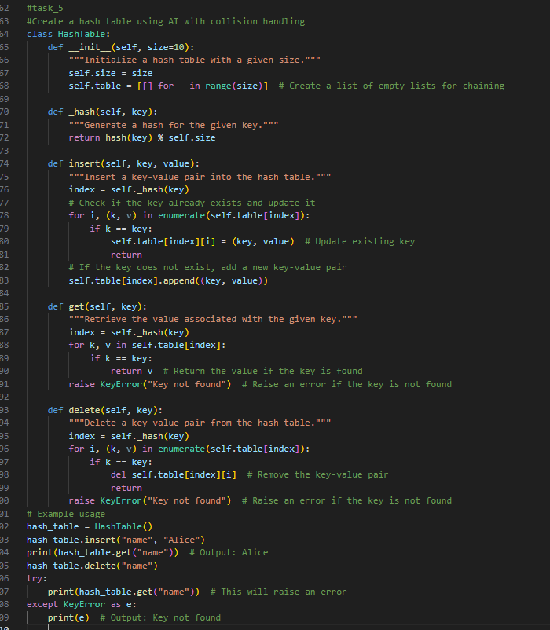
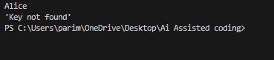
Justification:
A hash table stores data using a hash function to map keys to indexes. In this task, collision handling is done using chaining. The implementation supports insert, search, and delete operations, which shows how data can be stored and retrieved efficiently.

