Assignment – 4.2
2303A510H5
Bacth_30

Task 1: Zero-shot: Prompt AI with only the instruction.
PROMPT :
Write a Python function to determine whether a given number is prime
CODE and OUTPUT :
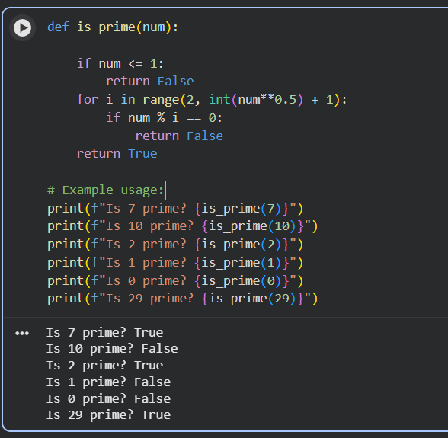
Justification :
In this task, zero-shot prompting was used, where only the instruction was provided to the AI without any examples. The prompt directly asked the AI to write a Python function to check whether a given number is prime. Since no examples or additional context were given, the AI relied entirely on its internal knowledge of prime numbers and basic programming logic. The generated function correctly checks divisibility and handles edge cases such as numbers less than or equal to 1. This demonstrates that zero-shot prompting is effective for simple and well-known problems, but it may lack optimization or detailed explanations.

Task 2: One-shot: Provide one example: Input: [1, 2, 3, 4], Output: 10
PROMPT :
Input: [1, 2, 3, 4], Output: 10 to help AI generate a function that calculates the sum of elements in a list.
Code and output:
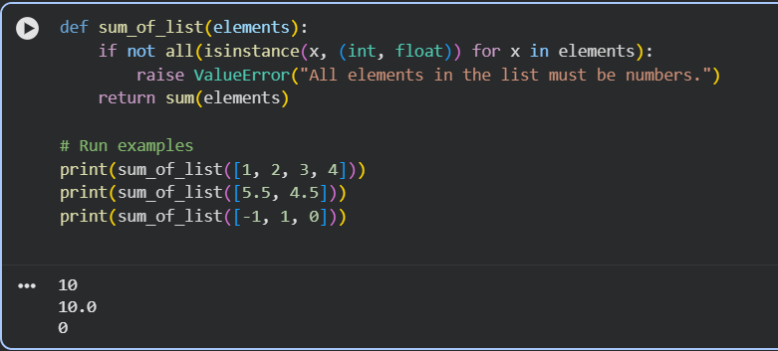
Justification :
In this task, one-shot prompting was applied by providing one input-output example:
Input: [1, 2, 3, 4]
Output: 10
This single example helped the AI clearly understand that the task was to calculate the sum of all elements in a list. The AI generated a correct Python function using a loop or built-in operations based on the given example. Compared to zero-shot prompting, the presence of one example improved clarity and reduced ambiguity. This shows that one-shot prompting is useful when a small hint is enough to guide the model.

Task 3: Few-shot: Give 2–3 examples
PROMPT :
create a function that extracts digits from an alphanumeric string input 1 abc123xyz,output 1 "123",input 2 no_digits_here output 2 "".
CODE and OUTPUT :

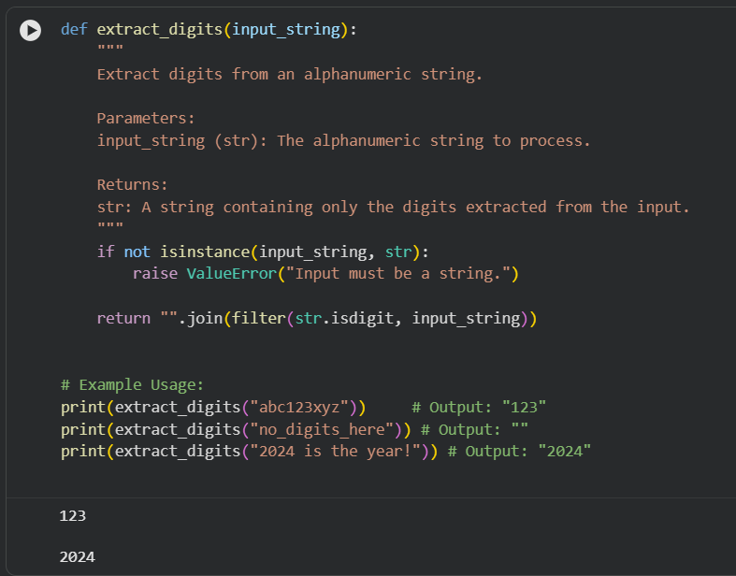
Justification :
In this task, few-shot prompting was used by providing two to three examples showing how digits should be extracted from alphanumeric strings. These examples clearly demonstrated the expected pattern and output format. With multiple examples, the AI was able to understand that: Only numeric characters should be extracted All other alphabetic or special characters should be ignored As a result, the generated function accurately returns only the digits from the input string. This task proves that few-shot prompting is very effective for pattern-based problems, where examples help the AI generalize the solution correctly.

Task 4: Compare zero-shot vs few-shot prompting
PROMPT :
Compare zero-shot vs few-shot prompting for generating a function that counts the number of vowels in a string, Output comparison + student explanation on how examples helped the model.
CODE :
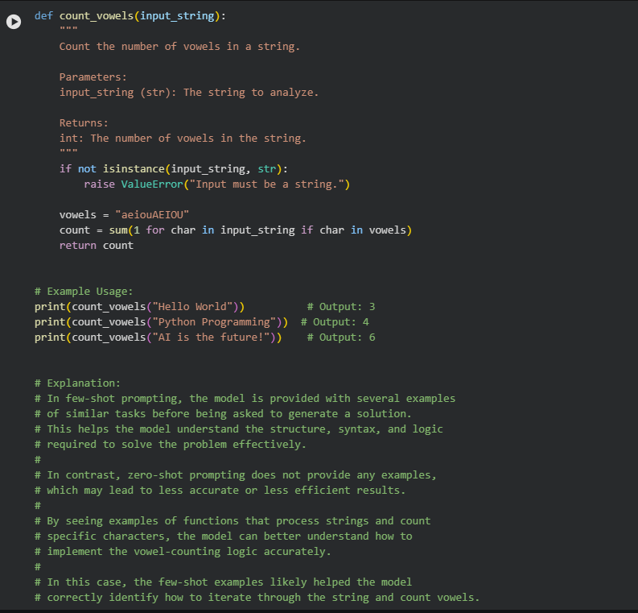
Output:

Justification :
This task compares zero-shot prompting and few-shot prompting for generating a function that counts vowels in a string. In the zero-shot approach, the AI generated a basic solution that counted vowels correctly but lacked clarity in handling uppercase letters or explaining the logic. In the few-shot approach, examples showed how vowels are counted in different strings. This helped the AI generate a more accurate and robust function, often including case-insensitive handling. The comparison shows that examples significantly improve AI performance, making the output more reliable and easier to understand. Few-shot prompting reduces errors and improves logical completeness.

Task 5: Use few-shot prompting with 3 sample inputs
PROMPT :
Use few-shot prompting with 3 sample inputs to generate a function that determines the minimum of three numbers without using the built-in min() function,A function that handles all cases with correct logic based on example patterns.
input 1 3, 1, 2 output 1 1
input 2 -1, -5, -3 output 2 -5
input 3 0, 0, 0 output 3 0
CODE and OUTPUT :
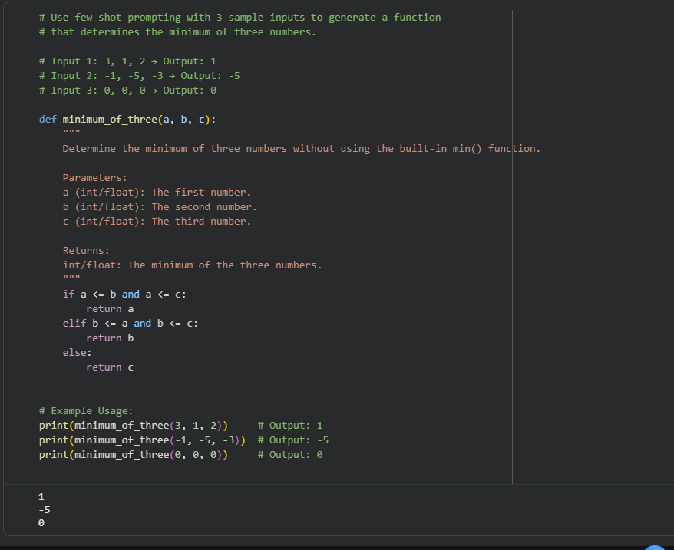

Justification :
In this task, few-shot prompting with three sample inputs was used to generate a function that finds the minimum of three numbers without using the built-in min() function. The provided examples helped the AI identify comparison patterns between three values and implement conditional logic correctly. The generated function successfully handles all possible cases, such as equal values and negative numbers. This task highlights how few-shot prompting helps the AI learn decision-making logic from examples rather than relying on built-in shortcuts.

