ASSIGNMENT_12.5
2303A510H5
Batch_30
Task Description #1 (Sorting – Merge Sort Implementation)
• Task: Use AI to generate a Python program that implements
the Merge Sort algorithm.

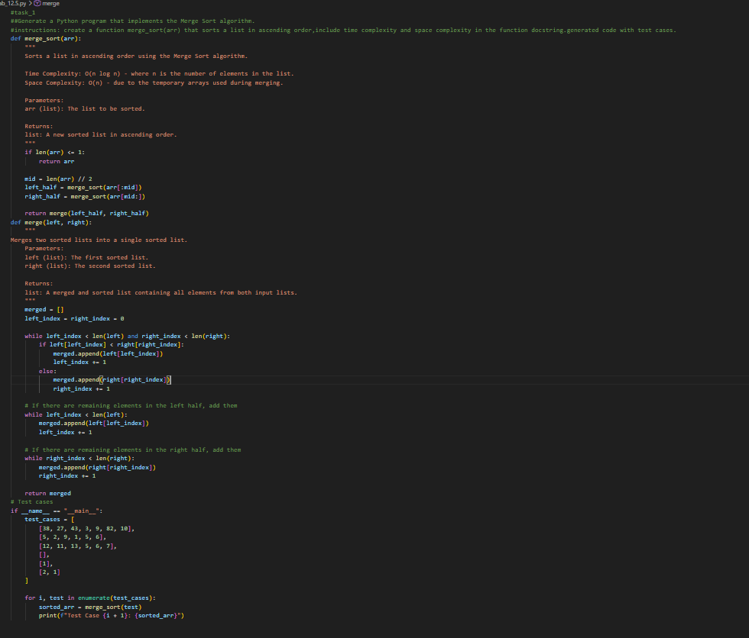
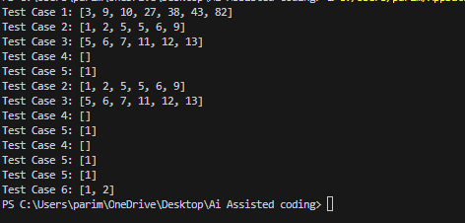
Task Description #2 (Searching – Binary Search with AI
Optimization)
• Task: Use AI to create a binary search function that finds a
target element in a sorted list.
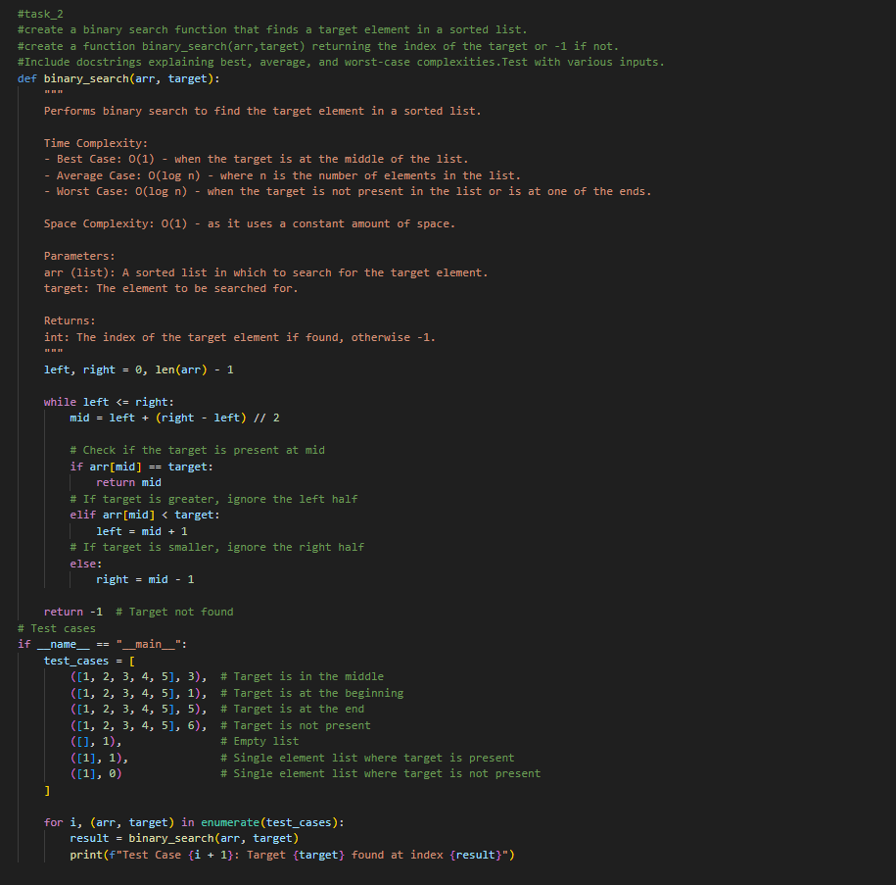
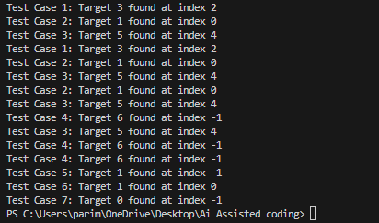
Task Description #3: Smart Healthcare Appointment Scheduling
System
A healthcare platform maintains appointment records containing
appointment ID, patient name, doctor name, appointment time, and
consultation fee. The system needs to:
1. Search appointments using appointment ID.
2. Sort appointments based on time or consultation fee.
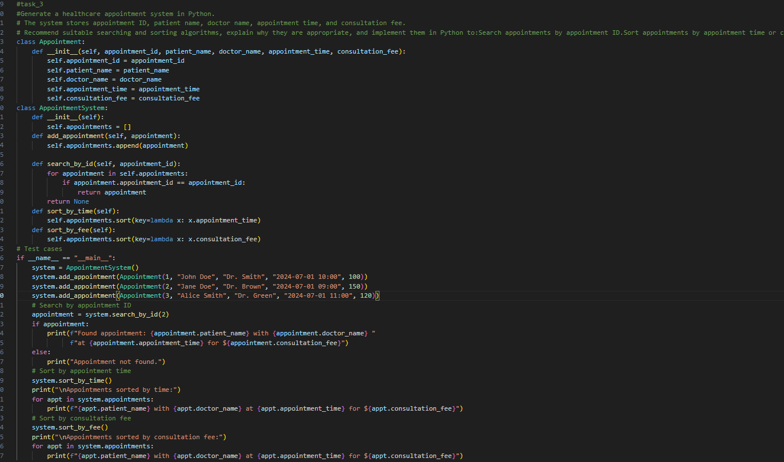
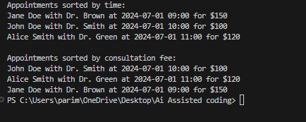
Task Description #4: Railway Ticket Reservation System
Scenario
A railway reservation system stores booking details such as ticket
ID, passenger name, train number, seat number, and travel date. The
system must:
1. Search tickets using ticket ID.
2. Sort bookings based on travel date or seat number.
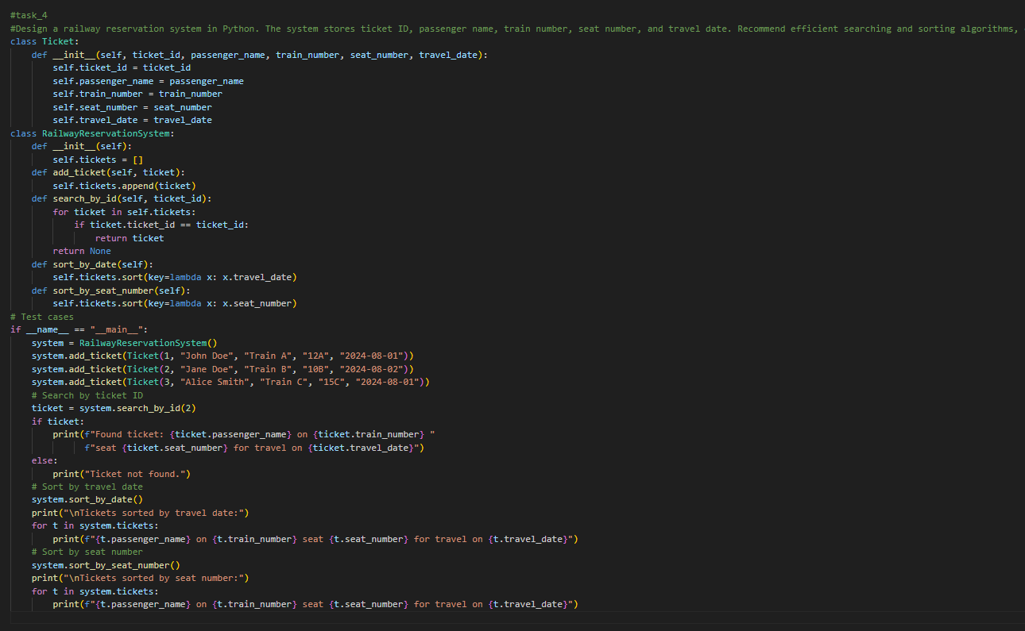
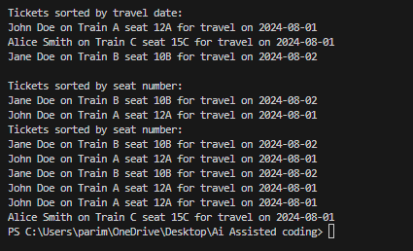
Task Description #5: Smart Hostel Room Allocation System
A hostel management system stores student room allocation details
including student ID, room number, floor, and allocation date. The
system needs to:
1. Search allocation details using student ID.
2. Sort records based on room number or allocation date.
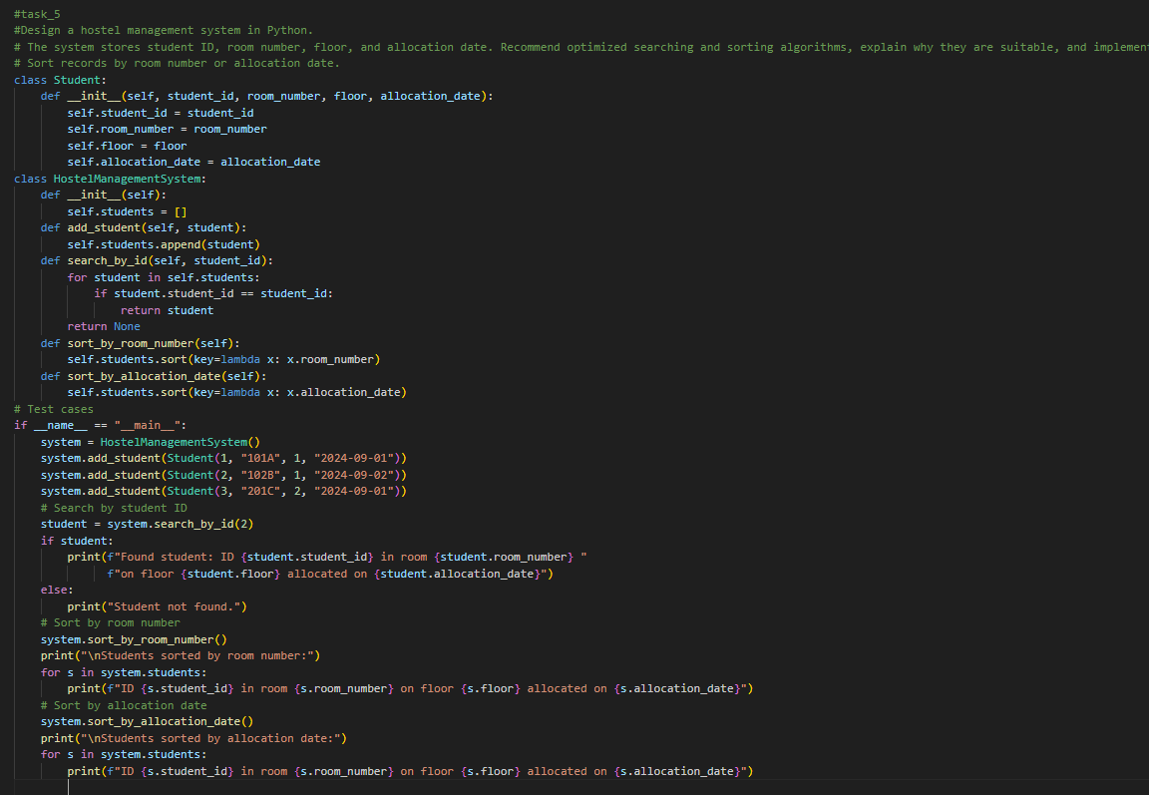
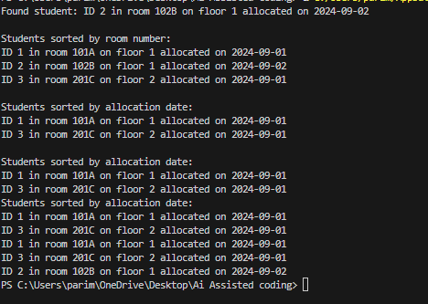
Task Description #6: Online Movie Streaming Platform
A streaming service maintains movie records with movie ID, title,
genre, rating, and release year. The platform needs to:
1. Search movies by movie ID.
2. Sort movies based on rating or release year.
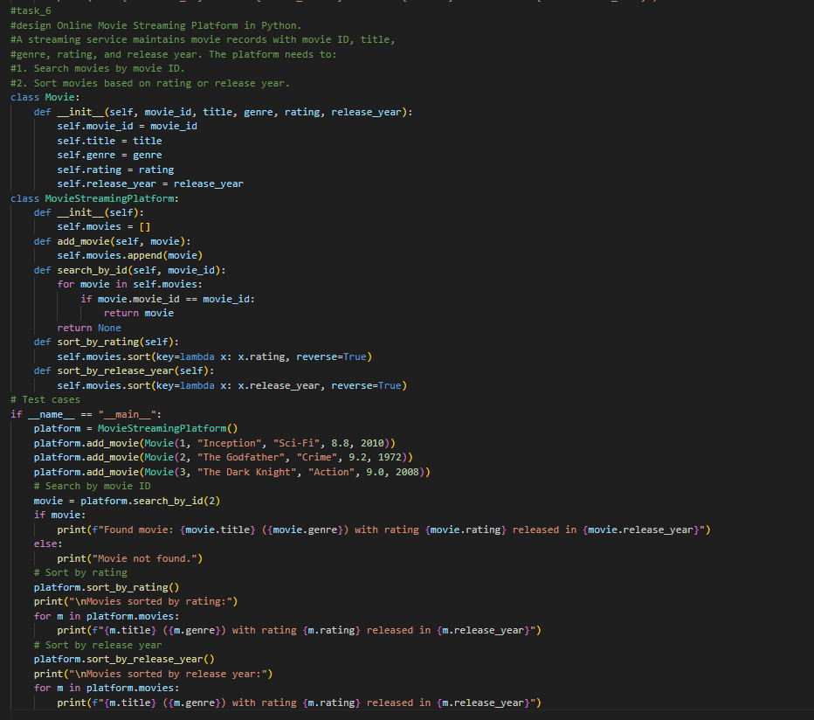
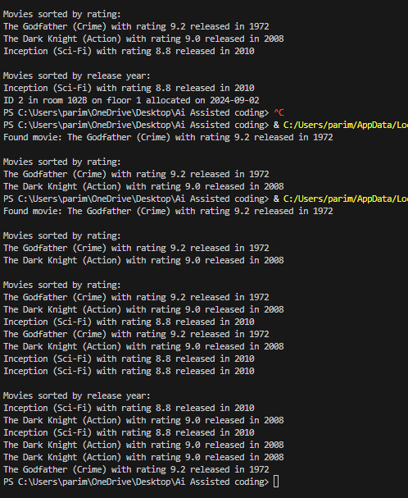
Task Description #7: Smart Agriculture Crop Monitoring System
An agriculture monitoring system stores crop data with crop ID, crop
name, soil moisture level, temperature, and yield estimate. Farmers
need to:
1. Search crop details using crop ID.
2. Sort crops based on moisture level or yield estimate.

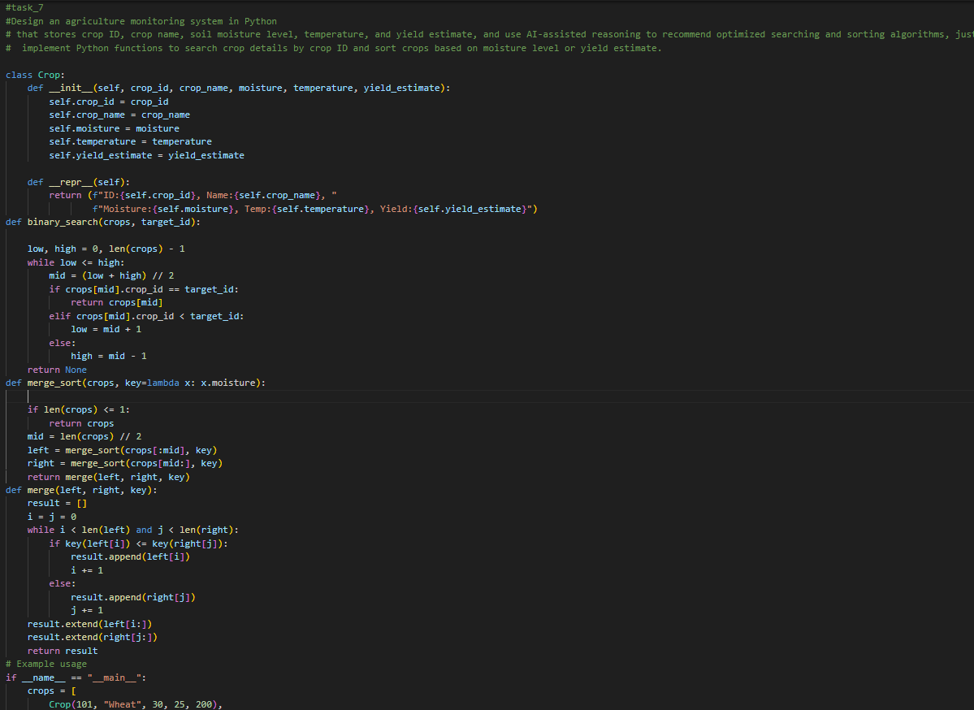
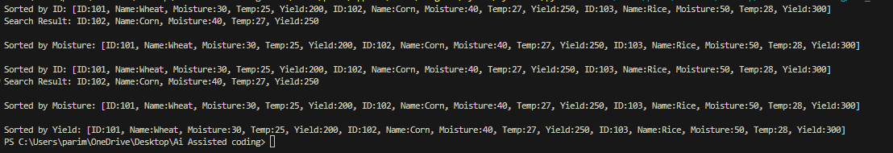
Task Description #8: Airport Flight Management System
An airport system stores flight information including flight ID,
airline name, departure time, arrival time, and status. The system
must:
1. Search flight details using flight ID.
2. Sort flights based on departure time or arrival time.
