ASSIGNMENT_13
Batch_30
2303A510H5
- Task: Use AI to refactor a given Python script that contains multiple repeated code blocks.
- Prompt:
  - identify duplicate logic and replace it with functions or classes.
  - Ensure the refactored code maintains the same output.
  - Add docstrings to all functions.
Code:
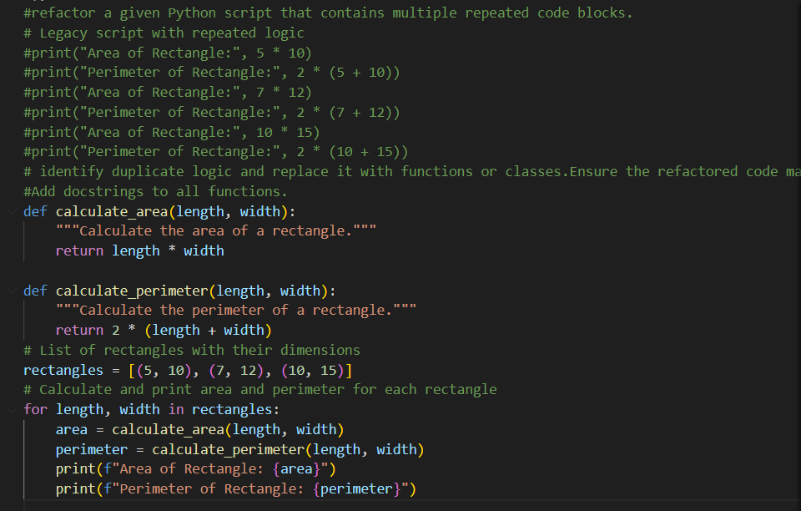
Output:
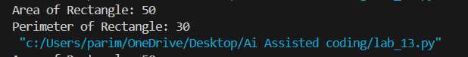
Task Description #2 (Refactoring – Extracting Reusable Functions)
Prompt: refactor a legacy script where multiple calculations are embedded directly inside the main code block.
Code:
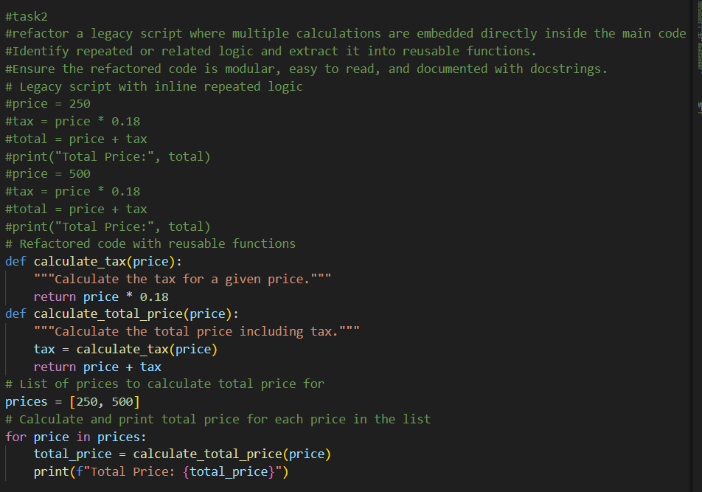
Output:
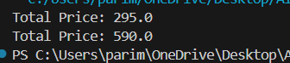
Task Description #3: Refactoring Using Classes and Methods (Eliminating Redundant Conditional Logic)
Refactor a Python script that contains repeated if–elif–else grading logic by implementing a structured, object-oriented solution using a class and a method.

Code:
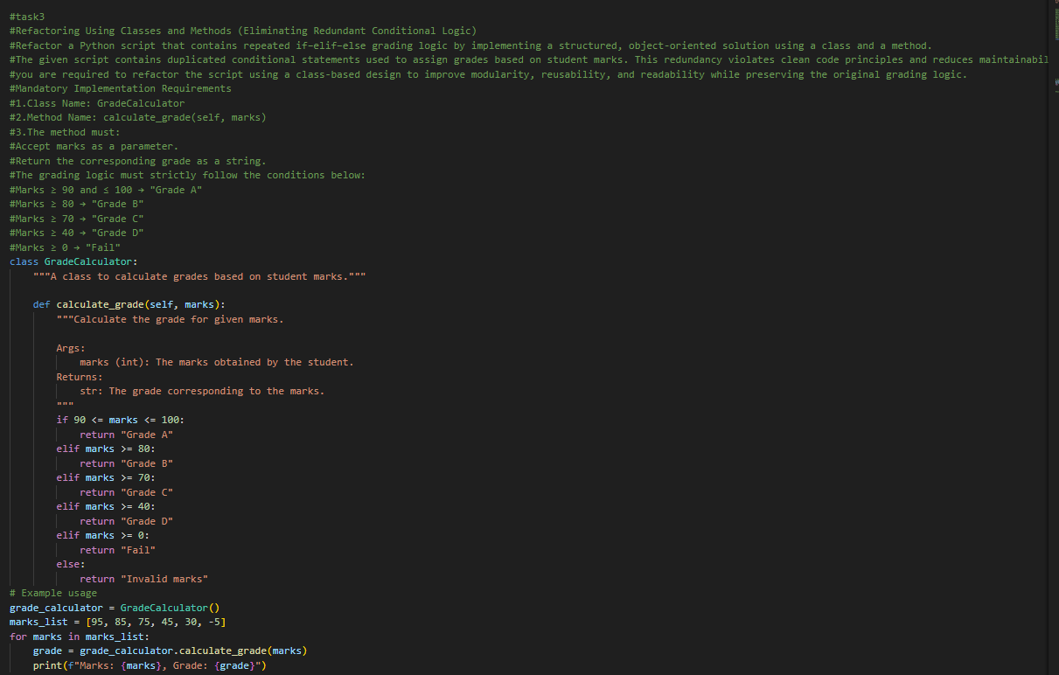
Output:
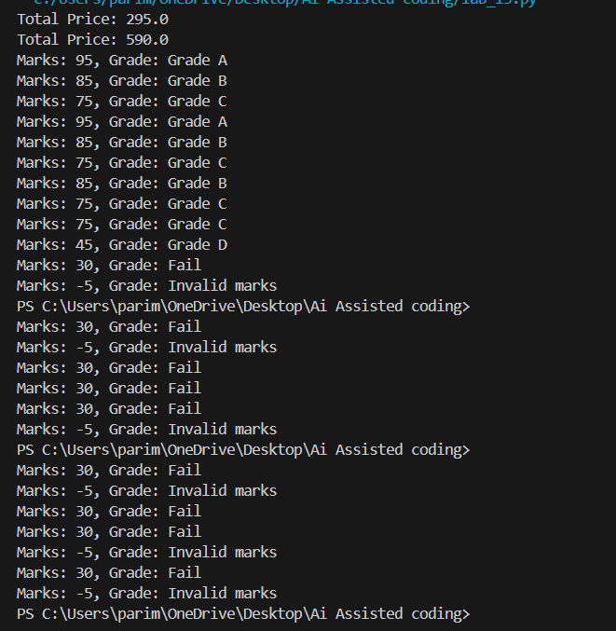
Task Description #4 (Refactoring – Converting Procedural Code to Functions)
Prompt: refactor procedural input–processing logic into functions.
Code:
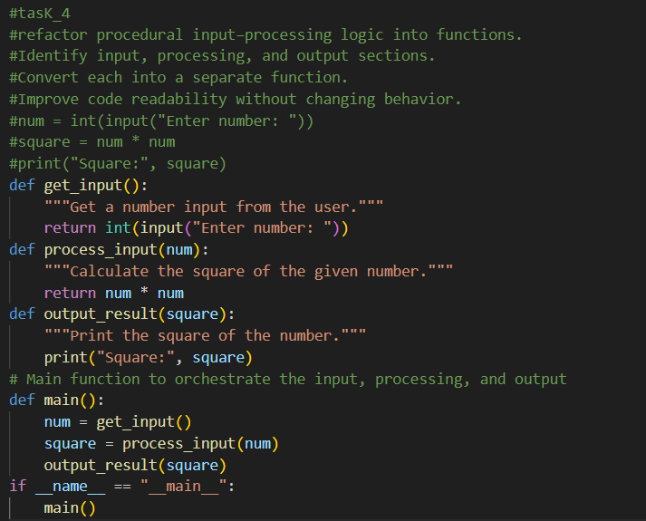
Output:
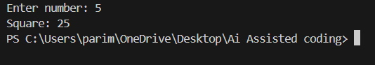

Task 5 (Refactoring Procedural Code into OOP Design)
Prompt: refactor procedural code into a class-based design
Code:
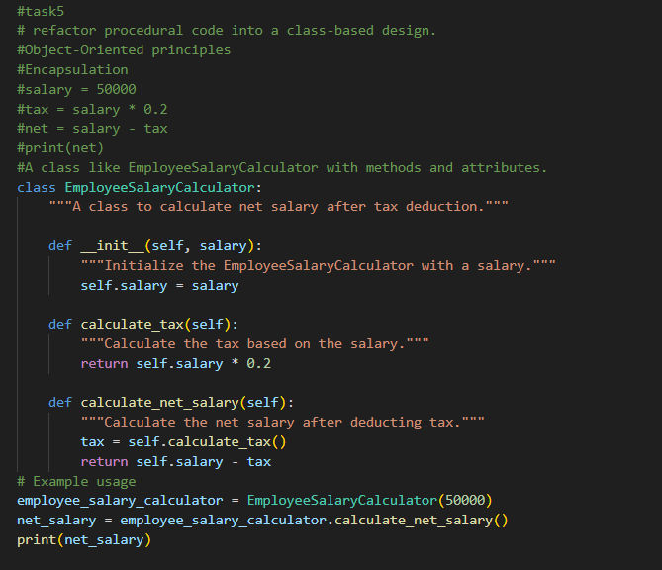
Output:
Task 6 (Optimizing Search Logic)
Task: Refactor inefficient linear searches using appropriate data structures.

Code:
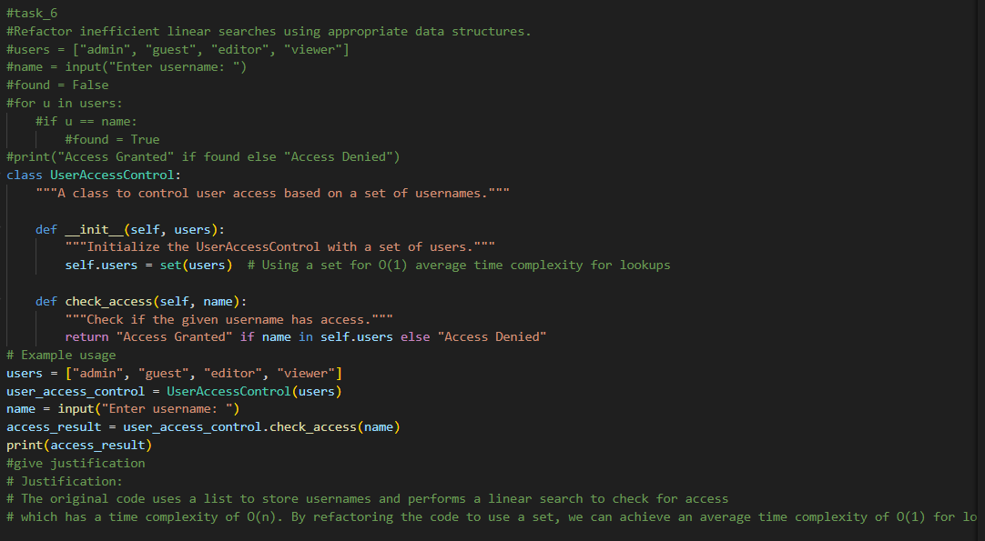
Output:
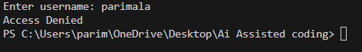
Task 7 – Refactoring the Library Management System
Code:
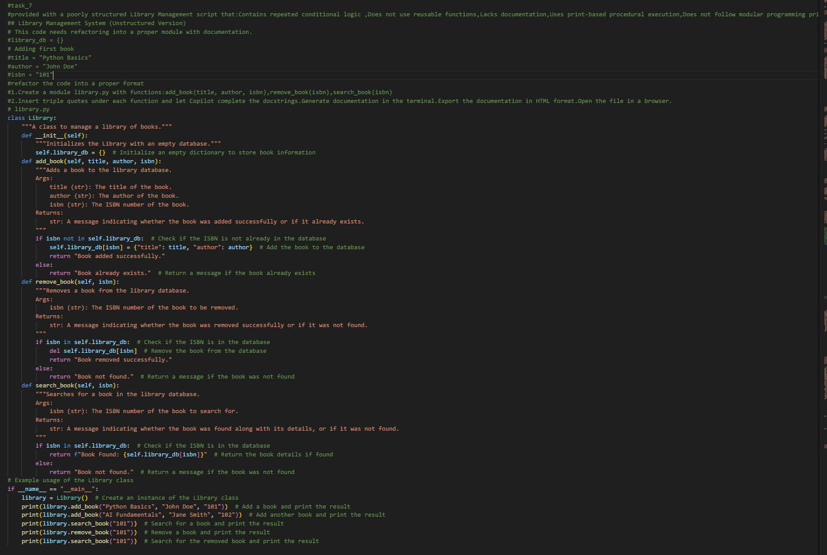

Output:
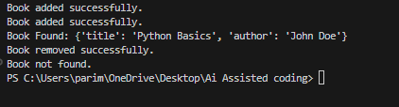
Task 8– Fibonacci Generator
Prompt:Write a program to generate Fibonacci series up to n.
Code:
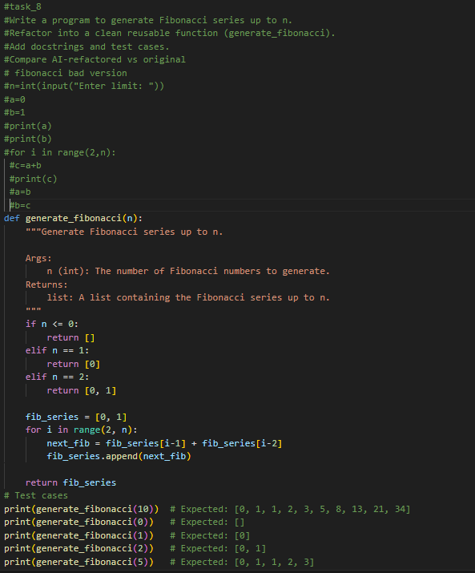
Output:
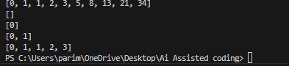
Task 9 – Twin Primes Checker
Prompt:Refactor into is_prime(n) and is_twin_prime(p1, p2).
Add docstrings and optimize.
Generate a list of twin primes in a given range.
Code:
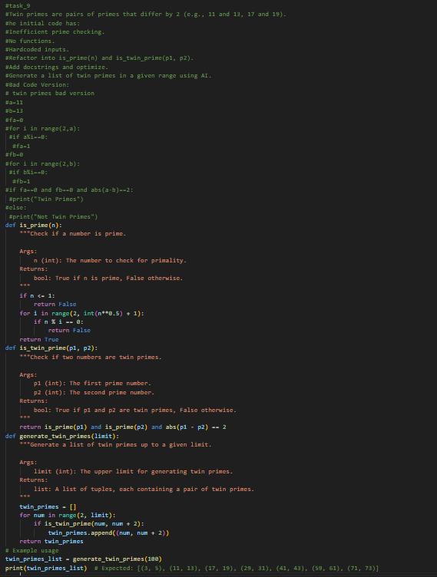
Output:

Task 10 – Refactoring the Chinese Zodiac Program
Objective
Prompt:Refactor the given poorly structured Python script into a clean, modular, and reusable implementation.
Code:
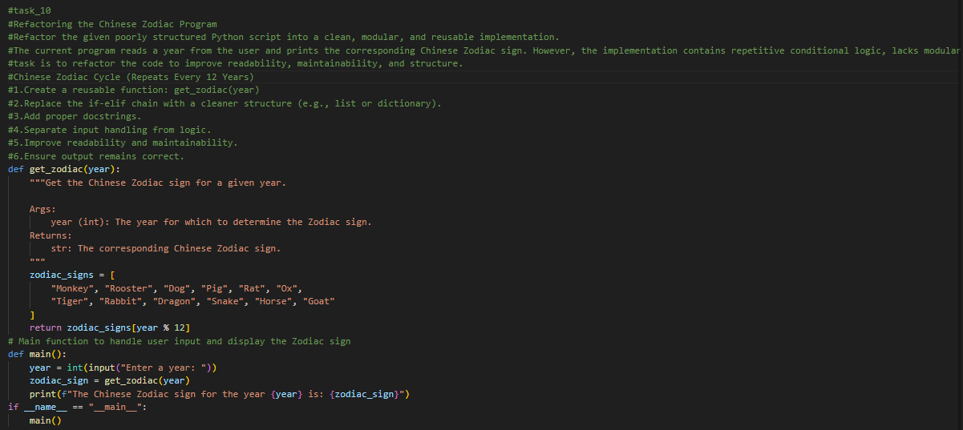
Output:
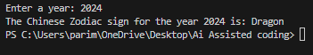
Task 11 – Refactoring the Harshad (Niven) Number Checker
Prompt:Refactor the given poorly structured Python script into a clean, modular, and reusable implementation.

Code:

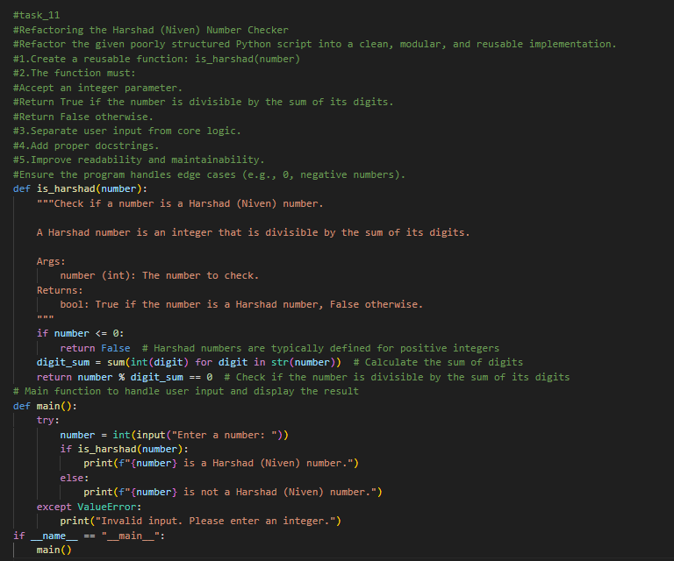
Output:
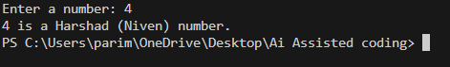
Task 12 – Refactoring the Factorial Trailing Zeros Program
Prompt: Refactor the given poorly structured Python script into a clean, modular, and efficient implementation.
The program calculates the number of trailing zeros in n! (factorial of n).

Code:
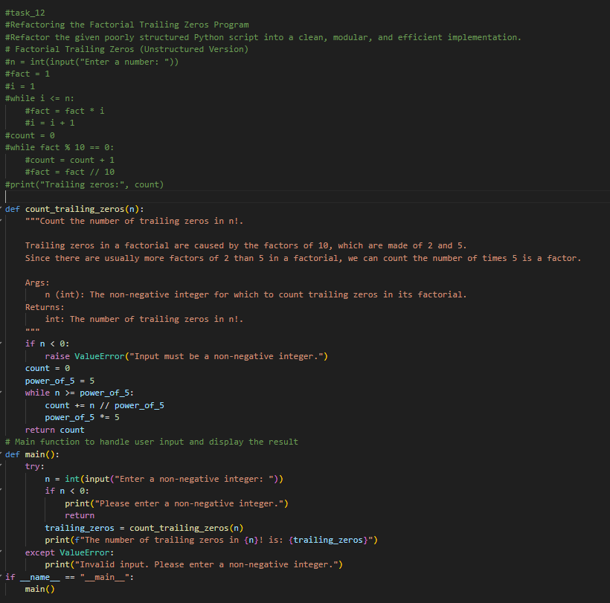
Output:
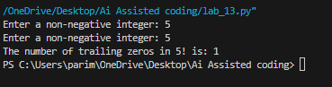
Task 13 (Collatz Sequence Generator – Test Case Design)
Prompt: Function: Generate Collatz sequence until reaching 1.

Code:
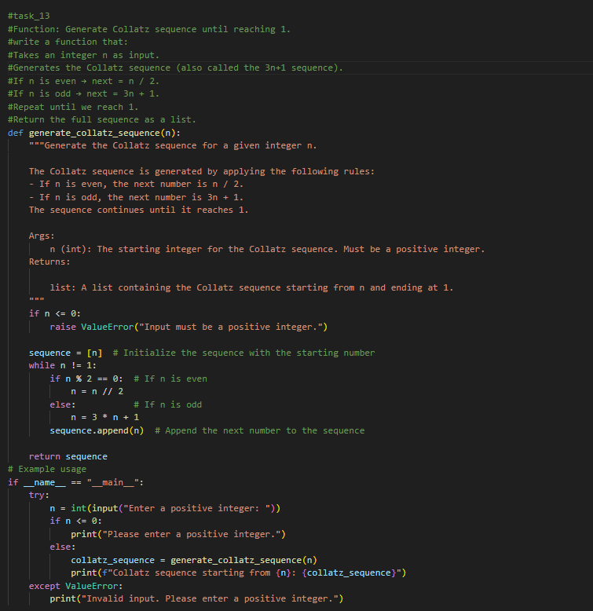
Output:
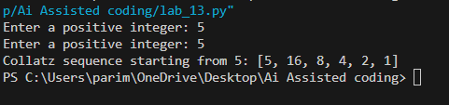
Task 14 (Lucas Number Sequence – Test Case Design)
Prompt:Function: Generate Lucas sequence up to n terms.
Code:
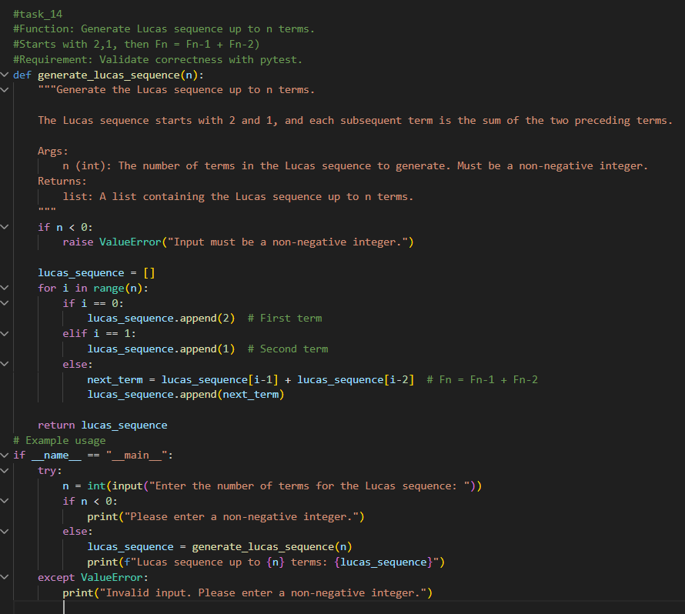
Output:
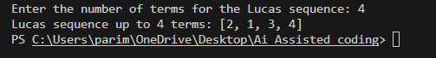
Task 15 (Vowel & Consonant Counter – Test Case Design)
Prompt:Function: Count vowels and consonants in string.

Code:
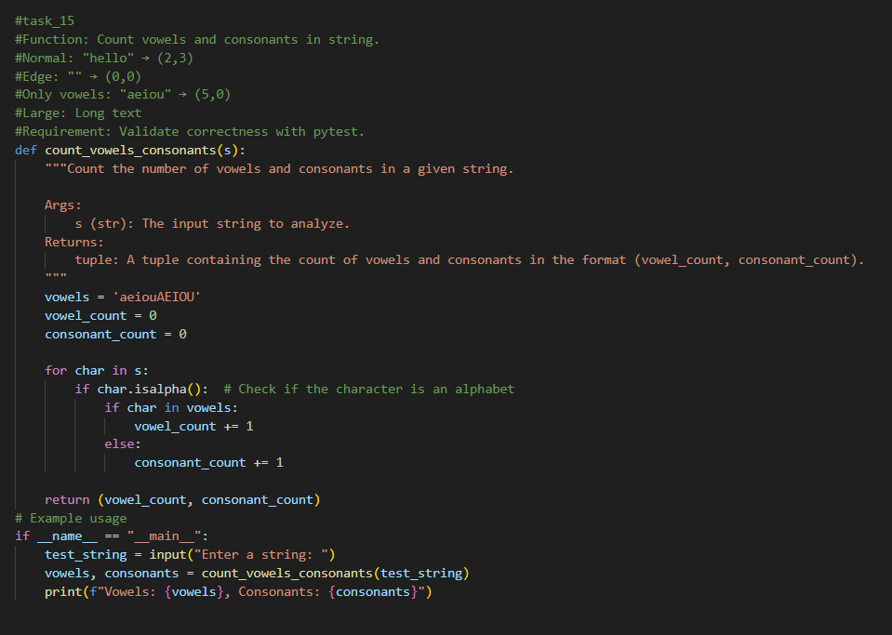
Output:
