Assignment – 9.5
2303A510H5
Batch_30
Task 1 – String Utilities Function
PROMPT :
#def reverse_string(text):
#return text[::-1]
#Write documentation in:(a) Docstring (b) Inline comments (c) Google-style documentation CODE :
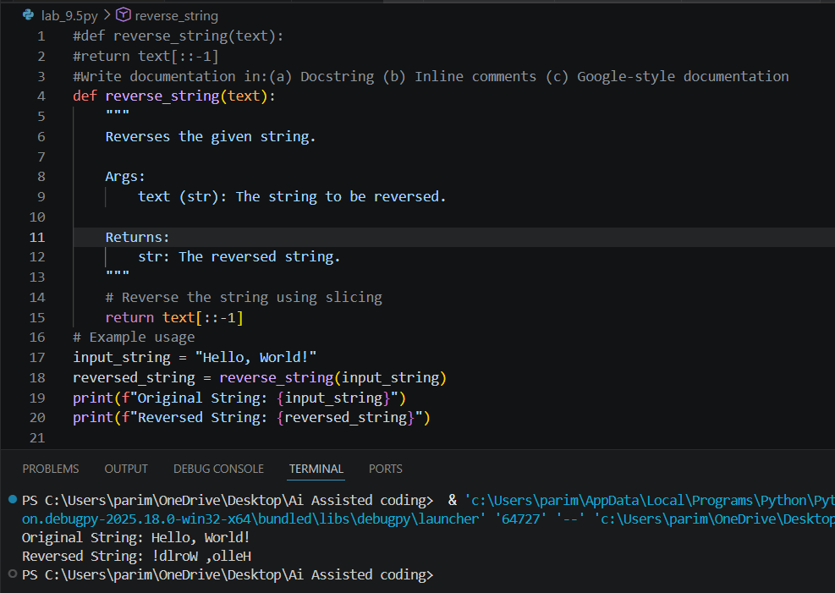
JUSTIFICATION :
Google-style documentation is most suitable for a utility-based string library because it clearly defines parameters and return values in a structured format. It improves readability and supports automatic documentation generation tools. It is widely used in professional development environments. Therefore, it enhances maintainability and scalability of utility libraries.
Task 2 – Password Strength Checker PROMPT :
#def check_strength(password):
#return len(password) >= 8
#Write documentation in:(a) Docstring (b) Inline comments (c) Google-style documentation CODE :
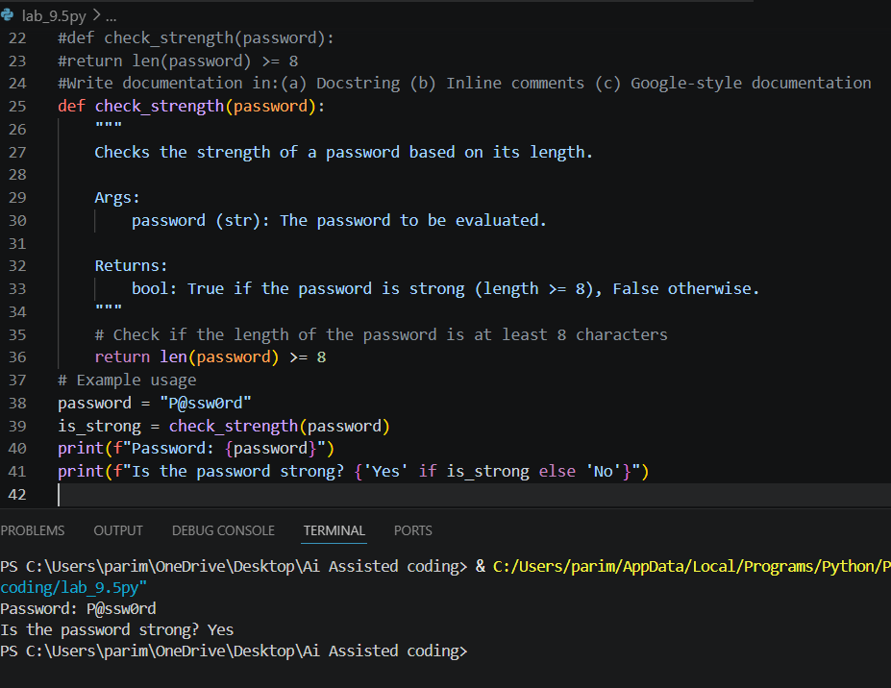

JUSTIFICATION :
For security-related code, structured documentation like Google-style is preferred because it clearly explains validation logic and return behavior. Security functions require precise parameter and output descriptions to avoid misuse. Proper documentation also helps in auditing and maintenance. Hence, structured documentation improves reliability and clarity. Task 3 – Math Utilities Module
PROMPT :
#Create a module math_utils.py with functions: square(n), cube(n), factorial(n)
#Write documentation in:(a) Docstring (b) Inline comments (c) Google-style documentation
CODE :
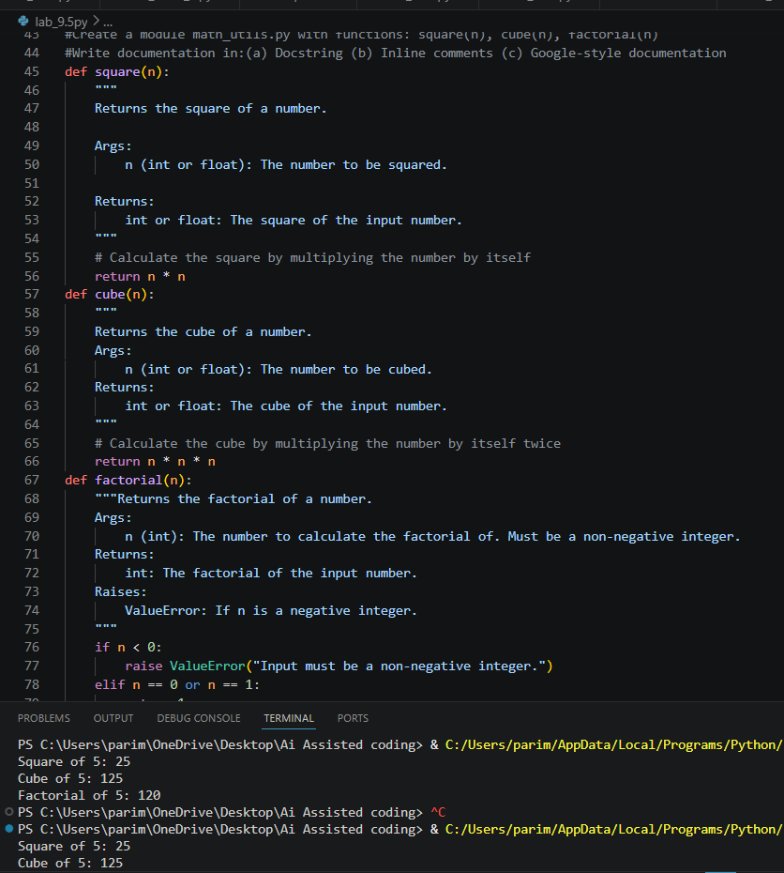

JUSTIFICATION :
Documenting mathematical functions improves clarity about input constraints and expected outputs. It helps prevent misuse, especially in functions like factorial where invalid inputs may cause errors. Automatically generated docstrings save time and maintain consistency. Exporting HTML documentation improves accessibility and professional presentation.
Task 4 – Attendance Management Module
PROMPT :
#Create a module attendance.py with functions: mark_present(student) , mark_absent(student) , get_attendance(student)
#Write documentation in:(a) Docstring (b) Inline comments (c) Google-style documentation
CODE :
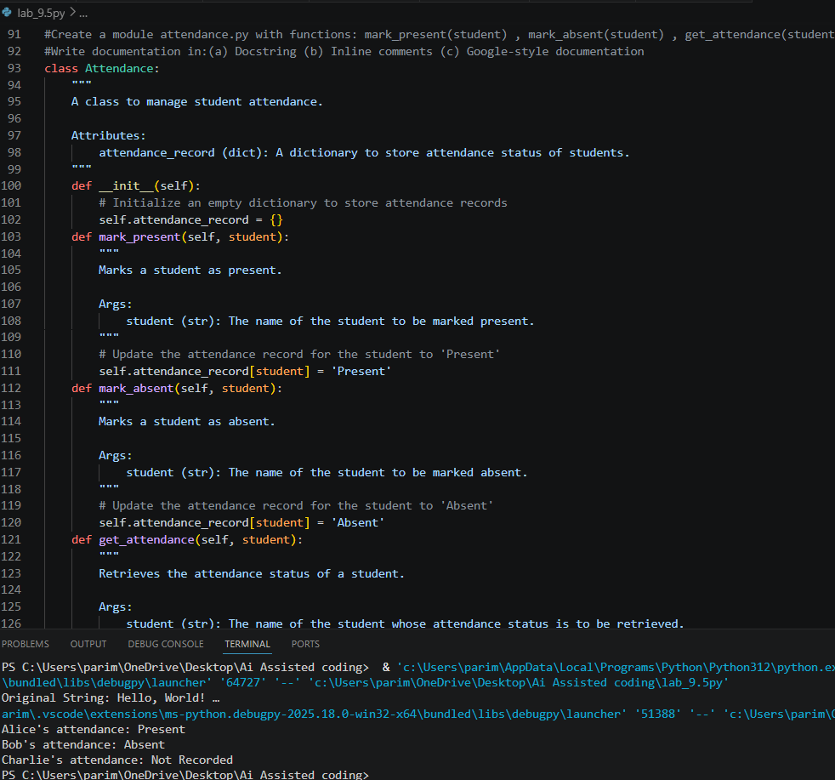

JUSTIFICATION :
Attendance systems require clear documentation to define function behavior and data handling. Proper docstrings improve maintainability and team collaboration. Generated documentation allows easy viewing in terminal and browser. This ensures better usability and transparency in academic or organizational systems.

Task 5 – File Handling Function
PROMPT :
#def read_file(filename):
#with open(filename, 'r') as f:
#return f.read()
#Write documentation in:(a) Docstring (b) Inline comments (c) Google-style documentation
CODE :
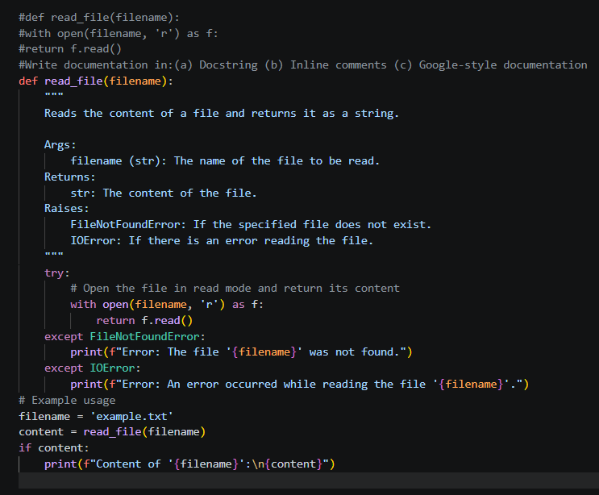
JUSTIFICATION :
Google-style documentation best explains exception handling because it clearly defines raised exceptions and return values. File operations are prone to errors like FileNotFoundError, so structured documentation improves understanding. It helps developers anticipate edge cases. Therefore, it enhances robustness and maintainability of file-handling code.

