Lab Assignment-7.5
Name: M. Hasini Hallticket:2303A51109
Batch:02

Task 1 (Mutable Default Argument – Function Bug)
Task: Analyze given code where a mutable default argument causes unexpected behavior. Use AI to fix it.
# Bug: Mutable default argument def add_item(item, items=[]): items.append(item)
return items print(add_item(1)) print(add_item(2))
Expected Output: Corrected function avoids shared list bug.

Screenshots:
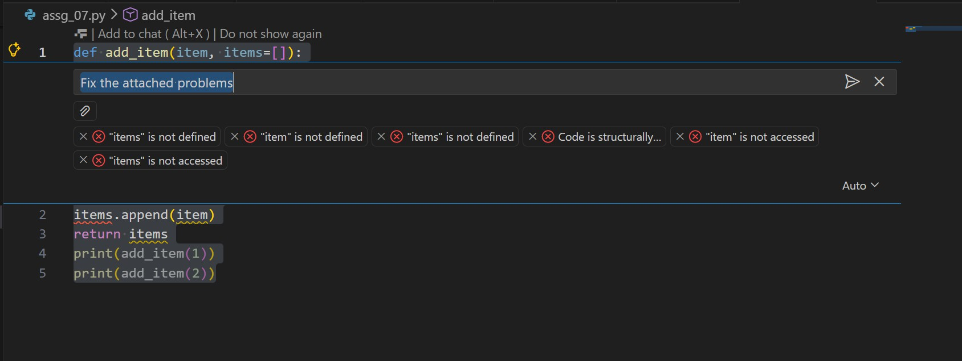

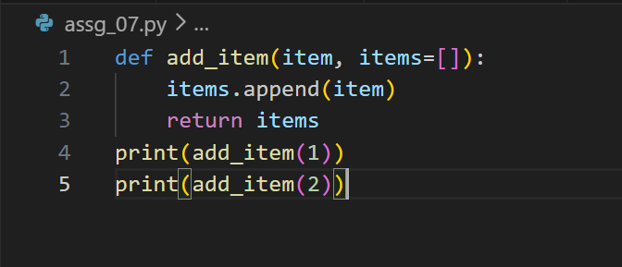
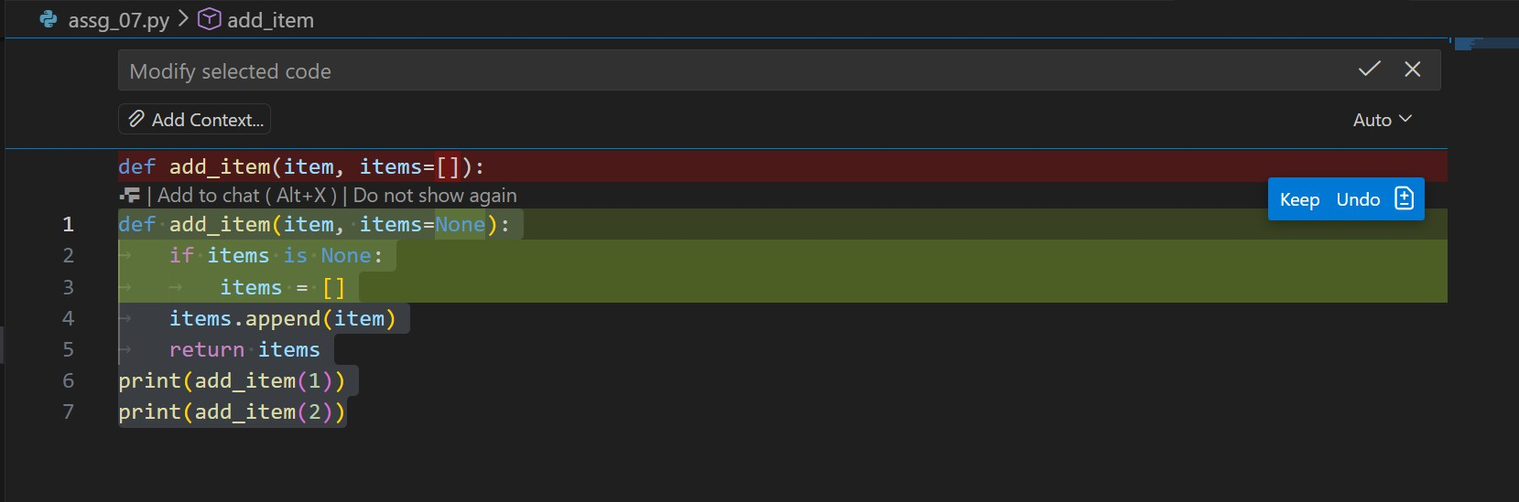
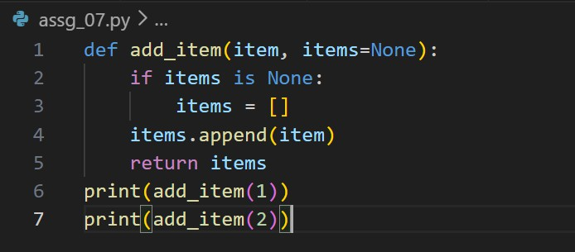

output:
Task 2 (Floating-Point Precision Error)
Task: Analyze given code where floating-point comparison fails. Use AI to correct with tolerance.
# Bug: Floating point precision issue def check_sum():
return (0.1 + 0.2) == 0.3 print(check_sum())
Expected Output: Corrected function

Screenshots:
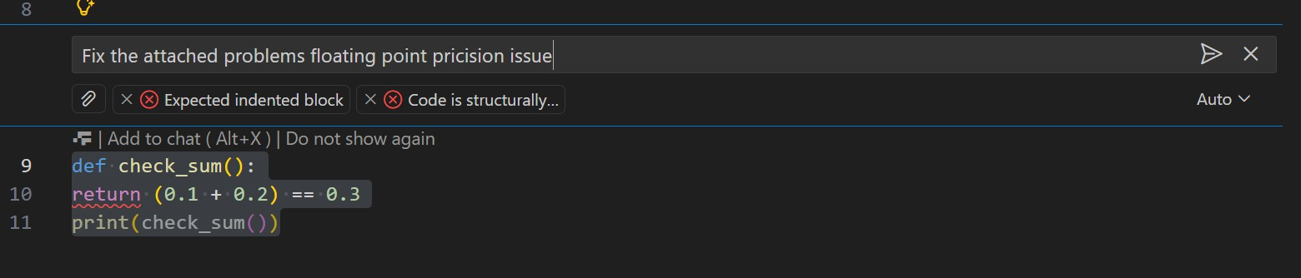
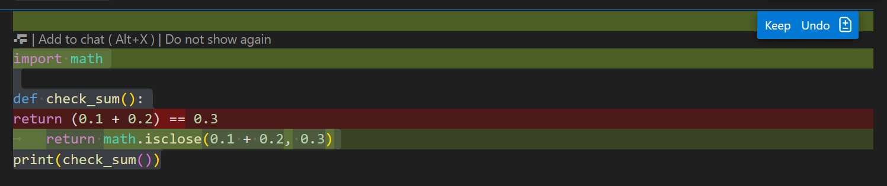

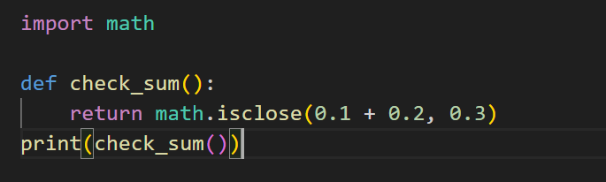
output:
Task 3 (Recursion Error – Missing Base Case)
Task: Analyze given code where recursion runs infinitely due to missing base case. Use AI to fix.
# Bug: No base case def countdown(n):
print(n)
return countdown(n-1) countdown(5)
Expected Output : Correct recursion with stopping condition.

Screenshots:
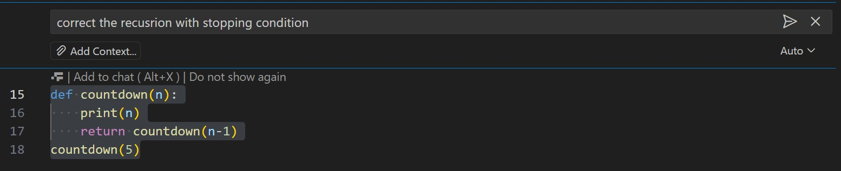

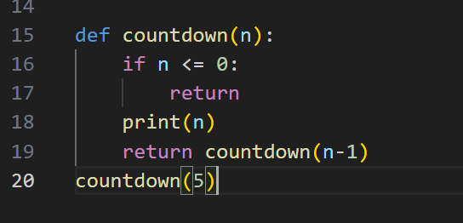
output:
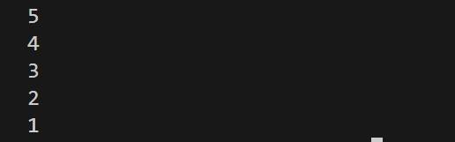
Task 4 (Dictionary Key Error)
Task: Analyze given code where a missing dictionary key causes error. Use AI to fix it.
# Bug: Accessing non-existing key def get_value():
data = {"a": 1, "b": 2} return data["c"] print(get_value())
Expected Output: Corrected with .get() or error handling

Screenshots:
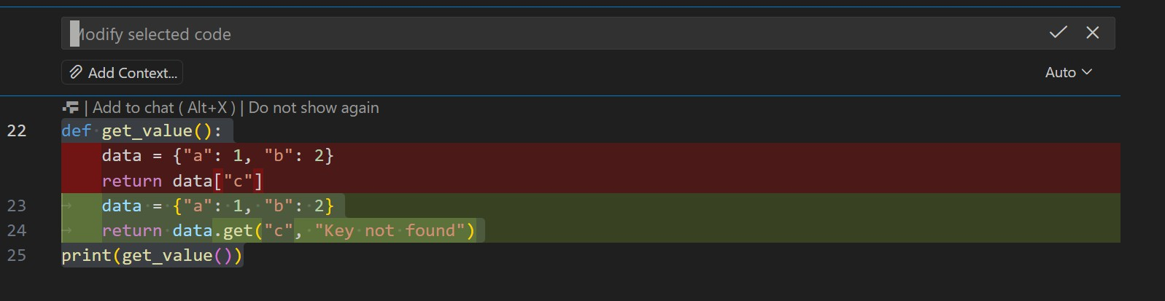
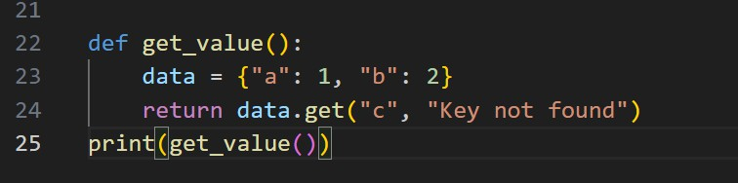

output:
Task 5 (Infinite Loop – Wrong Condition)
Task: Analyze given code where loop never ends. Use AI to detect and fix it.
# Bug: Infinite loop def loop_example(): i = 0
while i < 5:
print(i)
Expected Output: Corrected loop increments i.

Screenshots:
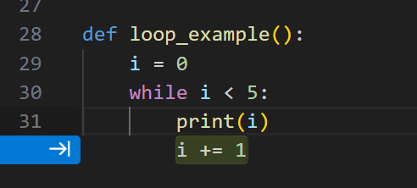
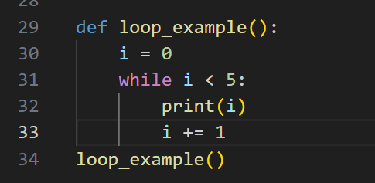

output:
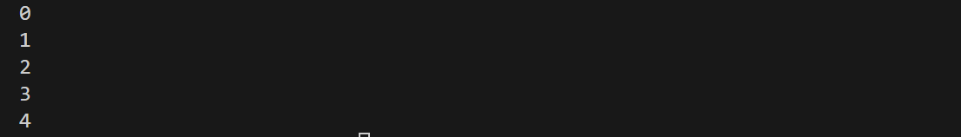

Task 6 (Unpacking Error – Wrong Variables)
Task: Analyze given code where tuple unpacking fails. Use AI to fix it.
# Bug: Wrong unpacking a, b = (1, 2, 3)
Expected Output: Correct unpacking or using _ for extra values.

Screenshots:
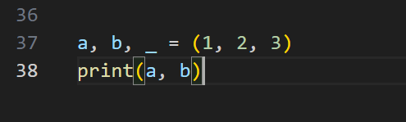

output:

Task 7 (Mixed Indentation – Tabs vs Spaces)
Task: Analyze given code where mixed indentation breaks execution. Use AI to fix it.
# Bug: Mixed indentation def func():
x = 5
y = 10
return x+y
Expected Output : Consistent indentation applied.

Screenshots:
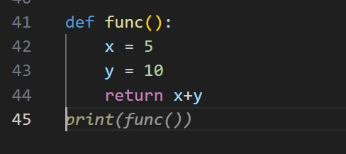
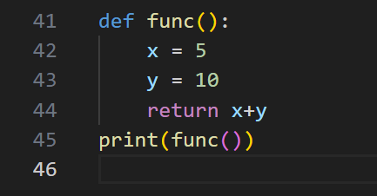

output:
Task 8 (Import Error – Wrong Module Usage)
Task: Analyze given code with incorrect import. Use AI to fix.

# Bug: Wrong import import maths print(maths.sqrt(16))
Expected Output: Corrected to import math

Screenshots:
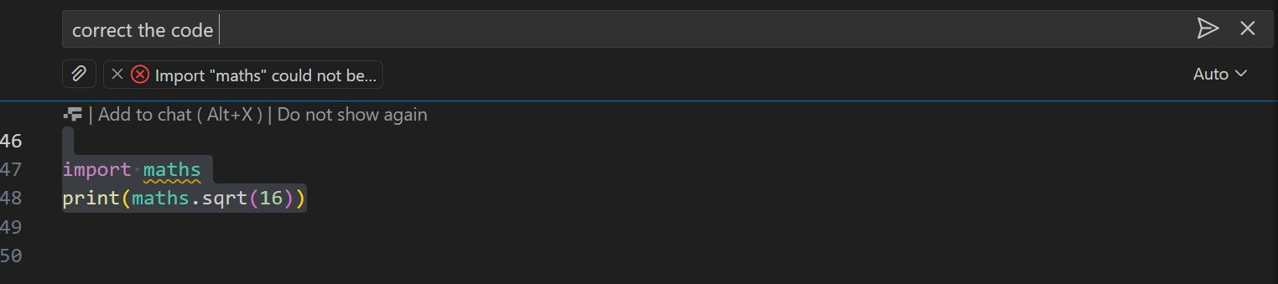
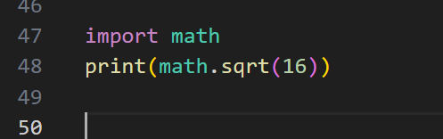

Output:

Task 9 (Unreachable Code – Return Inside Loop)
Task: Analyze given code where a return inside a loop prevents full iteration. Use AI to fix it.
# Bug: Early return inside loop def total(numbers):
for n in numbers:

return n print(total([1,2,3]))
Expected Output: Corrected code accumulates sum and returns after loop.

Screenshots:
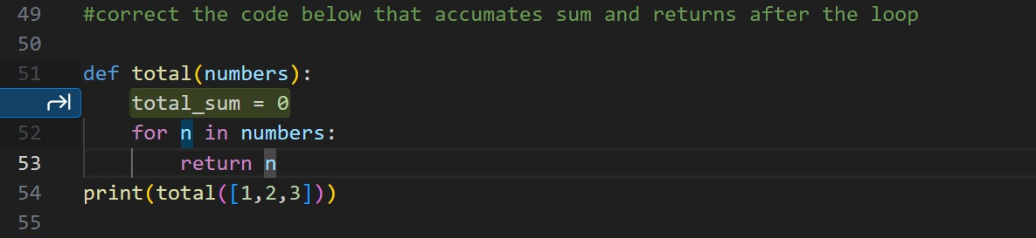
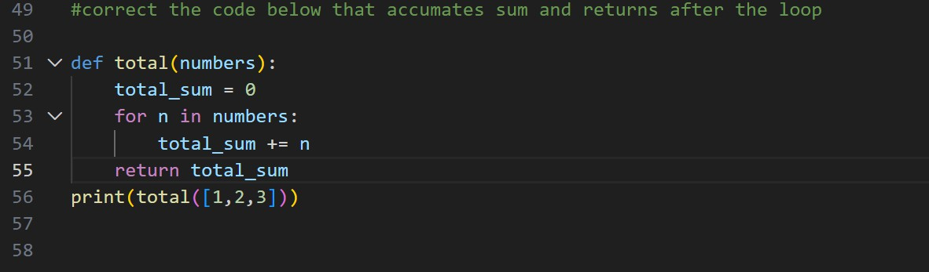

output:
Task 10 (Name Error – Undefined Variable)
Task: Analyze given code where a variable is used before being defined. Let AI detect and fix the error.

# Bug: Using undefined variable def calculate_area():
return length * width print(calculate_area()) Requirements:
- Run the code to observe the error.
- Ask AI to identify the missing variable definition.
- Fix the bug by defining length and width as parameters.
- Add 3 assert test cases for correctness. Expected Output :
- Corrected code with parameters.
- AI explanation of the bug. Successful execution of assertions.

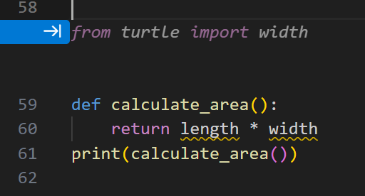
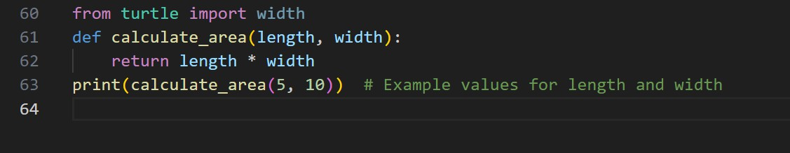
Screenshots:

output:
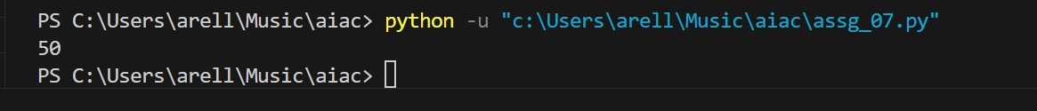
Task 11 (Type Error – Mixing Data Types Incorrectly)
Task: Analyze given code where integers and strings are added incorrectly. Let AI detect and fix the error.
# Bug: Adding integer and string def add_values():
return 5 + "10" print(add_values()) Requirements:
- Run the code to observe the error.
- AI should explain why int + str is invalid.
- Fix the code by type conversion (e.g., int("10") or str(5)).
- Verify with 3 assert cases. Expected Output #6:
- Corrected code with type handling.
- AI explanation of the fix.
Successful test validation.

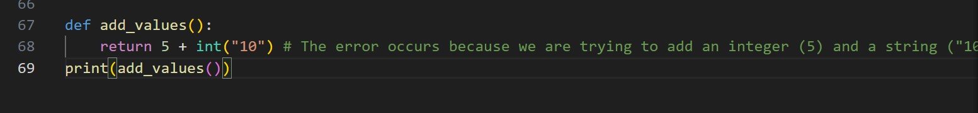
Screenshots:

output:
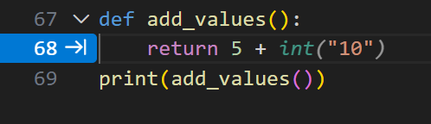

Task 12 (Type Error – String + List Concatenation)
Task: Analyze code where a string is incorrectly added to a list. # Bug: Adding string and list
def combine():
return "Numbers: " + [1, 2, 3] print(combine()) Requirements:
- Run the code to observe the error.
- Explain why str + list is invalid.
- Fix using conversion (str([1,2,3]) or " ".join()).
- Verify with 3 assert cases. Expected Output:

- Corrected code
- Explanation
- Successful test validation

Screenshots:
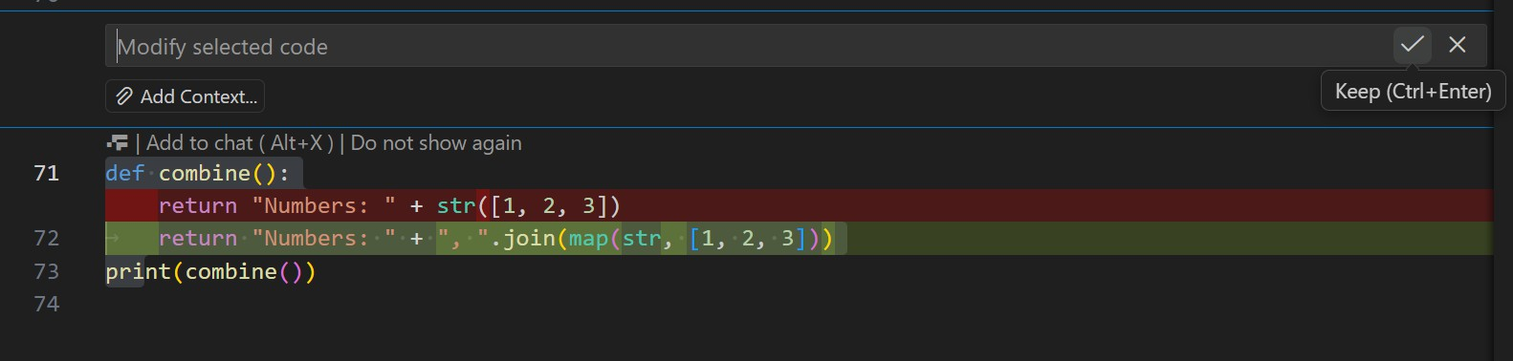
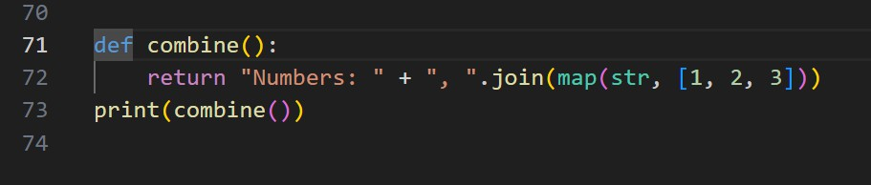

Output:
Task 13 (Type Error – Multiplying String by Float)
Task: Detect and fix code where a string is multiplied by a float. # Bug: Multiplying string by float
def repeat_text(): return "Hello" * 2.5 print(repeat_text()) Requirements:
- Observe the error.

- Explain why float multiplication is invalid for strings.
- Fix by converting float to int.
- Add 3 assert test cases.

Screenshots:
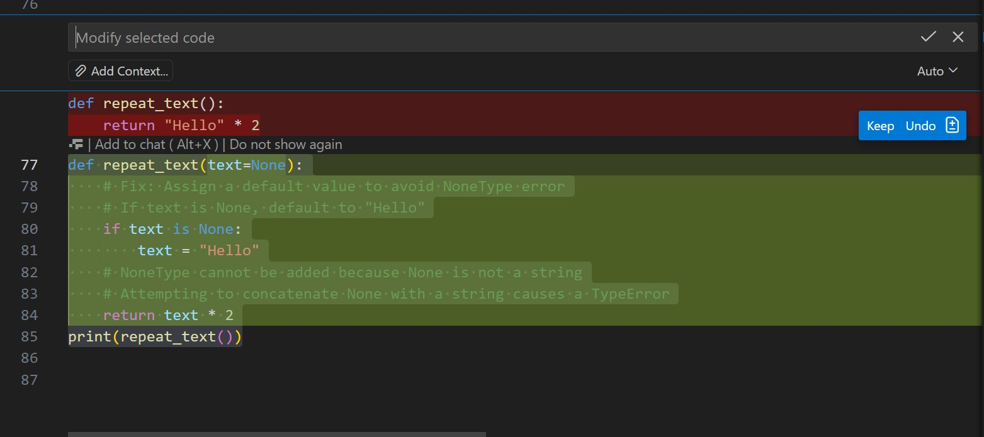
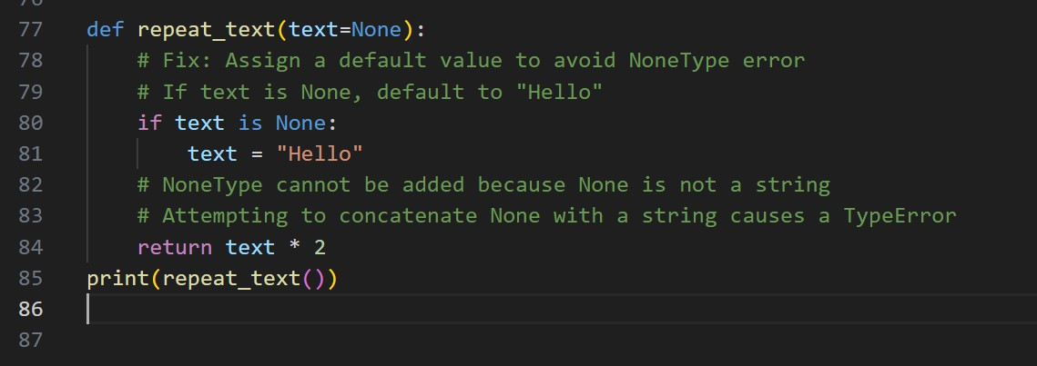
output:
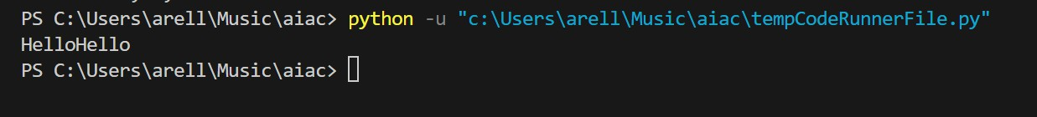
Task 15 (Type Error – Input Treated as String Instead of
Number)
Task: Fix code where user input is not converted properly. # Bug: Input remains string
def sum_two_numbers():
a = input("Enter first number: ")
b = input("Enter second number: ") return a + b print(sum_two_numbers()) Requirements:
- Explain why input is always string.
- Fix using int() conversion.
- Verify with assert test cases.

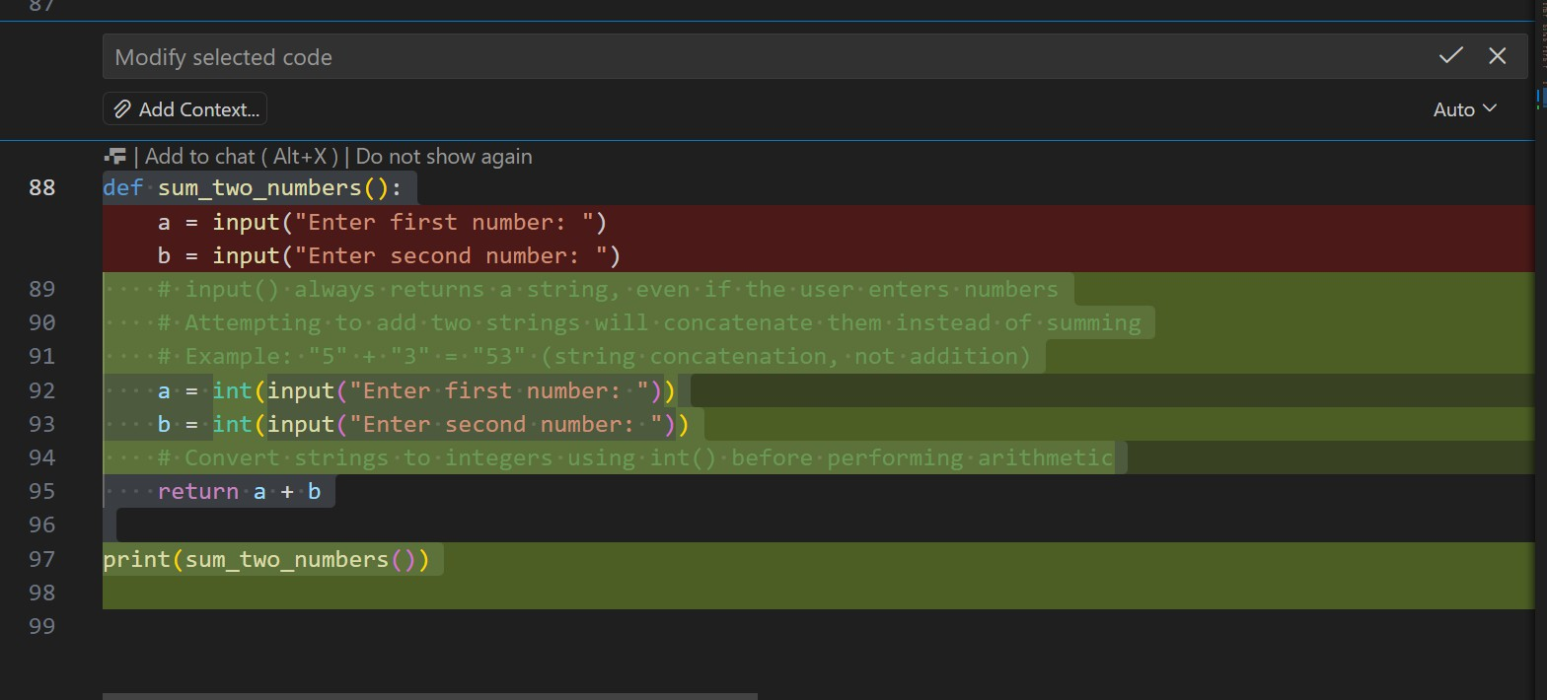
Screenshot:
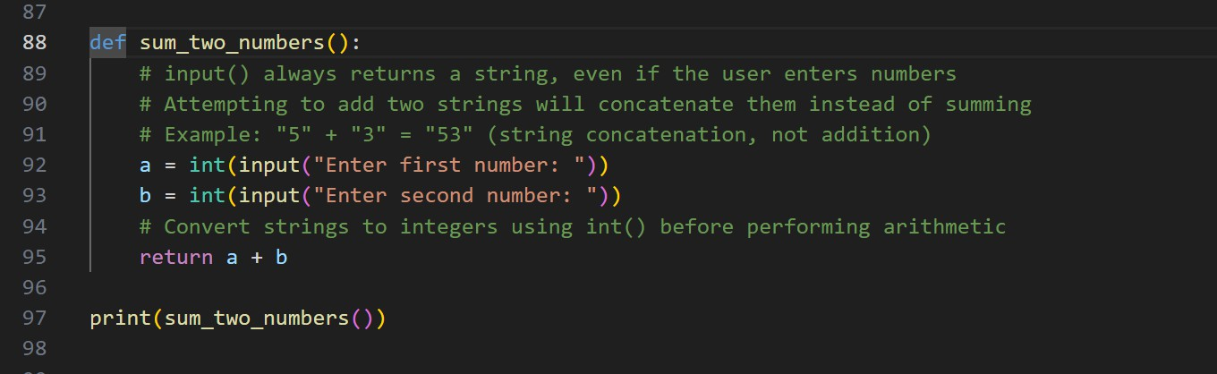

output:
