AI ASSISTED CODING ASSIGNMENT - 3.1
M.Akshith (2303A51110)
BATCH-02

Task Description
Design and refine prompts using different prompting strategies to generate Python programs for basic computational problems.

Question 1: Zero-Shot Prompting (Palindrome Number Program)
Write a zero-shot prompt (without providing any examples) to generate a Python function that checks whether a given number is a palindrome.
• Task Description
➢ Record the AI-generated code.
➢ Test the code with multiple inputs.
➢ Identify any logical errors or missing edge-case handling.
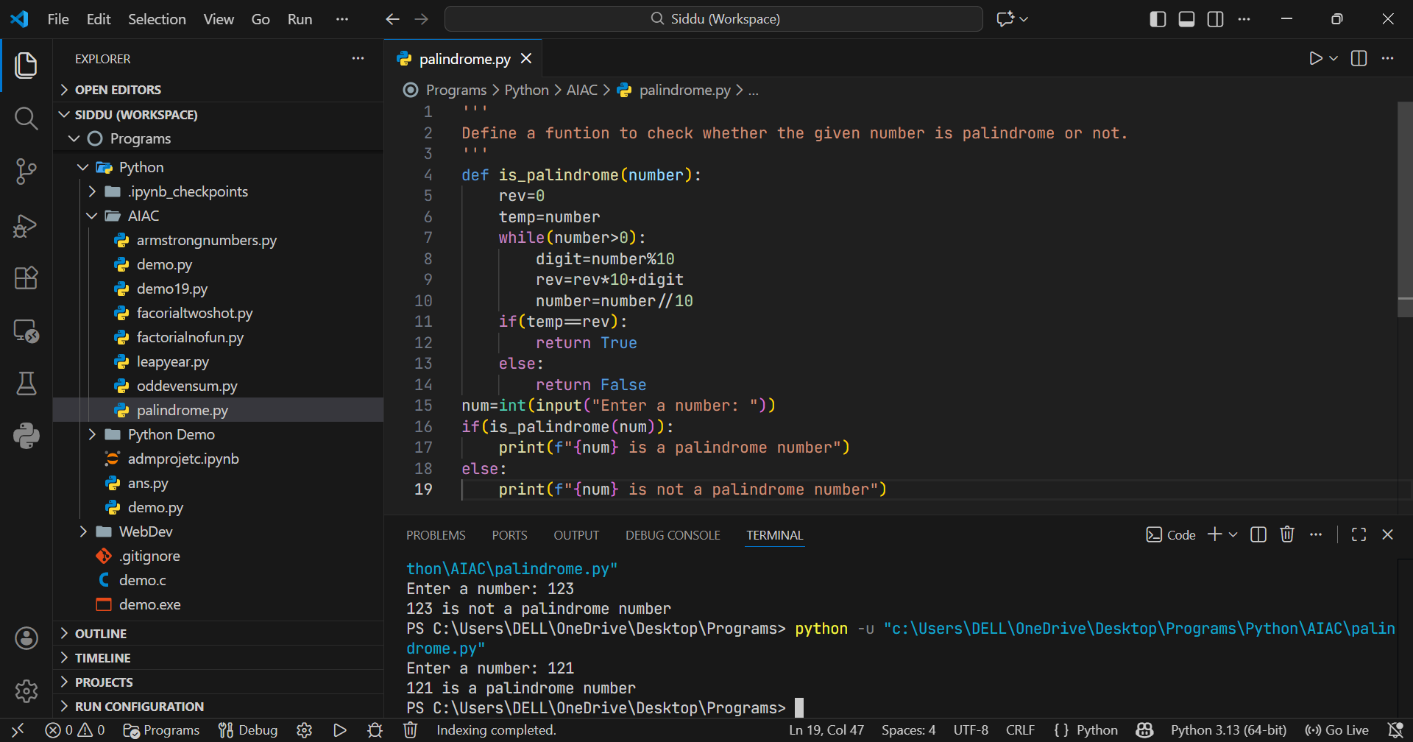
Question 2: One-Shot Prompting (Factorial Calculation)
Write a one-shot prompt by providing one input-output example and ask the AI to generate a Python function to compute the factorial of a given number.
• Example:
➢ Input: 5 → Output: 120
• Task Description
➢ Compare the generated code with a zero-shot solution.
➢ Examine improvements in clarity and correctness.
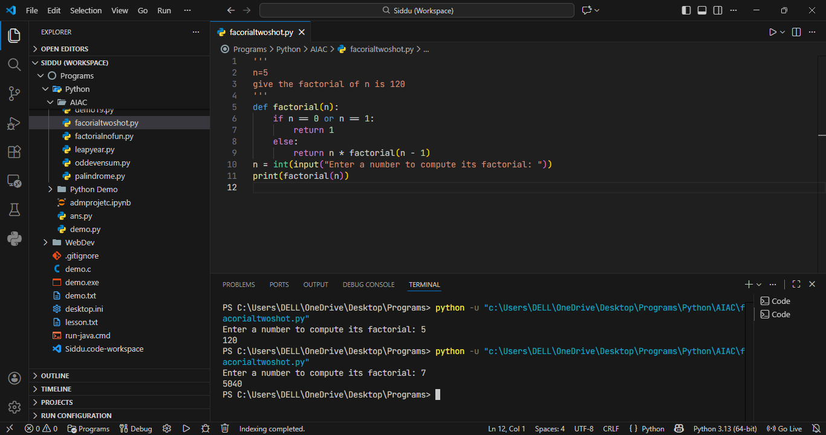

Question 3: Few-Shot Prompting (Armstrong Number Check)
Write a few-shot prompt by providing multiple input-output examples to guide the AI in generating a Python function to check whether a given number is an Armstrong number.
• Example:
➢ Input: 153 → Output: Armstrong Number
➢ Input: 370 → Output: Armstrong Number
➢ Input: 123 → Output: Not an Armstrong Number
• Task Description
➢ Analyse how multiple examples influence code structure and accuracy.
➢ Test the function with boundary values and invalid inputs.
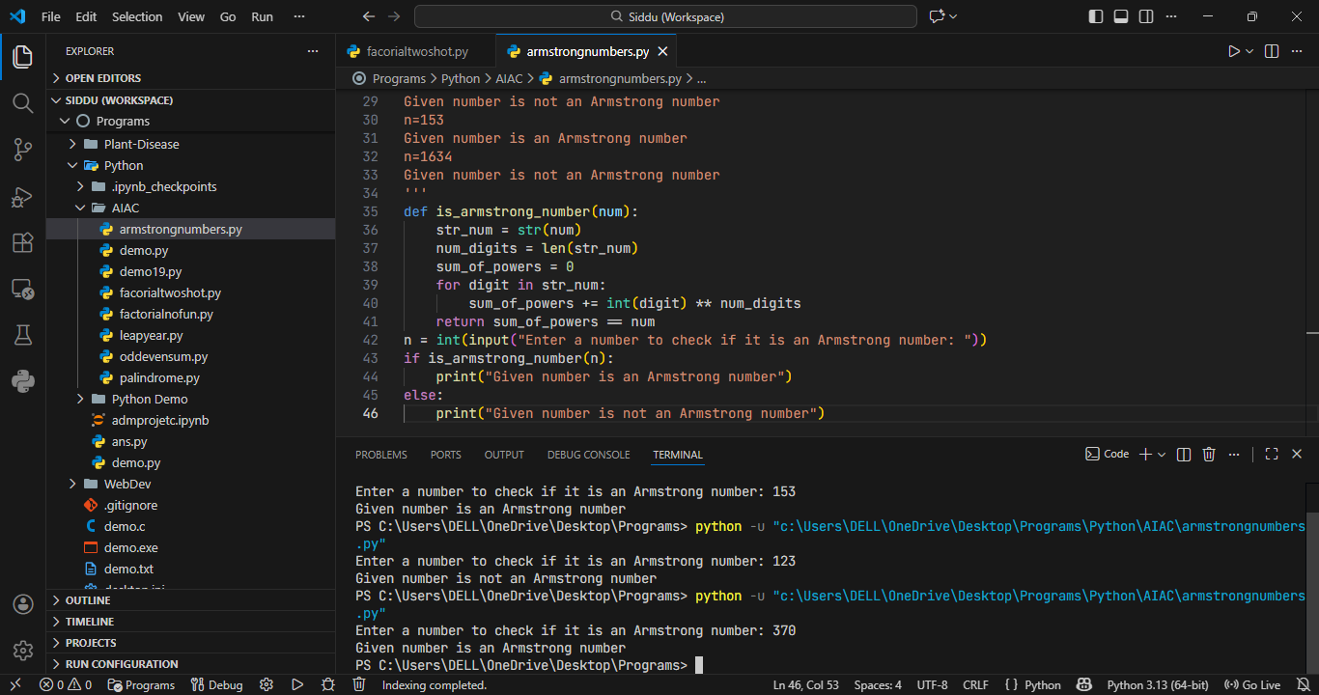

Question 4: Context-Managed Prompting (Optimized Number Classification)
Design a context-managed prompt with clear instructions and constraints to generate an optimized Python program that classifies a number as prime, composite, or neither.
• Task Description
➢ Ensure proper input validation.
➢ Optimize the logic for efficiency.
➢ Compare the output with earlier prompting strategies.
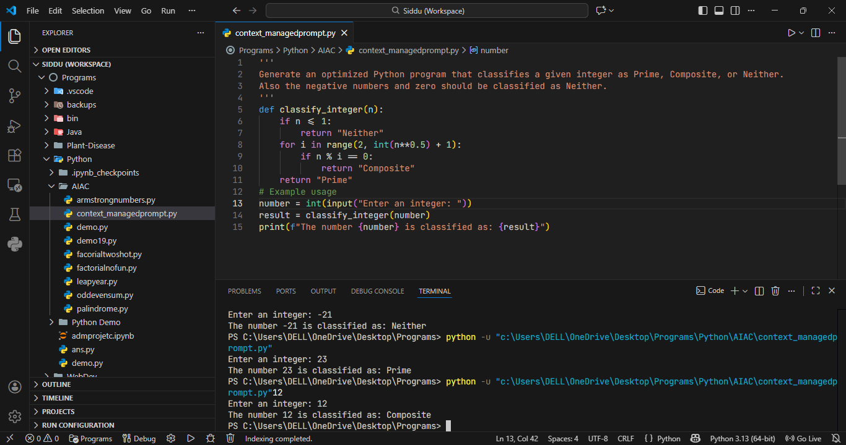

Question 5: Zero-Shot Prompting (Perfect Number Check)
Write a zero-shot prompt (without providing any examples) to generate a Python function that checks whether a given number is a perfect number.
• Task Description
➢ Record the AI-generated code.
➢ Test the program with multiple inputs.
➢ Identify any missing conditions or inefficiencies in the logic.
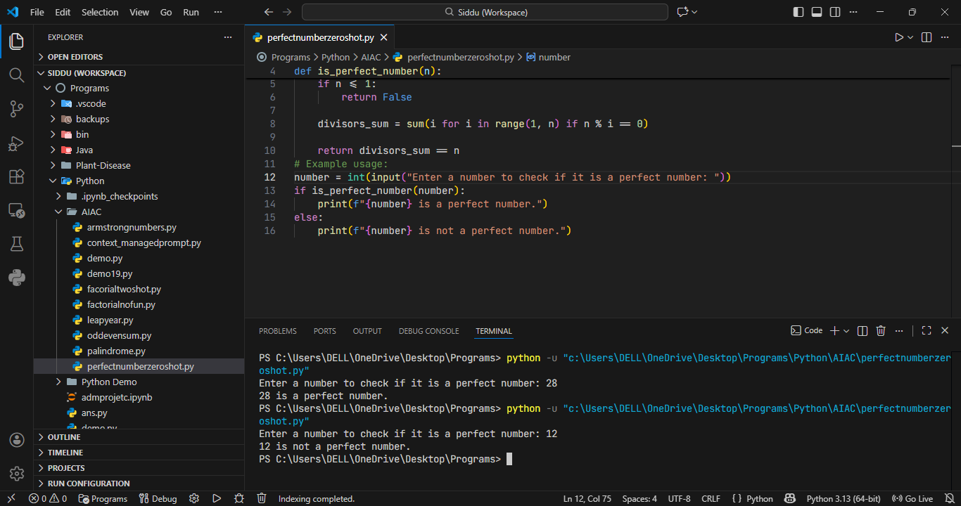

Question 6: Few-Shot Prompting (Even or Odd Classification with Validation)
Write a few-shot prompt by providing multiple input-output examples to guide the AI in generating a Python program that determines whether a given number is even or odd, including proper input validation.
• Example:
➢ Input: 8 → Output: Even
➢ Input: 15 → Output: Odd
➢ Input: 0 → Output: Even
• Task Description
➢ Analyse how examples improve input handling and output clarity.
➢ Test the program with negative numbers and non-integer inputs.
