AI ASSISTED CODING ASSIGNMENT – 9.1
M.Akshith(2303A51110)
BATCH-02
Problem 1:
Consider the following Python function:
def find_max(numbers):
return max(numbers)
Task:
- Write documentation for the function in all three formats:
(a) Docstring
(b) Inline comments
(c) Google-style documentation
- Critically compare the three approaches. Discuss the advantages, disadvantages, and suitable use cases of each style.
- Recommend which documentation style is most effective for a mathematical utilities library and justify your answer.
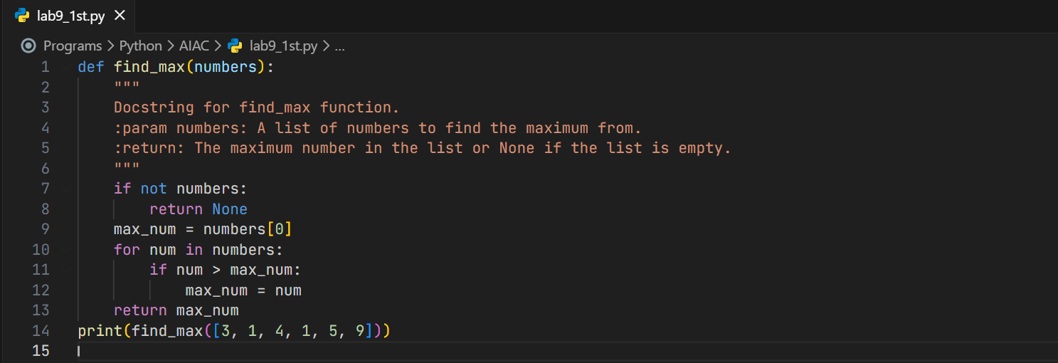
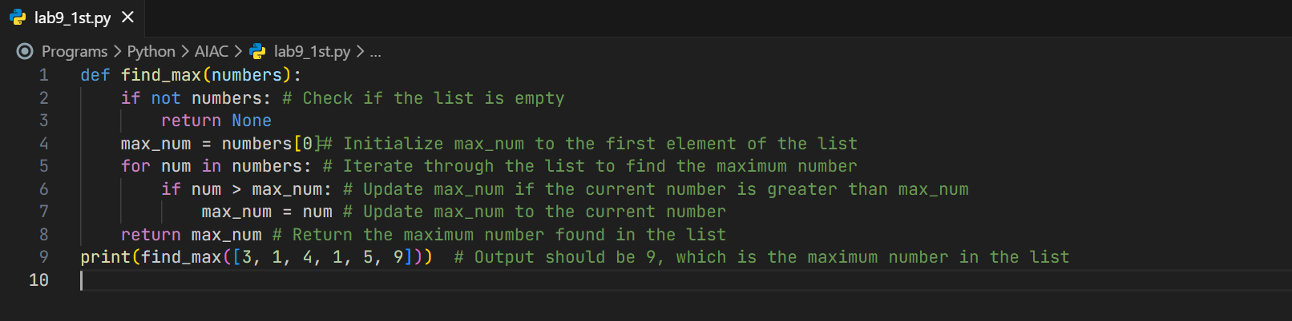
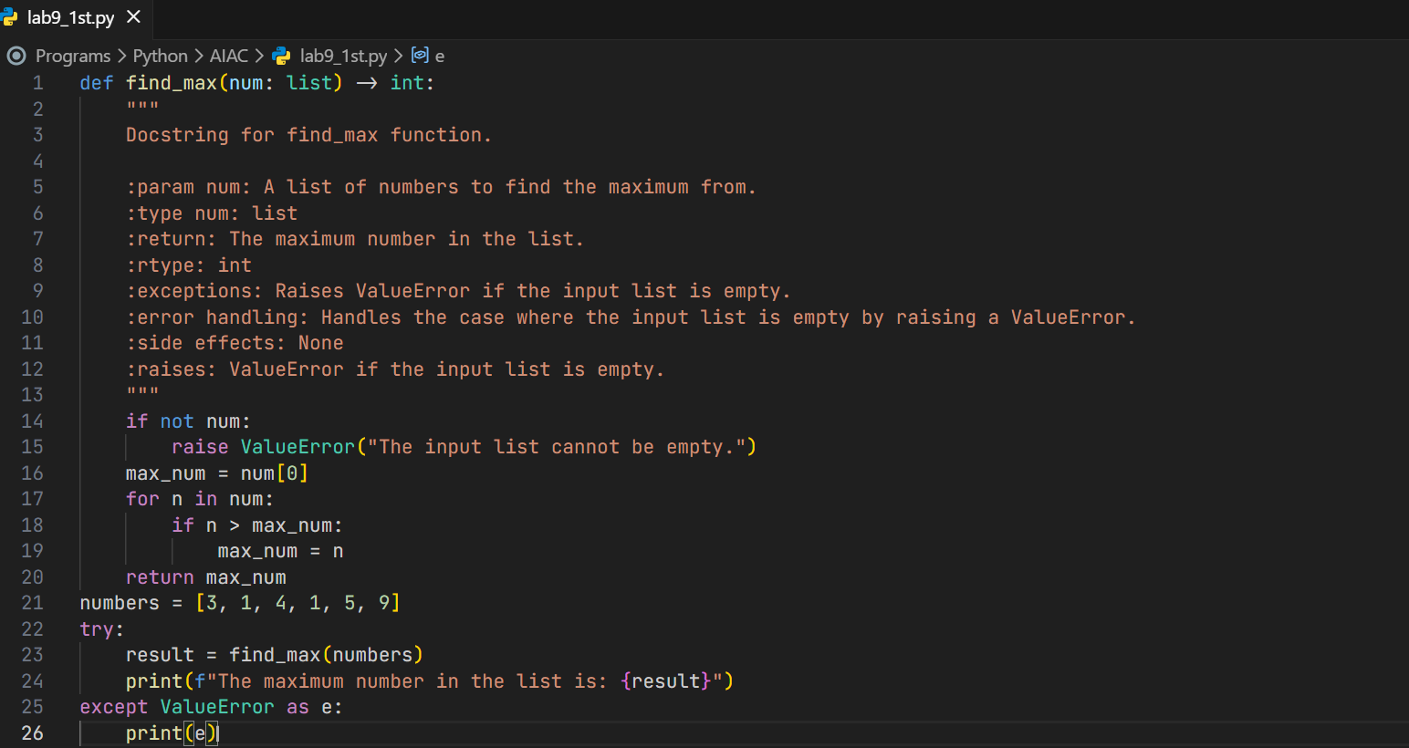
Output:
Problem 2:
Consider the following Python function:
def login(user, password, credentials):
return credentials.get(user) == password
Task:
- Write documentation in all three formats.
- Critically compare the approaches.
- Recommend which style would be most helpful for new developers onboarding a project, and justify your choice.
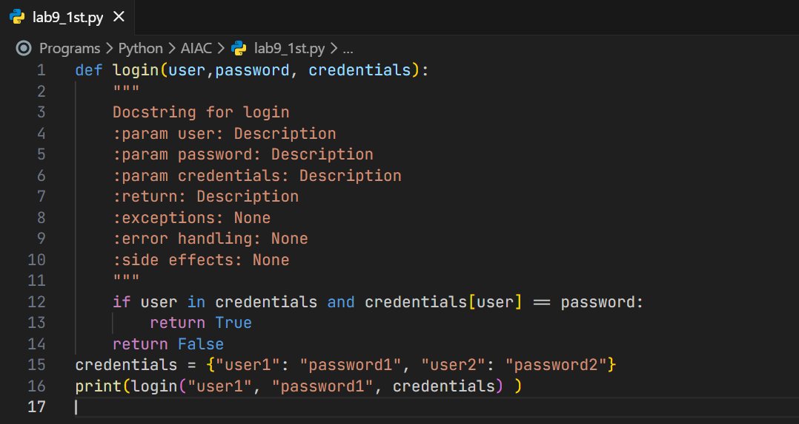
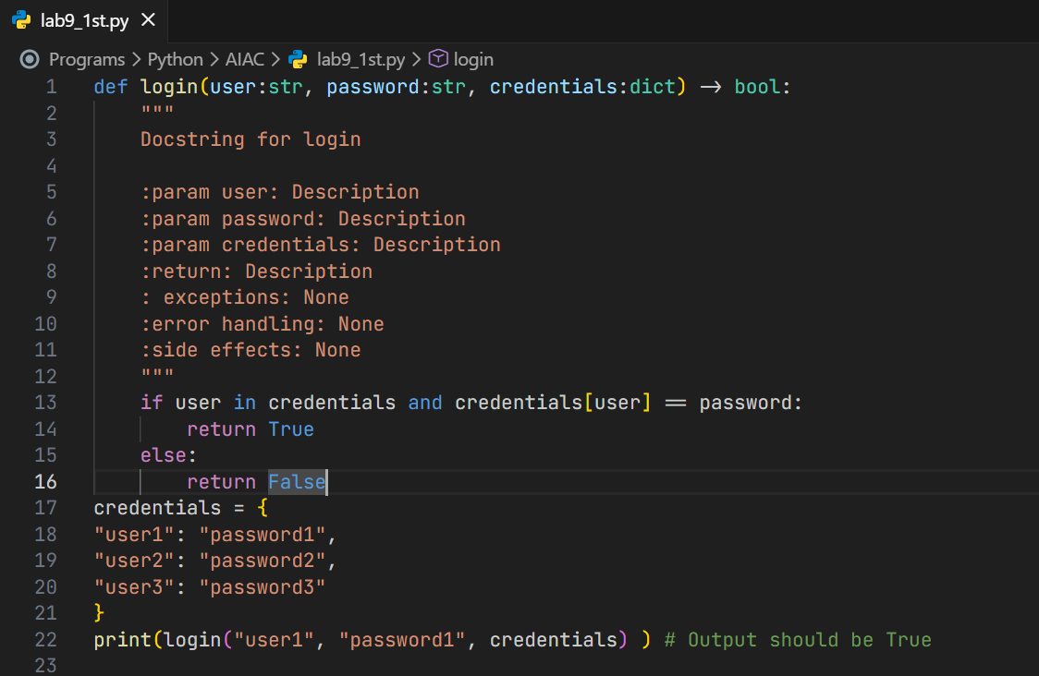
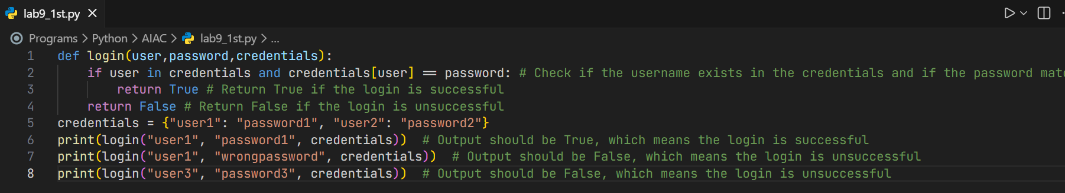
Output:

Problem 3: Calculator (Automatic Documentation Generation)
Task: Design a Python module named calculator.py anddemonstrate automatic documentation generation.
Instructions:
Instructions:
- Create a Python module calculator.py that includes the following functions, each written with appropriate docstrings:
add(a, b) – returns the sum of two numbers
subtract(a, b) – returns the difference of two numbers
multiply(a, b) – returns the product of two numbers
divide(a, b) – returns the quotient of two numbers
- Display the module documentation in the terminal using Python’s documentation tools.
- Generate and export the module documentation in HTML format using the pydoc utility, and open the generated HTML file in a web browser to verify the output.
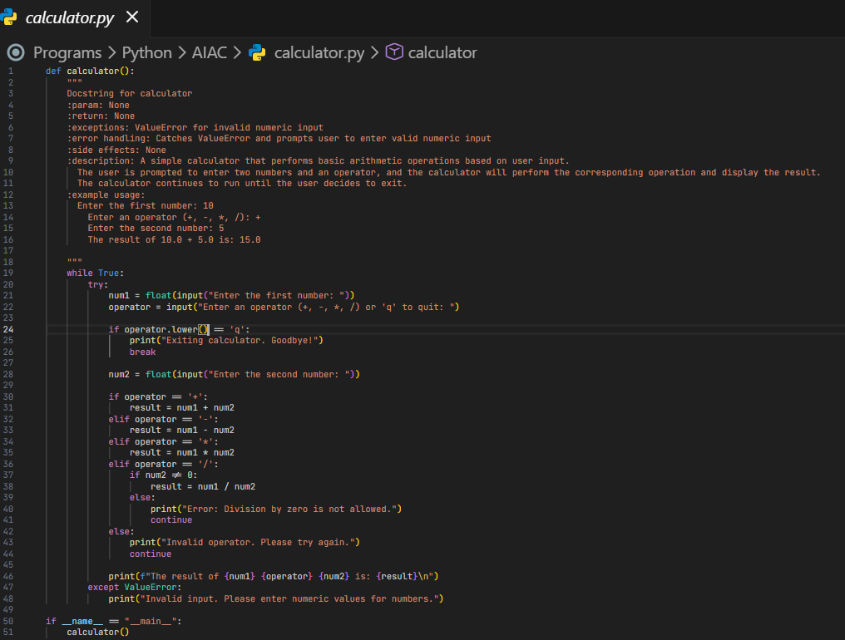
Output:
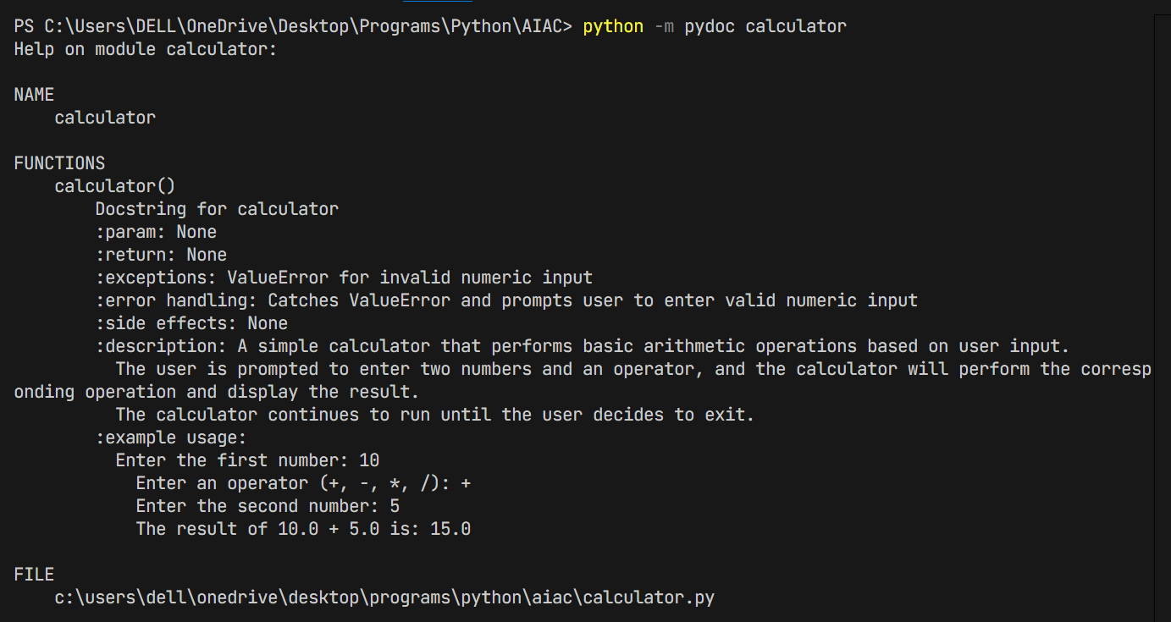
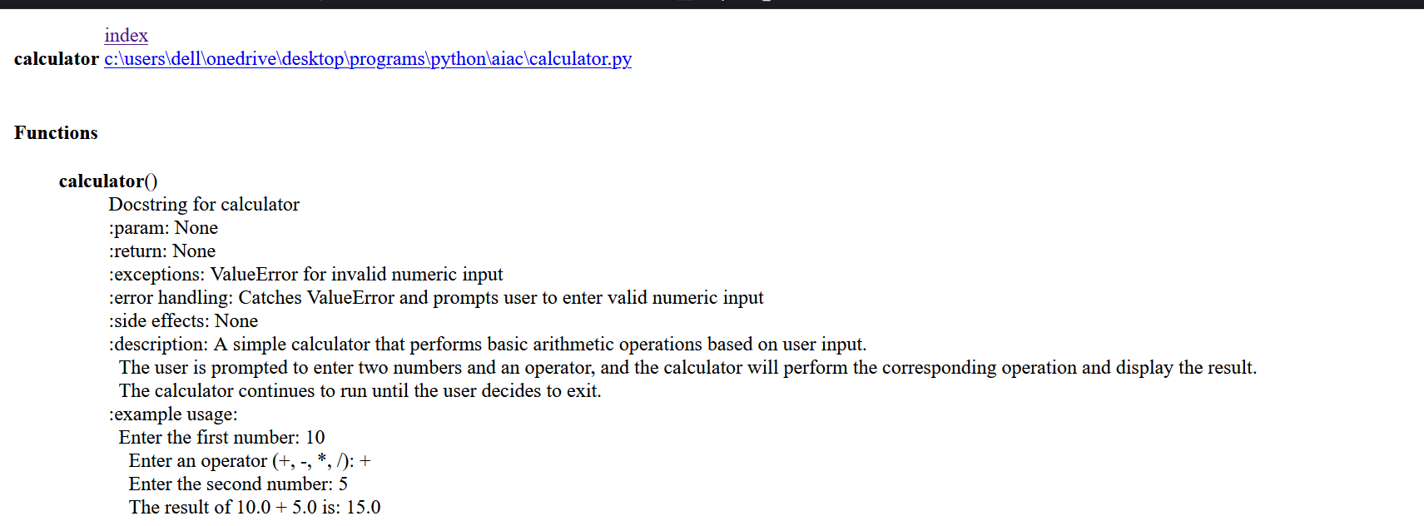
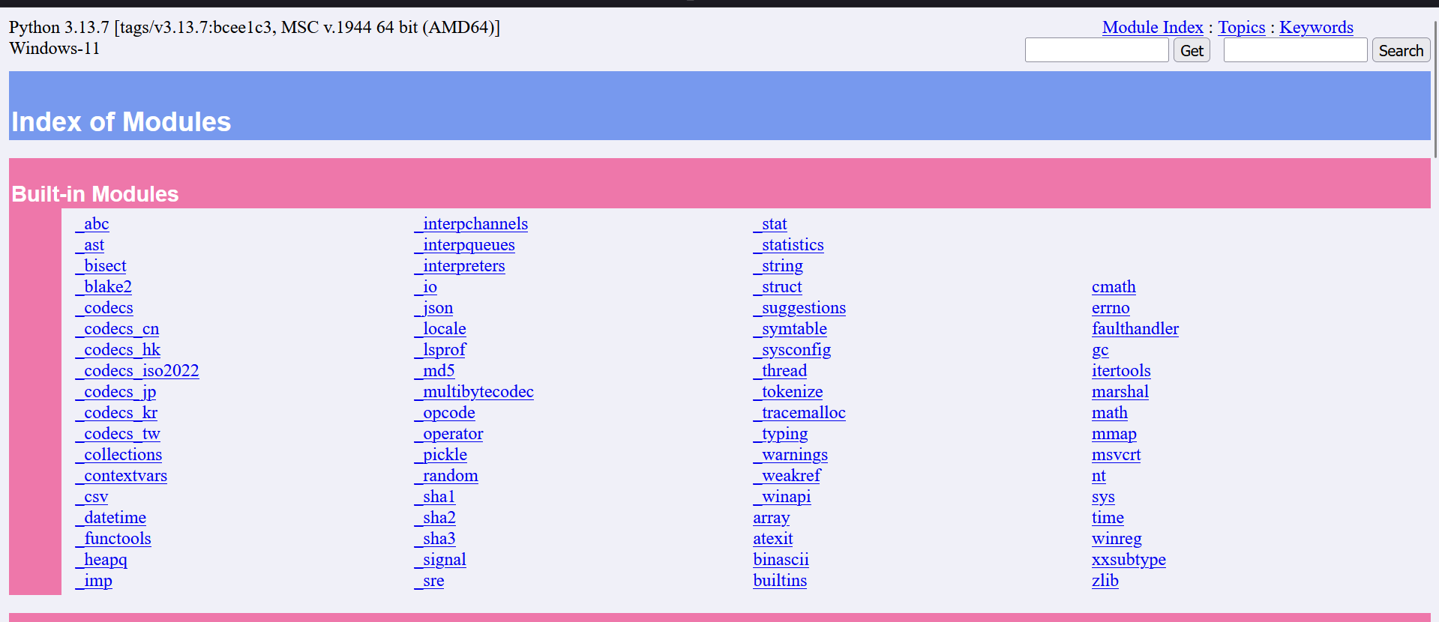
Problem 4: Conversion Utilities Module
Task:
- Write a module named conversion.py with functions:
decimal_to_binary(n)
binary_to_decimal(b)
decimal_to_hexadecimal(n)
- Use Copilot for auto-generating docstrings.
- Generate documentation in the terminal.
- Export the documentation in HTML format and open it in a browser.
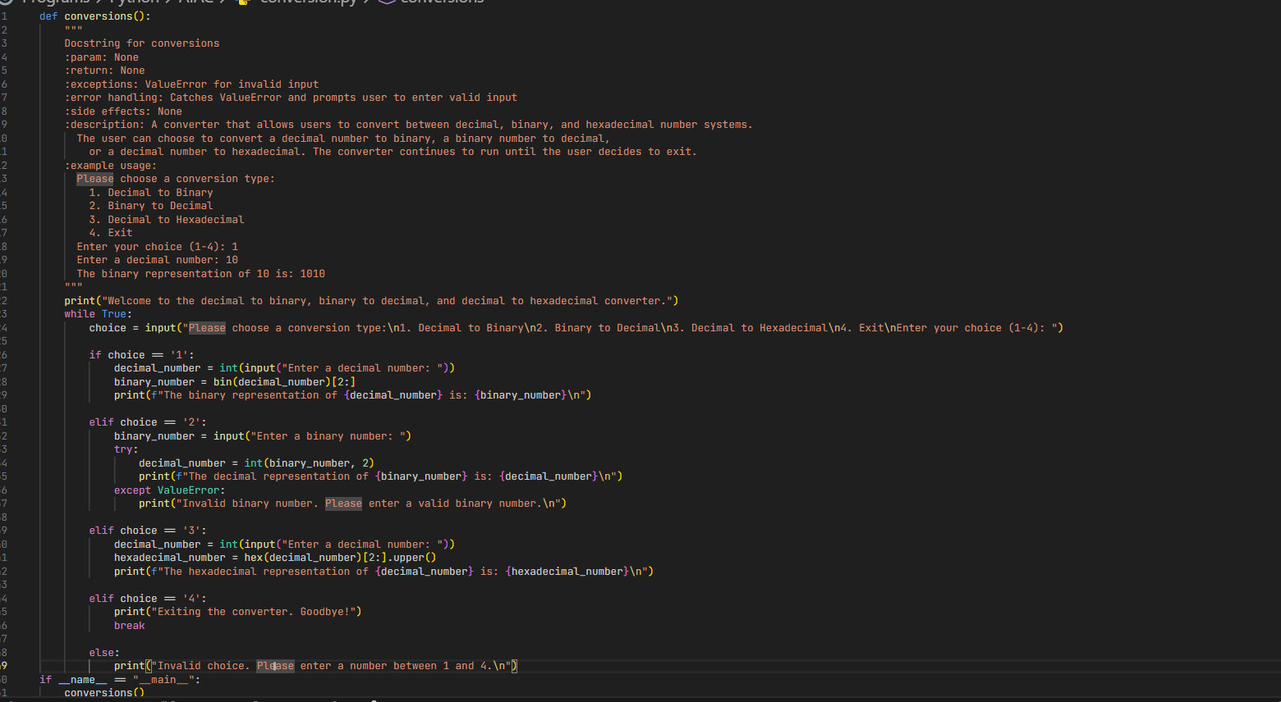
Output:
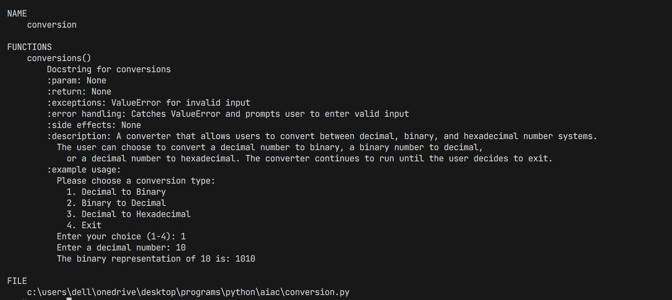
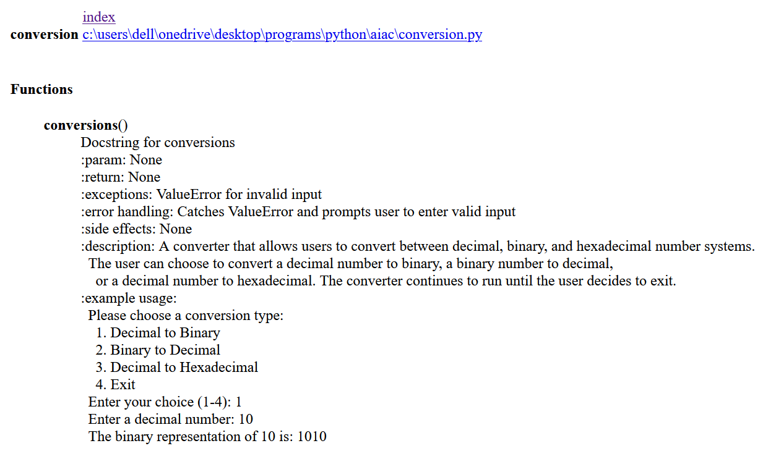
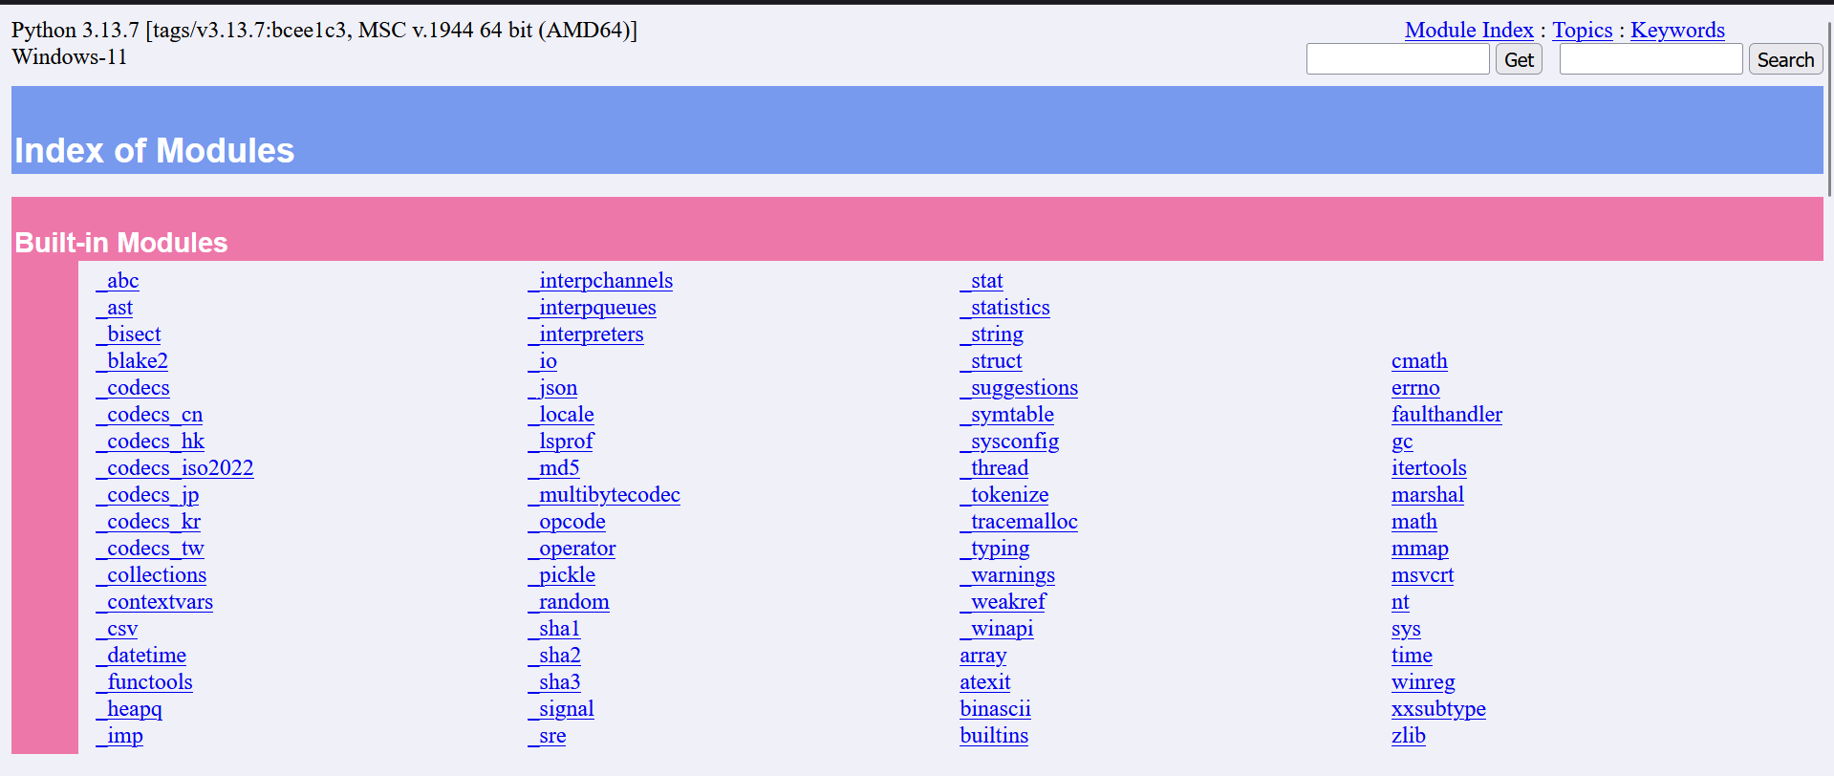
Problem 5: Course Management Module
Task:
- Create a module course.py with functions:
add_course(course_id, name, credits)
remove_course(course_id)
get_course(course_id)
- Add docstrings with Copilot.
- Generate documentation in the terminal.
- Export the documentation in HTML format and open it in a browser.
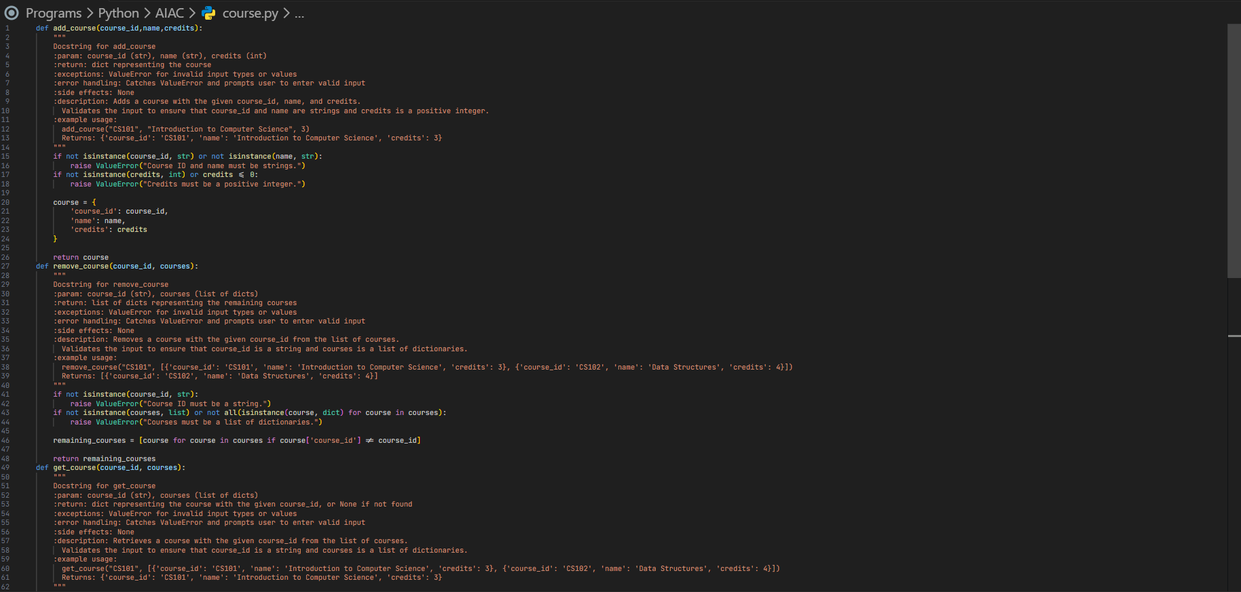

Output:
