Name : K.Suchira
Ht.no:2303A51146
Batch:17

4.3 Assisgnment

Task 1: Zero-Shot Prompting – Leap Year Check Scenario
Zero-shot prompting involves giving instructions without providing examples.
Task Description
Use zero-shot prompting to instruct an AI tool to generate a Python function that:
- Accepts a year as input
- Checks whether the given year is a leap year
- Returns an appropriate result
Note: No input-output examples should be provided in the prompt. Expected Output
- AI-generated leap year checking function
- Correct logical conditions
- Sample input and output
- Screenshot of AI-generated response (if required)

Prompt:- #Generate a Python function that accepts a year as input and determines whether the given year is a leap year or not. The function should apply the correct leap year rules and return an appropriate result with user input

Code:-
def is_leap_year(year):
"""Determine whether a given year is a leap year. A year is a leap year if it is divisible by 4,
except for end-of-century years, which must be divisible by 400.
Args:
year (int): The year to check.
Returns:
bool: True if the year is a leap year, False otherwise. """
if (year % 4 == 0 and year % 100 != 0) or (year % 400 == 0): return True
else:
return False # Example usage:

year_input = int(input("Enter a year: ")) if is_leap_year(year_input):
print(f"{year_input} is a leap year.") else:
print(f"{year_input} is not a leap year.")

Output:-

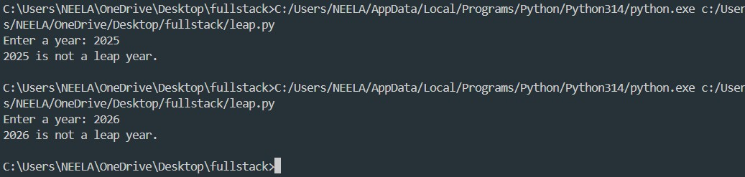
Analysis:- The program is logically correct, efficient, and well-structured. It effectively demonstrates zero-shot AI code generation by correctly implementing leap year rules and handling user input to produce accurate results.

- Task 2: One-Shot Prompting – Centimeters to Inches Conversion Scenario
One-shot prompting guides AI using a single example. Task Description
Use one-shot prompting by providing one input-output example to generate a Python
function that:
  - Converts centimeters to inches
  - Uses the correct mathematical formula Example provided in prompt:
Input: 10 cm → Output: 3.94 inches Expected Output
  - Python function with correct conversion logic
  - Accurate calculation
  - Sample test cases and outputs

Prompt:- #Generate a Python function that converts centimeters to inches using the correct mathematical formula. with user input.

Code:-

def cm_to_inches():
# Get user input
cm = float(input("Enter length in centimeters: ")) # Conversion factor
inches_per_cm = 0.393701
# Convert centimeters to inches inches = cm * inches_per_cm
# Display the result
print(f"{cm} centimeters is equal to {inches} inches.") # Call the function
cm_to_inches()

Output:-

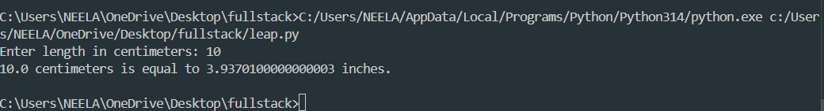

Analysis:- The program correctly implements a one-shot prompted AI solution to convert centimeters into inches. It applies the correct formula, handles user input efficiently, and produces accurate output, fulfilling all task requirements.
- Task 3: Few-Shot Prompting – Name Formatting Scenario
Few-shot prompting improves accuracy by providing multiple examples.
Task Description
Use few-shot prompting with 2–3 examples to generate a Python function that:
  - Accepts a full name as input
  - Formats it as “Last, First” Example formats:
  - "John Smith" → "Smith, John"
  - "Anita Rao" → "Rao, Anita"
Expected Output

  - Well-structured Python function
  - Output strictly following example patterns
  - Correct handling of names
  - Sample inputs and outputs

Prompt:- #Generate a Python function that takes a full name as input and formats it as ‘Last, First with user input.

Code:- def format_name(full_name): # Split the full name into parts name_parts = full_name.split()
# Check if there are at least two parts (first and last name)
if len(name_parts) < 2:
return "Please provide both first and last names." # Extract the first and last names
first_name = name_parts[0] last_name = name_parts[-1]
# Format the name as 'Last, First' formatted_name = f"{last_name}, {first_name}" return formatted_name
# Get user input
user_input = input("Enter your full name: ") # Format the name and print the result formatted = format_name(user_input) print("Formatted Name:", formatted)

Output:-

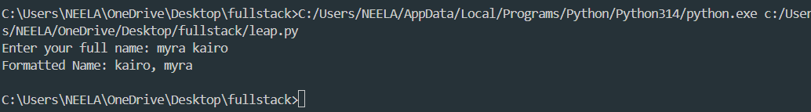
Analysis:- This task demonstrates few-shot prompting, where multiple examples guide the AI to generate accurate and consistent output. The program successfully formats names into the required “Last, First” structure while handling different name inputs correctly.

- Comparative Analysis – Zero-Shot vs Few-Shot

Scenario
Different prompt strategies may produce different code quality. Task Description
  - Use zero-shot prompting to generate a function that counts vowels in a
string
  - Use few-shot prompting for the same problem
  - Compare both outputs based on:
- Accuracy
- Readability
- Logical clarity Expected Output
  - Two vowel-counting functions
  - Comparison table or short reflection paragraph
  - Conclusion on prompt effectiveness

Prompt:-#Generate a Python function that counts the number of vowels in a given string and returns the count with user input.

Code:-
def count_vowels(input_string): vowels = "aeiouAEIOU" count = 0
for char in input_string: if char in vowels:
count += 1 return count
# Get user input
user_input = input("Enter a string: ") vowel_count = count_vowels(user_input)
print(f"The number of vowels in the given string is: {vowel_count}")

Output:-

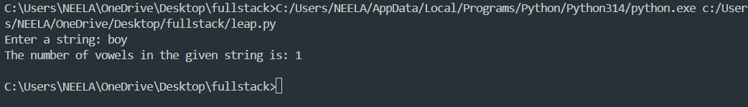
Analysis:- In zero-shot prompting, the AI is given only the task description without any examples. As a result, the generated vowel-counting function is

logically correct and easy to understand, but it follows a more basic and verbose approach using loops and counters. This makes the code beginner-friendly, though slightly longer.

5.
Task 5: Few-Shot Prompting – File Handling Scenario
File processing requires clear logical understanding. Task Description
Use few-shot prompting to generate a Python function that: Reads a .txt file
Counts the number of lines in the file Returns the line count
Expected Output
Working Python file-processing function Correct line count
Sample .txt input and output AI-assisted logic explanation

Prompt:-#Generate a Python function that reads a text file and counts the number of lines in it. with user input.

Code:-
def count_lines_in_file():
file_path = input("Please enter the path to the text file: ") try:
with open(file_path, 'r') as file:
lines = file.readlines() line_count = len(lines)
print(f"The number of lines in the file is: {line_count}") except FileNotFoundError:
print("The file was not found. Please check the path and try again.")
except Exception as e: print(f"An error occurred: {e}")

# Call the function count_lines_in_file()

Output:-

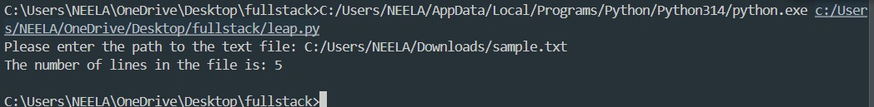
Analysis:- Saving the text file (sample.txt) in the Downloads folder is perfectly acceptable. Any valid .txt file stored anywhere on the system can be used, as long as the correct file path is provided to the program. By entering the full path of the file, Python can accurately locate, open, and read the file contents.

