Assignment:5.1 and 6
Name: P Ashwitha
HT No:2303A51163
Batch no:24

Task 1:
Employee Data: Create Python code that defines a class named
`Employee` with the following attributes: `empid`, `empname`,
`designation`, `basic_salary`, and `exp`. Implement a method
`display_details()` to print all employee details. Implement another
method `calculate_allowance()` to determine additional allowance
based on experience:
- If `exp > 10 years` → allowance = 20% of `basic_salary`
- If `5 ≤ exp ≤ 10 years` → allowance = 10% of `basic_salary`
- If `exp < 5 years` → allowance = 5% of `basic_salary`
Finally, create at least one instance of the `Employee` class, call the
`display_details()` method, and print the calculated allowance.
Code:
class Employee:
def __init__(self, empid, empname, designation, basic_salary, exp):
self.empid = empid
self.empname = empname
self.designation = designation
self.basic_salary = basic_salary
self.exp = exp

def display_details(self):
print(f"Employee ID: {self.empid}")
print(f"Employee Name: {self.empname}")
print(f"Designation: {self.designation}")
print(f"Basic Salary: {self.basic_salary}")
print(f"Experience: {self.exp} years")

def calculate_allowance(self):
if self.exp > 10:
allowance = 0.20 * self.basic_salary
elif 5 <= self.exp <= 10:
allowance = 0.10 * self.basic_salary
else:
allowance = 0.05 * self.basic_salary

print(f"Allowance: {allowance}")
print(f"Total Salary: {self.basic_salary + allowance}")

# Example usage
emp = Employee(101, "John Doe", "Manager", 50000, 12)
emp.display_details()
emp.calculate_allowance()
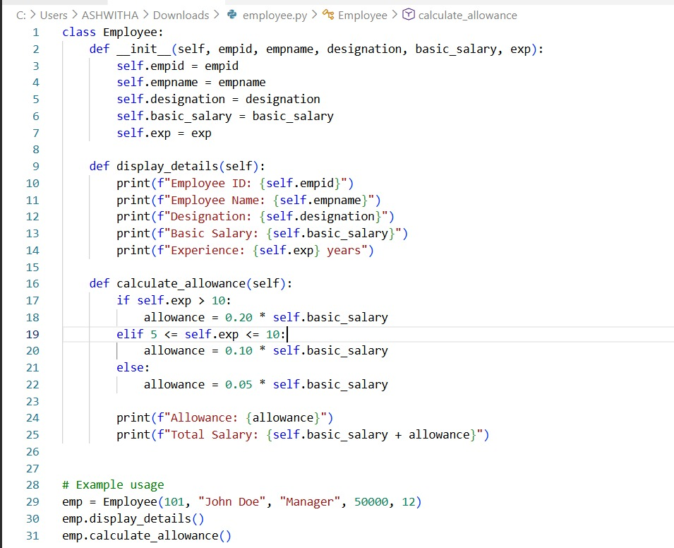
Output:
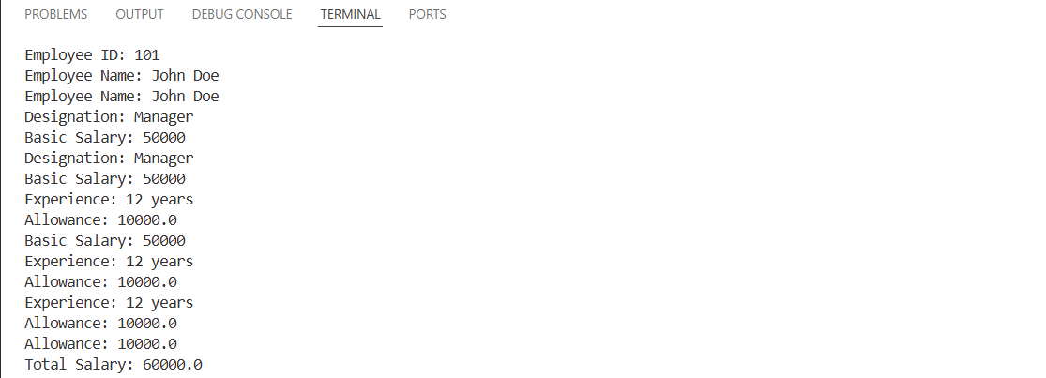
Task 2:
Electricity Bill Calculation- Create Python code that defines a class
named `ElectricityBill` with attributes: `customer_id`, `name`, and
`units_consumed`. Implement a method `display_details()` to print
customer details, and a method `calculate_bill()` where:
- Units ≤ 100 → ₹5 per unit
- 101 to 300 units → ₹7 per unit
- More than 300 units → ₹10 per unit
Create a bill object, display details, and print the total bill amount.
Code:
class ElectricityBill:
def __init__(self, customer_id, customer_name, units_consumed):
self.customer_id = customer_id
self.customer_name = customer_name
self.units_consumed = units_consumed

def calculate_bill(self):
if self.units_consumed <= 100:
rate = 1.5
elif self.units_consumed <= 300:
rate = 2.5
else:
rate = 4.0
total_bill = self.units_consumed * rate
return total_bill

def display_bill(self):
total_bill = self.calculate_bill()
print(f"Customer ID: {self.customer_id}")
print(f"Customer Name: {self.customer_name}")
print(f"Units Consumed: {self.units_consumed}")
print(f"Total Bill Amount: ${total_bill:.2f}")
# Example usage:
bill = ElectricityBill(12345, "Alice Smith", 250)
bill.display_bill()
bill.calculate_bill()
print(f"Calculated Bill: ${bill.calculate_bill():.2f}")
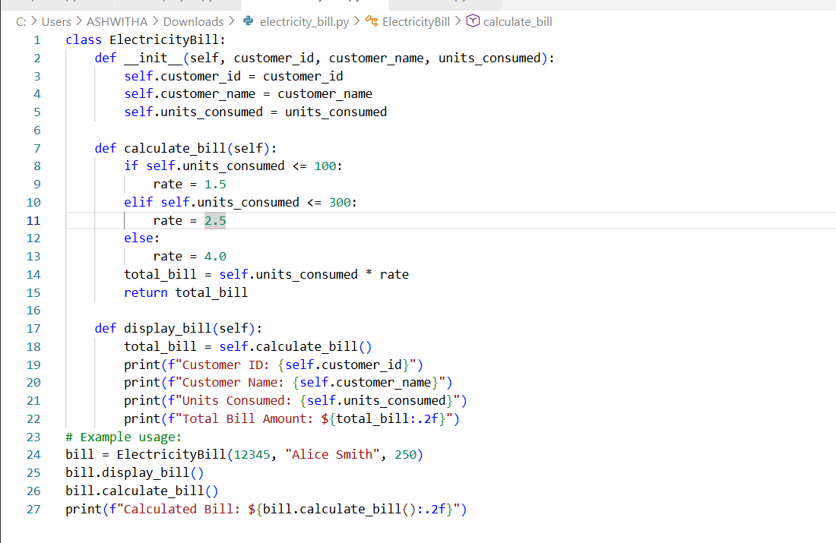
Output:
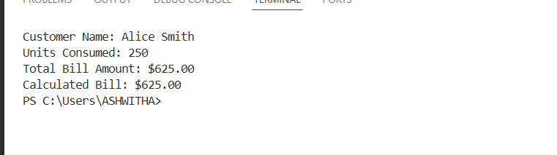
Task 3:
Product Discount Calculation- Create Python code that defines a
class named `Product` with attributes: `product_id`, `product_name`,
`price`, and `category`. Implement a method `display_details()` to
print product details. Implement another method
`calculate_discount()` where:
- Electronics → 10% discount
- Clothing → 15% discount
- Grocery → 5% discount
Create at least one product object, display details, and print the final
price after discount.
Code:
class Product:
def __init__(self,product_id,product_name,price,category):
self.product_id = product_id
self.product_name = product_name
self.price = price
self.category = category
def display_details(self):
print(f"Product ID: {self.product_id}")
print(f"Product Name: {self.product_name}")
print(f"Price: {self.price}")
print(f"Category: {self.category}")
def calculate_discount(self):
if self.category.lower() == "electronics":
discount = 0.10 * self.price
elif self.category.lower() == "clothing":
discount = 0.15 * self.price
else:
discount = 0.05 * self.price
print(f"Discount: {discount}")
print(f"Price after Discount: {self.price - discount}")
productobj1 = Product(301,"Smartphone",50000,"Electronics")
productobj1.display_details()
final_price = productobj1.calculate_discount()
print(final_price)
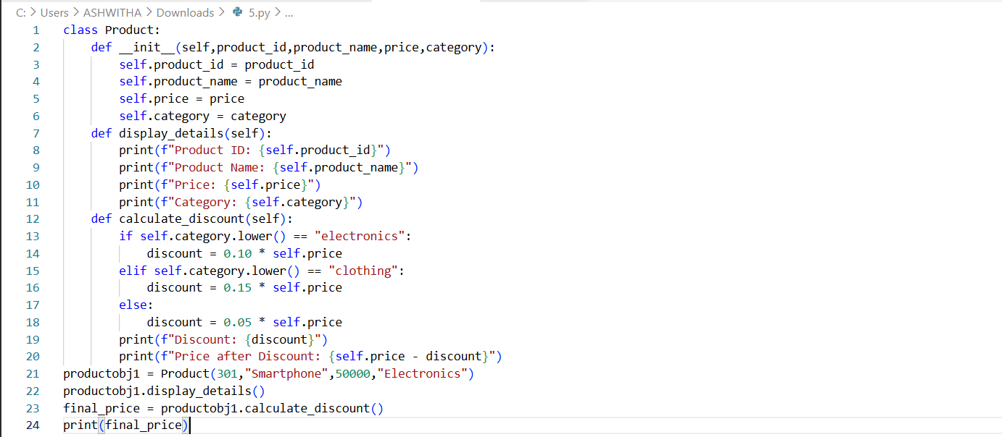
Output:
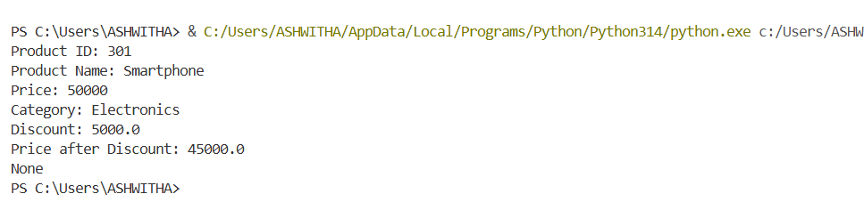

Task 4:
Book Late Fee Calculation- Create Python code that defines a class
named `LibraryBook` with attributes: `book_id`, `title`, `author`,
`borrower`, and `days_late`. Implement a method `display_details()`
to print book details, and a method `calculate_late_fee()` where:
- Days late ≤ 5 → ₹5 per day
- 6 to 10 days late → ₹7 per day
- More than 10 days late → ₹10 per day
Create a book object, display details, and print the late fee.
Code:
class LibraryBook:
def __init__(self,book_id,title,author,borrower,days_late):
self.book_id = book_id
self.title = title
self.author = author
self.borrower = borrower
self.days_late = days_late
def display_details(self):
print(f"Book ID: {self.book_id}")
print(f"Title: {self.title}")
print(f"Author: {self.author}")
print(f"Borrower: {self.borrower}")
print(f"Days Late: {self.days_late}")
def calculate_late_fee(self):
if self.days_late <=5 :
late_fee = self.days_late * 5
elif self.days_late <=10:
late_fee = self.days_late * 7
else:
late_fee = self.days_late * 10
print(f"Late Fee: {late_fee}")
bookobj1 = LibraryBook(401,"1984","George Orwell","Eve",8)
bookobj1.display_details()
print(bookobj1.calculate_late_fee())
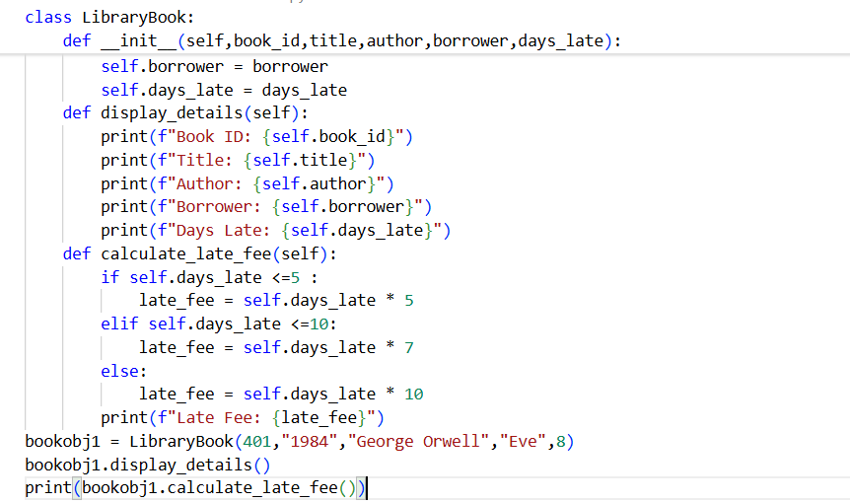
Output:
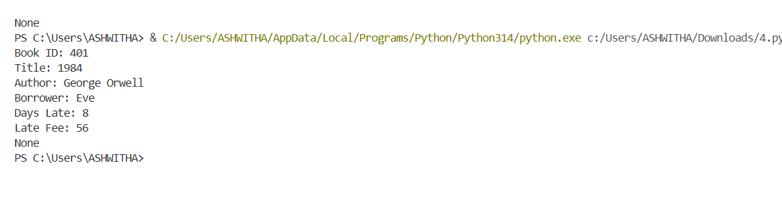
Task 5:
Student Performance Report - Define a function
`student_report(student_data)` that accepts a dictionary containing
student names and their marks. The function should:
- Calculate the average score for each student
- Determine pass/fail status (pass ≥ 40)
- Return a summary report as a list of dictionaries
Use Copilot suggestions as you build the function and format the
output.
Code:
class StudentReport:
def __init__(self, name, marks):
self.name = name
self.marks = marks

def average_grade(self):
return sum(self.marks) / len(self.marks)

def report(self):
avg = self.average_grade()
return f"Student: {self.name}, Average Grade: {avg:.2f}"
def determine_pass_fail(self):
avg = self.average_grade()
return "Pass" if avg >= 40 else "Fail"
def report_card(student):
print(student.report())
print("Result:", student.determine_pass_fail())
# Example usage
marks = [85, 42, 78, 90, 33]
student = StudentReport("Alice", marks)
report_card(student)

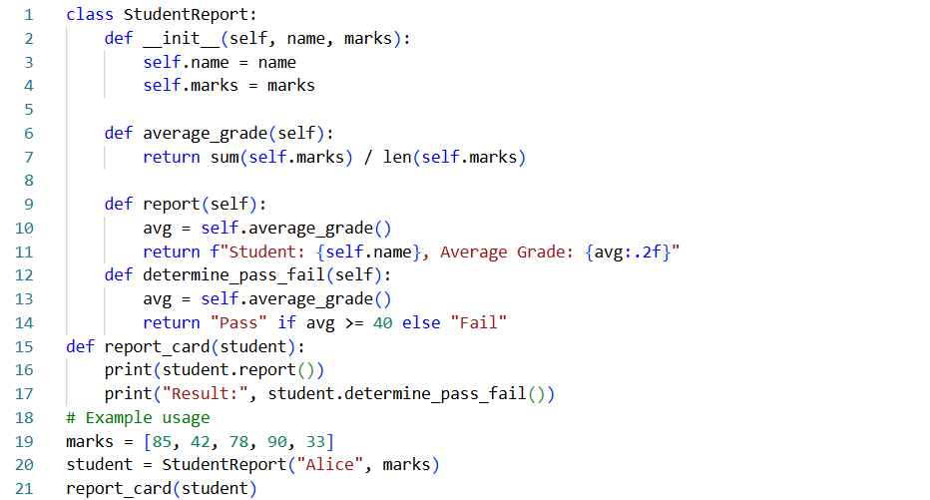
Output:
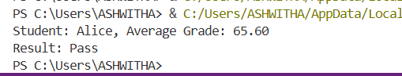
Task 6:
Taxi Fare Calculation-Create Python code that defines a class named
`TaxiRide` with attributes: `ride_id`, `driver_name`, `distance_km`,
and `waiting_time_min`. Implement a method `display_details()` to
print ride details, and a method `calculate_fare()` where:
- ₹15 per km for the first 10 km
- ₹12 per km for the next 20 km
- ₹10 per km above 30 km
- Waiting charge: ₹2 per minute
Create a ride object, display details, and print the total fare.
Code:
class TaxiRide :
def __init__(self, ride_id, driver_name, distance_km,waiting_time_min):
self.ride_id = ride_id
self.driver_name = driver_name
self.distance_km = distance_km
self.waiting_time_min = waiting_time_min
def display_details(self):
print(f"Ride ID: {self.ride_id}")
print(f"Driver Name: {self.driver_name}")
print(f"Distance (km): {self.distance_km}")
print(f"Waiting Time (min): {self.waiting_time_min}")
print(f"Ride details: {self.ride_id}, {self.driver_name}, {self.distance_km} km, {self.waiting_time_min} min")
def calculate_fare(self):
fare = 0
if self.distance_km <= 10:
fare += self.distance_km * 15
elif self.distance_km <= 30:
fare += 10 * 15 + (self.distance_km - 10) * 12
else:
fare += 10 * 15 + 20 * 12 + (self.distance_km - 30) * 10
fare += self.waiting_time_min * 2
return fare
# Example usage:
ride = TaxiRide("R123", "John Doe", 25, 5)
ride.display_details()
fare = ride.calculate_fare()
print(f"Total Fare: ${fare:.2f}")
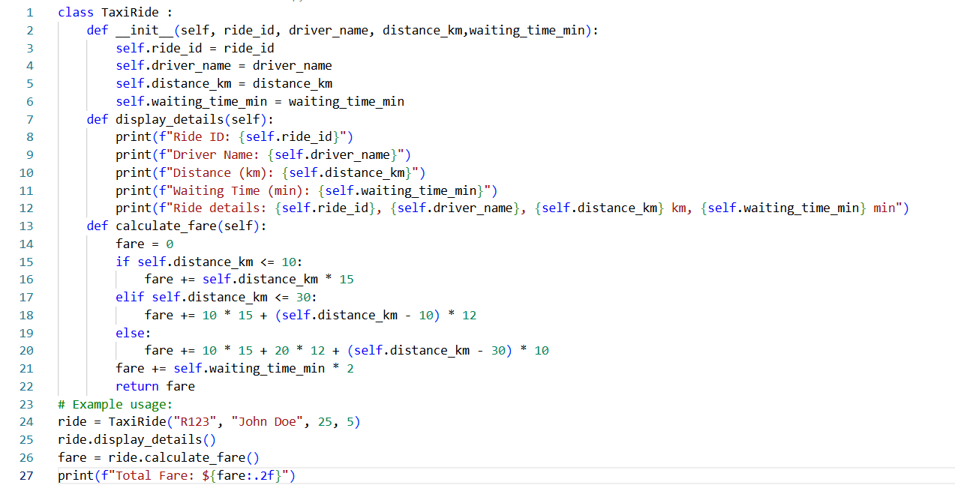
Output:
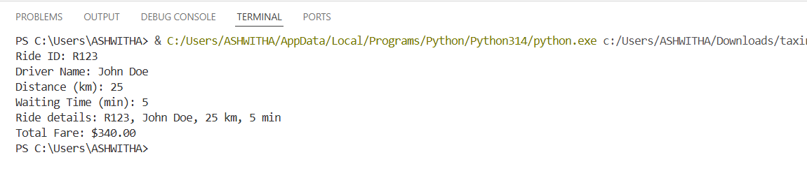
Task 7:
Statistics Subject Performance - Create a Python function
`statistics_subject(scores_list)` that accepts a list of 60 student scores
and computes key performance statistics. The function should return
the following:
- Highest score in the class
- Lowest score in the class
- Class average score
- Number of students passed (score ≥ 40)
- Number of students failed (score < 40)
Allow Copilot to assist with aggregations and logic
Code:
class StatisticsSubjectPerformance:
def statistics_subject(self, scores_list):
if not scores_list:
print("No scores available.")
return

highest_score = max(scores_list)
lowest_score = min(scores_list)
average_score = sum(scores_list) / len(scores_list)
passed_count = sum(1 for score in scores_list if score >= 40)
failed_count = len(scores_list) - passed_count
print(f"Number of Students Passed: {passed_count}")
print(f"Number of Students Failed: {failed_count}")
print(f"Highest Score: {highest_score}")
print(f"Lowest Score: {lowest_score}")
print(f"Average Score: {average_score:.2f}")
# Example usage
scores = [85, 42, 78, 90, 33, 67, 49, 58, 91, 37]
performance = StatisticsSubjectPerformance()
performance.statistics_subject(scores)

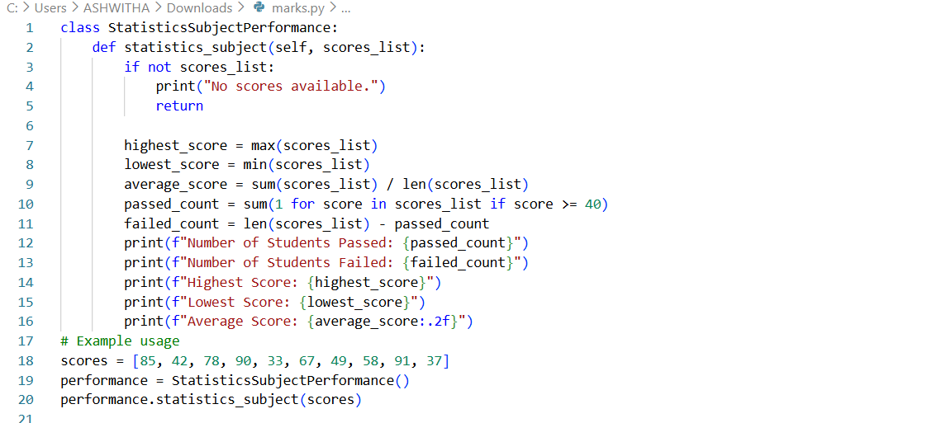
Output:
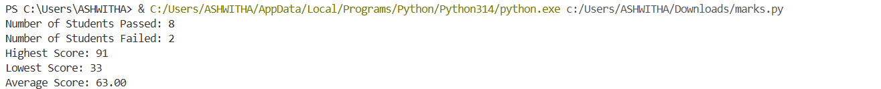
Task 8: (Transparency in Algorithm Optimization)
Task: Use AI to generate two solutions for checking prime numbers:
• Naive approach(basic)
• Optimized approach
Prompt:
“Generate Python code for two prime-checking methods and explain
how the optimized version improves performance.”
Expected Output:
• Code for both methods.
• Transparent explanation of time complexity.
• Comparison highlighting efficiency improvements.
Code:
#Generate Python code for two prime-checking methods and explain how the optimized version improves performance.well commented
# Method 1: Basic Prime Checking
def is_prime_basic(n):
"""Check if a number is prime using basic method."""
if n <= 1:
return False
for i in range(2, n):
if n % i == 0:
return False
return True
# Method 2: Optimized Prime Checking
def is_prime_optimized(n):
"""Check if a number is prime using optimized method."""
if n <= 1:
return False
if n <= 3:
return True
if n % 2 == 0 or n % 3 == 0:
return False
i = 5
while i * i<= n:
if n % i == 0 or n % (i + 2) == 0:
return False
i += 6
return True
# Example usage
number = 29
print(f"Is {number} prime? {is_prime_basic(number)}")
print(f"Is {number} prime? {is_prime_optimized(number)}")
# Explanation of Optimization:
# The optimized method reduces the number of checks needed to determine if a number is prime.
# Instead of checking all numbers up to n, it only checks up to the square root of n.
# It also skips even numbers and multiples of 3 after initial checks, significantly improving performance for larger numbers.
#Generate Python code that extracts specific information from a nested dictionary representing student data.
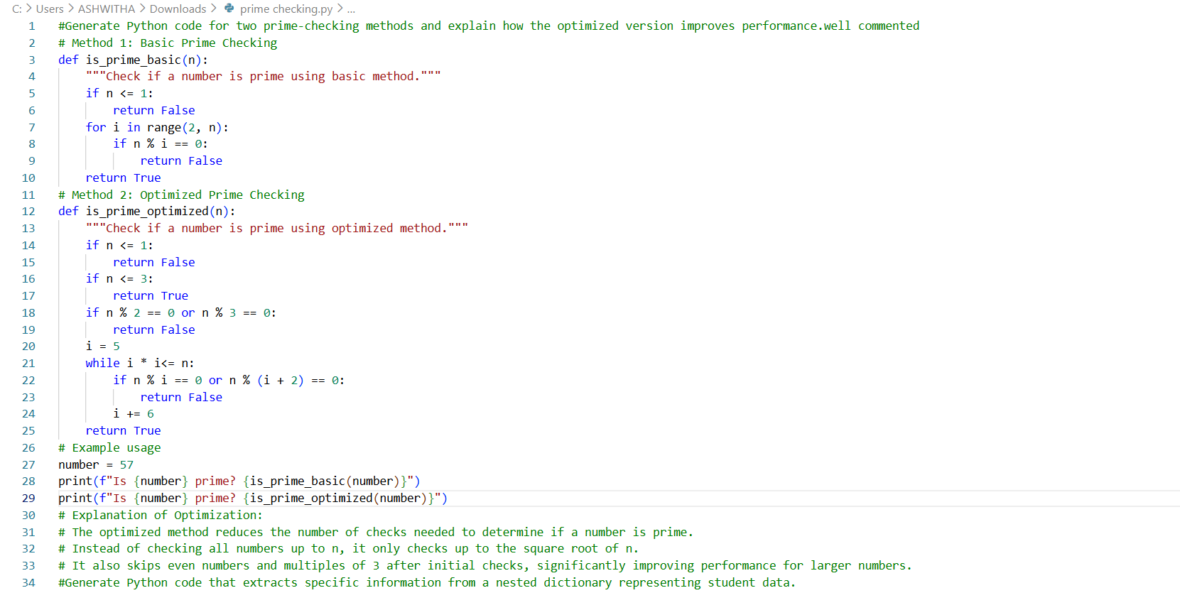
Output:
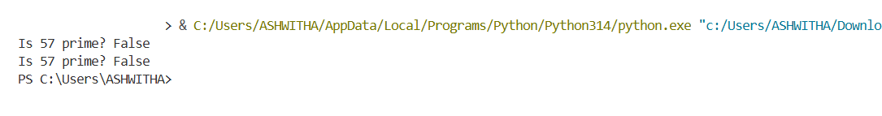
Task Description #9 (Transparency in Recursive Algorithms)
Objective: Use AI to generate a recursive function to calculate
Fibonacci numbers.
Instructions:
1. Ask AI to add clear comments explaining recursion.
2. Ask AI to explain base cases and recursive calls.
Expected Output:
• Well-commented recursive code.
• Clear explanation of how recursion works.
• Verification that explanation matches actual execution.
Code:
# write a code to generate a recursive function to calculate fibonacci numbers.
# - add clear comments explaining recusrion.
# - also explain base cases and recursive calls.
# - verification that explanation matches actual execution.
def fibonacci(n):
"""
Calculate the nth Fibonacci number using recursion.

The Fibonacci sequence is defined as:
F(0) = 0 (base case)
F(1) = 1 (base case)
F(n) = F(n-1) + F(n-2) for n > 1 (recursive case)

Parameters:
n (int): The position in the Fibonacci sequence to calculate.

Returns:
int: The nth Fibonacci number.
"""
# Base cases
if n == 0:
return 0
elif n == 1:
return 1
else:
# Recursive case: sum of the two preceding numbers
return fibonacci(n - 1) + fibonacci(n - 2)
# Example usage and verification
n = 6
print(f"The {n}th Fibonacci number is: {fibonacci(n)}")
# Explanation:
# When we call fibonacci(6), the function checks if n is 0 or 1. Since it's neither, it proceeds to the recursive case:
# fibonacci(6) = fibonacci(5) + fibonacci(4)
# This pattern continues, breaking down each call until it reaches the base cases:
# fibonacci(1) = 1 and fibonacci(0) = 0.
# The results are then combined back up the call stack to produce the final result.
# The execution for fibonacci(6) would look like this:
# fibonacci(6)
# = fibonacci(5) + fibonacci(4)
# = (fibonacci(4) + fibonacci(3)) + (fibonacci(3) + fibonacci(2))
# = ((fibonacci(3) + fibonacci(2)) + (fibonacci(2) + fibonacci(1))) + ((fibonacci(2) + fibonacci(1)) + (fibonacci(1) + fibonacci(0)))
# = ... and so on, until all calls reach the base cases.
# The final result is 8, which is the 6th Fibonacci number.
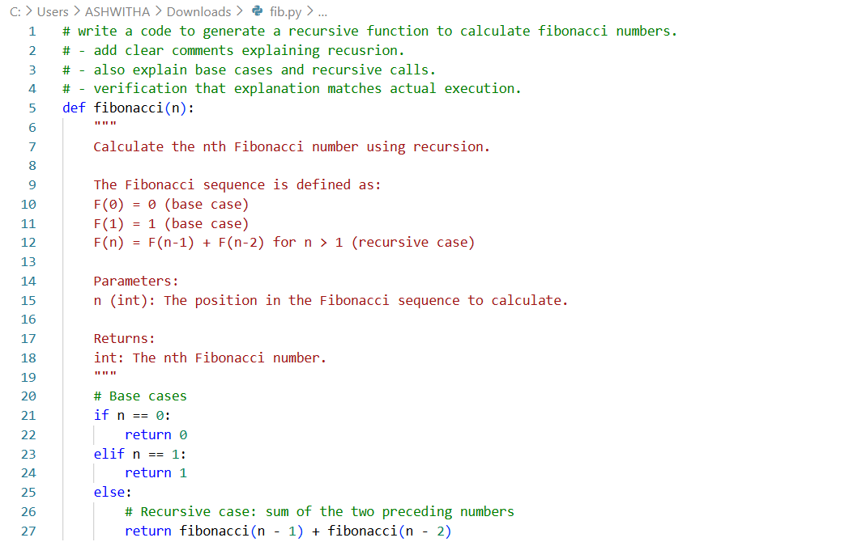
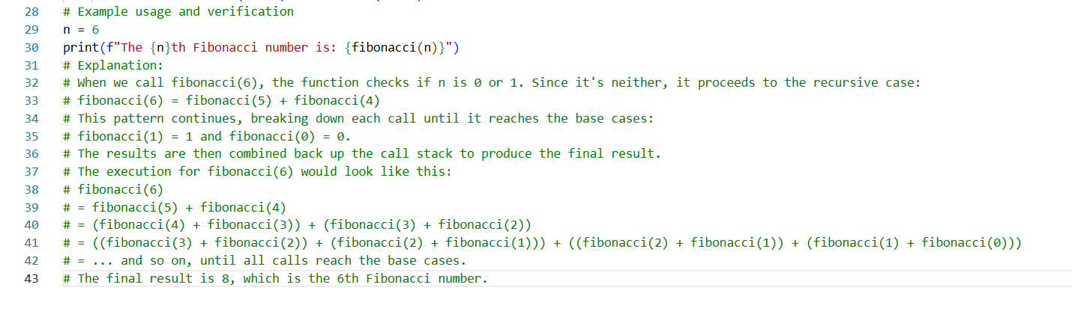
Output:
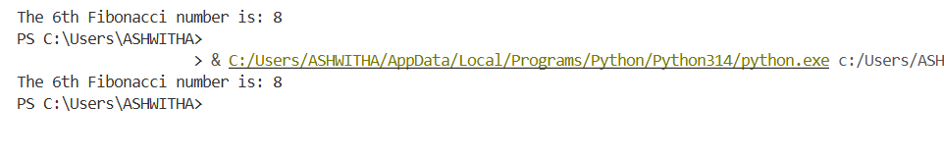
Task 10: (Transparency in Error Handling)
Task: Use AI to generate a Python program that reads a file and
processes data.
Prompt:
“Generate code with proper error handling and clear explanations for
each exception.”
Expected Output:
• Code with meaningful exception handling.
• Clear comments explaining each error scenario.
• Validation that explanations align with runtime behavior.
Code:
#generate a Python program that reads a file and processes data with proper error handling and clear explanations for each exception well as comments.
def read_and_process_file(file_path):
try:
# Attempt to open the file
with open(file_path, 'r') as file:
data = file.readlines()

# Process the data (for example, convert each line to an integer and sum them)
total = 0
for line in data:
try:
number = int(line.strip())
total += number
except ValueError as ve:
print(f"ValueError: Could not convert line to integer: '{line.strip()}'. Skipping this line.")

print(f"The total sum of the numbers in the file is: {total}")

except FileNotFoundError as fnfe:
print(f"FileNotFoundError: The file at path '{file_path}' was not found. Please check the path and try again.")
except IOError as ioe:
print(f"IOError: An error occurred while trying to read the file: {ioe}")
except Exception as e:
print(f"An unexpected error occurred: {e}")
# Example usage
file_path = 'data.txt' # Replace with your file path
read_and_process_file(file_path)
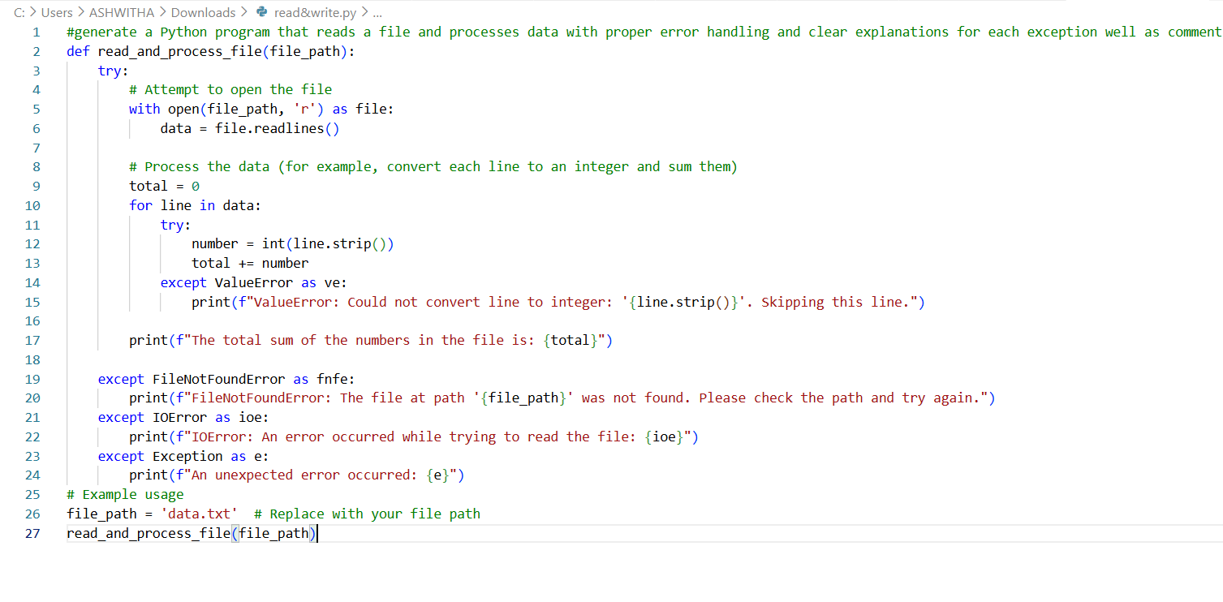
Output:
