Lab 7.5: Error Debugging with AI: Systematic approaches to
finding and fixing bugs

Name:P Ashwitha
HT No:2303A51163
Batch No:24

Task 1 (Mutable Default Argument – Function Bug)
Task: Analyze given code where a mutable default argument causes
unexpected behavior. Use AI to fix it.
# Bug: Mutable default argument
def add_item(item, items=[]):
items.append(item)
return items
print(add_item(1))
print(add_item(2))
Expected Output: Corrected function avoids shared list bug.

Code:
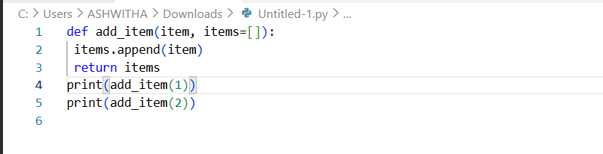
Output:
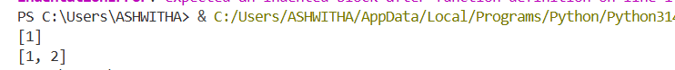

Corrected code:
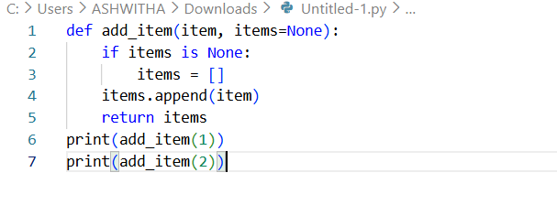
Output:
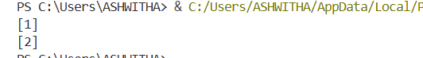

Task 2 (Floating-Point Precision Error)
Task: Analyze given code where floating-point comparison fails.
Use AI to correct with tolerance.
# Bug: Floating point precision issue
def check_sum():
return (0.1 + 0.2) == 0.3
print(check_sum())
Expected Output: Corrected function

Code:
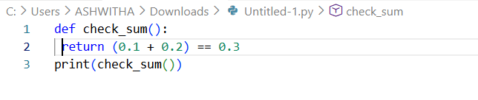
Output:

Corrected code:
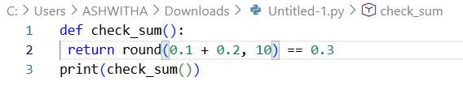
Output:
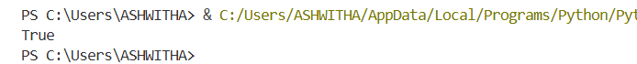

Task 3 (Recursion Error – Missing Base Case)
Task: Analyze given code where recursion runs infinitely due to
missing base case. Use AI to fix.
# Bug: No base case
def countdown(n):
print(n)
return countdown(n-1)
countdown(5)
Expected Output : Correct recursion with stopping condition.

Code:
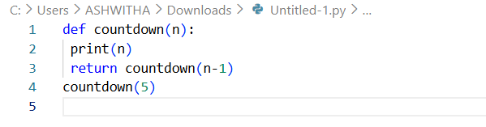
Output:
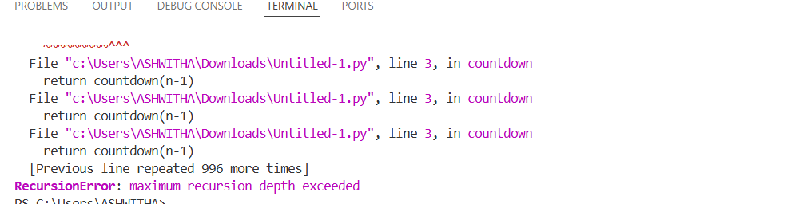

Corrected code:

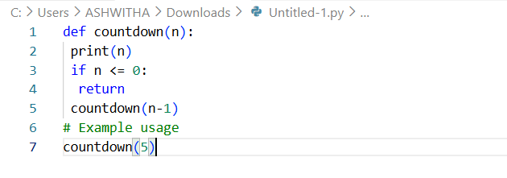
Output:
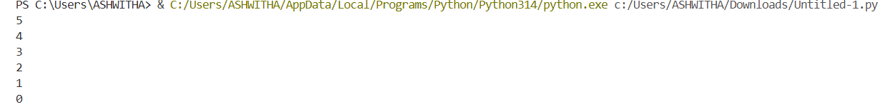

Task 4 (Dictionary Key Error)
Task: Analyze given code where a missing dictionary key causes
error. Use AI to fix it.
# Bug: Accessing non-existing key
def get_value():
data = {"a": 1, "b": 2}
return data["c"]
print(get_value())
Expected Output: Corrected with .get() or error handling.

Code:
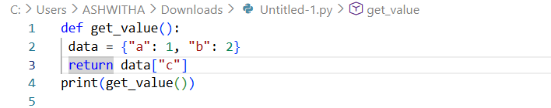
Output:

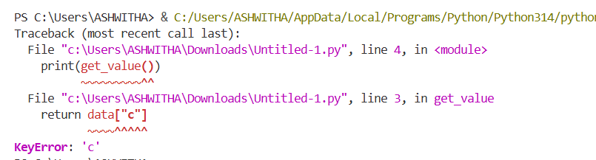

Corrected code:
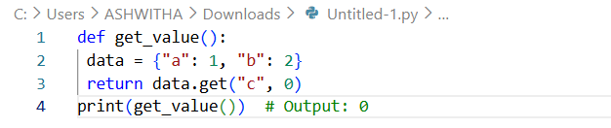
Output:

Task 5 (Infinite Loop – Wrong Condition)
Task: Analyze given code where loop never ends. Use AI to detect
and fix it.
# Bug: Infinite loop
def loop_example():
i = 0
while i < 5:
print(i)
Expected Output: Corrected loop increments i.
code:
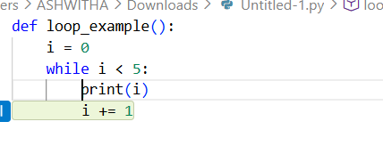
Output:

Corrected code:
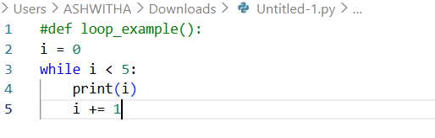
Output:
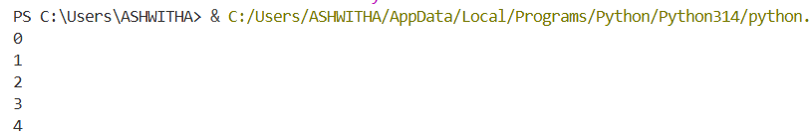

Task 6 (Unpacking Error – Wrong Variables)
Task: Analyze given code where tuple unpacking fails. Use AI to
fix it.
# Bug: Wrong unpacking
a, b = (1, 2, 3)
Expected Output: Correct unpacking or using _ for extra values.

Code:
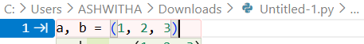
Output:
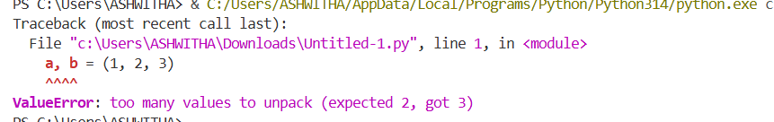

Corrected code:
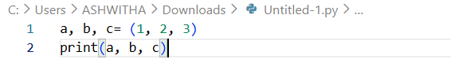
Output:

Task 7 (Mixed Indentation – Tabs vs Spaces)
Task: Analyze given code where mixed indentation breaks
execution. Use AI to fix it.
# Bug: Mixed indentation
def func():
x = 5
y = 10
return x+y
Expected Output : Consistent indentation applied.
Code:
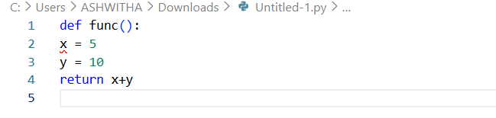
Output:
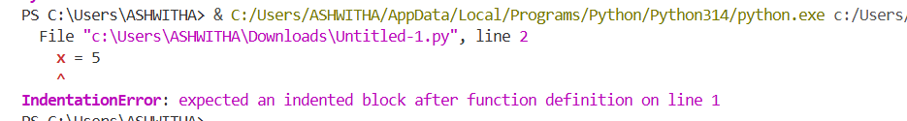

Corrected code:
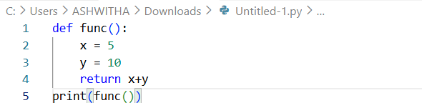
Output:

Task 8 (Import Error – Wrong Module Usage)
Task: Analyze given code with incorrect import. Use AI to fix.
# Bug: Wrong import
import maths
print(maths.sqrt(16))
Expected Output: Corrected to import math
Code:
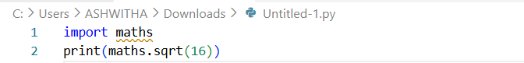
Output:
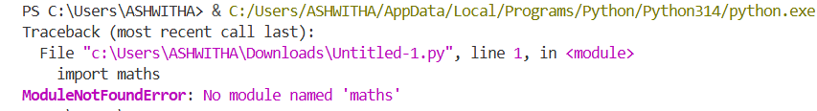

Corrected code:
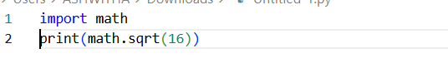
Output:

Task 9 (Unreachable Code – Return Inside Loop)
Task: Analyze given code where a return inside a loop prevents full
iteration. Use AI to fix it.
# Bug: Early return inside loop
def total(numbers):
for n in numbers:
return n
print(total([1,2,3]))
Expected Output: Corrected code accumulates sum and returns
after loop.
Code:
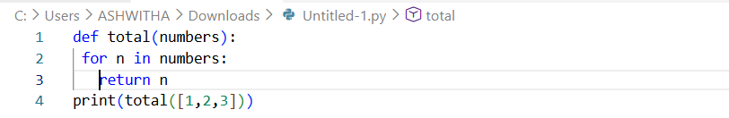
Output:

Corrected code:
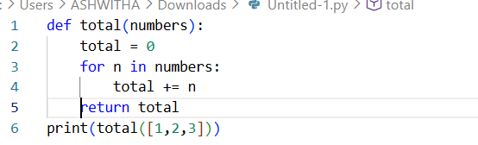
Output:

Task 10 (Name Error – Undefined Variable)
Task: Analyze given code where a variable is used before being
defined. Let AI detect and fix the error.
# Bug: Using undefined variable
def calculate_area():
return length * width
print(calculate_area())
Requirements:
• Run the code to observe the error.
• Ask AI to identify the missing variable definition.
• Fix the bug by defining length and width as parameters.
• Add 3 assert test cases for correctness.
Expected Output :
• Corrected code with parameters.
• AI explanation of the bug.
Successful execution of assertions.
Code:
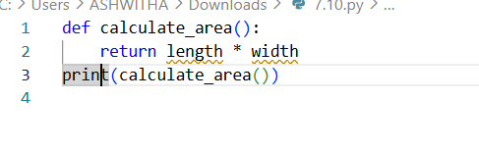
Output:
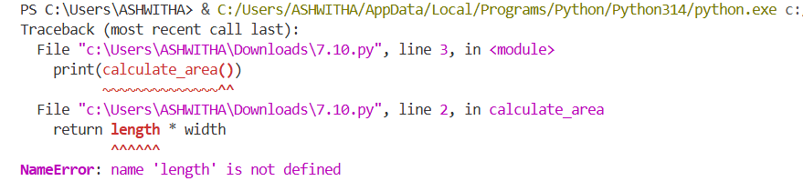

Corrected code:
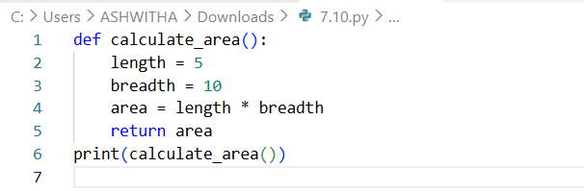
Output:

Task 11 (Type Error – Mixing Data Types Incorrectly)
Task: Analyze given code where integers and strings are added
incorrectly. Let AI detect and fix the error.
# Bug: Adding integer and string
def add_values():
return 5 + "10"
print(add_values())
Requirements:
• Run the code to observe the error.
• AI should explain why int + str is invalid.
• Fix the code by type conversion (e.g., int("10") or str(5)).
• Verify with 3 assert cases.
Expected Output #6:
• Corrected code with type handling.
• AI explanation of the fix.
Successful test validation.
Code:
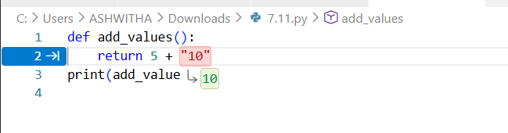
Output:
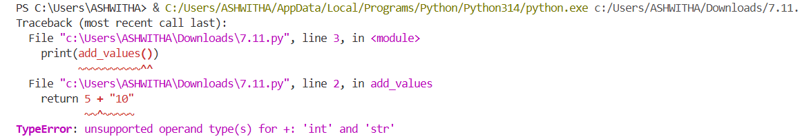

Corrected code:
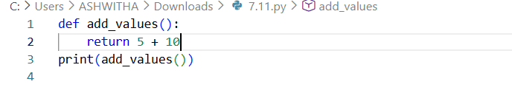
Output:

Task 12 (Type Error – String + List Concatenation)
Task: Analyze code where a string is incorrectly added to a list.
# Bug: Adding string and list
def combine():
return "Numbers: " + [1, 2, 3]
print(combine())
Requirements:
• Run the code to observe the error.
• Explain why str + list is invalid.
• Fix using conversion (str([1,2,3]) or " ".join()).
• Verify with 3 assert cases.
Expected Output:
• Corrected code
• Explanation
• Successful test validation
Code:
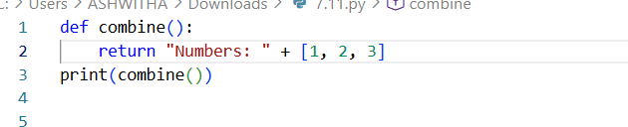
Output:
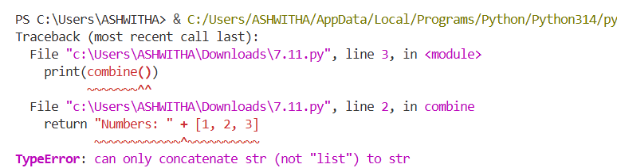

Corrected code:
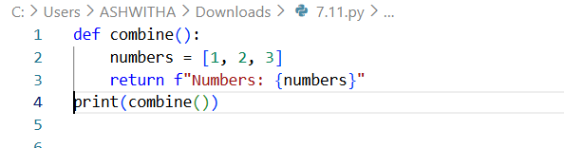
Output:
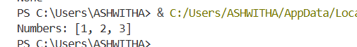

Task 13 (Type Error – Multiplying String by Float)
Task: Detect and fix code where a string is multiplied by a float.
# Bug: Multiplying string by float
def repeat_text():
return "Hello" * 2.5
print(repeat_text())
Requirements:
• Observe the error.
• Explain why float multiplication is invalid for strings.
• Fix by converting float to int.
• Add 3 assert test cases.
Code:
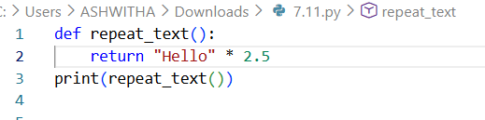
Output:
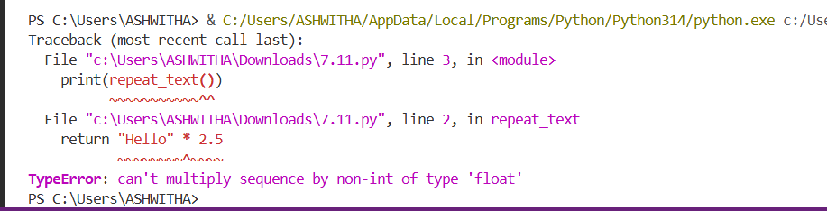

Corrected code:
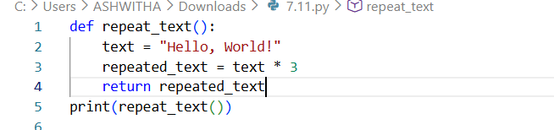
Output:

Task 14 (Type Error – Adding None to Integer)
Task: Analyze code where None is added to an integer.
# Bug: Adding None and integer
def compute():
value = None
return value + 10
print(compute())
Requirements:
• Run and identify the error.
• Explain why NoneType cannot be added.
• Fix by assigning a default value.
• Validate using asserts.
Code:
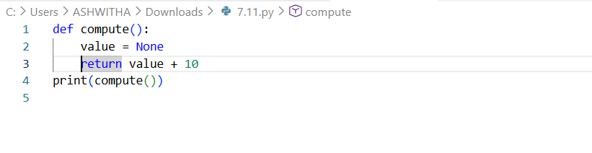
Output:
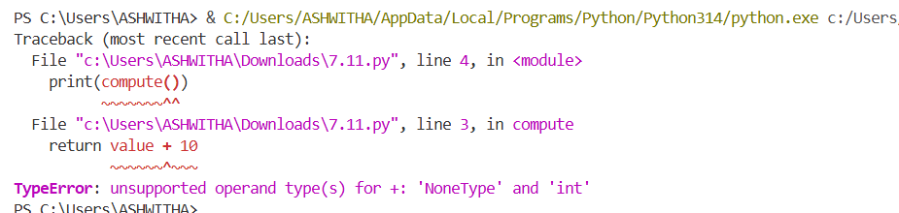

Corrected code:
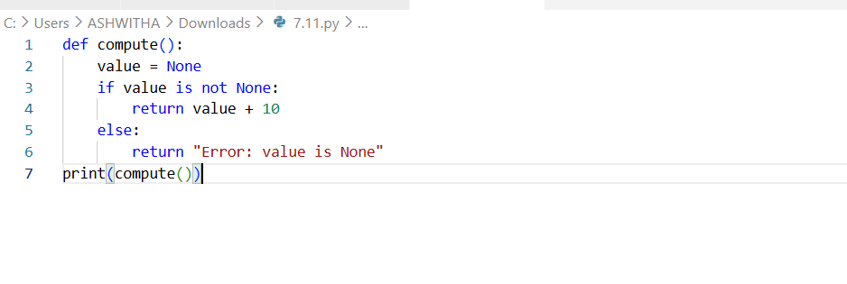
Output:

Task 15 (Type Error – Input Treated as String Instead of
Number)
Task: Fix code where user input is not converted properly.
# Bug: Input remains string
def sum_two_numbers():
a = input("Enter first number: ")
b = input("Enter second number: ")
return a + b
print(sum_two_numbers())
Requirements:
• Explain why input is always string.
• Fix using int() conversion.
• Verify with assert test cases.
Code:
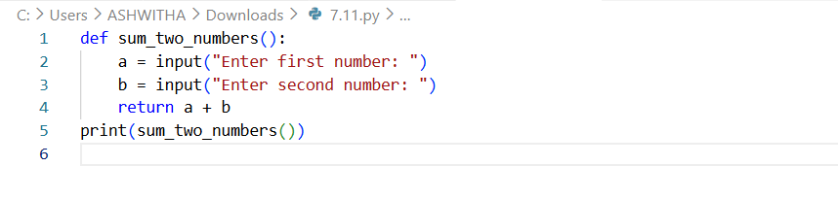
Output:
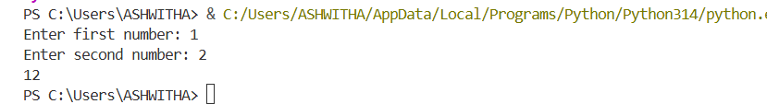

Corrected code:
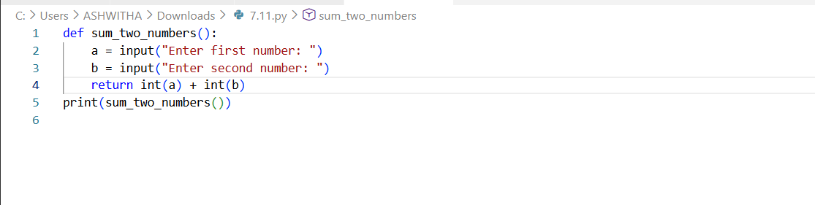
Output:

