Lab assignment 1.5
Name: P Ashwitha
HT No:2303A51163
Batch No:24

Task 1:
Prompt 1 : Write a python code to reverse a string without using functions.
CODE :
string = input("Enter a string: ")
reversed_string = ""
for char in string:
reversed_string = char + reversed_string
print("Reversed string:", reversed_string)
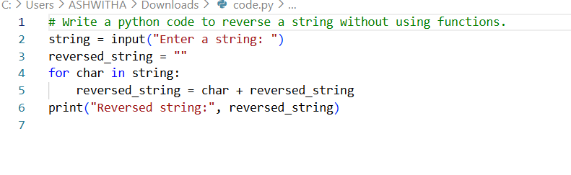
Output:
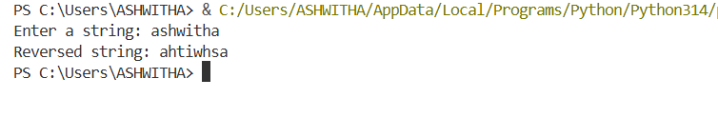
TASK 2:
Prompt 2 : Simplify this string reversal code and improve efficiency and readability.
CODE :
string = input("Enter a string: ")
reversed_string = string[::-1]
print("Reversed string:", reversed_string)
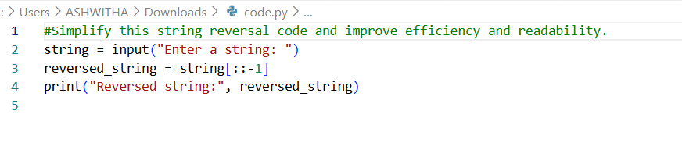
Output:
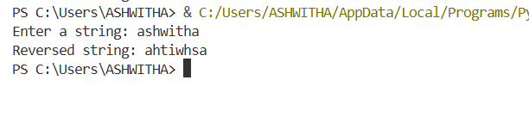
TASK 3:
Prompt 3 : Write a string reversal code in python with using functions.
CODE :
def reverse_string(string):
return string[::-1]
input_string = input("Enter a string: ")
reversed_string = reverse_string(input_string)
print("Reversed string:", reversed_string)
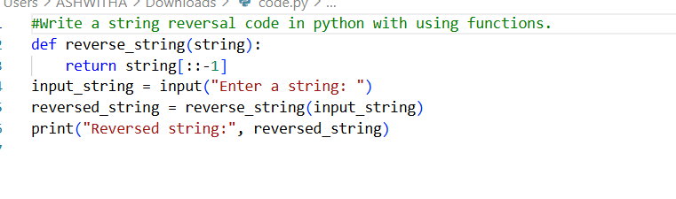
Output:
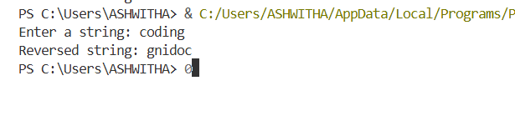
TASK 4:
Prompt 4 : Analyse the code with function and without function and give a comparsion table.
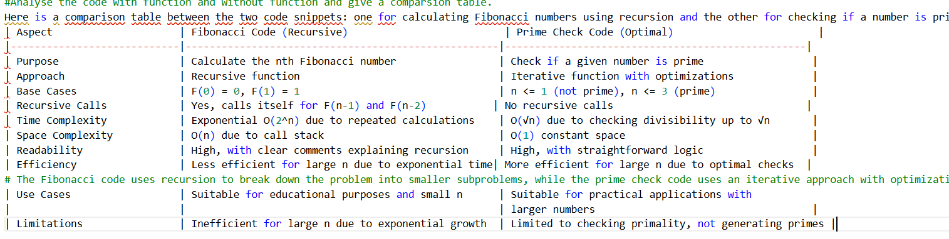
TASK 5:
Prompt 5 : Give different approaches to reverse a string like a loop based and built in or slicing based.
CODE :
# Loop-based approach
string = input("Enter a string: ")
reversed_string = ""
for char in string:
reversed_string = char + reversed_string
print("Reversed string:", reversed_string)
# Built-in function approach
string = input("Enter a string: ")
reversed_string = ''.join(reversed(string))
print("Reversed string:", reversed_string)
# Slicing-based approach
string = input("Enter a string: ")
reversed_string = string[::-1]
print("Reversed string:", reversed_string)
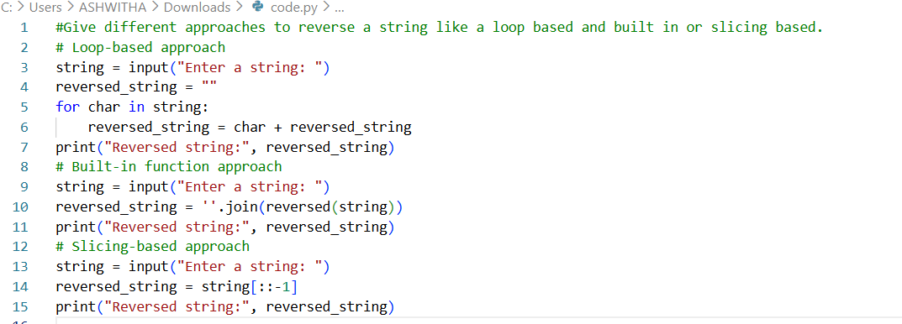
Output:
