Lab Assignment 3.3
Name:P Ashwitha
HT No:2303A51163
Batch No:24

Task 1:
Prompt 1 :Write a python program for an electricity billing system that reads previous units and current units and type of customer it should calculate units consumed.It should implements logic directly in main program and the energy charges depend on number of units consumed and customer type.
Code :
def calculate_bill(previous_units, current_units, customer_type):
units_consumed = current_units - previous_units
if customer_type == "Domestic":
if units_consumed <= 100:
bill = units_consumed * 2.5
elif units_consumed <= 200:
bill = 100 * 2.5 + (units_consumed - 100) * 3.5
else:
bill = 100 * 2.5 + 100 * 3.5 + (units_consumed - 200) * 4.5
elif customer_type == "Commercial":
if units_consumed <= 100:
bill = units_consumed * 4.5
elif units_consumed <= 200:
bill = 100 * 4.5 + (units_consumed - 100) * 6.5
else:
bill = 100 * 4.5 + 100 * 6.5 + (units_consumed - 200) * 8.5
return bill
previous_units = int(input("Enter previous units: "))
current_units = int(input("Enter current units: "))
customer_type = input("Enter customer type (Domestic/Commercial): ")
bill_amount = calculate_bill(previous_units, current_units, customer_type)
print(f"Bill amount: {bill_amount}")
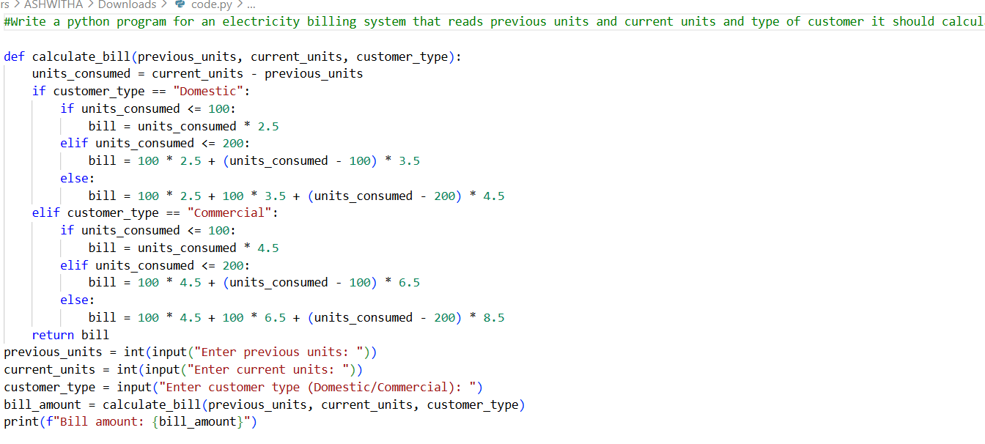
Output:
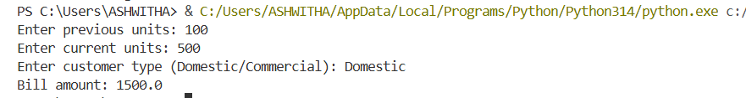
Task 2:
Prompt2 : In above code energy charges depend on number of units consumed and customer type .now it should calculate energy charge on domestic commercial industrial consumers
Code :
def calculate_bill(previous_units, current_units, customer_type):
units_consumed = current_units - previous_units
if customer_type == "Domestic":
if units_consumed <= 100:
bill = units_consumed * 2.5
elif units_consumed <= 200:
bill = 100 * 2.5 + (units_consumed - 100) * 3.5
else:
bill = 100 * 2.5 + 100 * 3.5 + (units_consumed - 200) * 4.5
elif customer_type == "Commercial":
if units_consumed <= 100:
bill = units_consumed * 4.5
elif units_consumed <= 200:
bill = 100 * 4.5 + (units_consumed - 100) * 6.5
else:
bill = 100 * 4.5 + 100 * 6.5 + (units_consumed - 200) * 8.5
elif customer_type == "Industrial":
if units_consumed <= 100:
bill = units_consumed * 6.0
elif units_consumed <= 200:
bill = 100 * 6.0 + (units_consumed - 100) * 8.0
else:
bill = 100 * 6.0 + 100 * 8.0 + (units_consumed - 200) * 10.0
return bill
previous_units = int(input("Enter previous units: "))
current_units = int(input("Enter current units: "))
customer_type = input("Enter customer type (Domestic/Commercial/Industrial): ")
bill_amount = calculate_bill(previous_units, current_units, customer_type)
print(f"Bill amount: {bill_amount}")
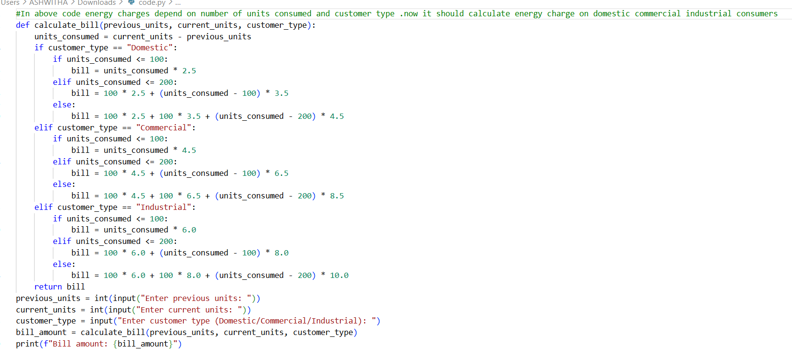
OUTPUT:

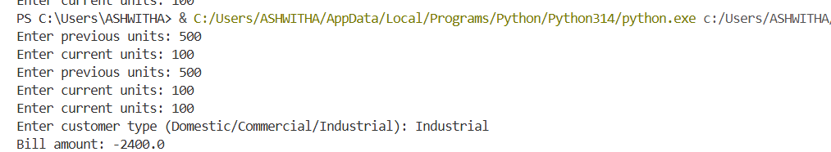
Task 3:
Prompt3 : In above code billing logic must be reusable for multiple consumers it should use defined functions to calculate energy charges,fixed charges and it return calculated value.
Code :
def calculate_energy_charges(units_consumed, customer_type):
if customer_type == "Domestic":
if units_consumed <= 100:
return units_consumed * 2.5
elif units_consumed <= 200:
return 100 * 2.5 + (units_consumed - 100) * 3.5
else:
return 100 * 2.5 + 100 * 3.5 + (units_consumed - 200) * 4.5
elif customer_type == "Commercial":
if units_consumed <= 100:
return units_consumed * 4.5
elif units_consumed <= 200:
return 100 * 4.5 + (units_consumed - 100) * 6.5
else:
return 100 * 4.5 + 100 * 6.5 + (units_consumed - 200) * 8.5
elif customer_type == "Industrial":
if units_consumed <= 100:
return units_consumed * 6.0
elif units_consumed <= 200:
return 100 * 6.0 + (units_consumed - 100) * 8.0
else:
return 100 * 6.0 + 100 * 8.0 + (units_consumed - 200) * 10.0
def calculate_fixed_charges(customer_type):
if customer_type == "Domestic":
return 50
elif customer_type == "Commercial":
return 100
elif customer_type == "Industrial":
return 150
def calculate_bill(previous_units, current_units, customer_type):
units_consumed = current_units - previous_units
energy_charges = calculate_energy_charges(units_consumed, customer_type)
fixed_charges = calculate_fixed_charges(customer_type)
total_bill = energy_charges + fixed_charges
return total_bill
previous_units = int(input("Enter previous units: "))
current_units = int(input("Enter current units: "))
customer_type = input("Enter customer type (Domestic/Commercial/Industrial): ")
bill_amount = calculate_bill(previous_units, current_units, customer_type)
print(f"Bill amount: {bill_amount}")
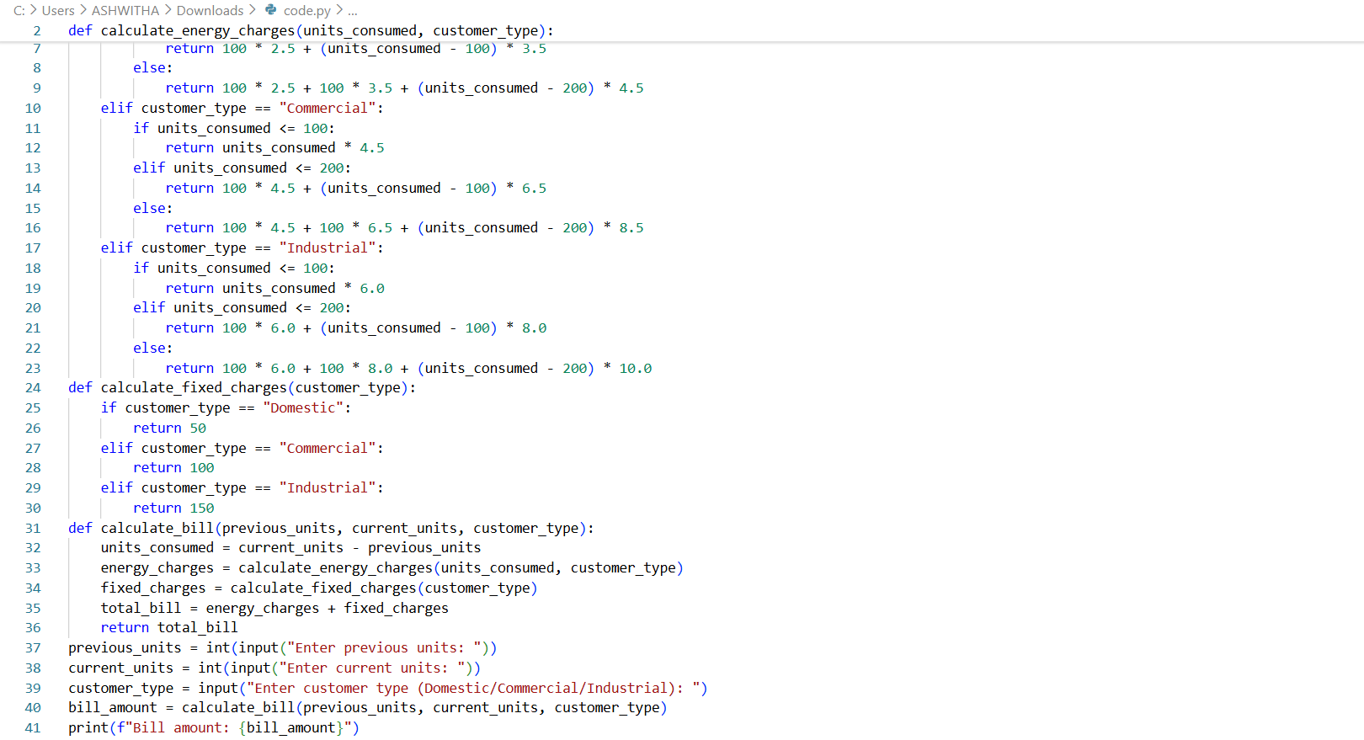
Output:
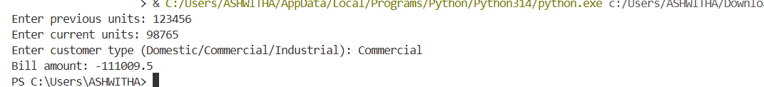
Task 4 :
Prompt4 : In above code it should include multiple additional charges liked fixed charge,customer charge,electricity duty.
def calculate_energy_charges(units_consumed, customer_type):
if customer_type == "Domestic":
if units_consumed <= 100:
return units_consumed * 2.5
elif units_consumed <= 200:
return 100 * 2.5 + (units_consumed - 100) * 3.5
else:
return 100 * 2.5 + 100 * 3.5 + (units_consumed - 200) * 4.5
elif customer_type == "Commercial":
if units_consumed <= 100:
return units_consumed * 4.5
elif units_consumed <= 200:
return 100 * 4.5 + (units_consumed - 100) * 6.5
else:
return 100 * 4.5 + 100 * 6.5 + (units_consumed - 200) * 8.5
elif customer_type == "Industrial":
if units_consumed <= 100:
return units_consumed * 6.0
elif units_consumed <= 200:
return 100 * 6.0 + (units_consumed - 100) * 8.0
else:
return 100 * 6.0 + 100 * 8.0 + (units_consumed - 200) * 10.0
def calculate_fixed_charges(customer_type):
if customer_type == "Domestic":
return 50
elif customer_type == "Commercial":
return 100
elif customer_type == "Industrial":
return 150
def calculate_customer_charge(customer_type):
if customer_type == "Domestic":
return 20
elif customer_type == "Commercial":
return 40
elif customer_type == "Industrial":
return 60
def calculate_electricity_duty(energy_charges):
return energy_charges * 0.05 # 5% electricity duty
def calculate_bill(previous_units, current_units, customer_type):
units_consumed = current_units - previous_units
energy_charges = calculate_energy_charges(units_consumed, customer_type)
fixed_charges = calculate_fixed_charges(customer_type)
customer_charge = calculate_customer_charge(customer_type)
electricity_duty = calculate_electricity_duty(energy_charges)
total_bill = energy_charges + fixed_charges + customer_charge + electricity_duty
return total_bill
previous_units = int(input("Enter previous units: "))
current_units = int(input("Enter current units: "))
customer_type = input("Enter customer type (Domestic/Commercial/Industrial): ")
bill_amount = calculate_bill(previous_units, current_units, customer_type)
print(f"Bill amount: {bill_amount}")
output:
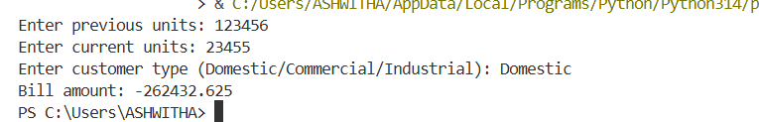
Task 5:
Code 5:
Prompt5: In above code it should print energy charges , fixed charges , customer charge,electricity duty ,total bill amount.
def calculate_energy_charges(units_consumed, customer_type):
if customer_type == "Domestic":
if units_consumed <= 100:
return units_consumed * 2.5
elif units_consumed <= 200:
return 100 * 2.5 + (units_consumed - 100) * 3.5
else:
return 100 * 2.5 + 100 * 3.5 + (units_consumed - 200) * 4.5
elif customer_type == "Commercial":
if units_consumed <= 100:
return units_consumed * 4.5
elif units_consumed <= 200:
return 100 * 4.5 + (units_consumed - 100) * 6.5
else:
return 100 * 4.5 + 100 * 6.5 + (units_consumed - 200) * 8.5
elif customer_type == "Industrial":
if units_consumed <= 100:
return units_consumed * 6.0
elif units_consumed <= 200:
return 100 * 6.0 + (units_consumed - 100) * 8.0
else:
return 100 * 6.0 + 100 * 8.0 + (units_consumed - 200) * 10.0
def calculate_fixed_charges(customer_type):
if customer_type == "Domestic":
return 50
elif customer_type == "Commercial":
return 100
elif customer_type == "Industrial":
return 150
def calculate_customer_charge(customer_type):
if customer_type == "Domestic":
return 20
elif customer_type == "Commercial":
return 40
elif customer_type == "Industrial":
return 60
def calculate_electricity_duty(energy_charges):
return energy_charges * 0.05 # 5% electricity duty
def calculate_bill(previous_units, current_units, customer_type):
units_consumed = current_units - previous_units
energy_charges = calculate_energy_charges(units_consumed, customer_type)
fixed_charges = calculate_fixed_charges(customer_type)
customer_charge = calculate_customer_charge(customer_type)
electricity_duty = calculate_electricity_duty(energy_charges)
total_bill = energy_charges + fixed_charges + customer_charge + electricity_duty
return energy_charges, fixed_charges, customer_charge, electricity_duty, total_bill
previous_units = int(input("Enter previous units: "))
current_units = int(input("Enter current units: "))
customer_type = input("Enter customer type (Domestic/Commercial/Industrial): ")
energy_charges, fixed_charges, customer_charge, electricity_duty, bill_amount = calculate_bill(previous_units, current_units, customer_type)
print(f"Energy Charges: {energy_charges}")
print(f"Fixed Charges: {fixed_charges}")
print(f"Customer Charge: {customer_charge}")
print(f"Electricity Duty: {electricity_duty}")
print(f"Total Bill amount: {bill_amount}")
OUTPUT :
Enter previous units: 5000
Enter current units: 6500
Enter customer type (Domestic/Commercial/Industrial): Domestic
Energy Charges: 6450.0
Fixed Charges: 50
Customer Charge: 20
Electricity Duty: 322.5
Enter customer type (Domestic/Commercial/Industrial): Domestic
Energy Charges: 6450.0
Fixed Charges: 50
Customer Charge: 20
Electricity Duty: 322.5
Energy Charges: 6450.0
Fixed Charges: 50
Customer Charge: 20
Electricity Duty: 322.5
Customer Charge: 20
Electricity Duty: 322.5
Electricity Duty: 322.5
Total Bill amount: 6842.5
Output:
