AIAC Assignment 3.5
Name: P Ashwitha
HT No:2303A51163
Batch no:24

Question 1: Zero-Shot Prompting (Leap Year Check)
Write a zero-shot prompt to generate a Python function that checks whether a given year is a leap year.
Task:
- Record the AI-generated code.
- Test with years like 1900, 2000, 2024.
- Identify logical flaws or missing conditions.
Prompt: write a python code to check if the given year is leap year or not

Code:
def is_leap_year(year):
if (year % 4 == 0 and year % 100 != 0) or (year % 400 == 0): return True
else:
return False # Example usage
year = int(input("Enter a year: ")) if is_leap_year(year):
print(f"{year} is a leap year.") else:
print(f"{year} is not a leap year.")

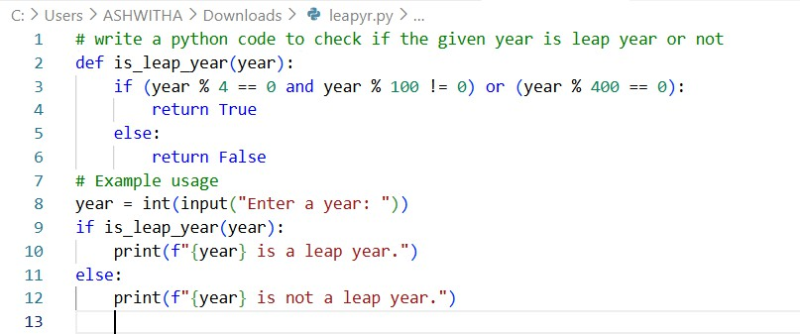

Output:
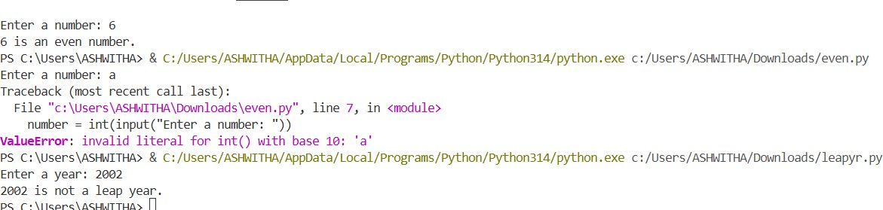

Question 2: One-Shot Prompting (GCD of Two Numbers)
Write a one-shot prompt with one example to generate a Python function that finds the Greatest Common Divisor (GCD) of two numbers. Example:
Input: 12, 18 → Output: 6 Task:
- Compare with a zero-shot solution.
- Analyze algorithm efficiency
Prompt: """
Input: 12, 18 → Output: 6 """

Code:

def gcd(a, b): while b:
a, b = b, a % b return a
# Example usage
num1 = int(input("Enter first number: "))

num2 = int(input("Enter second number: ")) result = gcd(num1, num2)
print(f"The GCD of {num1} and {num2} is {result}.")

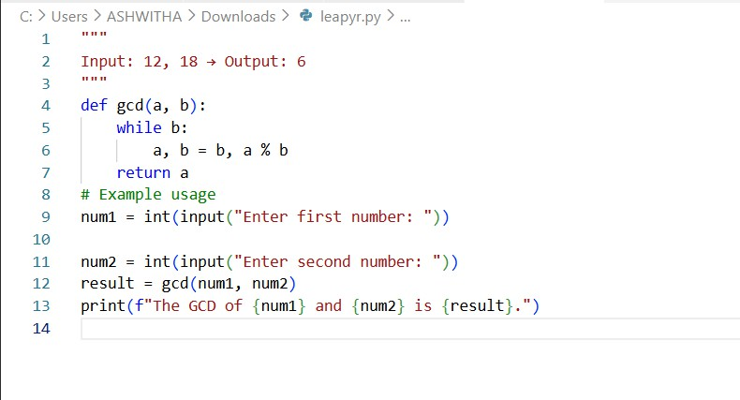

Output:
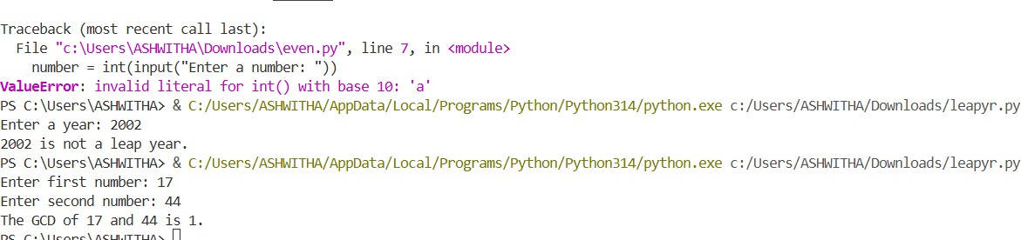

Question 3: Few-Shot Prompting (LCM Calculation)

Write a few-shot prompt with multiple examples to generate a Python function that computes the Least Common Multiple (LCM).
Examples:
- Input: 4, 6 → Output: 12
- Input: 5, 10 → Output: 10
- Input: 7, 3 → Output: 21 Task:
- Examine how examples guide formula selection.
- Test edge cases.
Prompt: """calculate the Least Common Multiple (LCM) of two given numbers. Input: 4, 6 → Output: 12
Input: 5, 10 → Output: 10
Input: 7, 3 → Output: 21 """

Code:
def lcm(a, b):
def lcm(x, y): while y:
x, y = y, x % y return x
return abs(a * b) // lcm(a, b) # Example usage
num1 = int(input("Enter first number: ")) num2 = int(input("Enter second number: "))
print(f"The LCM of {num1} and {num2} is {lcm(num1, num2)}")

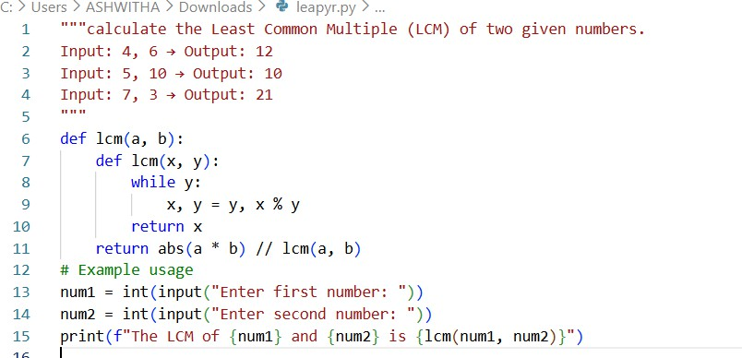

Output:
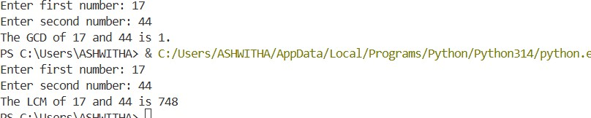

Question 4: Zero-Shot Prompting (Binary to Decimal Conversion) Write a zero-shot prompt to generate a Python function that converts a binary number to decimal.
Task:
- Test with valid and invalid binary inputs.
- Identify missing validation logic
Prompt: write a python code to convert binary number to decimal number

Code:
def binary_to_decimal(binary_str): decimal_number = 0
binary_str = binary_str[::-1] # Reverse the string to process from least significant bit for index, digit in enumerate(binary_str):
if digit == '1':

decimal_number += 2 ** index return decimal_number
# Example usage
binary_input = input("Enter a binary number: ")
decimal_output = binary_to_decimal(binary_input)
print(f"The decimal equivalent of binary {binary_input} is {decimal_output}.")
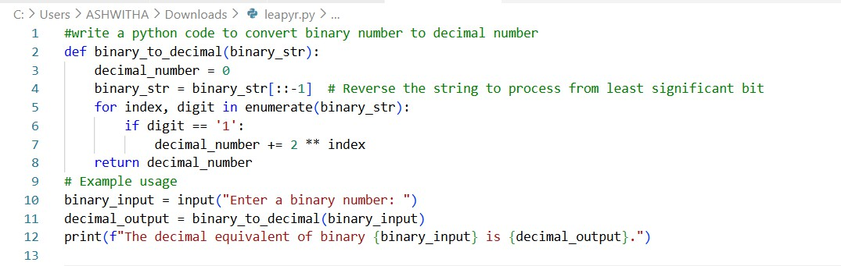

Output:

Question 5: One-Shot Prompting (Decimal to Binary Conversion)
Write a one-shot prompt with an example to generate a Python function that converts a decimal number to binary.
Example:
Input: 10 → Output: 1010 Task:
- Compare clarity with zero-shot output.
- Analyze handling of zero and negative numbers.

Prompt:
"""
Input: 10 → Output: 1010 """

Code:
def int_to_binary(n): if n == 0:
return "0" binary_str = "" while n > 0:
binary_str = str(n % 2) + binary_str n = n // 2
return binary_str # Example usage
number = int(input("Enter a number: ")) binary_representation = int_to_binary(number)
print(f"The binary representation of {number} is {binary_representation}.")
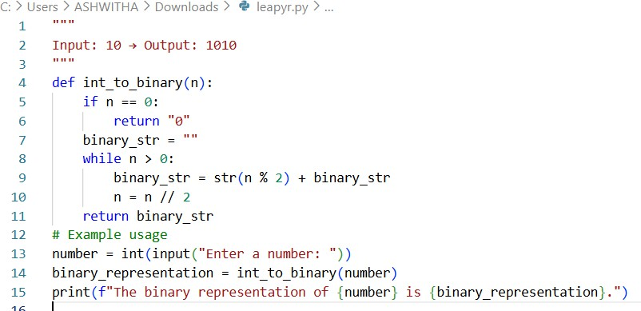

Output:
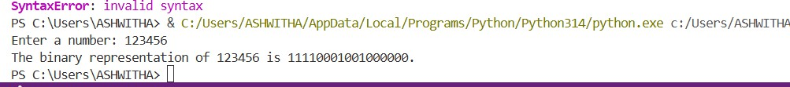

Question 6: Few-Shot Prompting (Harshad Number Check)

Write a few-shot prompt to generate a Python function that checks whether a number is a Harshad (Niven) number.
Examples:
- Input: 18 → Output: Harshad Number
- Input: 21 → Output: Harshad Number
- Input: 19 → Output: Not a Harshad Number Task:
- Test boundary conditions.
- Evaluate robustness

Prompt:
"""
Input: 18 → Output: Harshad Number Input: 21 → Output: Harshad Number Input: 19 → Output: Not a Harshad Number

"""

Code:
def is_harshad_number(n):
digit_sum = sum(int(digit) for digit in str(n)) return n % digit_sum == 0
# Example usage
number = int(input("Enter a number: ")) if is_harshad_number(number):
print(f"{number} is a Harshad Number.") else:
print(f"{number} is Not a Harshad Number.")

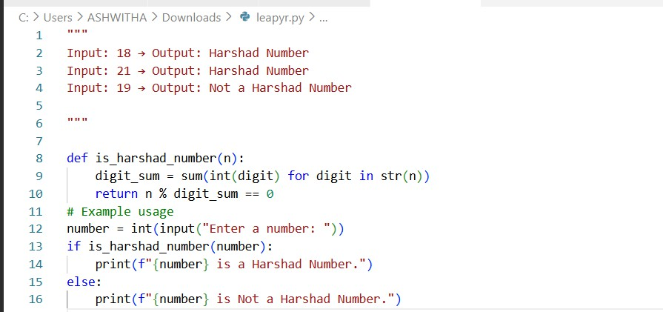
Output:
