1.# Write a Python function that checks whether a given number is a palindrome.
Code:
def is_palindrome(number):
if number < 0:
return False
temp=number
rev=0
while temp != 0:
rev = rev * 10 + temp % 10
temp //= 10
return rev == number
numbers = [121, 123, 1221, 10, 0, -121, 5]
for n in numbers:
print(f"{n} -> {is_palindrome(n)}")
Step-by-Step Explanation
- If the number is negative, return False.
- Store the original number in temp.
- Reverse the number using a while loop.
- Compare the reversed number with the original.
- If both are equal, it is a palindrome; otherwise, it is not.

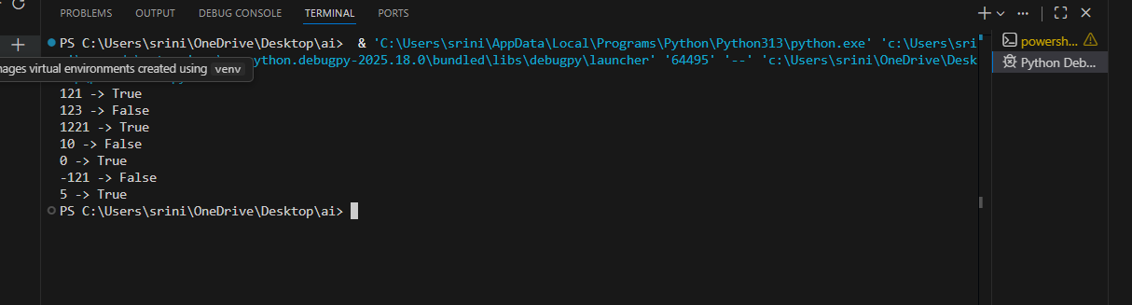

2. #Write a Python function to compute the factorial of a given number.
Code:
def factorial(n):
if n < 0:
return "Factorial is not defined for negative numbers"
if n==0 or n==1:
return 1
result = 1
for i in range(2, n + 1):
result *= i
return result
test_values = [5, 0, 1, 7, -3]
for val in test_values:
print(f"Input: {val} -> Output: {factorial(val)}")
Step-by-Step Explanation (Factorial Function)
- If the number is negative, return an error message.
- If the number is 0 or 1, return 1 (base case).
- Initialize result = 1.
- Use a for loop from 2 to n and multiply each value with result.
- Return the final factorial value.

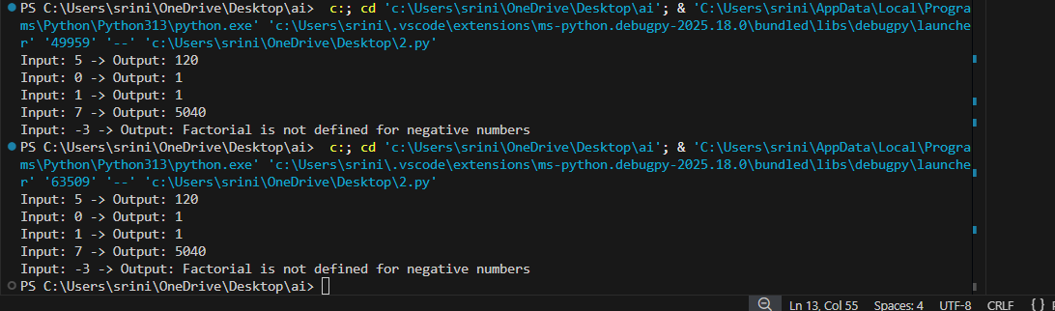

3.#Write a Python function to check whether a given number is an Armstrong number.
Code:
def is_armstrong(number):
if number < 0:
return "Invalid input"
digits = str(number)
power = len(digits)
total = 0
for d in digits:
total += int(d) ** power
if total == number:
return "Armstrong Number"
else:
return "Not an Armstrong Number"
n = int(input("Enter a number: "))
print("Result:", is_armstrong(n))
Step-by-Step Explanation (Armstrong Number)
- If the number is negative, return "Invalid input".
- Convert the number to a string to get each digit easily.
- Count the number of digits.
- Raise each digit to the power of the total digits and add them.
- Compare the sum with the original number.
- If both are equal, it is an Armstrong Number; otherwise, it is not.

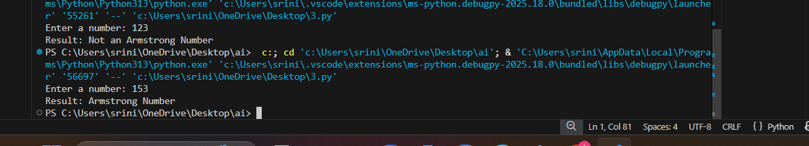

5. #Generate a Python function that checks whether a given number is a perfect number. The function should return True if the number is perfect, otherwise return False.
def is_perfect_number(n):
if n < 1:
return False
total=1
for i in range(2, int(n**0.5) + 1):
if n % i == 0:
total += i
if i != n // i:
total += n // i
return total == n
num=int(input("Enter a number: "))
if is_perfect_number(num):
print(f"{num} is a perfect number.")
else:
print(f"{num} is not a perfect number.")
Step-by-Step Explanation (Perfect Number)
- If the number is less than 1, return False.
- Initialize total = 1 (since 1 is a proper divisor).
- Loop from 2 to √n to find divisors.
- If i divides n, add both i and n//i to total.
- Compare the sum of proper divisors with the original number.
- If both are equal, it is a perfect number; otherwise, it is not.
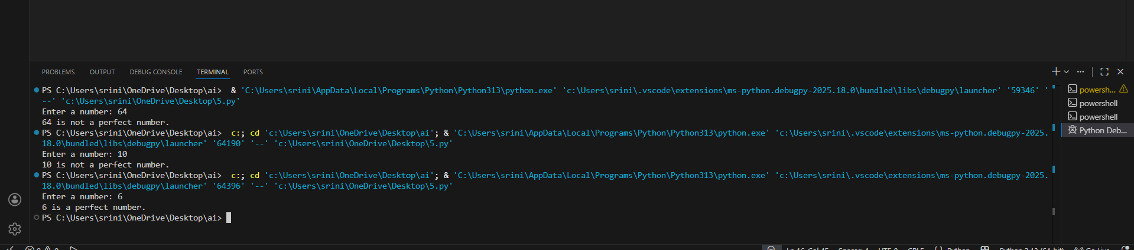

6. #Write a Python program that determines whether a given number is Even or Odd and includes proper input validation.

def even_or_odd():
n=input("Enter a number: ")
try:
n=int(n)
if n % 2 == 0:
print("Even")
else:
print("Odd")
except ValueError:
print("Invalid input. Please enter an integer.")
even_or_odd()
Step-by-Step Explanation (Even or Odd with Validation)
- Take input from the user.
- Try to convert the input into an integer.
- If conversion fails, display an invalid input message.
- If the number is divisible by 2, print Even.
- Otherwise, print Odd.
