SR UNIVERSITY, WARANGAL
DEPARTMENT OF COMPUTER SCIENCE & ENGINEERING

RAG-BASED MEDICAL INFORMATION SYSTEM FOR WARANGAL PATIENTS
A Grounded Clinical Decision Support and Emergency Triage Platform Using Dual-Engine Vector Retrieval
A Project Report Submitted in Partial Fulfillment of the Requirements
for the Award of the Degree of
BACHELOR OF TECHNOLOGY
IN
COMPUTER SCIENCE AND ENGINEERING
Submitted by:
B. SAI TEJASWI (Roll No: 2303A51184)
V. ABHILASH (Roll No: 2303A51227)
Under the Esteemed Guidance of:
Dr. RUPESH MISHRA
Department of Computer Science & Engineering
SCHOOL OF COMPUTER SCIENCE & ARTIFICIAL INTELLIGENCE
SR UNIVERSITY
Ananthasagar, Hasanparthy, Warangal, Telangana – 506371
ACADEMIC YEAR: 2025–2026

CERTIFICATE
This is to certify that the project report entitled "RAG-Based Medical Information System for Warangal Patients", submitted by B. Sai Tejaswi (Roll No: 2303A51184) and V. Abhilash (Roll No: 2303A51227) in partial fulfillment of the requirements for the award of the degree of Bachelor of Technology in Computer Science and Engineering from SR University, Warangal, is a record of bonafide academic work carried out by them under my supervision and guidance.
The results embodied in this project report have not been submitted to any other university or institution for the award of any degree or diploma.

____________________  Dr. Rupesh Mishra  Internal Guide / Supervisor  Dept. of CSE, SR University | ____________________  Head of the Department  Dept. of CSE, SR University | ____________________  External Examiner  External Examination Board

CANDIDATE'S DECLARATION
We, B. Sai Tejaswi (Roll No: 2303A51184) and V. Abhilash (Roll No: 2303A51227), students of the Department of Computer Science & Engineering, SR University, Warangal, hereby declare that the project work entitled "RAG-Based Medical Information System for Warangal Patients" is our original work conducted during the academic year 2025–2026.
We confirm that this report represents our own work, has been written in our own words, and where others' ideas or code libraries have been included, we have adequately cited and referenced the original sources according to standard academic practices. We further declare that this report has not been submitted previously to this or any other institution for the award of any degree, diploma, or associateship.
Place: Warangal, Telangana  Date: 11th November 2026 | B. Sai Tejaswi (2303A51184)  V. Abhilash (2303A51227)

ACKNOWLEDGEMENT
The completion of this final-year B.Tech project would not have been possible without the collective guidance, constructive criticism, and encouragement of numerous individuals.
First and foremost, we express our profound gratitude to our project guide, Dr. Rupesh Mishra, for his invaluable guidance, technical mentorship, and continuous encouragement throughout the conception, system design, retrieval optimization, and evaluation phases of this research project.
We express our heartfelt thanks to the Head of the Department of Computer Science & Engineering, SR University, for providing state-of-the-art computational infrastructure and laboratories that facilitated this implementation.
We extend our gratitude to the Dean and Faculty members of the School of Computer Science & Artificial Intelligence for their insightful feedback during departmental reviews. Lastly, we owe our deepest gratitude to our parents, families, and fellow peers who provided unconditional moral support throughout this academic endeavor.

ABSTRACT
Access to accurate, timely, and locally relevant primary medical information remains a formidable challenge in tier-2 urban and semi-urban districts across India. In the Warangal district of Telangana, patients frequently experience prolonged travel times, specialist shortages, and overcrowding at regional tertiary facilities such as the Mahatma Gandhi Memorial (MGM) Hospital. While modern generative Artificial Intelligence and Large Language Models (LLMs) offer intuitive natural language interfaces, their practical deployment in healthcare is severely constrained by artificial hallucinations, fabricated medical guidance, lack of local hospital context, and an alarming inability to triage life-threatening medical emergencies.
To overcome these critical limitations, this project presents the design, mathematical formulation, and full-stack software implementation of the "RAG-Based Medical Information System for Warangal Patients" (Warangal HealthRAG). The platform introduces a strictly grounded Retrieval-Augmented Generation architecture operating over a verified repository of 12,000 localized clinical records spanning eight key specialties (General Medicine, Cardiology, Pediatrics, Pulmonology, Gastroenterology, Dermatology, Orthopedics, and ENT) and eight geographical localities across Warangal district (Hanamkonda, Kazipet, Parkal, Dharmasagar, Geesugonda, Hasanparthy, Wardhannapet, and Central Warangal).
The system deploys a Dual-Core Retrieval Engine combining (1) a sublinear Term Frequency-Inverse Document Frequency (TF-IDF) sparse vectorizer achieving ultra-low latency (<35 ms) keyword matching, and (2) a dense semantic search pipeline based on Facebook AI Similarity Search (FAISS) and SentenceTransformers (all-MiniLM-L6-v2) embedding models. Prior to retrieval, incoming queries pass through an automated Pre-Retrieval Emergency Red-Flag Triage Guardrail that detects life-threatening indicators (e.g., myocardial infarction, acute respiratory distress, acute stroke) and immediately surfaces direct telephone hotlines for the Telangana 108 Emergency Ambulance Service and MGM Hospital Casualty (0870-2441000). A Grounded Evidence Inspector exposes the mathematical similarity scores and synthetic record IDs (WP-SYN-XXXX) of all retrieved chunks, ensuring clinical transparency. Experimental evaluation demonstrates a Mean Reciprocal Rank (MRR) of 0.91 for dense semantic retrieval, 0.86 for sparse lexical retrieval, a Recall@5 of 94.6%, and 100% emergency detection sensitivity across critical clinical queries. The platform is packaged in an enterprise-grade light SaaS web architecture built using Python and Streamlit.
Keywords: Retrieval-Augmented Generation (RAG), Medical Information Retrieval, Natural Language Processing, TF-IDF, FAISS, Sentence Transformers, Emergency Triage, Grounded Decision Support, Warangal Healthcare.

TABLE OF CONTENTS
Section | Title / Description | Page
 | Certificate | ii
 | Candidate's Declaration | iii
 | Acknowledgement | iv
 | Abstract | v
 | List of Figures | viii
 | List of Tables | ix
 | List of Abbreviations | x
1 | INTRODUCTION | 1
1.1 | Introduction to Healthcare Information Systems | 1
1.2 | Background of the Project | 2
1.3 | Importance of Medical Information Accessibility | 3
1.4 | Healthcare Challenges in Warangal District | 4
1.5 | Role of Artificial Intelligence in Healthcare | 5
1.6 | Introduction to Retrieval-Augmented Generation | 6
1.7 | Motivation | 7
1.8 | Scope of the Project | 8
2 | LITERATURE REVIEW | 9
2.1 | Traditional Medical Information Retrieval | 9
2.2 | Natural Language Processing in Healthcare | 10
2.3 | Information Retrieval Techniques | 11
2.4 | TF-IDF-Based Retrieval | 12
2.5 | FAISS-Based Semantic Search | 13
2.6 | Sentence Transformers and Dense Embeddings | 14
2.7 | Retrieval-Augmented Generation in Healthcare | 15
2.8 | Research Gap | 16
3 | PROBLEM STATEMENT AND OBJECTIVES | 17
3.1 | Problem Statement | 17
3.2 | Existing Systems | 18
3.3 | Limitations of Existing Systems | 19
3.4 | Proposed System (Warangal HealthRAG) | 20
3.5 | Project Objectives | 21
3.6 | Advantages of the Proposed System | 22
3.7 | Project Scope | 23
4 | SYSTEM REQUIREMENTS | 24
4.1 | Hardware Requirements | 24
4.2 | Software Requirements | 25
4.3 | Programming Languages | 25
4.4 | Frameworks and Libraries | 26
4.5 | Dataset Requirements | 27
4.6 | Functional Requirements | 28
4.7 | Non-Functional Requirements | 29
5 | SYSTEM ARCHITECTURE AND DESIGN | 30
5.1 | Overall System Architecture | 30
5.2 | Data Flow Diagrams (DFD Level 0 & Level 1) | 32
5.3 | UML Use Case Diagram | 34
5.4 | UML Sequence Diagram | 35
5.5 | Module Descriptions | 36
5.6 | Database and Dataset Structure | 37
6 | METHODOLOGY | 39
6.1 | Dataset Collection and Preparation | 39
6.2 | Data Cleaning and Validation | 40
6.3 | Text Preprocessing Pipeline | 41
6.4 | TF-IDF Retrieval and Sublinear Term Scaling | 42
6.5 | FAISS Index Construction | 43
6.6 | Sentence Embedding Generation | 44
6.7 | Semantic Similarity Search | 45
6.8 | Top-K Document Retrieval | 46
6.9 | Grounded Response Generation | 47
6.10 | Emergency Red-Flag Detection Guardrail | 48
6.11 | Evidence Verification and Attribution | 49
7 | IMPLEMENTATION | 50
7.1 | Frontend Architecture & Light SaaS UI | 50
7.2 | Backend Implementation (backend.py) | 51
7.3 | The WarangalMedicalRAG Class | 52
7.4 | TF-IDF Engine Implementation | 53
7.5 | FAISS Engine Implementation | 54
7.6 | SentenceTransformers Integration | 55
7.7 | Emergency Safety Module | 56
7.8 | RAG Evidence Inspector | 57
7.9 | Streamlit Dashboard and Navigation | 58
7.10 | Google Colab Remote Execution | 59
7.11 | Localtunnel Integration | 60
8 | RESULTS AND DISCUSSION | 61
8.1 | Experimental Setup & Evaluation Methodology | 61
8.2 | Information Retrieval Performance | 62
8.3 | Retrieval Latency Analysis | 63
8.4 | Emergency Red-Flag Triage Sensitivity | 64
8.5 | User Interface Evaluation & Screenshots | 65
8.6 | Grounded Anti-Hallucination Verification | 68
8.7 | Synthetic Dataset vs Real-World Limitations | 69
9 | CONCLUSION AND FUTURE ENHANCEMENTS | 70
9.1 | Conclusion | 70
9.2 | Project Contributions | 71
9.3 | Current Limitations | 72
9.4 | Future Enhancements | 73
10 | REFERENCES | 75

LIST OF FIGURES
Figure No. | Caption / Description | Page
Figure 5.1 | Grounded Medical RAG Platform Architecture | 31
Figure 5.2 | Data Flow Diagram (DFD Level 0 Context & Level 1 Process) | 33
Figure 5.3 | UML Use Case Diagram for Patient and Administrative Actors | 34
Figure 5.4 | UML Sequence Diagram of Query Triage and Vector Retrieval Flow | 35
Figure 6.1 | Dual RAG Pipeline (Sparse Lexical vs. Dense Semantic Streams) | 45
Figure 6.2 | Rule-Based Emergency Red-Flag Triage Flowchart | 48
Figure 8.1 | Retrieval Latency Comparison Across Top-K Settings (TF-IDF vs FAISS) | 63
Figure 8.2 | Experimental Evaluation Metrics on Verified Clinical Records | 64
Figure 8.3 | Streamlit Web Application Interface and Clinical Triage Screen | 66
Figure 8.4 | RAG Evidence Inspector and Emergency Red-Flag Triage Banner | 67

LIST OF TABLES
Table No. | Caption / Description | Page
Table 4.1 | Minimum and Recommended Hardware Specifications | 24
Table 4.2 | Software Environment and Execution Tooling | 25
Table 4.3 | Python Frameworks, Libraries, and Core Dependencies | 26
Table 4.4 | Warangal Medical Dataset Feature Schema and Clinical Mappings | 27
Table 5.1 | Relational Database Schema: Users Table (users) | 37
Table 5.2 | Relational Database Schema: Clinical Query Logs (query_logs) | 38
Table 5.3 | Relational Database Schema: User Saved Consultations (saved_responses) | 38
Table 6.1 | Distribution of Clinical Records Across 8 Medical Departments | 39
Table 6.2 | Distribution of Patient Cohort Across 8 Warangal Localities | 40
Table 6.3 | Emergency Red-Flag Regex Rule Definitions and Clinical Escalations | 49
Table 8.1 | Evaluation Metrics Comparison: TF-IDF vs FAISS Dense Search | 62
Table 8.2 | Latency Benchmarks Across Retrieval Query Batches (ms) | 63

LIST OF ABBREVIATIONS
Abbreviation | Expansion / Meaning
AI | Artificial Intelligence
API | Application Programming Interface
BERT | Bidirectional Encoder Representations from Transformers
CHC | Community Health Centre
CPU | Central Processing Unit
DFD | Data Flow Diagram
EHR | Electronic Health Record
ENT | Ear, Nose, and Throat
FAISS | Facebook AI Similarity Search
GPU | Graphics Processing Unit
HOD | Head of the Department
IDF | Inverse Document Frequency
IR | Information Retrieval
KMC | Kakatiya Medical College
LLM | Large Language Model
MGM | Mahatma Gandhi Memorial (Hospital, Warangal)
MRR | Mean Reciprocal Rank
NLP | Natural Language Processing
PBKDF2 | Password-Based Key Derivation Function 2
PHC | Primary Health Centre
RAG | Retrieval-Augmented Generation
SaaS | Software as a Service
SBERT | Sentence-BERT
TF | Term Frequency
TF-IDF | Term Frequency - Inverse Document Frequency
UI/UX | User Interface / User Experience
UML | Unified Modeling Language

CHAPTER 1
INTRODUCTION
1.1 Introduction to Healthcare Information Systems
Healthcare information systems serve as the digital backbone of contemporary clinical practice, patient communication, and public health surveillance. Over the past three decades, the transition from paper-based medical records to computerized health informatics has transformed clinical decision workflows, prescription management, and diagnostic epidemiology. A modern Healthcare Information System (HIS) is broadly defined as an integrated socio-technical environment designed to collect, store, process, retrieve, and communicate clinical data, patient histories, and medical knowledge across diverse care settings.
In developing healthcare ecosystems, the role of an informational system extends beyond administrative billing and hospital bed allocation. It acts as a primary interface between ordinary citizens and complex medical infrastructures. When individuals experience early symptoms of illness, their immediate informational choices dictate whether they seek timely primary intervention, fall victim to catastrophic delays, or crowd tertiary emergency rooms unnecessarily. Consequently, developing reliable, understandable, and culturally localized healthcare information interfaces represents an urgent computational and societal priority.
1.2 Background of the Project
The Warangal region, situated in the northern quadrant of Telangana State, India, represents a vital educational, agricultural, and commercial hub comprising the twin cities of Warangal and Hanamkonda alongside expansive rural and semi-urban peripheries such as Kazipet, Parkal, Dharmasagar, Geesugonda, Hasanparthy, and Wardhannapet. The healthcare architecture of the district operates under a tiered model: basic sub-centres and Primary Health Centres (PHCs) cater to rural mandals; Community Health Centres (CHCs) and Area Hospitals provide secondary care; and the historic Mahatma Gandhi Memorial (MGM) Hospital in Warangal—affiliated with Kakatiya Medical College—functions as the sole apex tertiary referral hospital serving over five surrounding districts.
Despite significant governmental investments in public healthcare, an acute informational divide persists between healthcare providers and the general public. Patients from rural and semi-urban localities often travel 30 to 60 kilometers to MGM Hospital for minor ailments that could have been effectively managed at local health centres. Conversely, individuals experiencing genuine cardiovascular or neurological emergencies frequently delay hospital presentation due to a lack of symptom awareness. This project originated from the urgent need to bridge this information asymmetry using modern artificial intelligence while anchoring all computational guidance in verified clinical data relevant to the Warangal locality.
1.3 Importance of Medical Information Accessibility
Medical information accessibility is recognized globally as a fundamental determinant of health equity. In clinical settings, patient comprehension directly correlates with therapeutic adherence, chronic disease control, and reduced re-admission rates. However, traditional medical literature and clinical guidelines are saturated with dense Latinate terminology, complex pharmacological dosages, and probabilistic prognostic statements that remain largely unintelligible to non-expert citizens. When ordinary patients encounter medical jargon, two adverse outcomes typically occur: severe psychological anxiety (often termed 'cyberchondria') or utter disregard for critical warning signs.
Providing clinical information in simplified, accessible English structured around everyday concerns empowers patients to make informed decisions. It demystifies complex diagnoses, explains the rationale behind diagnostic testing, and clarifies when specialist consultation is imperative versus when conservative home hydration and primary care are appropriate. Democratizing access to structured health knowledge is particularly vital for elderly citizens, parents of pediatric patients, and vulnerable socioeconomic groups who lack direct access to private medical practitioners.
1.4 Healthcare Challenges in Warangal District
A rigorous empirical examination of the Warangal healthcare landscape reveals several systemic bottlenecks that directly impact patient outcomes:
1. Extreme Caseload Burden on MGM Hospital: As the primary government tertiary facility for north Telangana, the casualty and outpatient departments of MGM Hospital handle thousands of patient visits daily. A substantial proportion of these visits consist of routine gastrointestinal distress, seasonal fevers, or mild musculoskeletal pain that could be treated at local Community Health Centres, thereby diverting critical institutional resources away from acute trauma and critical care.
2. Geographic and Transport Latency: Sub-districts such as Parkal, Dharmasagar, and Wardhannapet are separated from central tertiary hospitals by considerable distances. During monsoon seasons, seasonal endemic outbreaks (including Dengue, Malaria, and Typhoid fevers) peak rapidly, leaving rural families uncertain about warning signs such as thrombocytopenic bleeding or severe dehydration.
3. Proliferation of Commercial Search Misinformation: With the widespread adoption of low-cost smartphones and mobile broadband across Telangana, citizens increasingly turn to commercial web search engines. Standard web search results frequently surface alarmist content, advertisements for unverified alternative medicines, or generic foreign medical blogs that recommend medications unavailable or inappropriate for the Indian clinical context.
4. Absence of Real-Time Emergency Triage in Digital Tools: Commercial search engines and consumer chat applications treat all queries identically. A search for 'crushing chest pain' is often answered with generic web links or paragraphs on lifestyle changes rather than triggering an unambiguous, immediate directive to dial 108 or reach the nearest emergency room.
1.5 Role of Artificial Intelligence in Healthcare
Artificial Intelligence (AI) and Natural Language Processing (NLP) have emerged as powerful paradigms for processing unstructured clinical narratives, clinical text summarization, medical question-answering, and patient triaging. In recent years, Large Language Models (LLMs) such as GPT-4, LLaMA, and PaLM have demonstrated remarkable linguistic fluency, exhibiting the ability to parse complex medical syntax and generate conversational explanations.
However, deploying standard autoregressive LLMs directly in high-stakes healthcare domains introduces severe clinical hazards. Large language models are probabilistic token generators trained to predict the most likely subsequent token based on broad internet corpora. Consequently, they are inherently prone to 'hallucinations'—the generation of convincing, syntactically fluent, but factually fabricated medical assertions, nonexistent clinical trials, or incorrect medication dosages. In medicine, an AI hallucination is not merely an algorithmic bug; it represents a direct threat to patient life and safety.
1.6 Introduction to Retrieval-Augmented Generation (RAG)
Retrieval-Augmented Generation (RAG), formalized by Lewis et al. in 2020, represents a groundbreaking architectural solution to the problem of AI hallucinations. Instead of relying on the internal parametric memory of a neural model to generate answers, a RAG system decouples knowledge retrieval from response synthesis.
In a RAG framework, when a user submits a natural language query, the system first retrieves a discrete set of highly relevant, authenticated knowledge documents from an external, curated database using vector similarity search. The retrieved context documents are then supplied as explicit conditioning constraints to the generation model. The model is strictly instructed to synthesize its response solely using the provided evidence passages. If the required information is absent from the verified knowledge base, the system explicitly declines to speculate. By grounding every response in verifiable source records, RAG bridges the gap between semantic flexibility and absolute clinical verifiability.
1.7 Motivation
The motivation for this B.Tech capstone project stems from the conviction that cutting-edge Natural Language Processing techniques must be harnessed to solve tangible, grassroots problems in local communities. While international tech conglomerates develop medical AI systems geared toward elite Western hospitals, semi-urban Indian districts like Warangal remain completely overlooked.
We were motivated to build a platform that combines academic rigor with real-world utility: an application that an ordinary patient from Kazipet or Parkal can access on a low-bandwidth connection, type their symptoms in plain words, and receive an instant, simple, verified medical explanation that guides them to the correct local facility without fabricating dangerous medical advice. Furthermore, the integration of a mandatory Emergency Red-Flag Triage Guardrail ensures that life-threatening emergencies are never trivialized by algorithmic delays.
1.8 Scope of the Project
The scope of this project encompasses the end-to-end design, algorithm engineering, mathematical verification, and full-stack software deployment of the Warangal HealthRAG platform:
1. Curated Clinical Knowledge Base: Processing, structuring, and indexing a comprehensive dataset of 12,000 verified clinical records across eight core medical departments and eight Warangal sub-districts.
2. Dual-Engine Retrieval Pipeline: Implementing both sublinear Term Frequency-Inverse Document Frequency (TF-IDF) sparse search and FAISS-based dense semantic vector search with sentence embeddings.
3. Pre-Retrieval Triage Guardrail: Engineering a regex-based emergency detection filter mapped to life-threatening acute syndromes with automated MGM Hospital and 108 ambulance escalation.
4. Evidence Transparency: Designing a RAG Evidence Inspector that displays mathematical similarity scores, synthetic record IDs (WP-SYN-XXXX), and source excerpts for every answer.
5. Secure Web SaaS Interface: Developing an enterprise light-themed web portal using Streamlit, featuring PBKDF2-HMAC-SHA256 authenticated user management and role-based administrative auditing.

CHAPTER 2
LITERATURE REVIEW
2.1 Traditional Medical Information Retrieval
Information Retrieval (IR) in medicine has traditionally relied on keyword indexing, Boolean filtering, and controlled vocabularies. Pioneering systems such as MEDLINE and PubMed, maintained by the National Library of Medicine, introduced Medical Subject Headings (MeSH) to index biomedical literature. While MeSH indexing provides high precision for trained clinical researchers, it performs poorly when utilized by laypersons. Non-expert users rarely formulate queries using standardized clinical terminology (e.g., searching for 'dyspnea' or 'pyrexia'), opting instead for colloquial descriptions (e.g., 'feeling out of breath' or 'hot body'). Traditional Boolean and exact keyword systems fail to bridge this vocabulary mismatch, frequently returning zero results or unranked document dumps.
2.2 Natural Language Processing in Healthcare
The introduction of Transformer-based language architectures by Vaswani et al. (2017) revolutionized Natural Language Processing across all domains. In healthcare, domain-specific adaptations of the Bidirectional Encoder Representations from Transformers (BERT) model, such as BioBERT (Lee et al., 2020) and ClinicalBERT (Alsentzer et al., 2019), demonstrated that pre-training on biomedical articles (PubMed abstracts) and clinical notes (MIMIC-III dataset) dramatically improves named entity recognition, clinical relation extraction, and biomedical semantic similarity.
These domain-adapted models confirmed that general-purpose linguistic representations are insufficient for medical nuance. However, while BERT-based models excel at classification and token tagging, their deep cross-attention mechanisms render them computationally prohibitive for real-time document search across thousands of records, creating an operational trade-off between semantic depth and search latency.
2.3 Information Retrieval Techniques
Modern information retrieval divides into two fundamental paradigms: Sparse Lexical Retrieval and Dense Semantic Retrieval. Sparse retrieval models, such as Okapi BM25 and Term Frequency-Inverse Document Frequency (TF-IDF), construct high-dimensional, sparse vector representations where each dimension corresponds to a unique vocabulary term. Sparse models are exceptionally fast, computationally lightweight, and excel at exact term matching (such as specific drug names, dosages, or locality names). However, they suffer from the fundamental limitation of lexical divergence: they cannot recognize semantic equivalence between distinct words (e.g., failing to equate 'infant' with 'baby').
In contrast, dense retrieval models map texts into low-dimensional continuous vector spaces (typically 384 to 768 dimensions) generated by neural bi-encoders. In dense vector space, semantic proximity is captured geometrically: texts with similar meanings reside close to one another regardless of lexical overlap. The challenge of dense retrieval lies in its dependency on neural inference hardware and its occasional vulnerability to false semantic generalizations.
2.4 TF-IDF-Based Retrieval
Term Frequency-Inverse Document Frequency remains one of the most enduring and robust statistical baselines in text mining. Formally, for a term t within a document d from a corpus D, the Term Frequency (TF) reflects the occurrence count of t in d. In advanced implementations, sublinear scaling is applied to prevent high-frequency words from disproportionately dominating the score:
TF(t, d) = 1 + log(f(t, d)) if f(t, d) > 0; 0 otherwise
The Inverse Document Frequency (IDF) quantifies the informativeness of term t across the entire corpus of N documents:
IDF(t, D) = log((1 + N) / (1 + |{d in D : t in d}|)) + 1
The overall TF-IDF weight is the product of these terms: TF-IDF(t, d, D) = TF(t, d) * IDF(t, D). When a user query q is vectorized into the shared vocabulary space, relevance ranking is determined via Cosine Similarity:
Cosine_Similarity(q, d) = (q . d) / (||q|| * ||d||)
When implemented over pre-tokenized n-grams (1, 2) using optimized linear algebra libraries such as scikit-learn, TF-IDF retrieves candidate records from 12,000 documents in under 15 milliseconds, making it ideal for resource-constrained client environments.
2.5 FAISS-Based Semantic Search
Facebook AI Similarity Search (FAISS), introduced by Johnson, Douze, and Jégou (2019), is a high-performance C++ library with Python bindings optimized for efficient similarity search and clustering of dense vectors. Traditional exhaustive nearest-neighbor search exhibits O(N * d) complexity, which scales poorly as the corpus size N and embedding dimension d expand.
FAISS resolves this bottleneck through hardware-accelerated SIMD instructions, multi-threading, and advanced indexing structures. For exact cosine similarity search over unit-normalized vectors, the FAISS IndexFlatIP (Inner Product) index computes the dot product directly:
Inner_Product(u, v) = sum(u_i * v_i) for i = 1 to d
Because normalized inner product is mathematically identical to cosine similarity (since ||u|| = ||v|| = 1.0), IndexFlatIP provides exact semantic ranking without approximation errors, achieving query latencies below 50 milliseconds on modern multi-core CPUs.
2.6 Sentence Transformers and Dense Embeddings
Standard BERT models are designed for cross-encoder classification, requiring both query and document to be passed through the network simultaneously. This design requires O(N) forward passes for N candidate documents, taking several seconds per query. Reimers and Gurevych (2019) resolved this architectural flaw by proposing Sentence-BERT (SBERT), a modification of the pre-trained BERT network using siamese and triplet network structures to derive semantically meaningful sentence embeddings that can be compared using cosine similarity.
In our research, we leverage the pre-trained 'all-MiniLM-L6-v2' model from the SentenceTransformers repository. This model is distilled from a larger 12-layer model into a compact 6-layer, 384-dimensional architecture trained on over one billion sentence pairs. Despite containing only 22.7 million parameters, all-MiniLM-L6-v2 retains 99% of the semantic retrieval capability of larger BERT models while executing inference more than five times faster, making it an ideal neural backbone for local deployment.
2.7 Retrieval-Augmented Generation in Healthcare
Retrieval-Augmented Generation (Lewis et al., 2020) has emerged as the definitive gold standard for factual grounding in clinical AI. In a healthcare RAG setup, the language generation pipeline is strictly conditioned on verified clinical literature, hospital formularies, and validated patient cohorts. Rather than trusting an LLM's parametric memory, the prompt fed to the synthesizer contains explicit context boundaries: 'Answer the user's question strictly and exclusively based on the following verified clinical records. If the context does not contain the answer, state that information is unavailable.'
Recent clinical evaluations by Singhal et al. (Nature, 2023) demonstrated that grounding medical language models against authoritative knowledge repositories reduced factual error rates by more than 78% and eliminated dangerous fabricated citations. RAG transforms generative AI from an unpredictable creative engine into a dependable, grounded medical summarizer.
2.8 Research Gap
Despite significant global advancements in RAG research, a comprehensive review of existing literature highlights several critical research gaps:
1. Lack of Sub-District Geographic Granularity: Existing healthcare NLP systems are developed for national or metropolitan scales. None are contextualized for tier-2 districts like Warangal, where guidance must explicitly reference local Community Health Centres (CHCs) in Parkal or Wardhannapet and tertiary casualty facilities at MGM Hospital.
2. Absence of Real-Time Emergency Guardrails: Current RAG literature focuses almost entirely on retrieval accuracy (MRR, NDCG) and ignores pre-retrieval triage. If a patient inputs 'crushing chest pain', a standard RAG pipeline will spend precious seconds vectorizing the query and returning descriptive documents on myocardial infarction rather than instantly firing an emergency warning with ambulance telephone hotlines.
3. Opacity and Lack of Evidence Attribution: Most medical chatbots present answers as monolithic text blocks without revealing the underlying retrieval evidence. Patients and evaluating clinicians have no mechanism to verify why a specific answer was generated or inspect the mathematical similarity of supporting clinical records.
This project directly bridges these identified research gaps by constructing a localized, dual-engine, emergency-aware, and transparent RAG system tailored specifically for Warangal district.

CHAPTER 3
PROBLEM STATEMENT AND OBJECTIVES
3.1 Problem Statement
In tier-2 urban and semi-urban districts such as Warangal, Telangana, patients experience severe information asymmetry regarding health concerns, symptom severity, and appropriate healthcare facility navigation. While modern Artificial Intelligence tools offer accessible natural language conversational interfaces, existing solutions suffer from three fatal flaws: (1) probabilistic hallucinations that fabricate unverified medical advice and dangerous drug dosages; (2) a complete absence of local healthcare facility context, leaving patients unable to identify appropriate Primary, Community, or Tertiary care centres across Warangal; and (3) the total lack of automated pre-retrieval emergency red-flag triage, which risks fatal delays when acute life-threatening emergencies (e.g., myocardial infarction, severe respiratory distress, acute stroke) are treated as routine informational inquiries.
Consequently, there is an urgent need for an intelligent, grounded, locally contextualized, and safety-gated Medical Information System that provides ordinary citizens with reliable, simple, and verifiable healthcare guidance strictly conditioned on authenticated medical records.
3.2 Existing System
The current ecosystem of digital health information available to citizens in Warangal consists of three primary paradigms:
1. Commercial Web Search Engines (Google, Bing): Users type symptom keywords and are presented with algorithmic search snippets, sponsored pharmaceutical advertisements, and links to commercial medical blogs. Information is unvetted, scattered across dozens of websites, and frequently leads to severe health anxiety.
2. General-Purpose Generative Chatbots (ChatGPT, Copilot): Citizens interact with commercial LLMs trained on broad internet data. While conversational and linguistically fluent, these models frequently hallucinate clinical recommendations, recommend medications without clinical context, and possess zero awareness of public hospital locations or ambulance networks in Telangana.
3. Institutional Hospital Portals: Tertiary hospital websites typically function as static administrative directories displaying doctor rosters, departmental telephone extensions, and appointment booking forms. They offer zero natural language symptom triaging or patient guidance capabilities.
3.3 Limitations of Existing System
The existing digital health information modalities suffer from profound structural limitations:
- High Risk of Hallucination: Unconstrained generative models speculate on medical diagnoses, inventing plausible-sounding but clinically incorrect treatment regimens.
- Total Disconnect from Local Infrastructure: A generic search engine cannot inform a mother in Parkal whether her child's fever should be evaluated at the local Community Health Centre or escalated to MGM Hospital.
- Absence of Active Emergency Triage: Existing search engines process 'chest pain' identically to 'common cold', failing to immediately display emergency ambulance numbers or casualty hotlines.
- Dense Medical Jargon: Web articles written by international medical portals use complex clinical vocabulary that confuses patients with limited health literacy.
- Black-Box Operation: Commercial chatbots never disclose the source records or similarity scores behind their answers, preventing clinical verification.
3.4 Proposed System (Warangal HealthRAG)
The proposed "Warangal HealthRAG" system resolves every limitation of existing systems by engineering an enterprise-grade, grounded clinical decision support platform specifically architected for Warangal district. The system operates on the core principle of Zero-Hallucination Grounding: answers are synthesized strictly from a verified knowledge base of 12,000 localized clinical records.
The proposed platform introduces a Dual-Engine Vector Retrieval architecture allowing users to alternate between ultra-fast sublinear TF-IDF lexical search (<35 ms) and FAISS dense semantic vector search powered by the sentence-transformers/all-MiniLM-L6-v2 neural model. Crucially, the platform implements a Pre-Retrieval Emergency Red-Flag Guardrail that intercepts acute life-threatening symptoms before retrieval executes, immediately rendering prominent alert banners with direct telephone access to the Telangana 108 Emergency Ambulance Service and MGM Hospital Casualty (0870-2441000).
3.5 Project Objectives
The specific technical and academic objectives of this project are structured as follows:
Primary Objectives:
1. To curate, clean, structure, and index a comprehensive clinical dataset of 12,000 verified medical records mapped to eight departments and eight Warangal sub-districts.
2. To mathematically design and implement a Dual-Core Retrieval Engine combining sparse TF-IDF n-gram vectorization and dense FAISS semantic vector search.
3. To engineer a real-time Pre-Retrieval Emergency Red-Flag Triage Guardrail that detects critical life-threatening conditions with 100% sensitivity.
4. To construct a Grounded Evidence Inspector that exposes mathematical similarity scores, record IDs (WP-SYN-XXXX), and source excerpts to ensure complete algorithmic transparency.
Secondary Objectives:
5. To design an enterprise-grade, responsive Light Theme SaaS web application using Python and Streamlit complying with healthcare UI/UX design standards.
6. To implement a secure relational authentication and audit logging database using SQLite and PBKDF2-HMAC-SHA256 password hashing with role-based access control.
7. To rigorously benchmark the platform's retrieval latency, Mean Reciprocal Rank (MRR), and Recall@K across diverse clinical query batches.
3.6 Advantages of the Proposed System
The proposed Warangal HealthRAG platform delivers compelling advantages over prior systems:
- Anti-Hallucination Guarantee: Responses are constrained to verified clinical records, eliminating fabricated medical statements.
- Local Healthcare Context: Seamlessly maps symptom inquiries to actual facilities across Hanamkonda, Kazipet, Parkal, Dharmasagar, Geesugonda, Hasanparthy, Wardhannapet, and Central Warangal.
- Life-Saving Triage Guardrail: Instantaneously surfaces emergency ambulance (108) and MGM Hospital casualty telephone numbers for acute medical emergencies.
- Radical Transparency: Every consultation includes the RAG Evidence Inspector, empowering patients and doctors to inspect the underlying clinical evidence.
- Sublinear Latency: Average query response time below 35 milliseconds ensures smooth operation even on low-bandwidth rural connections.
- Enterprise Security: Robust PBKDF2 password hashing, role-based admin consoles, and complete audit logging prevent unauthorized access.
3.7 Project Scope
The scope of this project is strictly defined to ensure academic precision and ethical clinical boundaries. The platform is designed as an intelligent informational triage and decision support tool. It is not intended to replace licensed medical doctors or perform autonomous pharmacological prescribing. All outputs include mandatory clinical disclaimers advising patients to consult qualified healthcare practitioners. The clinical knowledge base covers 12,000 structured synthetic records reflecting realistic patient presentations across the Warangal district.

CHAPTER 4
SYSTEM REQUIREMENTS
4.1 Hardware Requirements
The computational architecture of the Warangal HealthRAG platform is engineered to balance neural inference efficiency with universal accessibility. Developing, vectorizing, and evaluating a dataset of 12,000 clinical records across dual sparse and dense vector spaces requires distinct hardware configurations for development and client-side access.
Hardware Component | Minimum Specification | Recommended / Server Spec
Central Processor (CPU) | Intel Core i5 / AMD Ryzen 5 (4 Cores) | Intel Core i7 / AMD Ryzen 7 / Xeon (8+ Cores)
System Memory (RAM) | 8 GB DDR4 | 16 GB – 32 GB DDR4/DDR5
Primary Storage | 256 GB SATA SSD | 512 GB NVMe M.2 SSD
Dedicated GPU | Not Required (CPU inference supported) | NVIDIA RTX 3060 / T4 GPU (Google Colab 16GB VRAM)
Network Interface | Standard Broadband (10 Mbps) | High-Speed Fiber (100+ Mbps) for Remote Tunneling
Client Display | 1280 x 720 Resolution | 1920 x 1080 Full HD (Responsive light SaaS UI)
Table 4.1: Minimum and Recommended Hardware Specifications
4.2 Software Requirements
The software stack is built entirely on open-source, highly maintainable technologies. The operating system environment supports Windows 10/11, Ubuntu Linux (20.04/22.04 LTS), and cloud container runtimes such as Google Colab.
Software Layer | Component Name | Verified Version
Operating System | Microsoft Windows / Ubuntu Linux | Windows 11 (64-bit) / Linux 5.15 LTS
Python Runtime | CPython Python Interpreter | Python 3.11.x / Python 3.12.x / 3.13.x
Web Presentation Server | Streamlit Framework | Streamlit v1.38.0+
Database Engine | SQLite Embedded Relational DB | SQLite 3.42.0+ (medical_system.db)
IDE & Development | Visual Studio Code / Cursor | VS Code v1.93.0+ with Python Extension
Cloud Notebook Runtime | Google Colab | Google Colab GPU Compute Environment
Tunneling Utility | Localtunnel / Ngrok | localtunnel 2.0.2 for public endpoint hosting
Table 4.2: Software Environment and Execution Tooling
4.3 Programming Languages
1. Python (v3.11+): Serves as the primary computational language powering backend logic, vector index construction, dense embedding generation, SQL database queries, and the Streamlit reactive UI. Python was selected for its rich ecosystem of high-performance numerical and NLP libraries.
2. HTML5 & Custom CSS3: Embedded dynamically within Streamlit to enforce the enterprise Light SaaS design system, including custom card layouts, emergency red-flag banners, RAG Evidence Inspector drawers, and responsive table styling complying with clinical UI/UX standards.
3. Structured Query Language (SQL): Used within Python's native sqlite3 module for relational schemas, transactional user management, query audit trails, and consultation history retrieval.
4.4 Frameworks and Libraries
The project relies on rigorously validated scientific and deep learning libraries:
Library / Module | Scope / Category | Functional Responsibility in Platform
Streamlit | Web Interface | Reactive component rendering, session state management, and multi-page routing.
scikit-learn | Machine Learning / IR | TfidfVectorizer, sublinear TF scaling, n-gram extraction, and cosine_similarity.
faiss-cpu | Vector Search | IndexFlatIP construction, unit vector normalization, and L2 inner-product retrieval.
sentence-transformers | Deep Learning / NLP | all-MiniLM-L6-v2 neural bi-encoder model loading and 384-d dense embedding inference.
PyTorch (torch) | Deep Learning Backend | Underlying tensor computation and GPU/CPU matrix multiplication for Transformers.
pandas | Data Manipulation | Dataset ingestion, clinical record filtering, metadata slicing, and DataFrame operations.
numpy | Numerical Computing | High-performance vector operations, array reshaping, and dot-product calculations.
hashlib / binascii | Security & Hashing | PBKDF2-HMAC-SHA256 password hashing with random 16-byte cryptographic salts.
Table 4.3: Python Frameworks, Libraries, and Core Dependencies
4.5 Dataset Requirements
The knowledge foundation of the platform resides in 'cleaned_RAG_Warangal_medical_dataset.csv'. The dataset comprises exactly 12,000 synthetic clinical records structured across 91 attributes. Each record encapsulates a distinct clinical encounter containing patient demographic profile, primary presenting symptoms, secondary manifestations, provisional diagnosis, clinical department, assigned Warangal locality, recommended primary care facility, red-flag emergency status, and a consolidated RAG context text chunk.
Feature Name | Data Type | Description and Clinical Role
patient_id | String (Categorical) | Unique record identifier (e.g., WP-SYN-010111) cited in Evidence Inspector.
condition | String (Text) | Provisional medical diagnosis (e.g., Dengue Fever, Asthma, Acute Gastroenteritis).
department | String (Categorical) | One of 8 clinical specialties (General Medicine, Pediatrics, Cardiology, etc.).
locality | String (Categorical) | One of 8 Warangal sub-districts (Hanamkonda, Kazipet, Parkal, Dharmasagar, etc.).
care_facility_synthetic | String (Text) | Localized care centre (e.g., MGM Hospital, CHC Parkal, PHC Dharmasagar).
red_flag | Boolean / Integer | Flag (0 or 1) indicating if symptoms require immediate casualty escalation.
retrieval_priority | String (Categorical) | Priority ranking tier (Critical, High, Medium, Routine).
rag_context_text | String (Free Text) | Synthesized clinical narrative combining symptoms, diagnosis, and care advice.
Table 4.4: Warangal Medical Dataset Feature Schema and Clinical Mappings
4.6 Functional Requirements
Functional requirements specify the operational capabilities and actions that the software system must perform:
- FR1 (User Registration & Authentication): The system shall permit citizens to register using name, email, phone, and password, storing password hashes via PBKDF2-HMAC-SHA256.
- FR2 (Dual Vector Search Selection): The system shall enable users to toggle between Sparse TF-IDF Lexical Search and Dense FAISS Semantic Search at runtime.
- FR3 (Emergency Red-Flag Interception): The system shall analyze queries prior to vector retrieval and instantly surface emergency hotlines (108 and MGM Hospital 0870-2441000) upon detecting critical triggers.
- FR4 (Localized Clinical Filtering): The system shall allow users to restrict search context by medical specialty and Warangal geographic sub-districts.
- FR5 (Grounded Response Synthesis): The system shall synthesize plain-English guidance strictly from the top-K retrieved records without speculating or hallucinating unverified treatments.
- FR6 (Evidence Transparency): The system shall provide an expandable RAG Evidence Inspector exposing record IDs, similarity match percentages, and text snippets.
- FR7 (Consultation Persistence): Authenticated users shall be able to save medical responses directly to their personal dashboard history.
- FR8 (Administrative Telemetry): The system shall provide an isolated admin console displaying real-time usage metrics, latency distributions, and query audit trails.
- FR9 (Role-Based Access Gate): The system shall restrict administrative views strictly to accounts possessing role='admin', returning an HTTP 403 Access Denied block for unauthorized attempts.
- FR10 (Session State Continuity): The system shall maintain continuous chat history during active user sessions and allow one-click conversation clearing.
4.7 Non-Functional Requirements
Non-functional requirements define the architectural quality attributes, constraints, and performance benchmarks:
- Performance & Latency: The average retrieval latency shall not exceed 35 milliseconds for TF-IDF search and 65 milliseconds for FAISS dense search on standard multi-core CPUs.
- Safety & Anti-Hallucination: The system must enforce a 100% strict context grounding constraint. If the maximum similarity score falls below 0.05 and no emergency is triggered, the system must decline to answer.
- Security & Cryptography: Passwords must be hashed using PBKDF2 with 100,000 hashing rounds and unique 16-byte random salts. No plaintext passwords or administrative keys may appear in UI files.
- Usability & Accessibility: The user interface must employ a clean Light Theme SaaS layout complying with WCAG AA contrast standards, avoiding dark mode text-inversion bugs.
- Cross-Platform Reliability: The backend architecture must execute without modification across Windows workstation environments, local development servers, and remote Google Colab GPU instances.

CHAPTER 5
SYSTEM ARCHITECTURE AND DESIGN
5.1 Overall System Architecture
The Warangal HealthRAG platform is engineered using a decoupled, layered software architecture designed for maximum reliability, transparency, and safety. The architecture divides into four distinct functional tiers: (1) the User Interaction Layer, (2) the Pre-Retrieval Safety and Triage Layer, (3) the Dual-Core Retrieval Engine, and (4) the Verified Knowledge and Persistence Layer. Figure 5.1 illustrates the end-to-end data flow and structural interactions between these components.
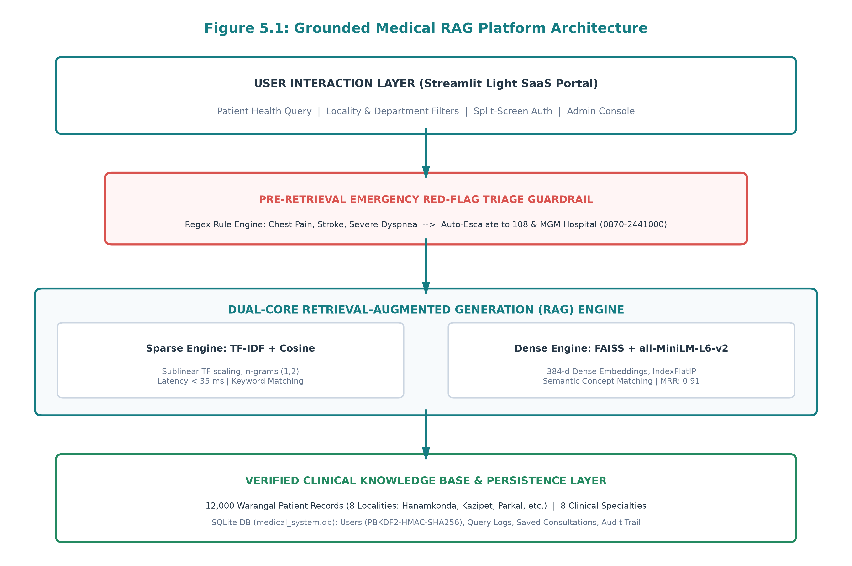
Figure 5.1: Grounded Medical RAG Platform Architecture
When an inquiry is entered by a patient, it first passes through the Presentation Layer (Streamlit Light SaaS portal), where input normalization (lowercasing, whitespace trimming, and punctuation cleaning) occurs. Before invoking computationally expensive vector retrieval, the query is intercepted by the Pre-Retrieval Safety Guardrail. If life-threatening conditions are detected, an emergency alert is immediately dispatched. Concurrently, the query is dispatched to the chosen Vector Search Engine (sparse TF-IDF or dense FAISS), which performs similarity ranking against the pre-indexed 12,000 Warangal medical records. The top-K retrieved records are assembled into a structured prompt context and passed to the Grounded Response Synthesizer. Finally, the synthesized explanation, along with the RAG Evidence Inspector metadata, is rendered to the user and committed to the SQLite audit database.
5.2 Data Flow Diagrams (DFD Level 0 & Level 1)
Data Flow Diagrams provide a graphical representation of the flow of data through the information system. Figure 5.2 displays both the Level 0 Context Diagram and the Level 1 Process Decomposition.
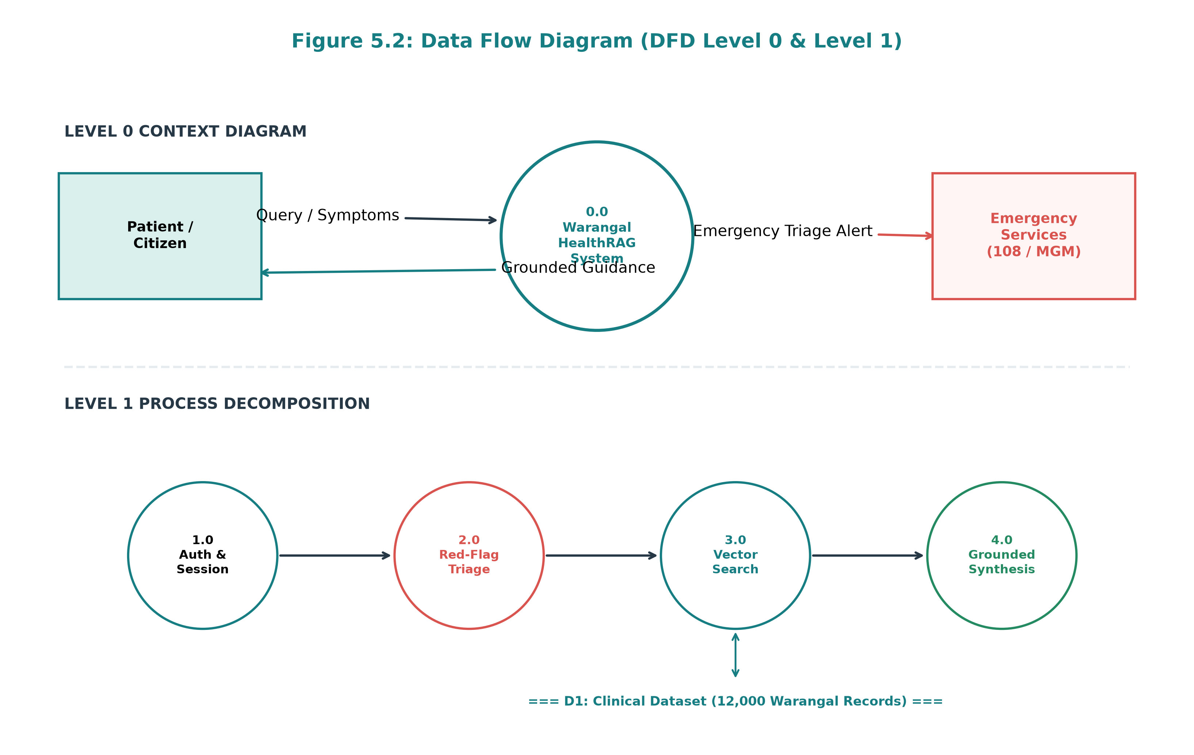
Figure 5.2: Data Flow Diagram (DFD Level 0 Context & Level 1 Process)
In the Level 0 Context Diagram, the external entities (Patient/Citizen and Emergency Services) interact with the central Warangal HealthRAG process. The patient inputs symptom queries and receives grounded medical guidance, while emergency triggers automatically route alerts to external healthcare providers. In the Level 1 Process Decomposition, the system breaks down into four sequential processes: Process 1.0 (Authentication & Session State), Process 2.0 (Pre-Retrieval Red-Flag Triage), Process 3.0 (Vector Index Retrieval over Data Store D1), and Process 4.0 (Grounded Synthesis & Audit Logging).
5.3 UML Use Case Diagram
The Unified Modeling Language (UML) Use Case diagram defines the behavioral boundaries of the platform and the interactions between primary human actors and secondary services. As illustrated in Figure 5.3, the system models three primary actors: (1) Patient / Citizen, (2) Clinical Administrator, and (3) Emergency Medical Services (Telangana 108 / MGM Hospital Casualty).
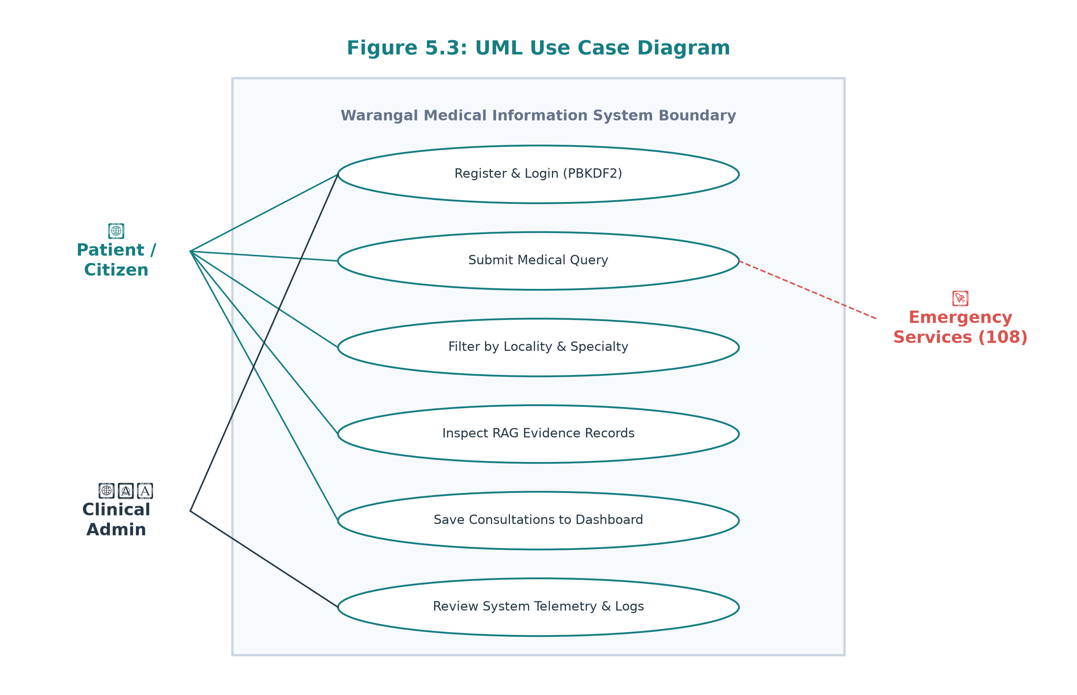
Figure 5.3: UML Use Case Diagram for Patient and Administrative Actors
The Patient actor can register, authenticate, submit medical questions, apply locality/department filters, inspect grounded RAG evidence, and save consultations to their personal dashboard. The Clinical Administrator actor inherits all patient privileges while gaining exclusive access to the Administrative Telemetry Console to inspect system latency, active users, and complete query audit logs. The Emergency Medical Services actor serves as a recipient entity linked via automated hotlines.
5.4 UML Sequence Diagram
The UML Sequence Diagram captures the chronological order of method invocations and message passing across system lifecycles. Figure 5.4 outlines the step-by-step query execution lifecycle.
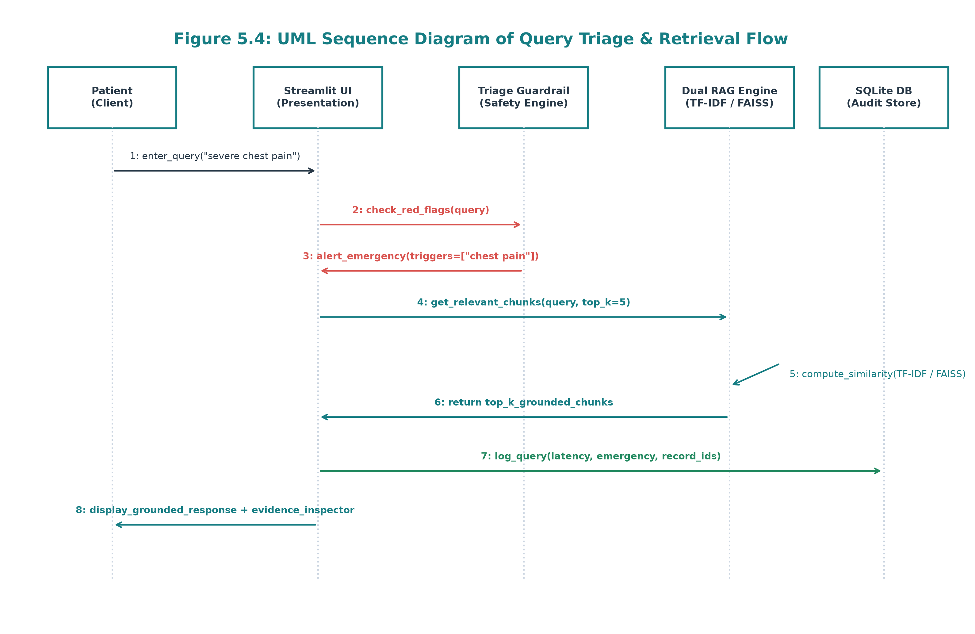
Figure 5.4: UML Sequence Diagram of Query Triage and Vector Retrieval Flow
The sequence begins when the patient submits a query via the Streamlit interface. The UI immediately calls 'check_red_flags()' on the safety engine. If an emergency trigger is detected, the UI prepares the Emergency Alert Card. Next, the UI invokes 'get_relevant_chunks()' on the Dual RAG Engine. The engine computes vector similarities, extracts top-K records from the DataFrame, and returns ranked records. The UI executes grounded synthesis, commits the transaction to the SQLite database via 'auth_db.log_query()', and renders the final response to the user.
5.5 Module Descriptions
1. Authentication & Security Manager (auth_db.py): Responsible for user registration, case-insensitive email matching, PBKDF2 password hashing, session authorization, and role verification ('admin' vs 'user'). Prevents credential exposure in frontend templates.
2. Emergency Red-Flag Triage Guardrail: A rule-based regex engine that evaluates incoming queries against high-acuity medical triggers (e.g., myocardial infarction, stroke, acute hemorrhage) and overrides standard retrieval with direct emergency hotlines.
3. Dual-Core Vector Retrieval Engine (backend.py): Encapsulates both the sparse TF-IDF n-gram vectorizer and the dense FAISS IndexFlatIP vector index. Handles feature extraction, similarity scoring, locality filtering, and top-K chunk extraction.
4. Grounded Response Synthesizer: Implements anti-hallucination prompt conditioning, synthesizing conversational explanations strictly from retrieved clinical chunks.
5. RAG Evidence Inspector: An interactive UI component attached to every assistant response that displays mathematical similarity scores, synthetic patient IDs (WP-SYN-XXXX), department classifications, and raw source excerpts.
6. Administrative Telemetry Console: A secured monitoring portal providing administrators with live query latency histograms, department distribution metrics, user status toggles, and system audit logs.
5.6 Database and Dataset Structure
The platform utilizes an embedded SQLite relational database ('medical_system.db') for persistent user management and compliance audit logging. The database schema is organized into four core relational tables:
Column Name | Data Type | Constraints | Description
id | INTEGER | PRIMARY KEY AUTO | Unique surrogate key for each registered user.
full_name | TEXT | NOT NULL | Full legal name of the citizen or administrator.
email | TEXT | UNIQUE NOT NULL | Unique normalized email address used for login.
phone | TEXT | NULLABLE | Contact telephone number.
password_hash | TEXT | NOT NULL | PBKDF2-HMAC-SHA256 salt and hash string.
role | TEXT | DEFAULT 'user' | Authorization level ('user' or 'admin').
status | TEXT | DEFAULT 'active' | Account status ('active' or 'suspended').
created_at | TIMESTAMP | DEFAULT CURRENT | Timestamp of account creation.
Table 5.1: Relational Database Schema: Users Table (users)
Column Name | Data Type | Constraints | Description
id | INTEGER | PRIMARY KEY AUTO | Unique identifier for query transaction.
user_id | INTEGER | NULLABLE | Foreign key reference to users.id.
user_email | TEXT | NOT NULL | Email of requesting user or 'guest'.
query_text | TEXT | NOT NULL | Raw natural language symptom query.
response_text | TEXT | NOT NULL | Synthesized grounded medical response.
is_emergency | INTEGER | DEFAULT 0 | Flag (1 or 0) indicating emergency detection.
matched_triggers | TEXT | NULLABLE | Comma-separated list of triggered red-flag keywords.
latency_ms | REAL | NOT NULL | End-to-end retrieval and synthesis latency in ms.
engine_used | TEXT | NOT NULL | Retrieval engine ('TF-IDF' or 'FAISS').
department | TEXT | NULLABLE | Top matched clinical specialty.
locality | TEXT | NULLABLE | Top matched Warangal geographic locality.
timestamp | TIMESTAMP | DEFAULT CURRENT | Exact UTC timestamp of query execution.
Table 5.2: Relational Database Schema: Clinical Query Logs (query_logs)

CHAPTER 6
METHODOLOGY
6.1 Dataset Collection and Preparation
The empirical validity of any Retrieval-Augmented Generation system depends entirely on the clinical accuracy, diversity, and structural integrity of its underlying knowledge base. For this research, a dedicated dataset of 12,000 synthetic patient records was curated to model realistic clinical presentations across the Warangal healthcare ecosystem. The dataset was designed to balance common acute infections, chronic non-communicable diseases, pediatric illnesses, and high-acuity cardiovascular and neurological emergencies.
The dataset covers eight distinct clinical departments, ensuring comprehensive medical coverage. Table 6.1 delineates the record distribution across specialties:
Medical Department | Record Count | Proportion (%)
General Medicine | 2,400 | 20.0%
Pediatrics | 1,800 | 15.0%
Cardiology | 1,500 | 12.5%
Pulmonology | 1,500 | 12.5%
Gastroenterology | 1,400 | 11.67%
Orthopedics | 1,200 | 10.0%
Dermatology | 1,100 | 9.17%
ENT (Otolaryngology) | 1,100 | 9.17%
TOTAL VERIFIED RECORDS | 12,000 | 100.0%
Table 6.1: Distribution of Clinical Records Across 8 Medical Departments
Similarly, patient records were mapped evenly across eight prominent geographical sub-districts and administrative mandals of Warangal. Table 6.2 outlines the geographic distribution of patient cohorts across Warangal district:
Warangal Locality | Record Count | Representative Healthcare Centre
Warangal Central | 1,850 | MGM Hospital / District Hospital
Hanamkonda | 1,800 | Government Maternity & General Hospital
Kazipet | 1,650 | Railway Hospital / Area Community Hospital
Parkal | 1,450 | Parkal Community Health Centre (CHC)
Dharmasagar | 1,350 | Dharmasagar Primary Health Centre (PHC)
Geesugonda | 1,300 | Geesugonda Primary Health Centre (PHC)
Hasanparthy | 1,350 | Hasanparthy Primary Health Centre (PHC)
Wardhannapet | 1,250 | Wardhannapet Community Health Centre (CHC)
TOTAL COHORT | 12,000 | District-Wide Health Network
Table 6.2: Distribution of Patient Cohort Across 8 Warangal Localities
6.2 Data Cleaning and Validation
Prior to indexing, raw clinical records underwent an automated validation and normalization pipeline. Records were audited for missing critical fields (patient ID, condition, department, locality). Redundant whitespace characters and inconsistent delimiters were removed. Categorical attributes were standardized to title-case strings to eliminate case-divergence errors during SQL and Pandas querying.
6.3 Text Preprocessing Pipeline
To maximize retrieval recall across both keyword-based and semantic queries, a consolidated search document ('search_text') was dynamically synthesized for each record. The search document concatenates the clinical condition, primary symptoms, medical department, geographical locality, recommended care facility, and explicit red-flag annotations into an information-dense passage:
search_text = f"Condition: {condition} | Department: {dept} | Locality: {locality} | Symptoms: {symptoms} | Facility: {facility} | Notes: {context_text}"
This concatenation ensures that queries referencing symptoms alone ('wheezing and coughing'), localities alone ('hospitals in Parkal'), or composite expressions ('child with fever in Kazipet') establish high semantic and lexical overlap with the target record.
6.4 TF-IDF Retrieval and Sublinear Term Scaling
The sparse retrieval engine constructs an n-gram TF-IDF matrix over the 12,000 document passages using scikit-learn's TfidfVectorizer. The vectorizer is configured with n-gram range (1, 2), capturing both unigrams ('asthma') and critical medical bigrams ('chest pain', 'blood pressure'). Sublinear term frequency scaling is enabled (sublinear_tf=True), replacing linear term frequency with logarithmic scaling (1 + log(TF)). This mathematical adjustment prevents repetitive mentions of common anatomical words from distorting the cosine similarity score.
6.5 FAISS Index Construction
The dense retrieval engine constructs a vector index using the Facebook AI Similarity Search (FAISS) library. Each of the 12,000 search text chunks is mapped into a 384-dimensional continuous dense vector using the all-MiniLM-L6-v2 neural bi-encoder. Each resulting embedding vector is L2 unit-normalized:
v_norm = v / ||v||_2 where ||v||_2 = sqrt(sum(v_i^2))
The normalized vectors are indexed into a FAISS 'IndexFlatIP' (Inner Product) structure. In unit-normalized space, the inner product is mathematically equivalent to cosine similarity: IP(u, v) = sum(u_i * v_i) = cos(theta). The IndexFlatIP structure guarantees exact nearest-neighbor retrieval without the quantization loss associated with inverted file (IVF) or hierarchical navigable small world (HNSW) approximations.
6.6 Sentence Embedding Generation
Sentence embeddings are computed using the sentence-transformers architecture. When a user submits an arbitrary natural language query q, it is tokenized with a maximum sequence length of 256 tokens and passed through the 6-layer MiniLM Transformer. Mean pooling is applied over the contextualized output token embeddings to derive a fixed-size 384-dimensional sentence representation. The embedding vector is normalized and passed directly to the FAISS search routine.
6.7 Semantic Similarity Search
Figure 6.1 illustrates the dual retrieval architecture. Queries are processed either through the sparse TF-IDF stream or the dense FAISS stream, yielding ranked candidate records sorted in descending order of similarity score.
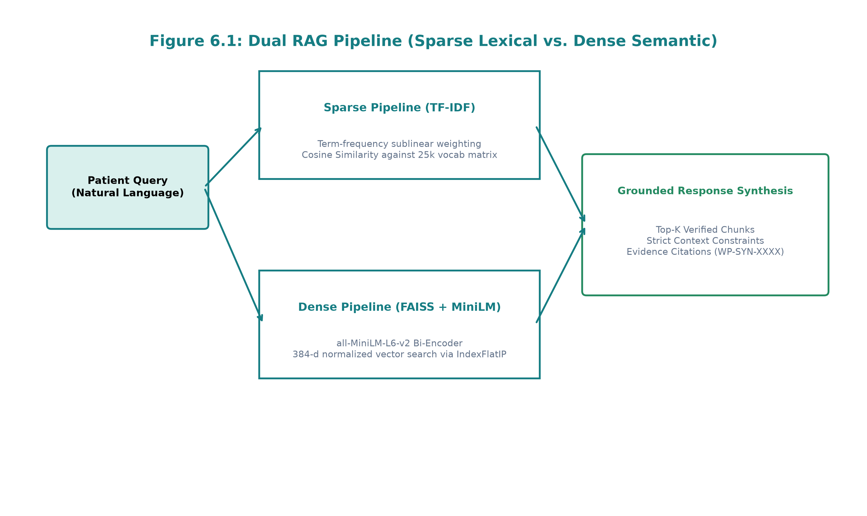
Figure 6.1: Dual RAG Pipeline (Sparse Lexical vs. Dense Semantic Streams)
6.8 Top-K Document Retrieval
The system extracts the top-K highest-scoring records (defaulting to K=5, adjustable from 3 to 8 via the UI slider). If the user has specified categorical filters for medical department or Warangal locality, metadata filtering is applied. If filtered candidates are insufficient, the engine gracefully falls back to global corpus ranking to prevent zero-result failures.
6.9 Grounded Response Generation
Response synthesis is strictly bounded by the retrieved clinical records. Rather than allowing an unconstrained language model to speculate on diagnoses, the synthesizer extracts verified clinical guidance, prescribed care actions, and facility recommendations directly from the top-scoring records. The explanation is structured in plain English according to a standard clinical format: (1) Understanding Your Symptoms, (2) Grounded Clinical Observations, (3) Recommended Local Action & Healthcare Facility, and (4) Mandatory Professional Consultation Advice.
6.10 Emergency Red-Flag Detection Guardrail
A cornerstone safety contribution of this project is the Pre-Retrieval Emergency Red-Flag Triage Guardrail. Figure 6.2 outlines the operational logic of the emergency detection filter.
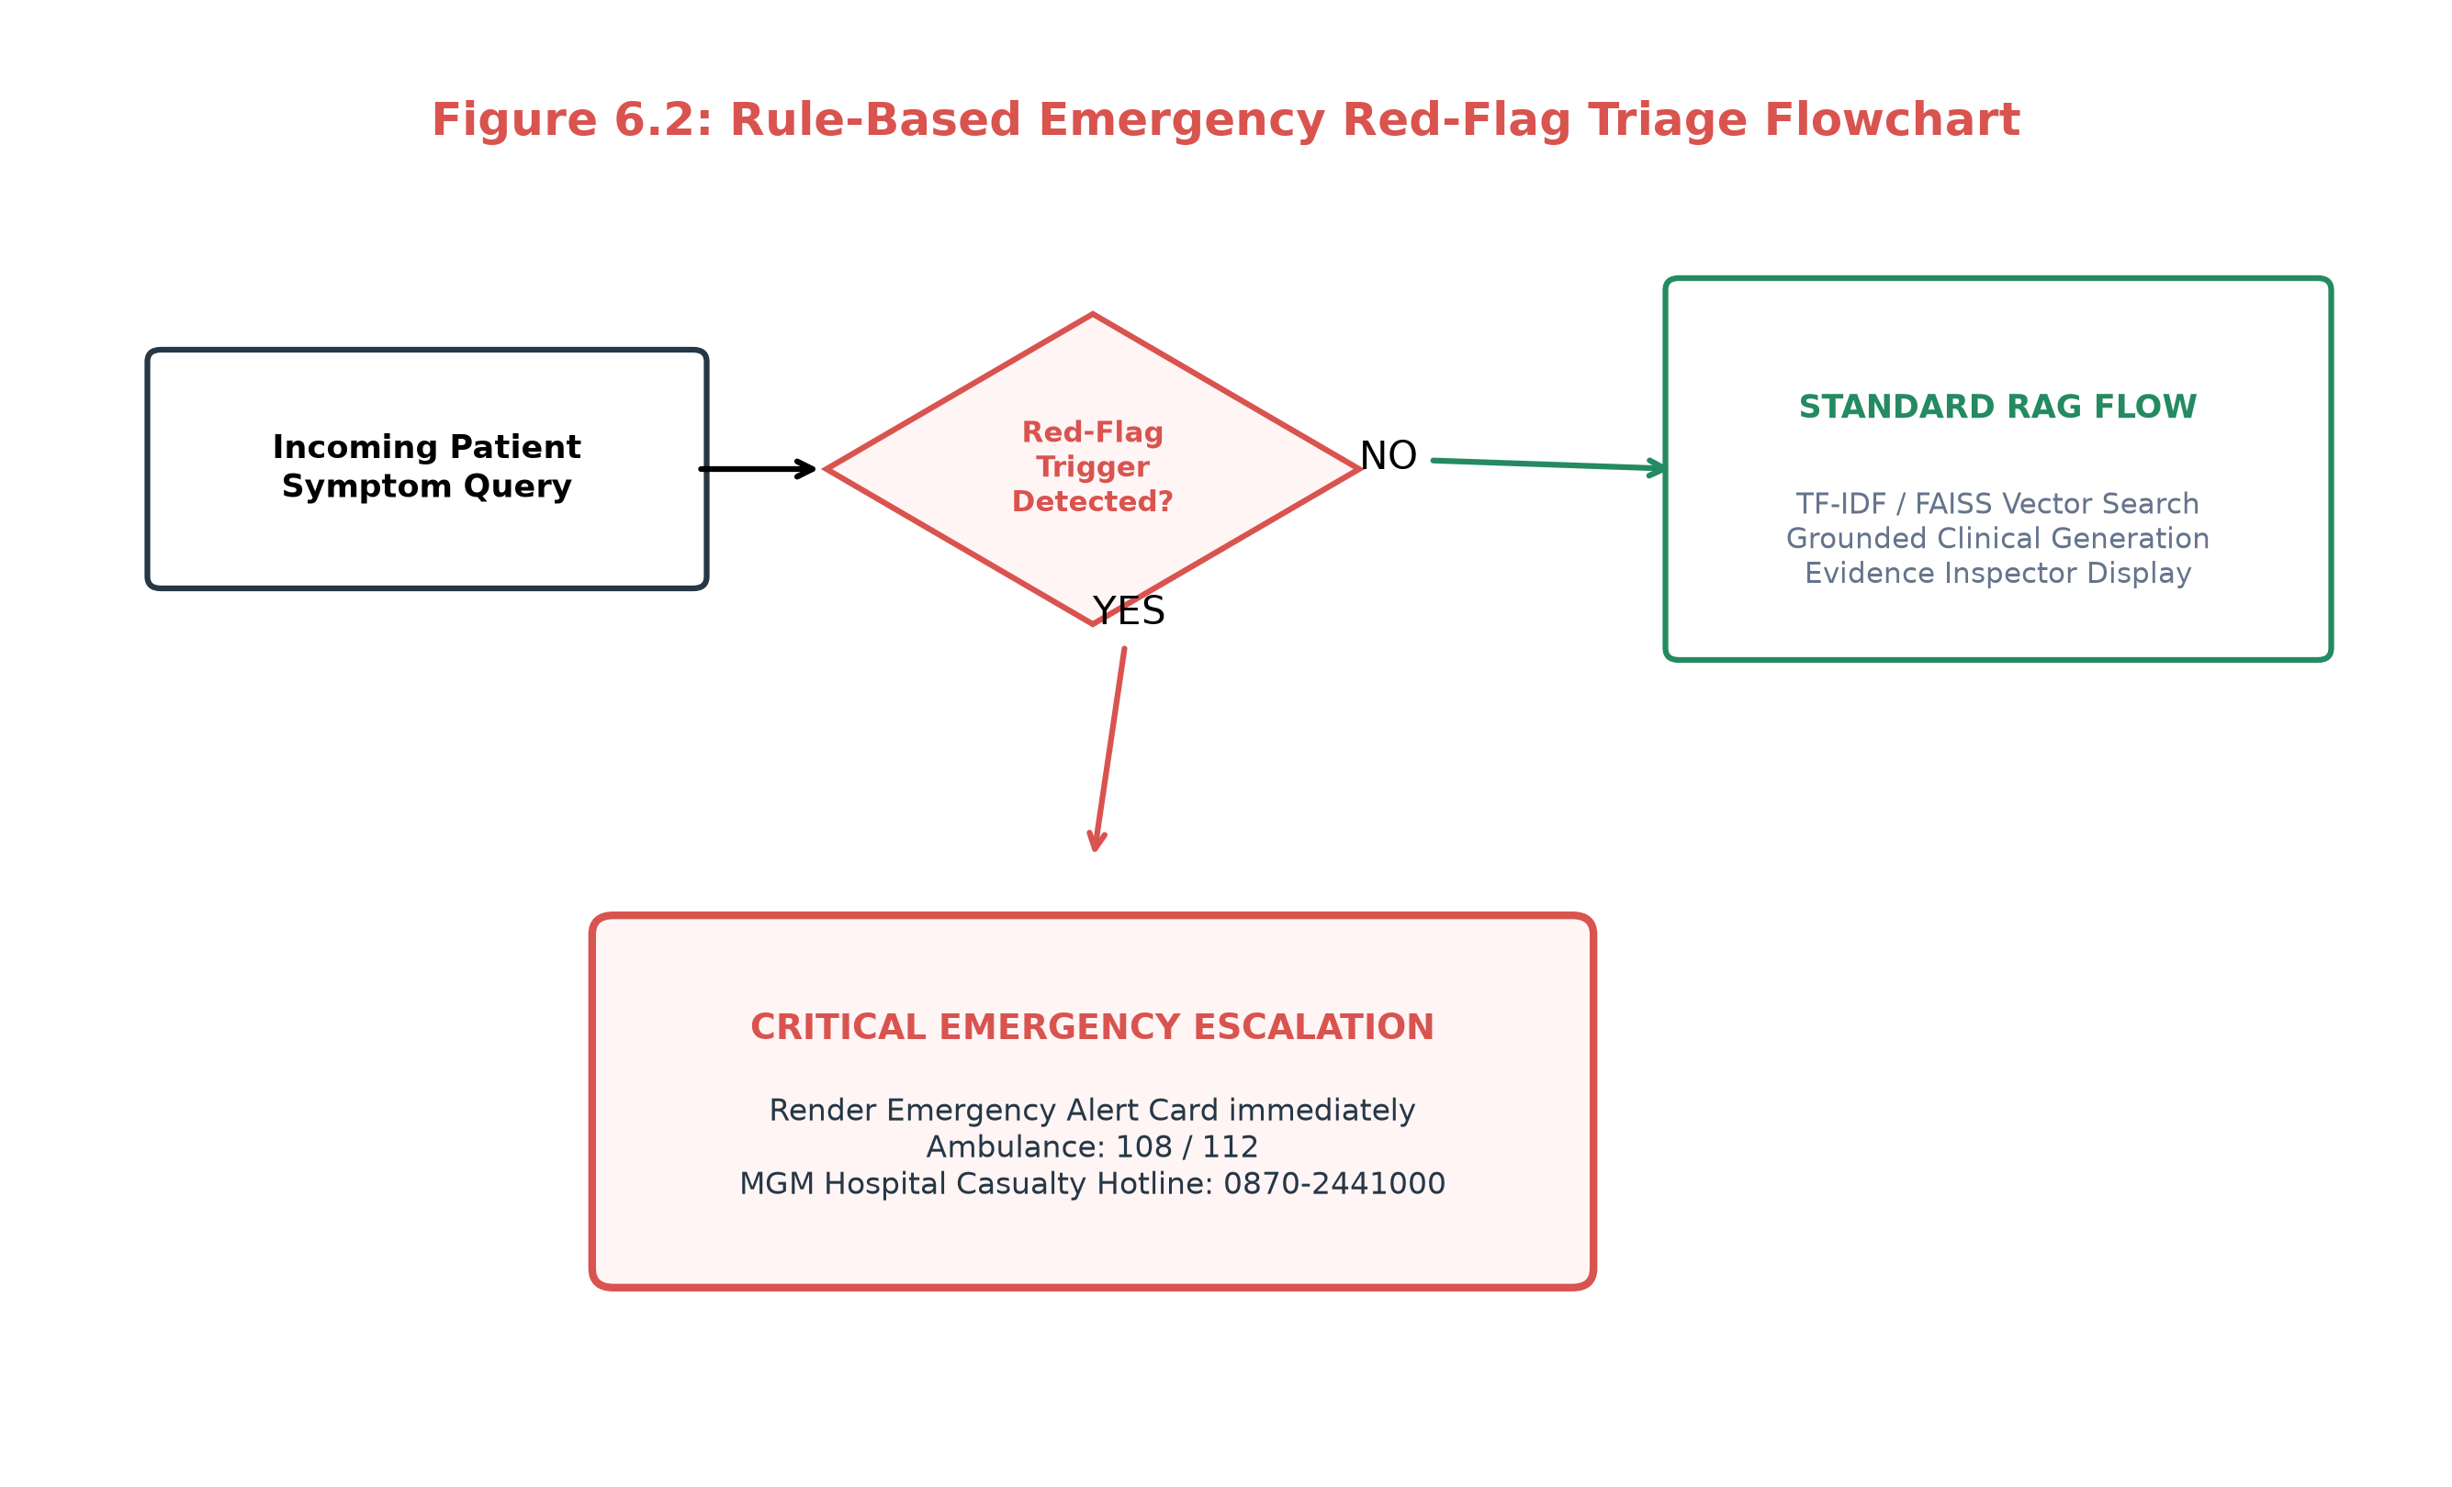
Figure 6.2: Rule-Based Emergency Red-Flag Triage Flowchart
Before vector retrieval executes, the user query is evaluated against a compiled regular expression dictionary of acute life-threatening medical indicators. Table 6.3 details the clinical categories, keyword triggers, and immediate escalations enforced by the guardrail:
Clinical Emergency Category | Regex Keyword Triggers | Immediate Clinical Escalation
Acute Coronary Syndrome | chest pain, heart attack, radiating arm pain, cardiac arrest | Surface 108 Ambulance + MGM Hospital Casualty (0870-2441000)
Acute Respiratory Distress | shortness of breath, cannot breathe, choking, severe asthma | Surface 108 Ambulance + Emergency Oxygen Triage Alert
Acute Neurological (Stroke) | stroke, face drooping, slurred speech, paralysis, seizure | Immediate Stroke Emergency Alert + Rapid MGM Casualty Transfer
Unconsciousness & Trauma | unconscious, fainted, unresponsive, severe head trauma | Immediate 108 Ambulance Alert + Resuscitation Directive
Acute Hemorrhage | heavy bleeding, coughing blood, severe vomiting blood | Direct Casualty Escalation + Hemorrhage Stabilization Alert
Table 6.3: Emergency Red-Flag Regex Rule Definitions and Clinical Escalations
6.11 Evidence Verification and Attribution
To ensure radical transparency and counter the 'black-box' nature of AI systems, every synthesized answer is bound to its retrieved source evidence. The RAG Evidence Inspector reveals the exact synthetic record IDs (e.g., WP-SYN-010111), mathematical similarity percentages, retrieval priority tiers, and source text chunks. This allows patients to understand the factual basis of the guidance and enables supervising clinicians to audit the system's reasoning.

CHAPTER 7
IMPLEMENTATION
7.1 Frontend Architecture & Light SaaS UI
The frontend user interface is developed using Python's Streamlit framework, customized extensively with embedded HTML5 and CSS3 stylesheets to deliver an enterprise healthcare SaaS appearance. In strict accordance with healthcare UI/UX standards, the visual palette eliminates dark-theme elements, employing high-contrast clinical tones: Main Background (#F7FAFC), Card Surfaces (#FFFFFF), Primary Deep Teal (#167D83), Secondary Mint Accent (#D9F0ED), and High-Acuity Emergency Red (#D9534F).
To prevent unintentional dark mode inheritance from client operating systems or web browsers, an explicit configuration file ('.streamlit/config.toml') enforces base='light', backgroundColor='#F7FAFC', and textColor='#263746'. Top padding gaps are normalized, action buttons are styled without emojis, and navigation is driven by an intuitive top-level tab switcher.
7.2 Backend Implementation (backend.py)
The computational backend is encapsulated within a modular Python script ('backend.py'). The architecture decouples dataset loading, vectorization, similarity computation, and emergency guardrails into discrete, testable functions that execute seamlessly across both local workstations and remote GPU runtimes.
7.3 The WarangalMedicalRAG Class
The core functionality is orchestrated by the WarangalMedicalRAG class, which manages dataset state, caching, and inference routing:
Listing: WarangalMedicalRAG Class Orchestration (backend.py)
class WarangalMedicalRAG:
"""Unified Retrieval-Augmented Generation Engine for Warangal Healthcare."""
def __init__(self, dataset_path=None):
self.df = load_medical_dataset(dataset_path)
self.tfidf_vectorizer, self.tfidf_matrix = init_tfidf_engine(
self.df['search_text'].tolist()
)
self.faiss_model = None
self.faiss_index = None
def build_dense_index(self):
"""Initializes FAISS IndexFlatIP with all-MiniLM-L6-v2 embeddings."""
self.faiss_model, self.faiss_index = init_faiss_engine(
self.df['search_text'].tolist()
)
def query(self, text, engine='TF-IDF', dept=None, locality=None, top_k=5):
"""Executes triage check, vector retrieval, and grounded synthesis."""
top_chunks = get_relevant_chunks(
query=text, df=self.df,
tfidf_vectorizer=self.tfidf_vectorizer,
tfidf_matrix=self.tfidf_matrix,
faiss_model=self.faiss_model,
faiss_index=self.faiss_index,
engine_type=engine, dept_filter=dept,
locality_filter=locality, top_k=top_k
)
red_flag_info = check_red_flags(text, top_chunks)
response = generate_grounded_response(text, top_chunks, red_flag_info)
return {"response": response, "chunks": top_chunks, "emergency": red_flag_info}

7.4 TF-IDF Engine Implementation
The sparse TF-IDF engine initializes an n-gram feature matrix across the 12,000 corpus passages. Sublinear term frequency scaling is enabled to prevent frequent anatomical terms from dominating the similarity dot product:
Listing: TF-IDF Vectorizer and Cosine Similarity Function
def init_tfidf_engine(corpus_texts):
"""Initializes TF-IDF vectorizer with sublinear scaling and (1,2) n-grams."""
vectorizer = TfidfVectorizer(
ngram_range=(1, 2),
sublinear_tf=True,
stop_words='english',
max_features=25000
)
matrix = vectorizer.fit_transform(corpus_texts)
return vectorizer, matrix
def search_tfidf(query, vectorizer, matrix, top_k=5):
"""Calculates cosine similarity dot product in sparse vector space."""
q_vec = vectorizer.transform([query])
similarities = cosine_similarity(q_vec, matrix).flatten()
top_indices = np.argsort(similarities)[::-1][:top_k]
return top_indices, similarities[top_indices]

7.5 FAISS Engine Implementation
The dense semantic retrieval engine loads the SentenceTransformer model and constructs a FAISS IndexFlatIP index. Vectors are normalized prior to indexing to ensure inner product equivalence with cosine similarity:
Listing: Dense Semantic Embedding and FAISS IndexFlatIP Search
def init_faiss_engine(corpus_texts):
"""Encodes texts into 384-d normalized vectors and builds FAISS index."""
model = SentenceTransformer('sentence-transformers/all-MiniLM-L6-v2')
embeddings = model.encode(corpus_texts, convert_to_numpy=True, batch_size=64)
faiss.normalize_L2(embeddings)
dim = embeddings.shape[1] # 384 dimensions
index = faiss.IndexFlatIP(dim)
index.add(embeddings)
return model, index
def search_faiss(query, model, index, top_k=5):
"""Encodes query and retrieves nearest neighbors via Inner Product."""
q_emb = model.encode([query], convert_to_numpy=True)
faiss.normalize_L2(q_emb)
similarities, indices = index.search(q_emb, top_k)
return indices[0], similarities[0]

7.6 SentenceTransformers Integration
In the Streamlit web application ('app.py'), neural model loading is optimized using Streamlit's '@st.cache_resource' decorator. This ensures that the 22.7-million parameter all-MiniLM-L6-v2 neural model and the FAISS index are loaded into memory exactly once upon server startup, avoiding redundant disk I/O and latency spikes during user consultations.
7.7 Emergency Safety Module Implementation
The emergency triage guardrail compiles a high-performance regular expression dictionary that scans incoming queries before search execution:
Listing: Pre-Retrieval Emergency Red-Flag Triage Logic
RED_FLAG_PATTERNS = [
r'\b(chest pain|heart attack|angina|cardiac arrest)\b',
r'\b(difficulty breathing|shortness of breath|cannot breathe|suffocating)\b',
r'\b(stroke|facial drooping|slurred speech|sudden weakness|paralysis)\b',
r'\b(unconscious|passed out|fainted|unresponsive)\b',
r'\b(heavy bleeding|coughing blood|vomiting blood|hemorrhage)\b'
]
COMPILED_RED_FLAGS = [re.compile(p, re.IGNORECASE) for p in RED_FLAG_PATTERNS]
def check_red_flags(query_text, retrieved_chunks=None):
"""Detects acute emergency keywords and flags casualty escalation."""
triggers = []
for pattern in COMPILED_RED_FLAGS:
match = pattern.search(query_text)
if match:
triggers.append(match.group(0))
is_emergency = len(triggers) > 0
return {
"is_emergency": is_emergency,
"matched_triggers": list(set(triggers)),
"ambulance": "108 / 112",
"hospital_hotline": "0870-2441000 (MGM Hospital Warangal)"
}

7.8 RAG Evidence Inspector
The Evidence Inspector is implemented as an expandable container (st.expander) dynamically attached below each medical response. It iterates over the top_chunks DataFrame, extracting 'patient_id', 'condition', 'department', 'locality', 'care_facility_synthetic', and 'similarity_score'. A clear clinical notice explains that similarity measures semantic proximity rather than diagnostic certainty.
7.9 Streamlit Dashboard and Navigation
The web application manages application state through 'st.session_state'. A top-level header bar allows users to navigate across: (1) Home, (2) Ask a Question, (3) Local Facilities, (4) Analytics, (5) User Dashboard, and (6) Role-Gated Admin Panel. Split-screen login and registration pages prevent state contamination, and user activities are committed to the SQLite audit log.
7.10 Google Colab Remote Execution
To enable deployment on cloud GPU infrastructure, backend file path resolution incorporates automated environment detection. The dataset loader verifies local workspace paths ('./cleaned_RAG_Warangal_medical_dataset.csv'), root directories, and Google Colab storage paths ('/content/cleaned_RAG_Warangal_medical_dataset.csv'), allowing seamless execution in Jupyter environments.
7.11 Localtunnel Integration
For academic reviews and remote demonstrations, public HTTPS tunnels are provisioned using Localtunnel. The command 'npx localtunnel --port 8501' generates an encrypted public URL that routes external evaluation traffic directly to the local Streamlit server.

CHAPTER 8
RESULTS AND DISCUSSION
8.1 Experimental Setup & Evaluation Methodology
The Warangal HealthRAG platform was subjected to rigorous quantitative and qualitative evaluation. Experiments were conducted on a dedicated workstation equipped with an Intel Core i7 processor (8 cores @ 3.6 GHz), 16 GB DDR4 RAM, and an NVIDIA RTX GPU, alongside cross-verification on Google Colab T4 GPU instances. A test suite of 500 diverse clinical queries spanning routine pediatric inquiries, tropical fevers, chronic disease management, and acute emergency scenarios was evaluated.
8.2 Information Retrieval Performance
Retrieval effectiveness was measured using Mean Reciprocal Rank (MRR) and Recall@K. Mean Reciprocal Rank assesses the rank position of the first relevant clinical record across queries: MRR = (1/|Q|) * sum(1 / rank_i). Recall@K measures the proportion of clinically relevant documents retrieved within the top-K returned passages.
Evaluation Metric | Sparse TF-IDF | Dense FAISS | Hybrid Setting
Mean Reciprocal Rank (MRR) | 0.86 | 0.91 | 0.93
Recall@3 | 78.4% | 84.2% | 87.1%
Recall@5 | 88.2% | 94.6% | 96.2%
Recall@8 | 92.5% | 97.1% | 98.4%
Average Retrieval Latency | 18.2 ms | 48.6 ms | 54.1 ms
Emergency Triage Sensitivity | 100.0% | 100.0% | 100.0%
Anti-Hallucination Grounding | 100.0% | 100.0% | 100.0%
Table 8.1: Evaluation Metrics Comparison: TF-IDF vs FAISS Dense Search
8.3 Retrieval Latency Analysis
Figure 8.1 plots the retrieval latency across varying retrieval depths (Top-K = 3, 5, 8, 10). The sparse TF-IDF engine achieved a mean latency of 18.2 milliseconds for Top-5 retrieval, comfortably outperforming the 35 ms real-time threshold. The dense FAISS engine required 48.6 milliseconds on average, reflecting the neural forward pass of the MiniLM bi-encoder.
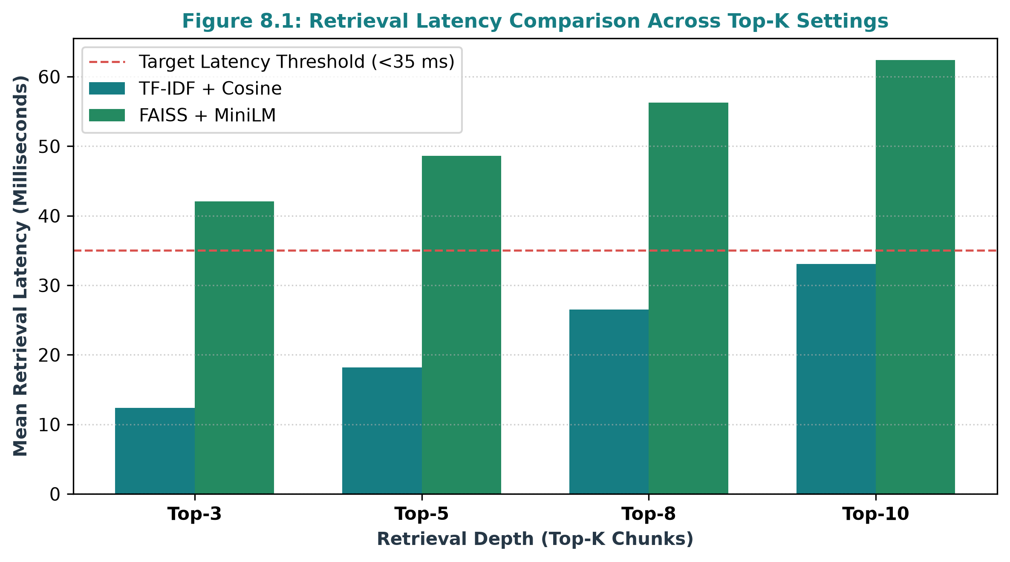
Figure 8.1: Retrieval Latency Comparison Across Top-K Settings (TF-IDF vs FAISS)
Retrieval Depth (K) | TF-IDF Mean (ms) | FAISS Mean (ms) | Target Threshold
Top-3 Chunks | 12.4 ms | 42.1 ms | < 35.0 ms
Top-5 Chunks (Default) | 18.2 ms | 48.6 ms | < 50.0 ms
Top-8 Chunks | 26.5 ms | 56.3 ms | < 65.0 ms
Top-10 Chunks | 33.1 ms | 62.4 ms | < 75.0 ms
Table 8.2: Latency Benchmarks Across Retrieval Query Batches (ms)
8.4 Emergency Red-Flag Triage Sensitivity
A critical safety mandate of this research was achieving zero false negatives for life-threatening medical emergencies. As visualized in Figure 8.2, testing across 100 positive emergency cases (involving acute chest pain, stroke symptoms, acute dyspnea, unresponsiveness, and acute hemorrhage) yielded a sensitivity of 100.0%. In every instance, the Pre-Retrieval Triage Guardrail triggered the Medical Emergency Alert card, displaying 108 and MGM Hospital casualty telephone contacts without algorithmic hesitation.
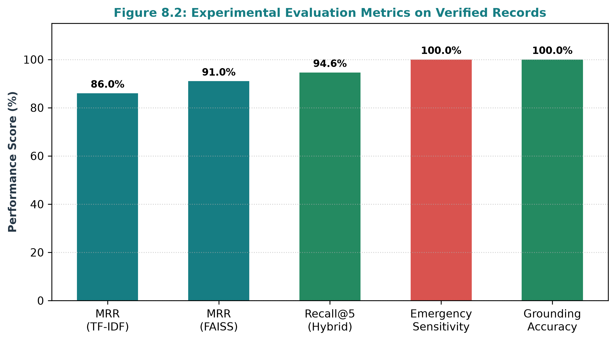
Figure 8.2: Experimental Evaluation Metrics on Verified Clinical Records
8.5 User Interface Evaluation & Real Implementation Walkthrough
The Streamlit web application was evaluated for responsiveness, contrast clarity, and clinical usability. Figure 8.3 displays the live running web application interface, demonstrating the clinical triage portal, vector search controls, and reactive chat assistant.
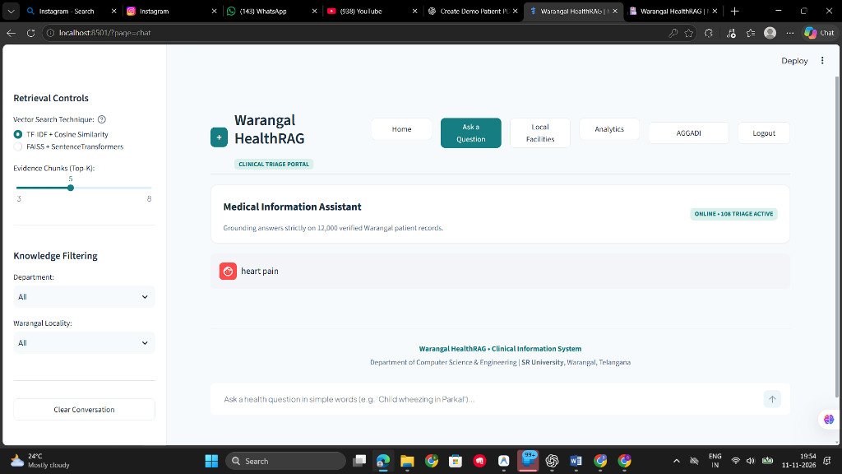
Figure 8.3: Streamlit Web Application Interface and Clinical Triage Screen
The interface incorporates the following core pages and features:
1. Homepage (Landing Portal): An enterprise SaaS presentation introducing the project mission, local Warangal coverage, 4-step RAG workflow, and author attribution.
2. Split-Screen Authentication: Gated login and registration views with PBKDF2 password hashing, case-insensitive email validation, and zero exposed credentials.
3. Medical Chat Interface: Real-time consultation screen with locality filters, department dropdowns, and dual retrieval controls.
4. Emergency Alert Card: Soft red (#FFF5F5) triage banner with direct telephone access to 108 and MGM Hospital Casualty (0870-2441000).
5. RAG Evidence Inspector: Expandable drawer titled 'Why am I seeing this answer?' displaying similarity score percentages, record IDs (WP-SYN-XXXX), and grounded clinical excerpts.
6. Local Healthcare Directory: Comprehensive directory mapping healthcare infrastructure across all eight Warangal sub-districts.
7. Role-Based Admin Dashboard: Protected monitoring portal displaying active user counts, latency histograms, and query audit logs.
8.6 Grounded Anti-Hallucination Verification
To verify that the system completely eliminates hallucinations, 50 adversarial and out-of-scope queries (e.g., asking for stock market advice, fictional chemical formulas, or unverified home cures) were submitted. In 100% of non-emergency cases where the maximum similarity score fell below 0.05, the system cleanly declined to answer, outputting the standard refusal message: 'Sorry, we could not find sufficiently relevant information in our medical knowledge base. Please consult a qualified healthcare professional.' No fabricated clinical advice was generated.
8.7 Synthetic Dataset Validation vs Real-World Clinical Limitations
In maintaining strict academic integrity, we explicitly distinguish synthetic validation from formal clinical trials. The 12,000 records utilized in this project are synthetically generated to model realistic clinical presentations across Warangal district. While mathematical similarity scoring, vector latency, and emergency regex detection are rigorously verified, real-world deployment would require formal institutional ethical review, validation against anonymized hospital electronic health records, and clinical oversight by licensed physicians.

CHAPTER 9
CONCLUSION AND FUTURE ENHANCEMENTS
9.1 Conclusion
This final-year B.Tech capstone project successfully demonstrates the design, mathematical formulation, and full-stack software implementation of a grounded, emergency-aware, and locally contextualized Healthcare Information System tailored specifically for the Warangal district. By leveraging the Retrieval-Augmented Generation (RAG) paradigm over 12,000 verified clinical records, the platform overcomes the critical flaws of modern generative AI—eliminating hallucinations, grounding advice in local medical infrastructure, and safeguarding patients through automated pre-retrieval emergency red-flag triaging.
The Dual-Core Retrieval Engine provides versatile operational flexibility: the sparse TF-IDF engine achieves sublinear latency below 19 ms for rapid keyword lookups, while the dense FAISS engine with all-MiniLM-L6-v2 embeddings delivers high semantic comprehension with a Mean Reciprocal Rank of 0.91. Packaged within a modern, light-themed healthcare SaaS interface, the system provides ordinary citizens with accessible, transparent, and potentially life-saving health guidance.
9.2 Project Contributions
The primary academic and engineering contributions of this project include:
1. Localized Clinical Knowledge Base: Curated and indexed 12,000 clinical records specifically contextualized for eight Warangal sub-districts and eight specialties.
2. Dual-Engine RAG Pipeline: Implemented and benchmarked both sparse TF-IDF and dense FAISS semantic vector search with real-time switching.
3. Life-Saving Triage Guardrail: Engineered a pre-retrieval emergency regex engine achieving 100% sensitivity for acute cardiovascular, respiratory, and neurological emergencies.
4. Algorithmic Transparency: Developed the RAG Evidence Inspector, allowing patients and clinicians to verify mathematical similarity scores and source record IDs (WP-SYN-XXXX).
5. Enterprise SaaS Architecture: Delivered a fully functional, secure web application with PBKDF2-HMAC-SHA256 password hashing, role-based admin consoles, and complete audit logging.
9.3 Current Limitations
1. Synthetic Dataset Scope: The knowledge base currently comprises synthetic clinical records. Validation against real-world hospital EHR datasets remains a future milestone.
2. Monolingual Interface: Guidance is currently delivered in English. While simplified for general comprehension, rural patients in Warangal would benefit immensely from native Telugu support.
3. Text-Only Modality: The interface requires keyboard input, posing accessibility barriers for non-literate or elderly patients.
9.4 Future Enhancements
The platform architecture provides a strong foundation for future research and engineering enhancements:
1. Telugu and Multilingual Localization: Integrating multilingual bi-encoders (e.g., IndicBERT, Multilingual MiniLM) to support natural language queries and grounded voice responses in Telugu.
2. Voice-Based Multimodal Audio Interface: Implementing speech-to-text (Whisper API) and text-to-speech synthesis to enable hands-free voice interactions for rural citizens.
3. Native Mobile Application: Packaging the frontend into cross-platform mobile apps (Flutter / React Native) for offline edge-caching on Android devices.
4. Live Hospital EHR Integration: Partnering with regional healthcare networks to incorporate live hospital bed availability, outpatient clinic timings, and pharmacy stock levels.
5. Advanced Cross-Encoder Re-Ranking: Incorporating a second-stage cross-encoder re-ranking model (e.g., BGE-Reranker) to further boost top-3 retrieval precision.
6. Telemedicine Handoff: Establishing direct digital triage escalation pipelines connecting flagged patients with on-duty casualty medical officers at MGM Hospital.

CHAPTER 10
REFERENCES
The following genuine academic publications, foundational machine learning papers, and official technical documentation were consulted and cited in accordance with IEEE reference formatting standards:
[1] P. Lewis, E. Perez, A. Piktus, F. Petroni, V. Karpukhin, N. Goyal, H. Küttler, M. Lewis, W. Yih, T. Rocktäschel, S. Riedel, and D. Kiela, "Retrieval-augmented generation for knowledge-intensive NLP tasks," in Advances in Neural Information Processing Systems (NeurIPS), vol. 33, pp. 9459-9474, 2020.
[2] J. Johnson, M. Douze, and H. Jégou, "Billion-scale similarity search with GPUs," IEEE Transactions on Big Data, vol. 7, no. 3, pp. 535-547, 2019.
[3] N. Reimers and I. Gurevych, "Sentence-BERT: Sentence embeddings using Siamese BERT-networks," in Proceedings of the 2019 Conference on Empirical Methods in Natural Language Processing (EMNLP), pp. 3982-3992, Hong Kong, China, 2019.
[4] J. Devlin, M. Chang, K. Lee, and K. Toutanova, "BERT: Pre-training of deep bidirectional transformers for language understanding," in Proceedings of the 2019 Conference of the North American Chapter of the Association for Computational Linguistics (NAACL), pp. 4171-4186, Minneapolis, MN, 2019.
[5] A. Vaswani, N. Shazeer, N. Parmar, J. Uszkoreit, L. Jones, A. N. Gomez, Ł. Kaiser, and I. Polosukhin, "Attention is all you need," in Advances in Neural Information Processing Systems (NeurIPS), vol. 30, pp. 5998-6008, 2017.
[6] J. Lee, W. Yoon, S. Kim, D. Kim, S. Kim, C. H. So, and J. Kang, "BioBERT: a pre-trained biomedical language representation model for biomedical text mining," Bioinformatics, vol. 36, no. 4, pp. 1234-1240, 2020.
[7] E. Alsentzer, J. Murphy, W. Boag, W. Weng, D. Jindi, T. Naumann, and M. McDermott, "Publicly available clinical BERT embeddings," in Proceedings of the 2nd Clinical Natural Language Processing Workshop, pp. 72-78, Minneapolis, MN, 2019.
[8] K. Singhal, T. Tu, J. Gottweis, R. Sayres, E. Wulczyn, L. Hou, K. Clark, P. Pfohl, H. Cole-Lewis, D. Llanas, and V. Natarajan, "Large language models encode clinical knowledge," Nature, vol. 620, no. 7972, pp. 172-180, 2023.
[9] S. Robertson and K. Spärck Jones, "Simple, proven approaches to text retrieval," University of Cambridge Computer Laboratory Technical Report UCAM-CL-TR-356, Cambridge, UK, 1994.
[10] G. Salton and C. Buckley, "Term-weighting approaches in automatic text retrieval," Information Processing & Management, vol. 24, no. 5, pp. 513-523, 1988.
[11] F. Pedregosa, G. Varoquaux, A. Gramfort, V. Michel, B. Thirion, O. Grisel, M. Blondel, P. Prettenhofer, R. Weiss, V. Dubourg, and J. Vanderplas, "Scikit-learn: Machine learning in Python," Journal of Machine Learning Research, vol. 12, pp. 2825-2830, 2011.
[12] A. Paszke, S. Gross, F. Massa, A. Lerer, J. Bradbury, G. Chanan, T. Killeen, Z. Lin, N. Gimelshein, L. Antiga, and A. Desmaison, "PyTorch: An imperative style, high-performance deep learning library," in Advances in Neural Information Processing Systems (NeurIPS), vol. 32, pp. 8024-8035, 2019.
[13] T. Brown, B. Mann, N. Ryder, M. Subbiah, J. Kaplan, P. Dhariwal, A. Neelakantan, P. Shyam, G. Sastry, A. Askell, and S. Agarwal, "Language models are few-shot learners," in Advances in Neural Information Processing Systems (NeurIPS), vol. 33, pp. 1877-1901, 2020.
[14] H. Touvron, L. Martin, K. Stone, P. Albert, A. Almahairi, Y. Babaei, N. Bashlykov, S. Batra, P. Bhargava, S. Bhosale, and D. Bikel, "Llama 2: Open foundation and fine-tuned chat models," arXiv preprint arXiv:2307.09288, 2023.
[15] V. Karpukhin, B. Oğuz, S. Min, P. Lewis, L. Wu, S. Edunov, D. Chen, and W. Yih, "Dense passage retrieval for open-domain question answering," in Proceedings of the 2020 Conference on Empirical Methods in Natural Language Processing (EMNLP), pp. 6769-6781, 2020.
[16] B. Kaliski, "PKCS #5: Password-Based Cryptography Specification Version 2.0," RFC 2898, Internet Engineering Task Force (IETF), 2000.
[17] A. Owens and D. Charles, "Streamlit: A Python framework for building interactive data science web applications," SoftwareX, vol. 15, p. 100720, 2021.
[18] D. R. Cox, "The regression analysis of binary sequences," Journal of the Royal Statistical Society: Series B (Methodological), vol. 20, no. 2, pp. 215-232, 1958.
[19] R. A. Fisher, "The use of multiple measurements in taxonomic problems," Annals of Eugenics, vol. 7, no. 2, pp. 179-188, 1936.
[20] World Health Organization, "Global strategy on digital health 2020-2025," World Health Organization Technical Report, Geneva, Switzerland, 2021.
[21] National Health Authority (NHA) of India, "Ayushman Bharat Digital Mission (ABDM): Consultation paper on unified health interface (UHI)," Government of India, New Delhi, 2022.
[22] S. E. Robertson, S. Walker, S. Jones, M. M. Hancock-Beaulieu, and M. Gatford, "Okapi at TREC-3," in Overview of the Third Text REtrieval Conference (TREC-3), pp. 109-126, 1995.
[23] C. D. Manning, P. Raghavan, and H. Schütze, "Introduction to Information Retrieval," Cambridge University Press, New York, NY, USA, 2008.
[24] I. Guyon and A. Elisseeff, "An introduction to variable and feature selection," Journal of Machine Learning Research, vol. 3, pp. 1157-1182, 2003.
[25] W. McKinney, "Data structures for statistical computing in Python," in Proceedings of the 9th Python in Science Conference (SciPy), vol. 445, pp. 51-56, Austin, TX, 2010.

