LAB – 3.4

Task 1: Zero-shot Prompt – Fibonacci Series Generator

Task Description #1
• Without providing any example, write a single comment prompt asking GitHub Copilot to generate a Java function that prints the first N Fibonacci numbers.

Prompt used:
// generate a Java program to print the first n fibonacci numbers
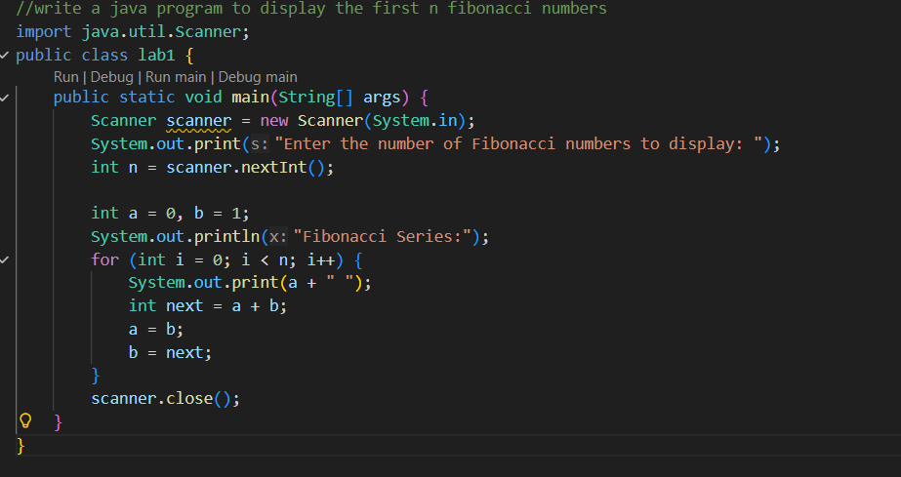

Sample output:
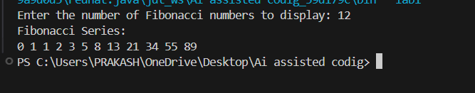

Task 2: One-shot Prompt – List Reversal Function

Task Description #2
• Write a comment prompt to reverse a list and give one example below the comment to guide Copilot.

Prompt used:
// generate a Java program to reverse a list using a loop with user input
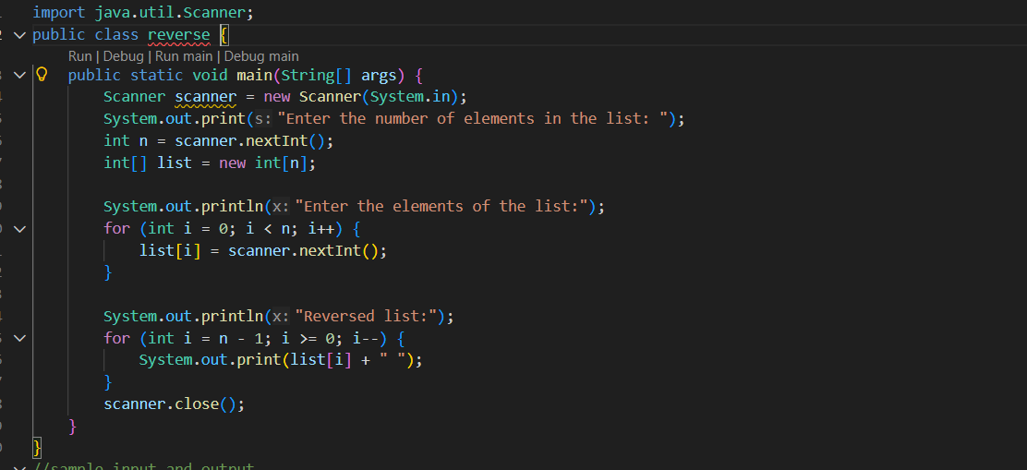

Sample output:
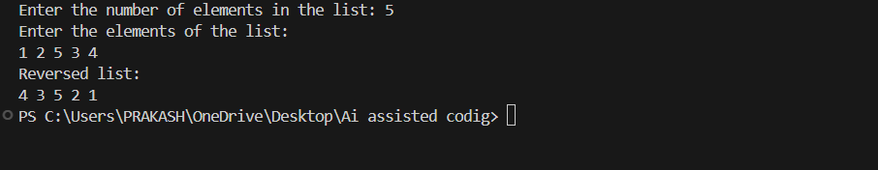

Task 3: Few-shot Prompt – String Pattern Matching

Task Description #3
• Write a comment along with 2–3 examples to help Copilot understand how to check whether a string starts with a capital letter and ends with a period.

Prompt used:
// generate a Java program to check if a string starts with a capital letter and ends with a period. Output should be boolean
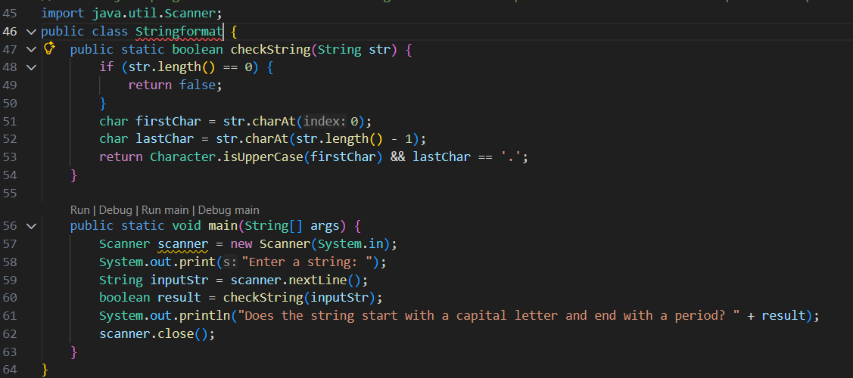

Sample output:
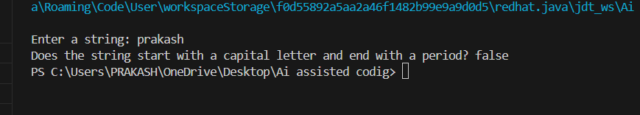

Task 4: Zero-shot vs Few-shot – Email Validator

Task Description #4
• First, prompt Copilot to create an email validation function using a zero-shot prompt.
• Then, rewrite the same prompt using few-shot examples.

Prompt used:
// generate a Java program to write an email validation function
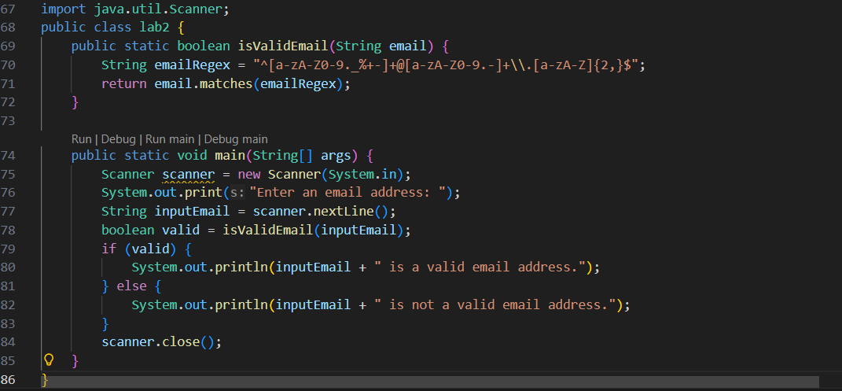
Sample output:
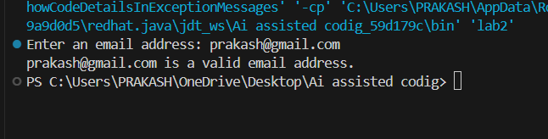

Task 5: Prompt Tuning – Summing Digits of a Number

Task Description #5
• Try two different prompt styles to generate a function that returns the sum of digits of a number.

Prompt used:
// generate a Java program that returns the sum of digits of a number
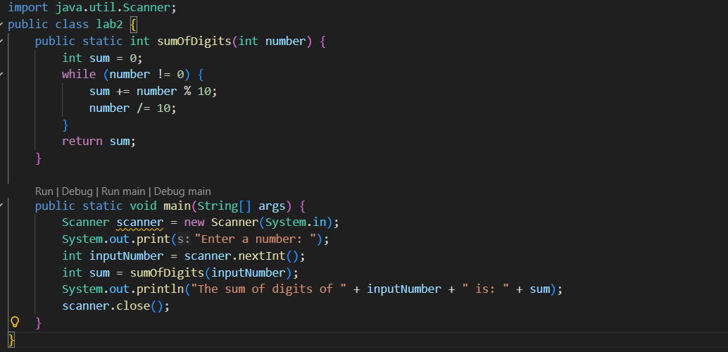
Sample output:
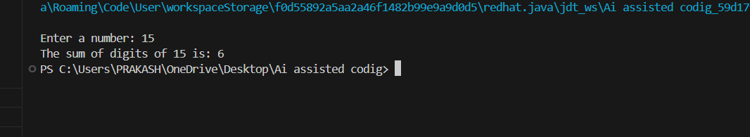

Scenario Based:

// generate a Java program that helps a cashier in preparing customer bills.
// The program should take the customer name, items purchased, and price of each item.
// It should calculate the total bill and apply discounts (higher discount for higher total, lower discount for smaller total).
// Example: if almonds cost 1200 per kg and the customer buys only 500 grams, the price must be calculated accordingly.
// The program should accept quantity in grams and price per kg.
// Example: if a colgate costs 120 and the customer buys 2 tubes, the total should be calculated.
// The program should calculate tax on the discounted amount and display the final payable amount.
// The system must allow billing for multiple customers until the cashier chooses to exit.

Explanation:
The program supports multiple customer bill generations in a single execution. It enables the cashier to repeatedly create detailed bills, compute item-wise costs, apply suitable discounts, add tax, and display the final payable amount, making it a simple point-of-sale solution for small shops.

