Week-6.3
Task Description #1: Classes (Student Class):
Scenario: You are developing a simple student information management module.
#prompt:
#Generate a Python Student class with attributes name, roll number, and branch.
#Add a method to display student details.
#it takes input from the user.
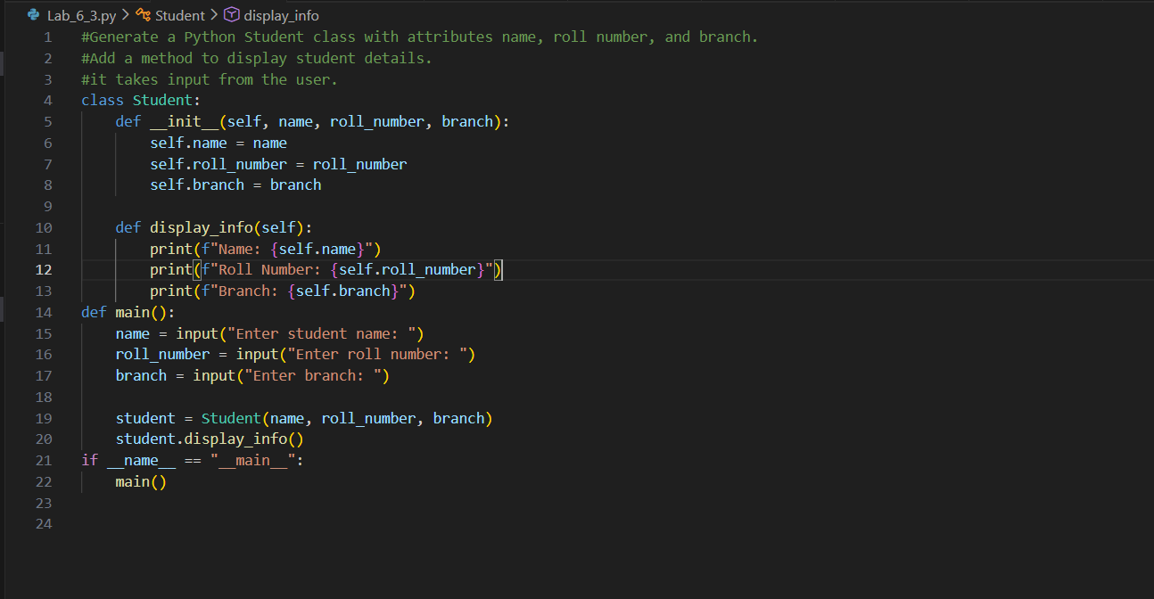
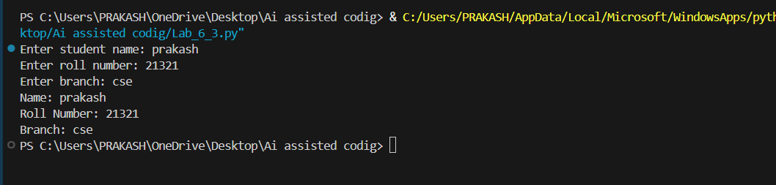

Task Description #2: Loops (Multiples of a Number)
Scenario:
You are writing a utility function to display multiples of a given number.
#Prompt:
#Generate a Python function to print the first 10 multiples of a number using a loop.
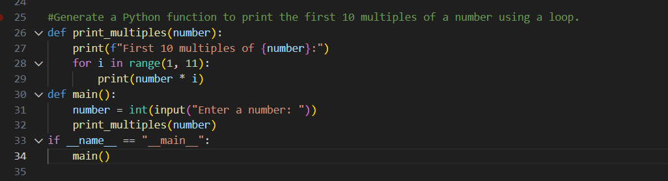
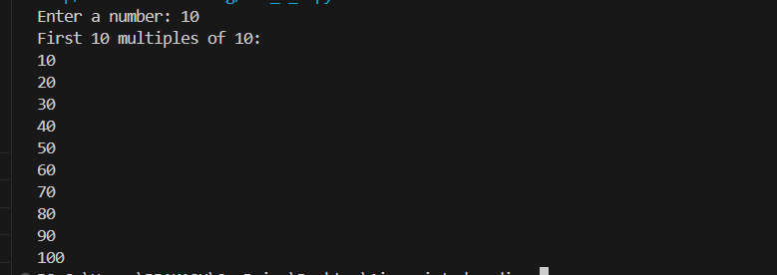

TASK 3 : Conditional Statements (Age Classification)
Scenario:
You are building a basic classification system based on age.
#Prompt:
#Generate Python code using if-elif-else to classify age as child, teenager, adult, or senior.
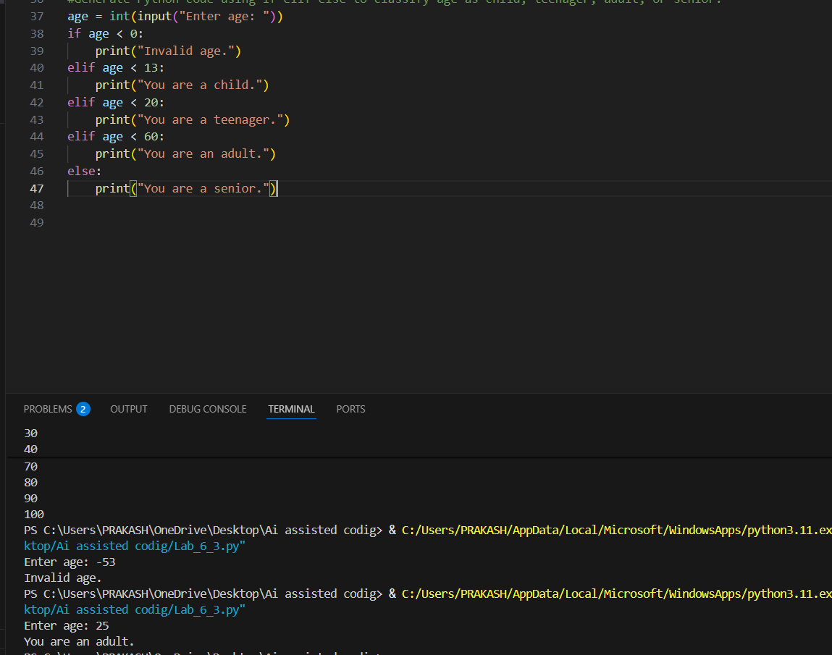
Task 4 : For and While Loops (Sum of First n Numbers)
Scenario :
You need to calculate the sum of the first n natural numbers.
#Prompts :
#Generate a Python function to calculate the sum of first n numbers using a for loop.
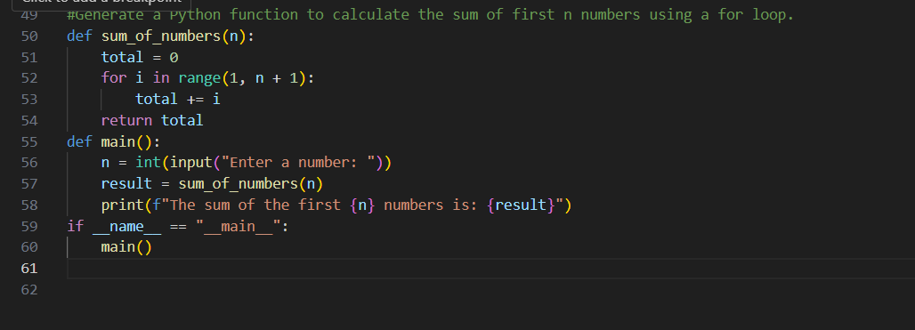
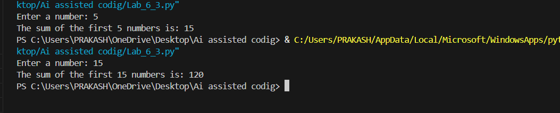
Task-5 : Classes (Bank Account Class)
Scenario :
You are designing a basic banking application.
#Prompts :
Generate a Python BankAccount class with deposit, withdraw, and check_balance methods.
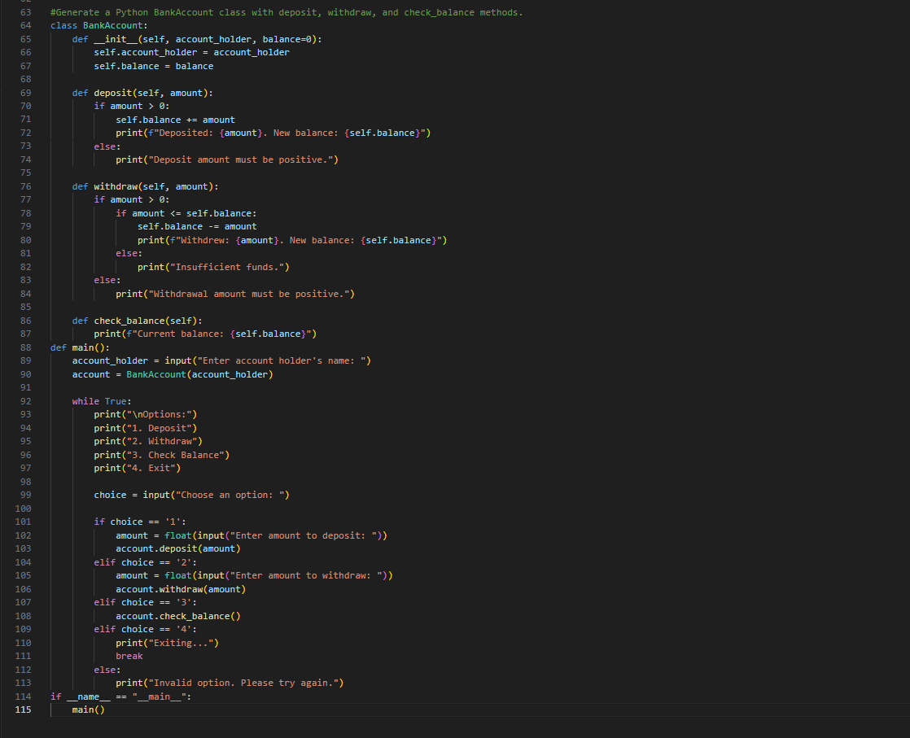
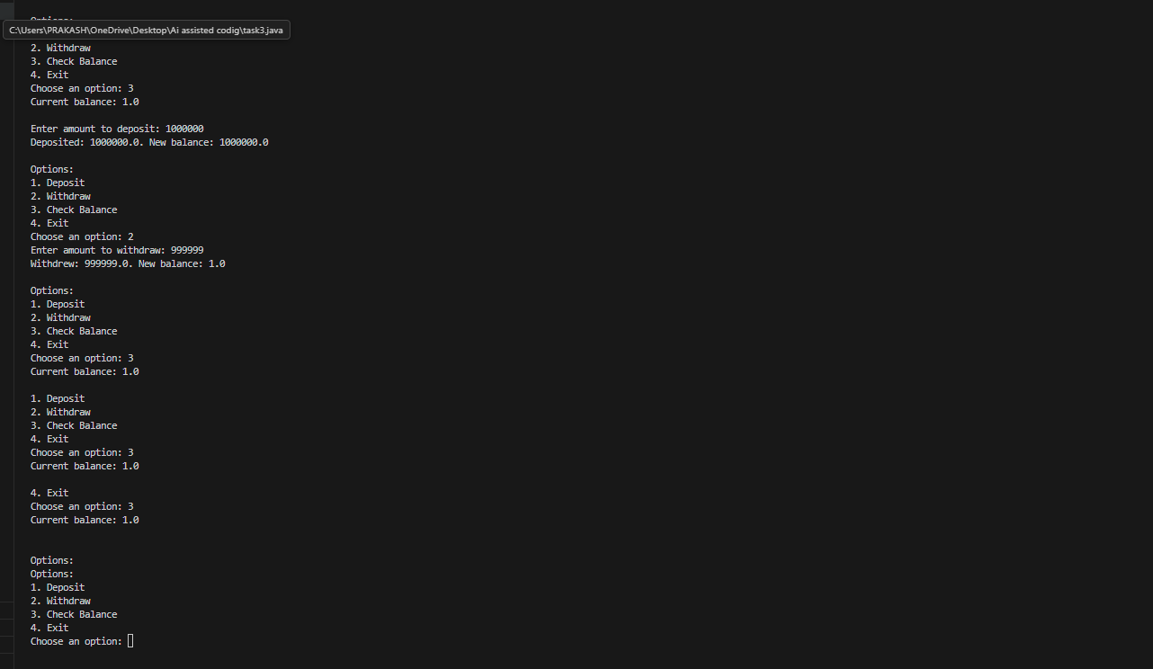
CODE EXPLANATION:
Task 1: Student Class Implementation
This task involves creating a class Student with attributes such as name, roll number, and branch.
The class includes a method display_details() to print student information, and the main program creates an object to display the details.
Task 2: Multiples of a Number Using Loops
This task involves generating a function to print the first 10 multiples of a given number using looping constructs.
Both for loop and while loop implementations are used to compare different iterative approaches.
Task 3: Age Classification Using Conditional Statements
This task involves creating a function that classifies a person into age groups like child, teenager, adult, or senior.
The classification is implemented using nested if-elif-else conditional statements.
Task 4: Sum of First n Natural Numbers
This task involves writing a function sum_to_n() to calculate the sum of the first n natural numbers.
The logic is implemented using both for loop and while loop to compare different methods of iteration.
Task 5: Bank Account Class Implementation
This task involves creating a class BankAccount with methods such as deposit(), withdraw(), and check_balance().
The main program demonstrates account operations and updates the balance accordingly.

