2303A51200 ---------------- batch 04
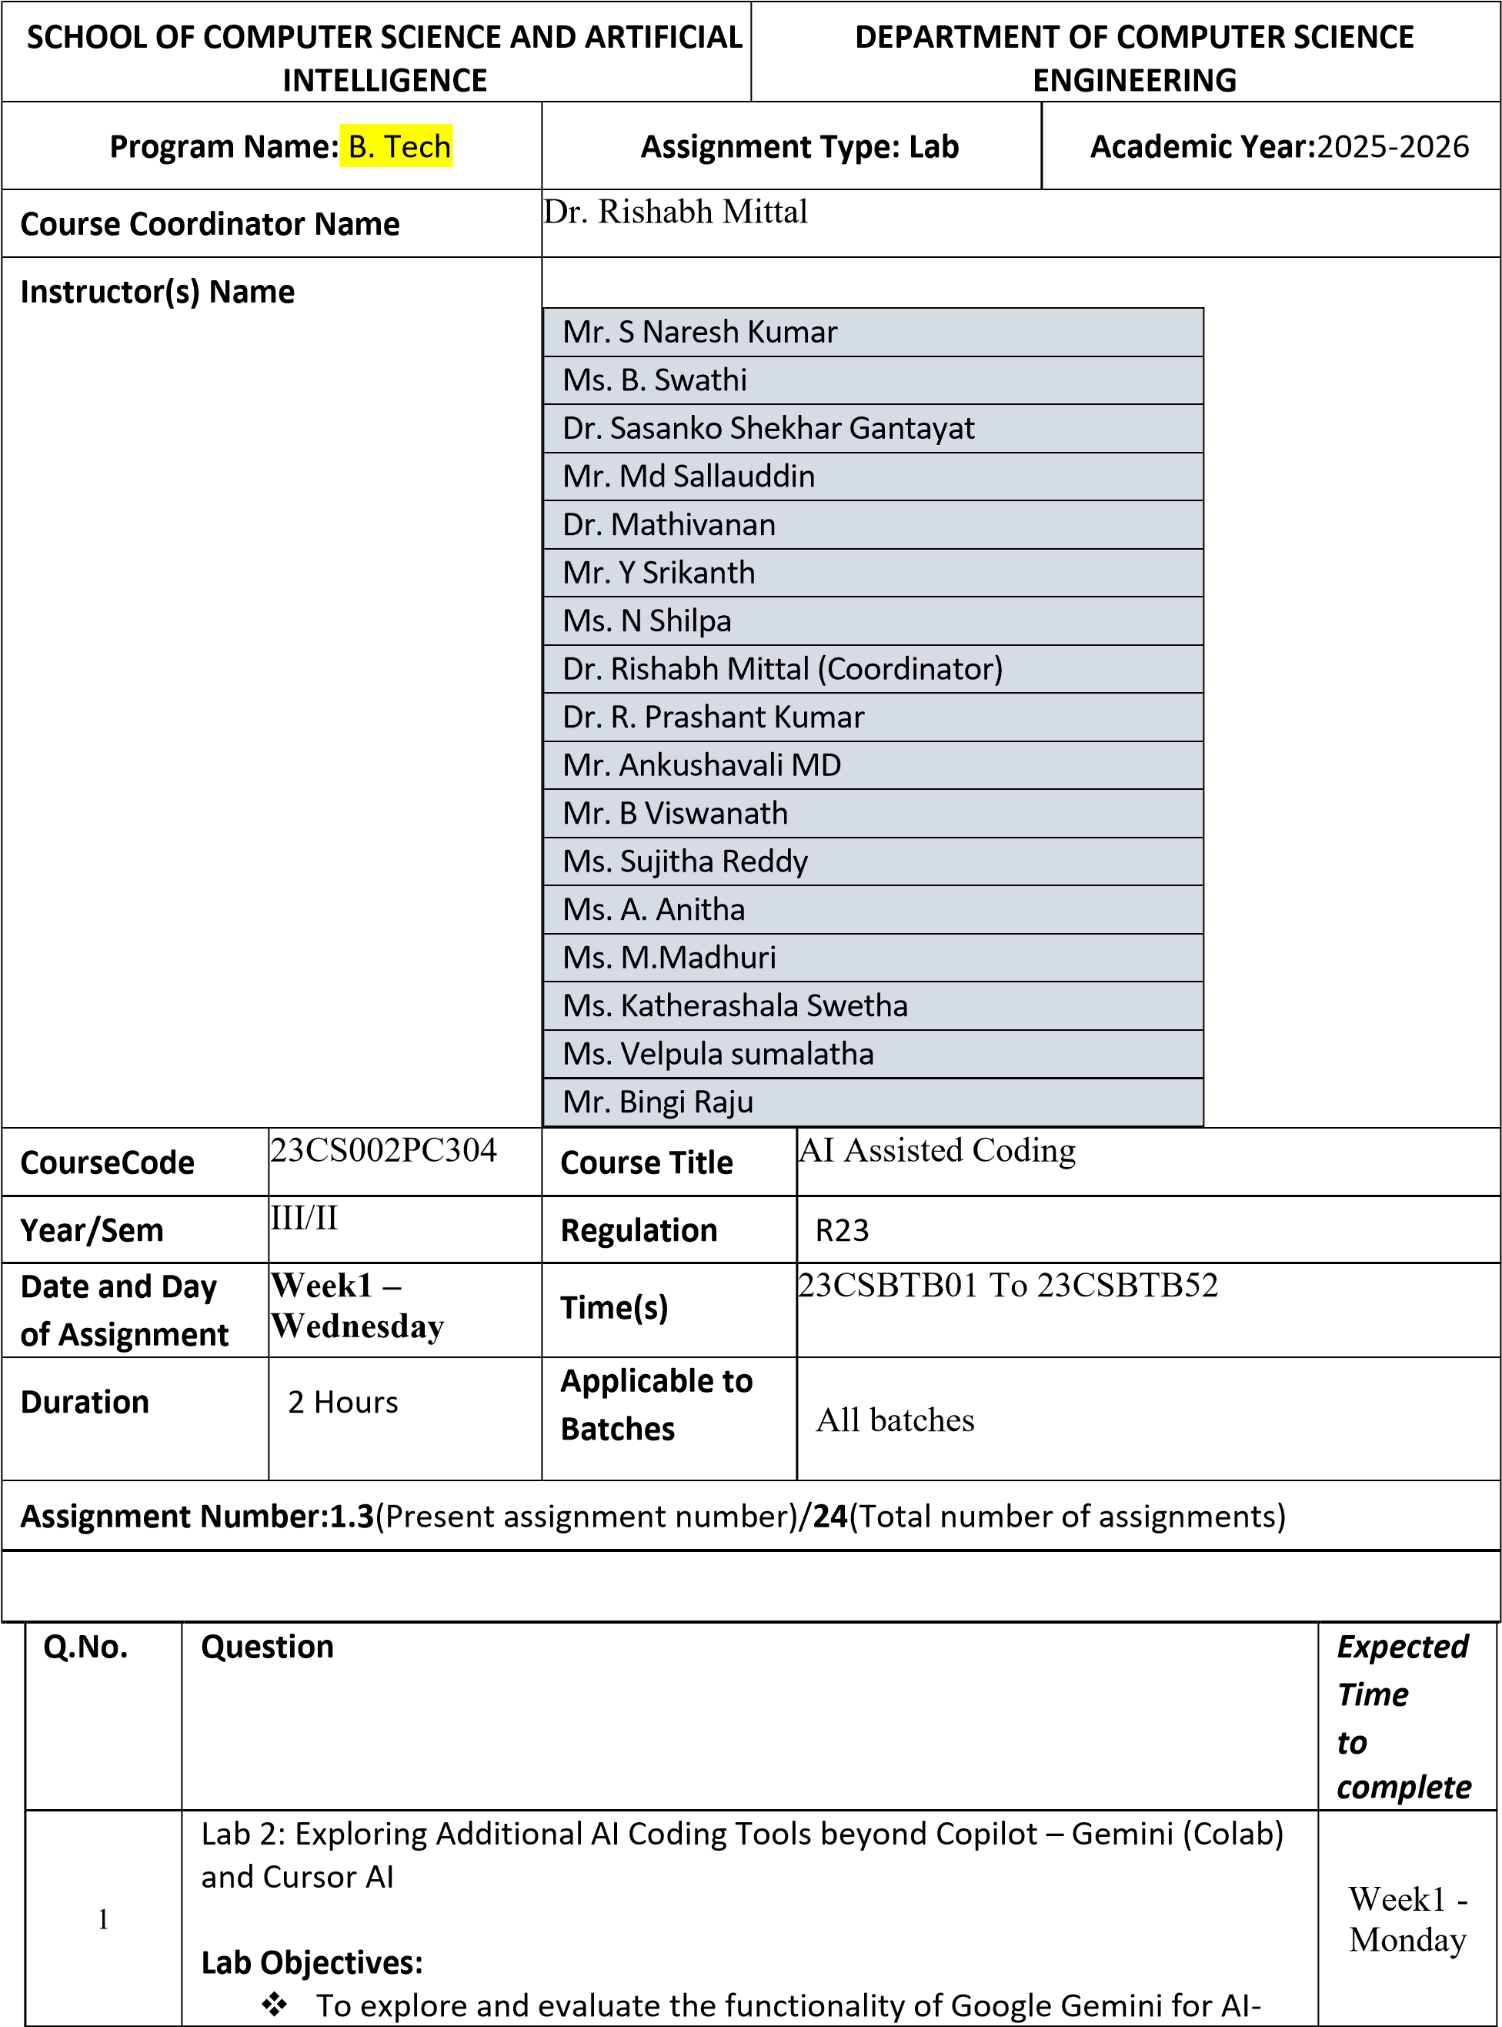

assisted coding within Google Colab.
- To understand and use Cursor AI for code generation, explanation, and refactoring.
- To compare outputs and usability between Gemini, GitHub Copilot, and Cursor AI.
- To perform code optimization and documentation using AI tools.

Lab Outcomes (LOs):
After completing this lab, students will be able to:
- Generate Python code using Google Gemini in Google Colab.
- Analyze the effectiveness of code explanations and suggestions by Gemini.
- Set up and use Cursor AI for AI-powered coding assistance.
- Evaluate and refactor code using Cursor AI features.
- Compare AI tool behavior and code quality across different platforms.
Task 1: Refactoring Odd/Even Logic (List Version)

- Scenario:
You are improving legacy code.

- Task:
Write a program to calculate the sum of odd and even numbers in a list, then refactor it using AI.

- Expected Output:
- Original and improved code

Prompt
“Write a Python program to calculate the sum of odd and even numbers in a list. Then refactor the code to improve readability and efficiency.”
Code
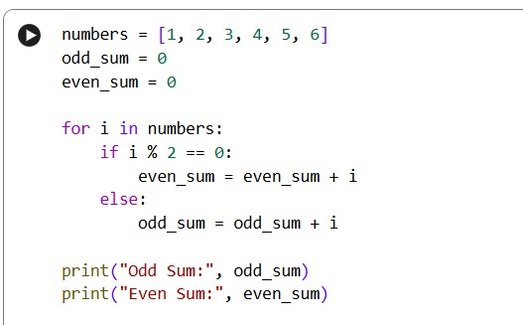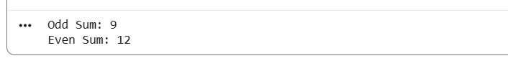

Code Output

Explanation

•

The original code uses loops and conditional statements.

•

The refactored version uses

Python genera
tor expressions

with
the

_{sum()}

function.

•

This improves:

o

Readability

o

Performance

o

Code length

•

AI tools suggest modern Pythonic practices.

Task 2: Area Calculation Explanation

❖

Scenario:

You are onboarding a junior developer.

❖

Task:

Ask Gemini to explain a function that calculates the area of different

shapes.

❖ Expected Output: ➢ Code
➢ Explanation

Prompt
“Explain a Python function that calculates the area of different shapes such as circle, rectangle, and triangle.”
Code
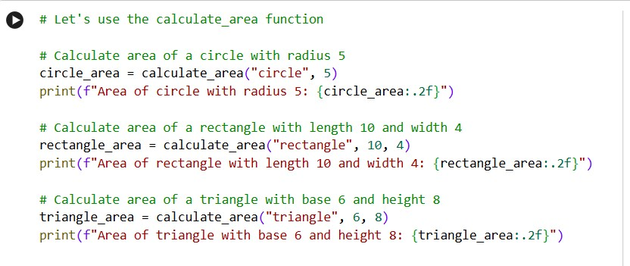
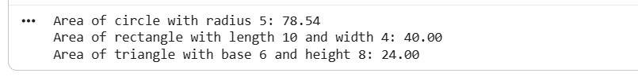Code Output
Explanation
- This function calculates area based on the shape type.
- Parameters:
  - _{shape}: type of shape (circle, rectangle, triangle) o value1, value2: dimensions
- Logic:
  - Circle → π × r² o Rectangle → length × width o Triangle → ½ × base × height
- AI explanation is clear and beginner-friendly, suitable for onboarding juniors.

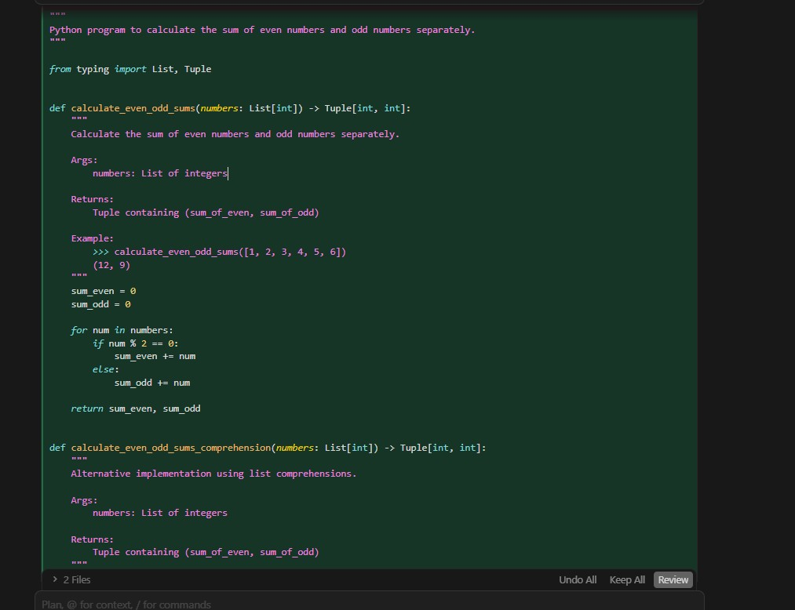
Task 3: Prompt Sensitivity Experiment

- Scenario:
You are testing how AI responds to different prompts.

- Task:
Use Cursor AI with different prompts for the same problem and observe code changes.

- Expected Output: ➢ Prompt list
➢ Code variations

Code

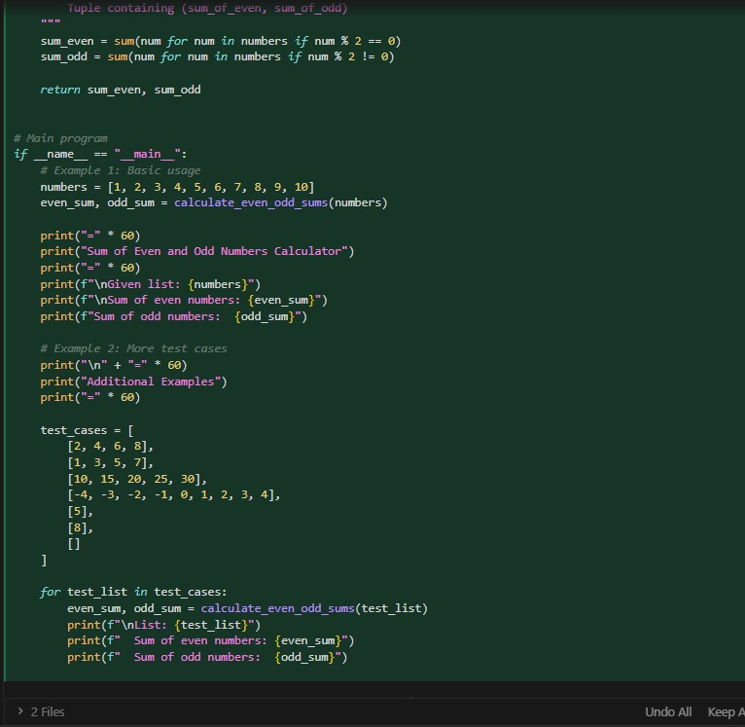

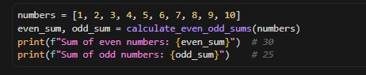
Code output

Explanation
- Simple prompts → short solutions
- Detailed prompts → structured logic
- Advanced prompts → reusable, safe code
- AI output quality depends heavily on prompt clarity

Task 4: Tool Comparison Reflection

- Scenario:
You must recommend an AI coding tool.

- Task:
Based on your work in this topic, compare Gemini, Copilot, and Cursor AI for usability and code quality.

- Expected Output: Short written reflection

Prompt used
“Compare Google Gemini, GitHub Copilot, and Cursor AI based on usability and code quality.”
Code
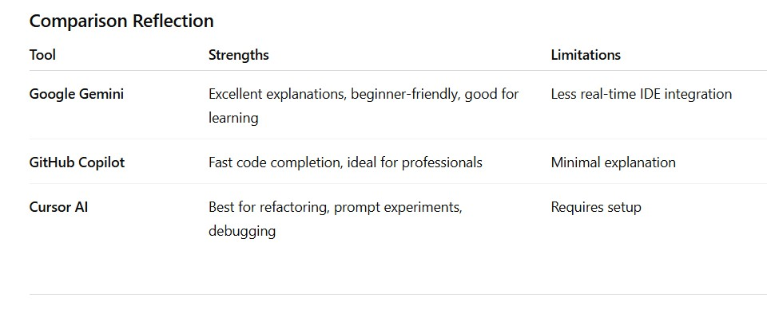
Explanation
  - Gemini is best for students and learning
  - Copilot is best for fast development
  - Cursor AI is best for code optimization and experimentation
Recommended Tool for this Lab: Google Gemini + Cursor AI

Note: Report should be submitted as a word document for all tasks in a single document with prompts, comments & code explanation, and output and if required, screenshots.

