Lab-2: Exploring Additional AI Coding Tools beyond Copilot – Gemini (Colab) and Cursor AI
Name: K.sathwik
2303A51202
BRANCH: CSE
BATCH-04
LAB: AI Coding Tools

Lab Objectives:
- To explore and evaluate Google Gemini for AI-assisted coding in Google Colab
- To use GitHub Copilot for AI-assisted programming in VS Code
- To compare code quality, clarity, and correctness
- To analyze how different AI tools solve the same problem

Task-1: Cleaning Sensor Data
Prompt
You are cleaning IoT sensor data where negative values are invalid.
Task
Generate a function that removes all negative numbers from a list.
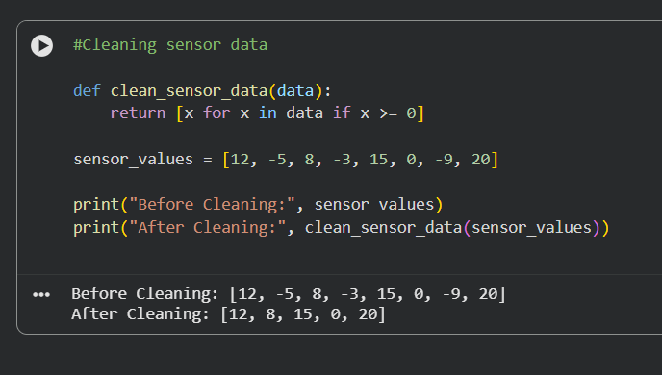
The above Code has been Generated by Gemini (Colab)

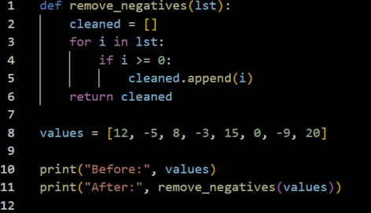
Output:
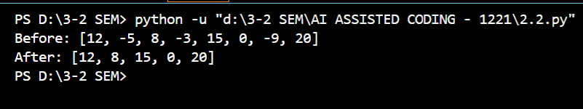
The above code has been generated by Github co-poilot (In vs code)

Task 1 – Cleaning Sensor Data
Problem:
Remove negative values from IoT sensor data.
Gemini Performance
Gemini produced a compact and optimized solution using list comprehension. The logic was simple, efficient, and mathematically correct. It also directly showed the “before” and “after” outputs, which made the data-cleaning process easy to verify.

Copilot Performance
Copilot generated a loop-based solution that manually checks each value and appends valid numbers. While the output was correct, the code was longer and more procedural.
Comparison
Gemini showed better data-processing efficiency and cleaner syntax, while Copilot followed a traditional programming style.
Winner: Gemini (more Pythonic and clean)

Task-2: String Character Analysis
PROMPT : Count vowels, consonants, and digits in a string.
Gemini code
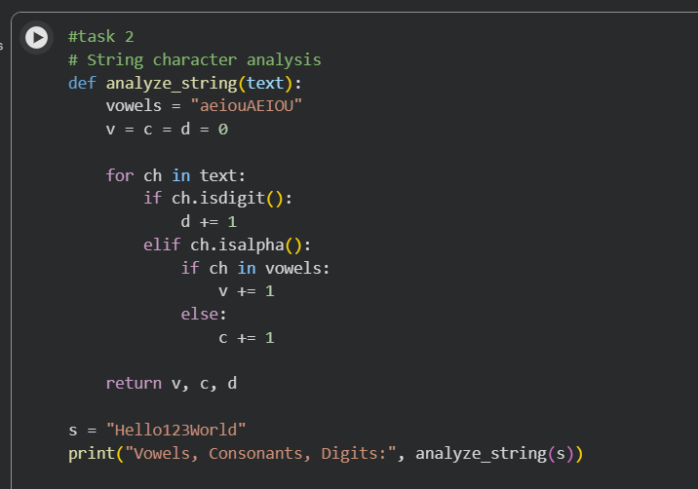

Output
Github co-poilot in (Vs code)
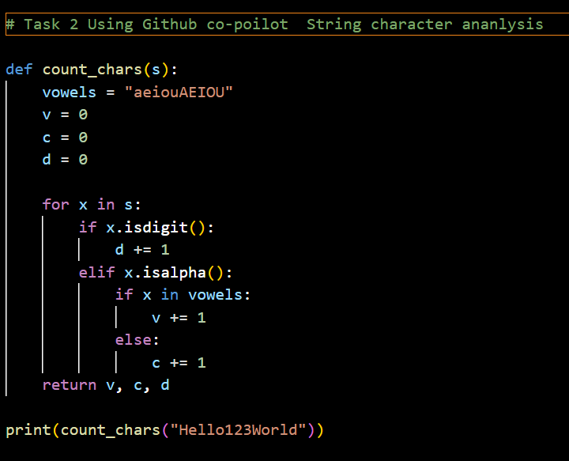
Output:
Task 2 – String Character Analysis
Problem:
Count vowels, consonants, and digits in a string.
Gemini Performance
Gemini handled multiple character categories (letters, vowels, consonants, digits) with clear conditional logic. It ensured that only alphabetic characters were counted as vowels or consonants, improving correctness.

Copilot Performance
Copilot also gave a working solution, but its structure was slightly repetitive and less optimized. It relied more on basic conditional checks without refinement.
Comparison
Gemini’s code was more logically refined and structured, whereas Copilot’s solution was simpler but less elegant.
Winner: Gemini

Task-3: Palindrome Check (Tool Comparison)
PROMPT : generate palindrome checking function using gemini and co poilot then compare the results

Gemini
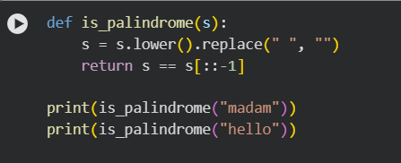
Output

Using Github co-poilot
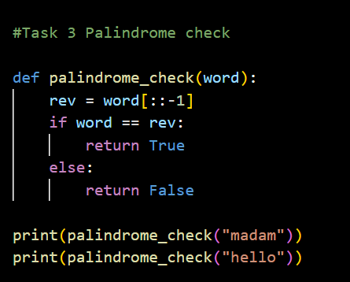
Output:
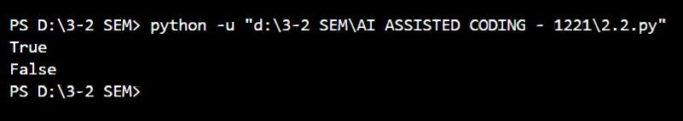
Task 3 – Palindrome Check
Problem:
Check whether a string is a palindrome.
Gemini Performance
Gemini handled real-world cases such as:
- Different letter cases
- Spaces inside the string
This made the function more robust and usable.
Copilot Performance
Copilot checked only direct string reversal, which fails for inputs like "Madam" or "nurses run".
Comparison
Gemini provided a real-world compatible solution, while Copilot gave a basic logical check.
Winner: Gemini

Task-4: Code Explanation Using Gemini
Prompt - Prime Number Check
Using gemini in colab
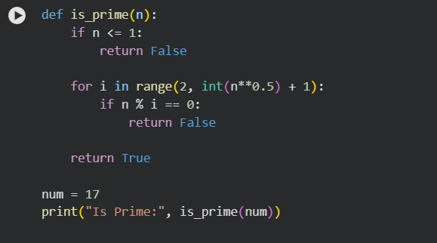
Output

def is_prime(n): | Defines a function named is_prime that takes one input number n.
if n <= 1: | Checks if the number is less than or equal to 1. Numbers ≤1 are not prime.
return False | If the condition is true, the function returns False.
for i in range(2, int(n**0.5) + 1): | Loops from 2 to the square root of n. This is an optimized way to check factors.
if n % i == 0: | Checks if n is divisible by i.
return False | If divisible, n is not prime, so return False.
return True | If no divisor is found, the number is prime.
num = 17 | Assigns 17 to the variable num.
print("Is Prime:", is_prime(num)) | Calls the function and prints the result.

Using github co-poilot
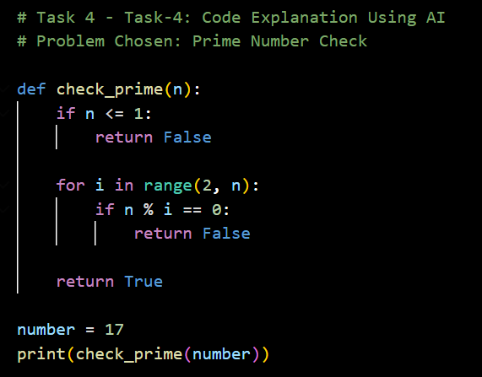
Output
Line | Explanation
def check_prime(n): | Defines a function named check_prime that takes input n.
if n <= 1: | Checks if the number is less than or equal to 1.
return False | Returns False because such numbers are not prime.
for i in range(2, n): | Loops from 2 to n-1 to check all possible divisors.
if n % i == 0: | Checks if n is divisible by i.
return False | If divisible, it is not a prime number.
return True | If no divisor is found, the number is prime.
number = 17 | Assigns 17 to the variable number.
print(check_prime(number)) | Prints whether 17 is prime or not.
Gemini’s version is optimized because it checks divisibility only up to √n, while Copilot’s version checks all numbers up to n−1, making it slower for large inputs.

Task 4 – Code Explanation
Problem:
Explain a Python function line by line.
Gemini Performance
Gemini explained each line in simple and technical language, helping the student understand:
- Why each statement is used
- How the logic flows
This makes it suitable for learning and debugging.
Copilot Performance
Copilot does not provide explanations. It only generates or completes code.
Comparison
Gemini acts as a teacher, while Copilot acts only as a coding assistant.
Winner: Gemini
Gemini generated a more optimized and professional version of the prime-checking algorithm, while Copilot produced a correct but slower solution.
Hence, Gemini is better for understanding and code quality, whereas Copilot is useful for quick code generation.

