2303A51204
Batch 04

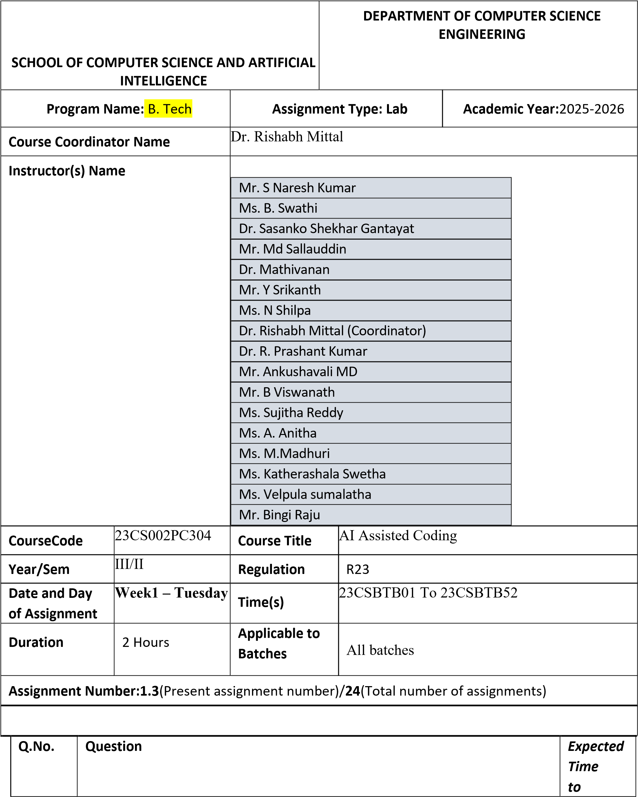
complete

and Cursor AI

Lab Objectives:
- To explore and evaluate the functionality of Google Gemini for AIassisted coding within Google Colab.
- To understand and use Cursor AI for code generation, explanation, and refactoring.
- To compare outputs and usability between Gemini, GitHub Copilot, and Cursor AI.

1

Lab 2: Exploring Additional AI Coding Tools

beyond Copilot

–

Gemini (Colab)

- To perform code optimization and documentation using AI tools.

Lab Outcomes (LOs):
After completing this lab, students will be able to:
- Generate Python code using Google Gemini in Google Colab.
- Analyze the effectiveness of code explanations and suggestions by Gemini.
- Set up and use Cursor AI for AI-powered coding assistance.
- Evaluate and refactor code using Cursor AI features. Week1 -
- Compare AI tool behavior and code quality across different platforms. Monday
Task 1: Cleaning Sensor Data

- Scenario:
- You are cleaning IoT sensor data where negative values are invalid.

- Task:
Use Gemini in Colab to generate a function that filters out all negative numbers from a list.

- Expected Output:
- Before/after list
- Screenshot of Colab execution
- OUTPUT ❖ PROMPT:
- 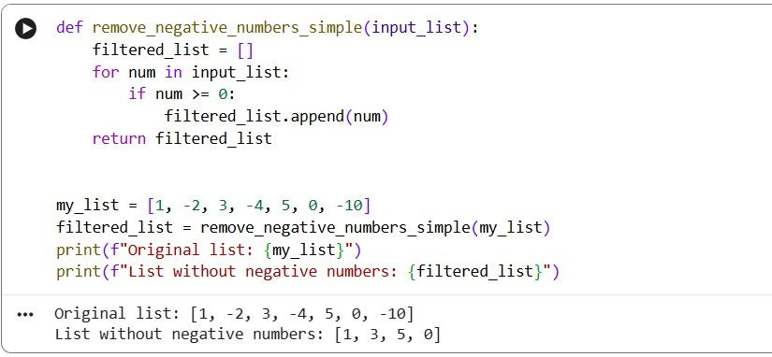

- Explanation:
- The function loops through each number in the input list.
- It checks if the number is 0 or positive.
- Only non-negative numbers are added to a new list.
- Finally, it returns the filtered list without negative values.
_____________________________________________________________
Task 2: String Character Analysis

- Scenario:
You are building a text-analysis feature.

- Task:
Use Gemini to generate a Python function that counts vowels, consonants, and digits in a string.

- Expected Output:
  - Working function
  - Sample inputs and outputs

Output:
Prompt
Generate a python function that counts vowels constants and numbers in a string

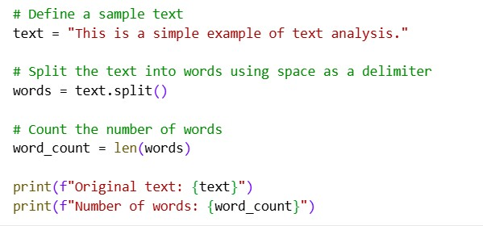

Output for code

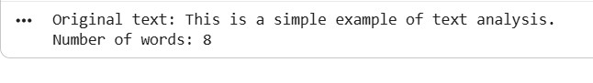

Eplanation:

The function goes through each character in the given string.

If the character is a letter, it checks whether it is a vowel or a consonant.

If the character is a digit, it increases the digit count.

Finally, it returns the counts of vowels, consonants, and digits.
____________________________________________________________ Task 3: Palindrome Check – Tool Comparison

- Scenario:
You must decide which AI tool is clearer for string logic.

- Task:
Generate a palindrome-checking function using Gemini and Copilot, then compare the results.

- Expected Output:
  - Side-by-side code comparison
  - Observations on clarity and structure

Output
Prompt
Generating palindrome code in git hub copilot , gemi

ni and comparison

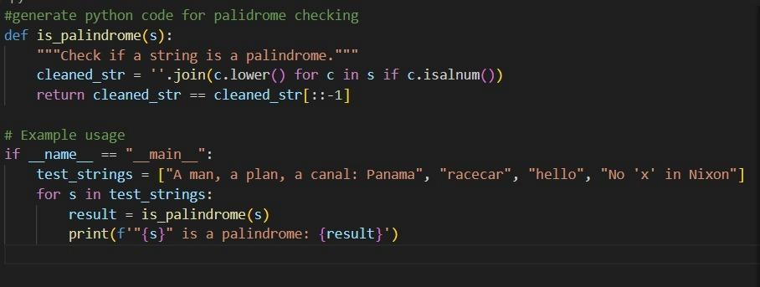

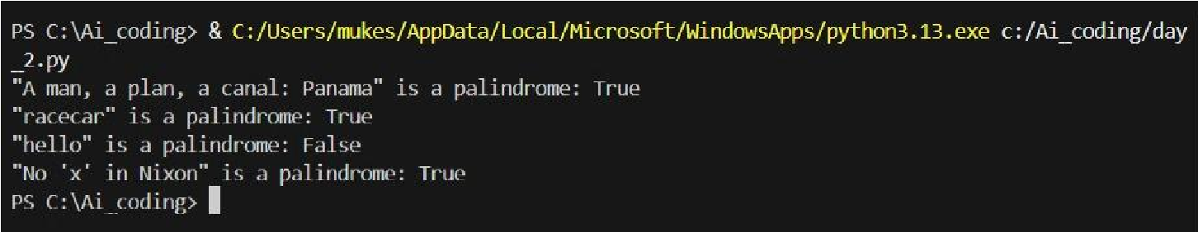

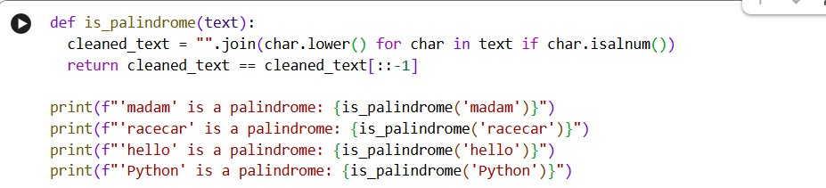

Output for code
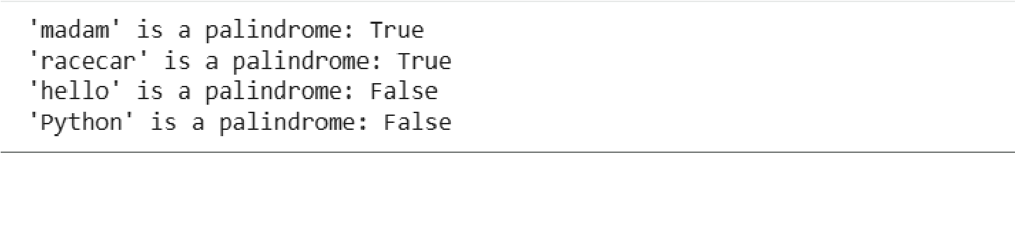
Eplanation:
Step-by-step comparison of both palindrome codes:

Function Definition:
Both codes define a function named is_palindrome that takes a string as input.

Text Cleaning:
In both codes, the input string is converted to lowercase and all nonalphanumeric characters are removed to ensure accurate palindrome

checking.

Palindrome Logic:
Each code compares the cleaned string with its reverse using string slicing ([::-1]) to determine if it is a palindrome.

Return Value:
Both functions return True if the string is a palindrome and False otherwise.

Testing the Function:
The first code directly calls the function with print() statements, while the second code tests multiple strings inside an if __name__ == "__main__" block.

Code Structure:
The first code is simple and straightforward, whereas the second code is better structured, includes a docstring, and is more suitable for larger programs.

_______________________________________________________________
Task 4: Code Explanation Using AI

- Scenario:
You are reviewing unfamiliar code written by another developer.

- Task:
Ask Gemini to explain a Python function (prime check OR palindrome check) line by line.

- Expected Output: ➢ Code snippet
  - AI explanation
  - Student comments on understanding

Output prompt
generate a python code for prime number explain line by line
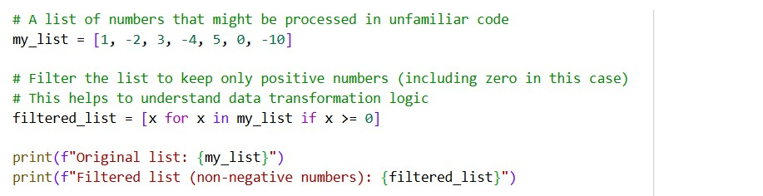
Output for code
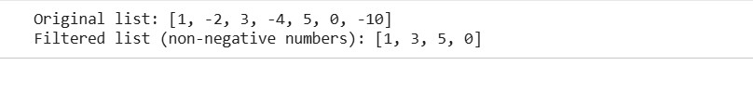

Explanation:
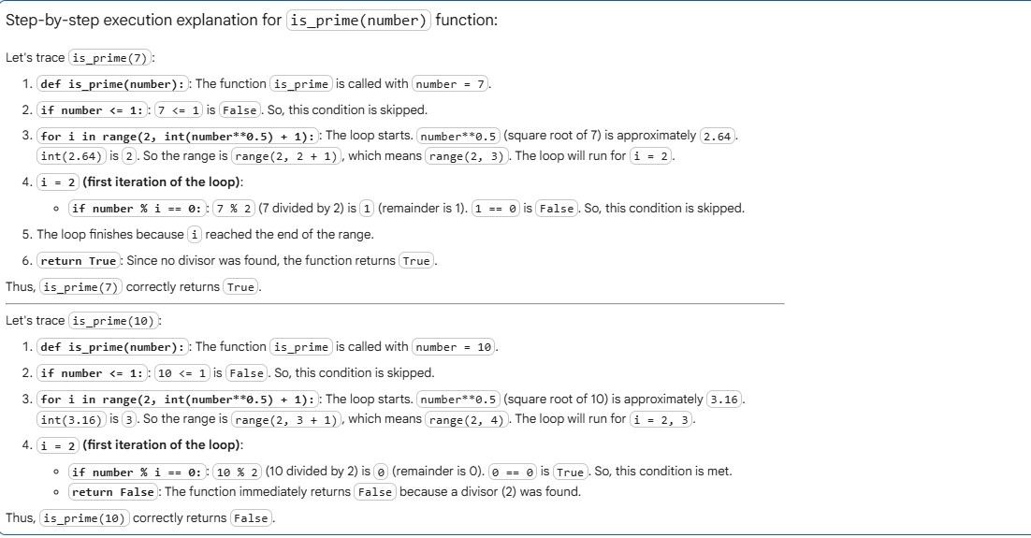

Note: Report should be submitted as a word document for all tasks in a single document with prompts, comments & code explanation, and output and if required, screenshots.

