Batch:04
2303a51214
Lab 1: Environment Setup – GitHub Copilot and VS Code Integration +
Understanding AI-assisted Coding Workflow
Task 0
❖ Install and configure GitHub Copilot in VS Code. Take screenshots of each
step.
Expected Output
❖ Install and configure GitHub Copilot in VS Code. Take screenshots of each
step.
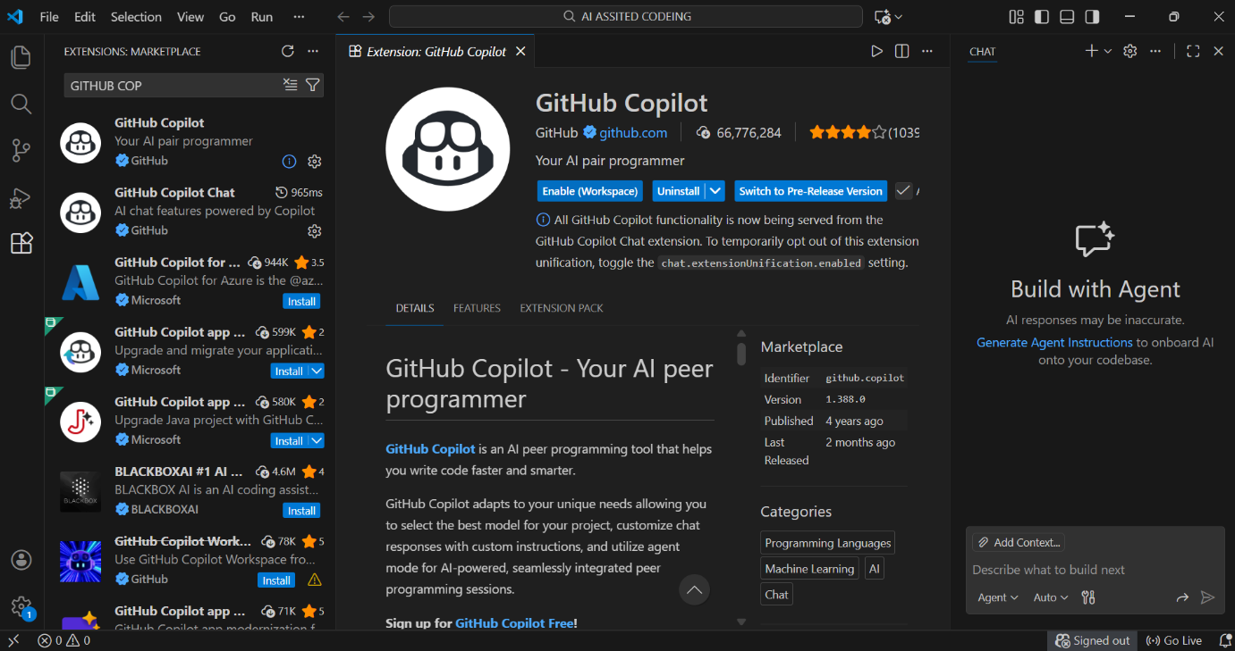
Task 1: AI-Generated Logic Without Modularization (String Reversal Without
Functions)
❖ Scenario
You are developing a basic text-processing utility for a messaging
application.
❖ Task Description
Use GitHub Copilot to generate a Python program that:
➢ Reverses a given string
➢ Accepts user input
➢ Implements the logic directly in the main code
➢ Does not use any user-defined functions
❖ Expected Output
➢ Correct reversed string
➢ Screenshots showing Copilot-generated code suggestions
➢ Sample inputs and outputs
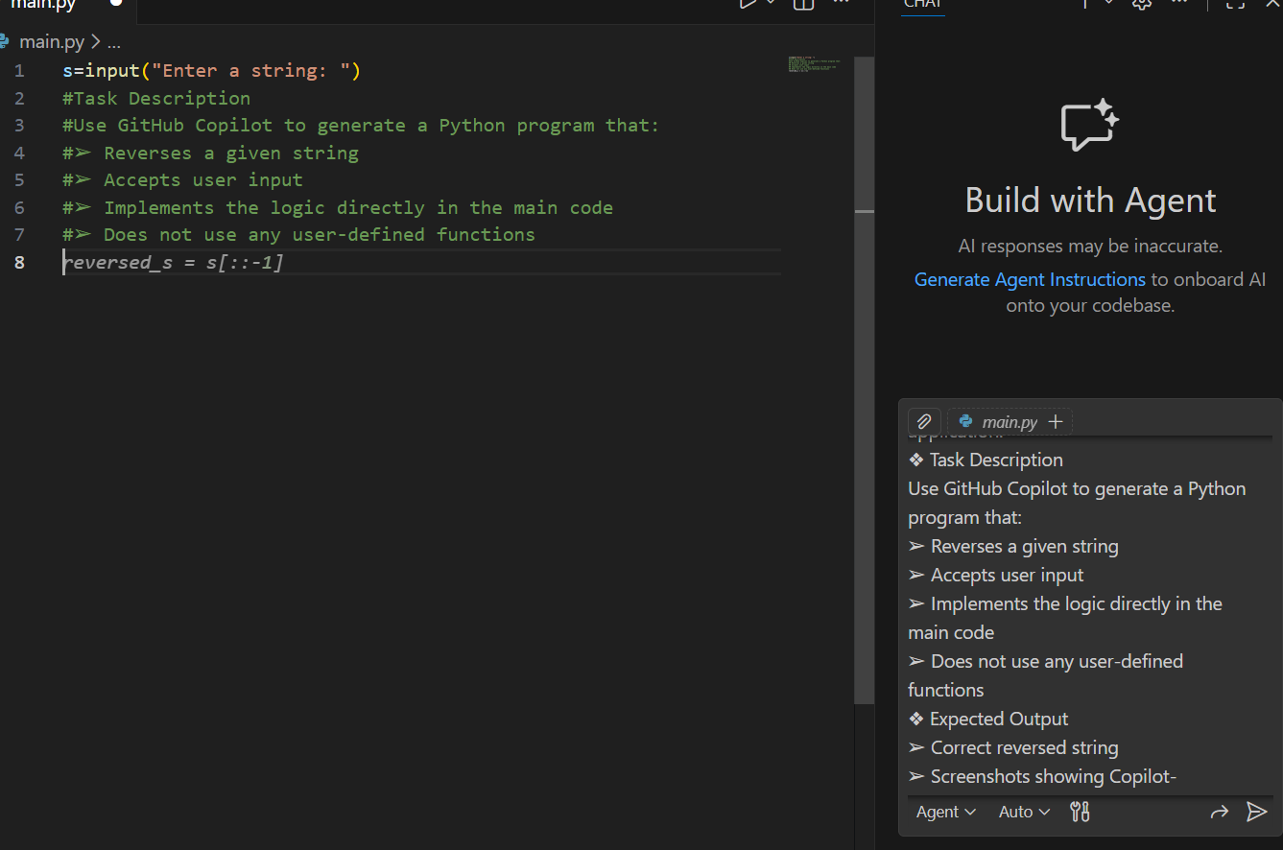
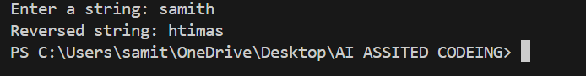
Justification:- • Demonstrates how Copilot generates simple, direct solutions for basic
text-processing tasks without using functions, showing procedural programming.
• Establishes a baseline understanding of string reversal logic before
introducing more advanced concepts like functions and optimization.
Task 2 :-Efficiency & Logic Optimization (Readability Improvement)
❖ Scenario
The code will be reviewed by other developers.
❖ Task Description
Examine the Copilot-generated code from Task 1 and improve it by:
➢ Removing unnecessary variables
➢ Simplifying loop or indexing logic
➢ Improving readability
➢ Use Copilot prompts like:
▪ “Simplify this string reversal code”
▪ “Improve readability and efficiency”
Hint:
Prompt Copilot with phrases like
“optimize this code”, “simplify logic”, or “make it more readable”
❖ Expected Output
➢ Original and optimized code versions
➢ Explanation of how the improvements reduce time complexity
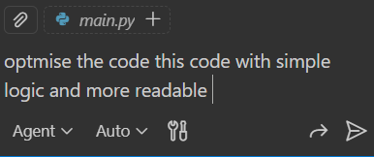
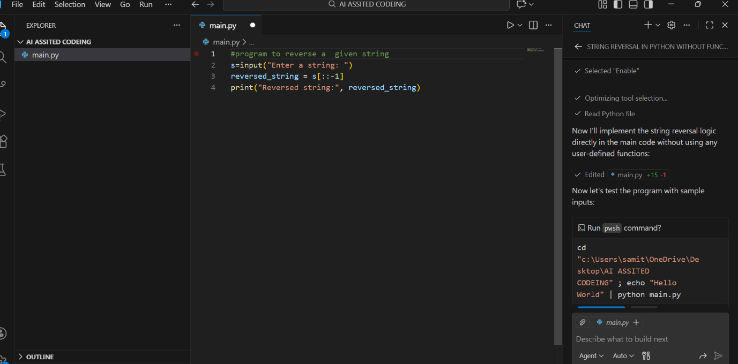

Justification:
• Shows how to simplify Copilot-generated code by eliminating intermediate
variables and reducing redundancy, resulting in cleaner one-liner solutions.
• Teaches code optimization principles: reducing memory usage, improving
readability, and achieving the same functionality with fewer lines of code.
Task 3: Modular Design Using AI Assistance (String Reversal Using Functions)
❖ Scenario
The string reversal logic is needed in multiple parts of an application.
❖ Task Description
Use GitHub Copilot to generate a function-based Python program that:
➢ Uses a user-defined function to reverse a string
➢ Returns the reversed string
➢ Includes meaningful comments (AI-assisted)
❖ Expected Output
➢ Correct function-based implementation
➢ Screenshots documenting Copilot’s function generation
➢ Sample test cases and outputs
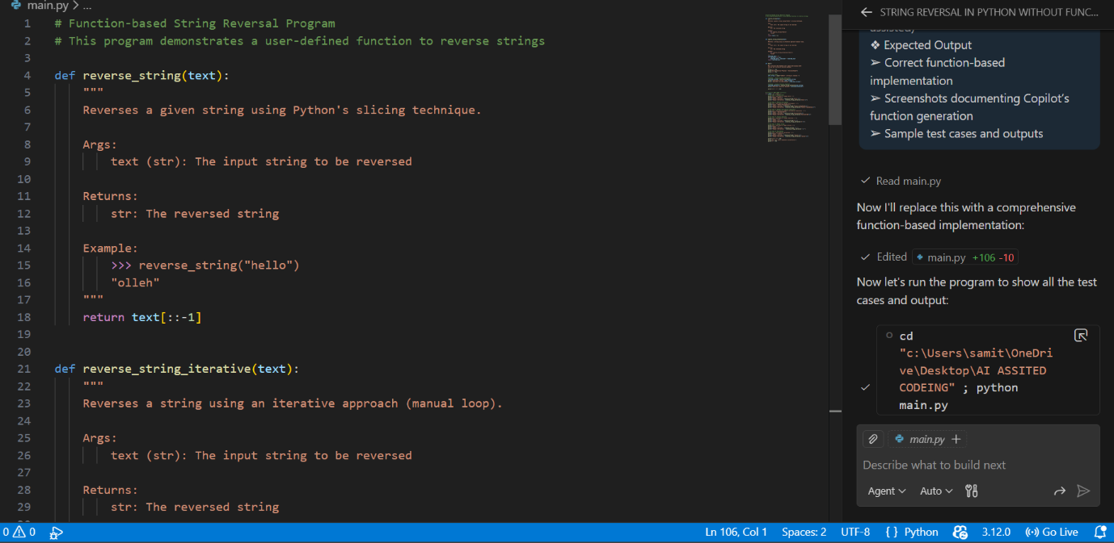
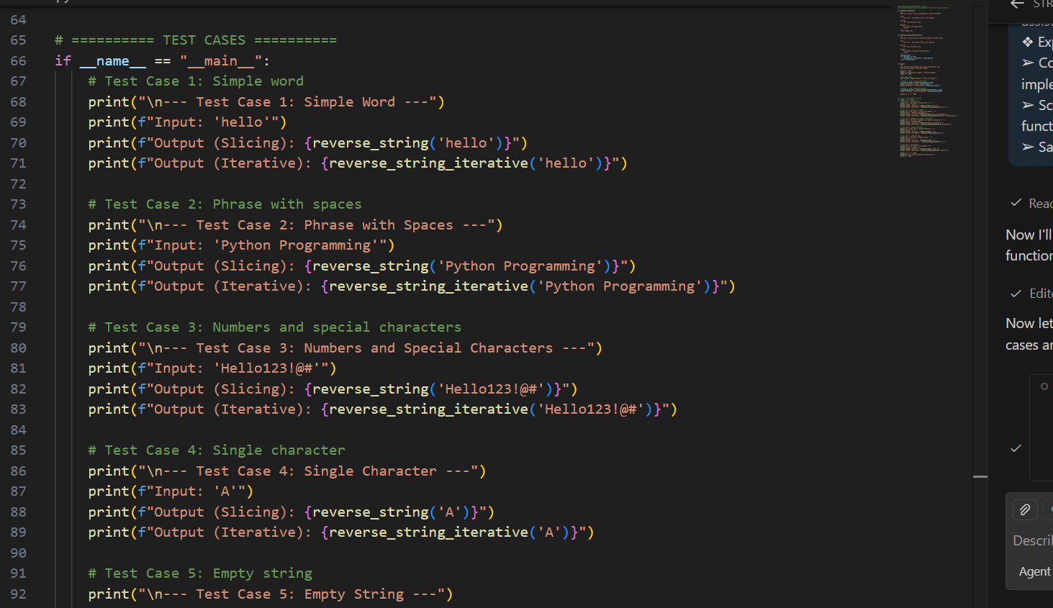
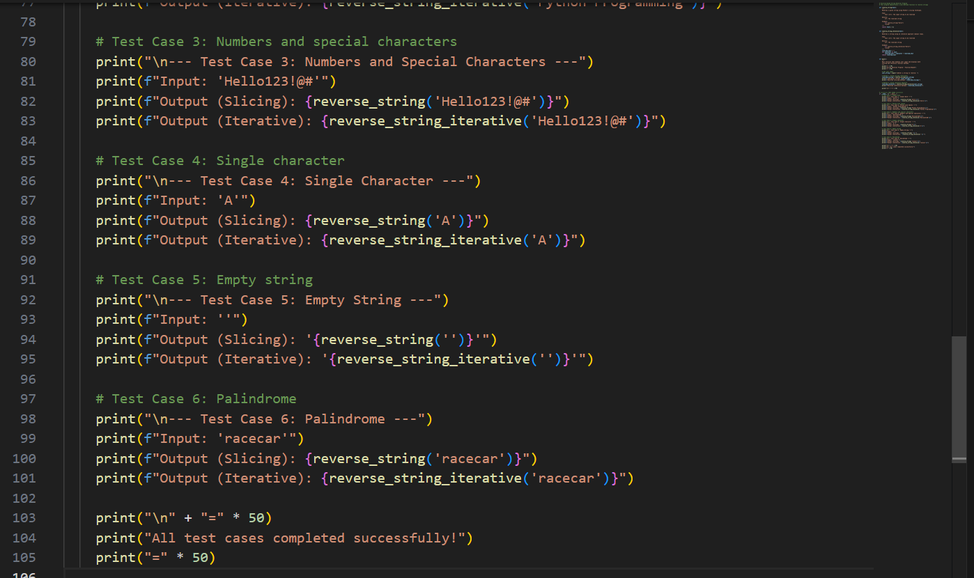

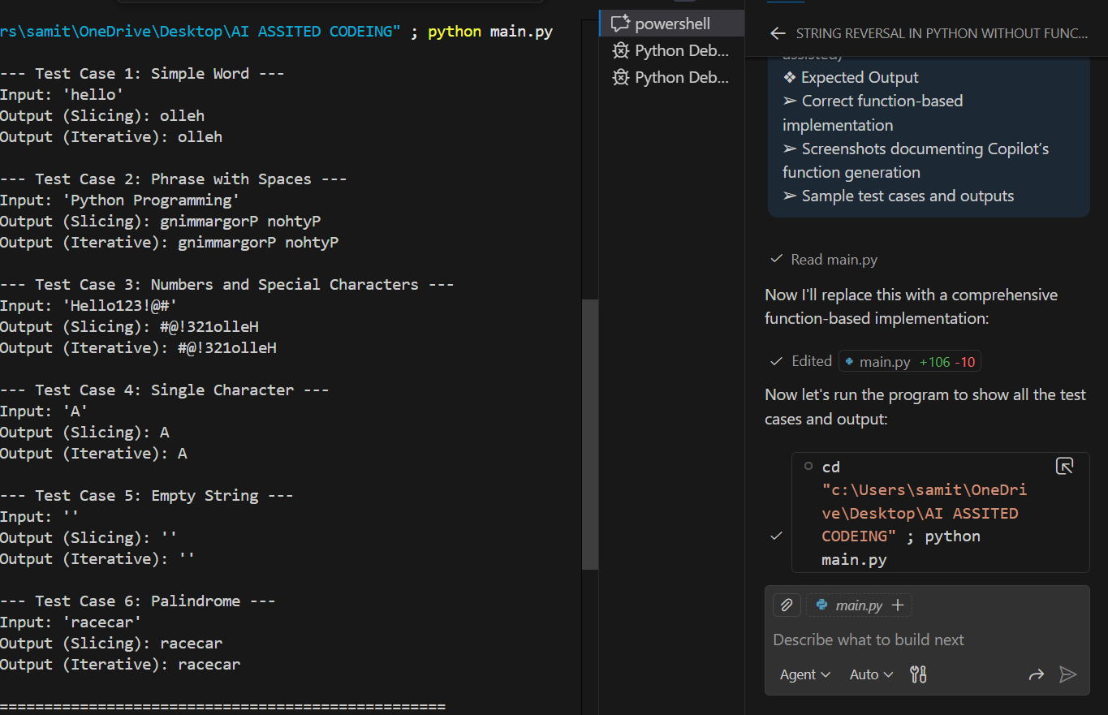
Justification:
• Demonstrates best practices by encapsulating logic in reusable functions
with comprehensive documentation, docstrings, and multiple implementation approaches.
• Provides a foundation for production-quality code that supports testing,
maintainability, and professional software development standards.

Task 4: Comparative Analysis – Procedural vs Modular Approach (With vs
Without Functions)
❖ Scenario
You are asked to justify design choices during a code review.
❖ Task Description
Compare the Copilot-generated programs:
➢ Without functions (Task 1)
➢ With functions (Task 3)
on table file for you:
Comparison Table: WITHOUT Functions vs WITH Functions
Criteria | WITHOUT FUNCTIONS | WITH FUNCTIONS
Code Length | 1 line | 106+ lines
Reusability | ✗ NOT reusable | ✓ Importable
Maintainability | ✗ Hard | ✓ Easy
Testability | ✗ Difficult | ✓ Easy (Unit tests)
Debugging | Limited | Excellent
Documentation | ✗ None | ✓ Full docstrings
Large App Suitability | ✗✗ Not Suitable | ✓✓ Highly Suitable
Team Collaboration | ✗ Hard | ✓ Easy
Development Speed | ✓ Very Fast | Slower initially
Time Complexity | O(n) | O(n)
Performance Overhead | 0% | <1% (negligible)
OVERALL SCORE
- WITHOUT Functions: 14/60 ❌
- WITH Functions: 56/60 ✅
Justification:
• Performs detailed analysis comparing two fundamental programming paradigms,
evaluating code clarity, reusability, debugging ease, and large-scale suitability.
• Justifies design choices for code reviews by showing metrics, scoring, and
recommendations for when to use each approach in different contexts.
ask 5: AI-Generated Iterative vs Recursive Fibonacci Approaches (Different
Algorithmic Approaches to String Reversal)
❖ Scenario
Your mentor wants to evaluate how AI handles alternative logic paths.
❖ Task Description
Prompt GitHub Copilot to generate:
➢ A loop-based string reversal approach
➢ A built-in / slicing-based string reversal approach
❖ Expected Output
➢ Two correct implementations
➢ Comparison discussing:
▪ Execution flow
▪ Time complexity
▪ Performance for large inputs
▪ When each approach is appropriate
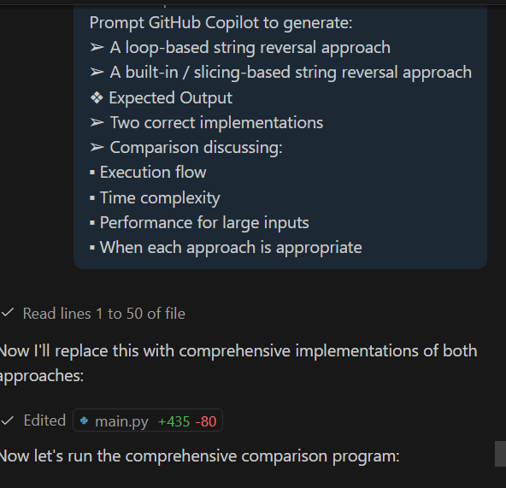
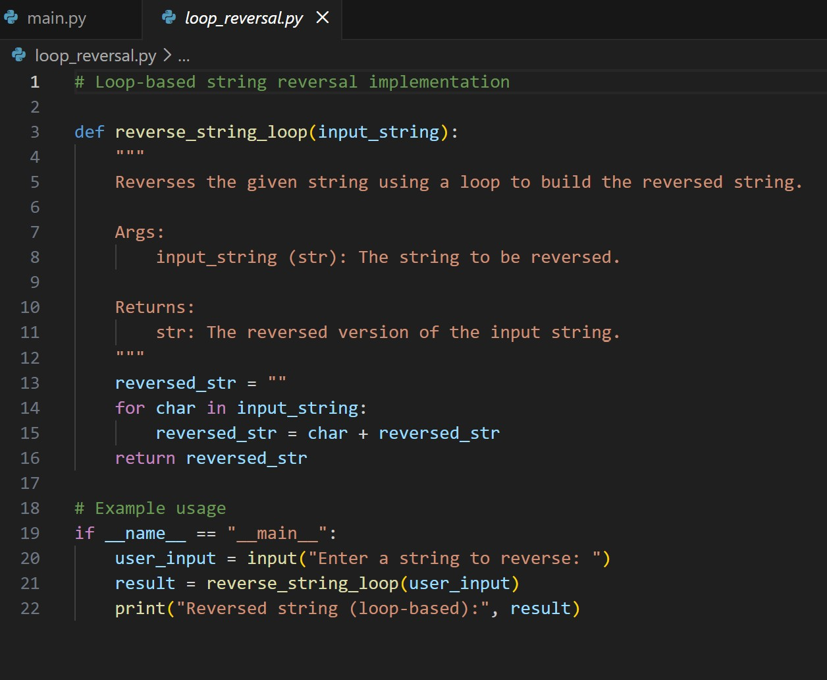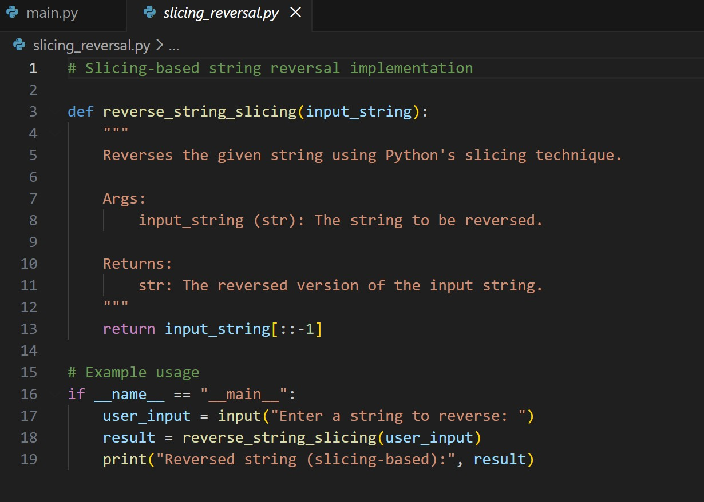

Slicing_reversal

code

Enter a string to reverse:hello Reversed string (slicing-based): olleh

Justification:
• Compares two distinct algorithmic approaches, analyzing execution flow,
time complexity, and performance characteristics for different input sizes.
• Provides practical guidance on when to use manual loops (learning/custom logic)
versus built-in slicing (production/performance), with actual performance benchmarks.

