2303A51214
Batch:04
Assignment :2.2

Task 1: Cleaning Sensor Data ❖ Scenario:
- You are cleaning IoT sensor data where negative values are invalid.
- Task:
Use Gemini in Colab to generate a function that filters out all negative numbers from a list. ❖ Expected Output:
- Before/after list
- Screenshot of Colab execution
_____________________________________________________________

Prompt : Give me a function for cleaning IOT sensor data where negative values are invalid it should filter all the negative values from a list

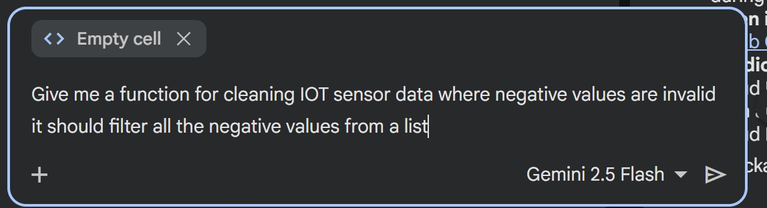

Code : def clean_iot_sensor_data(data_list):
"""
Cleans IoT sensor data by filtering out negative (invalid) values.

Args:
data_list (list): A list of sensor readings, which may include negative values.

Returns:
list: A new list containing only the valid (non-negative) sensor readings.
"""
cleaned_data = [value for value in data_list if value >= 0] return cleaned_data

sensor_readings = [23.5, -1.2, 25.1, 0.0, -0.5, 22.9] cleaned_readings = clean_iot_sensor_data(sensor_readings) print(f"Original readings: {sensor_readings}")
print(f"Cleaned readings: {cleaned_readings}")

Output:
Original readings: [23.5, -1.2, 25.1, 0.0, -0.5, 22.9]
Cleaned readings: [23.5, 25.1, 0.0, 22.9]

Task02:String Character Analysis ❖ Scenario:
You are building a text-analysis feature.
❖ Task:
Use Gemini to generate a Python function that counts vowels, consonants, and digits in a string. ❖ Expected Output:
- Working function
- Sample inputs and outputs

Prompt:
Generate a function which analyzes text and counts vowels,consonants, and digits in a string which is provided as an input to the function

Code : def analyze_text(text_string):
"""
Analyzes a given string and counts the number of vowels, consonants, and digits.

Args:
text_string (str): The input string to be analyzed.

Returns:
dict: A dictionary containing the counts of 'vowels', 'consonants', and 'digits'.
"""
vowels = "aeiou" vowel_count = 0 consonant_count = 0 digit_count = 0

for char in text_string:
char_lower = char.lower() if char_lower.isalpha(): if char_lower in vowels: vowel_count += 1 else:
consonant_count += 1
elif char_lower.isdigit():
digit_count += 1

return {
"vowels": vowel_count,
"consonants": consonant_count,
"digits": digit_count
}

Input and Output :
Text: 'Hello World 123!'
Vowels: 3
Consonants: 7
Digits: 3

Task 3: Palindrome Check – Tool Comparison

- Scenario:
You must decide which AI tool is clearer for string logic.
- Task:
Generate a palindrome-checking function using Gemini and Copilot, then compare the results. ❖ Expected Output:
- Side-by-side code comparison
- Observations on clarity and structure

Prompt Collab : Generate a palindrome checking function where a string is passed to it to check it is either palindrome or not.

import re

def is_palindrome(text):
"""
Checks if a given string is a palindrome.
Ignores non-alphanumeric characters and is case-insensitive.

Args:
text (str): The input string to check.

Returns:
bool: True if the string is a palindrome, False otherwise.
"""
# Remove non-alphanumeric characters and convert to lowercase processed_text = re.sub(r'[^a-zA-Z0-9]', '', text).lower()

# Compare the processed string with its reverse return processed_text == processed_text[::-1]

# Example usage:
print(f"'Madam' is a palindrome: {is_palindrome('Madam')}") print(f"'racecar' is a palindrome: {is_palindrome('racecar')}") print(f"'A man, a plan, a canal: Panama' is a palindrome: {is_palindrome('A man, a plan, a canal: Panama')}") print(f"'hello' is a palindrome: {is_palindrome('hello')}") print(f"'Was it a car or a cat I saw?' is a palindrome: {is_palindrome('Was it a car or a cat I saw?')}")

Input and Output :
'Madam' is a palindrome: True
'racecar' is a palindrome: True
'A man, a plan, a canal: Panama' is a palindrome: True
'hello' is a palindrome: False
'Was it a car or a cat I saw?' is a palindrome: True

Prompt github copilot : Generate a palindrome checking function where a string is passed to it to check it is either palindrome or not.

Code:

def is_palindrome(s):
"""
Check if a string is a palindrome.

Args:
s (str): The string to check.

Returns:
bool: True if the string is a palindrome, False otherwise.
""" return s == s[::-1]

if __name__ == "__main__": user_input = input("Enter a string to check if it's a palindrome: ") if is_palindrome(user_input):
print(f"'{user_input}' is a palindrome.") else:
print(f"'{user_input}' is not a palindrome.")
Output:
Enter a string to check if it's a palindrome: madam 'madam' is a palindrome.
Enter a string to check if it's a palindrome: adithya 'adithya' is not a palindrome.

Observation on clarity and structure : Here in colab gemini gave a function where only alpha numeric characters are present and others are removed and then it is converted to lower() using function and then used a slicing function to reverse it.
In vscode it is only processing a given string and not removing any non alphanumeric characters it will return true or false based on that.

Task 4: Code Explanation Using AI

- Scenario:
You are reviewing unfamiliar code written by another developer.
- Task:
Ask Gemini to explain a Python function (prime check OR palindrome check) line by line. ❖ Expected Output:
- Code snippet
- AI explanation
- Student comments on understanding

def is_palindrome(s):
"""
Check if a string is a palindrome.

Args:
s (str): The string to check.

Returns:
bool: True if the string is a palindrome, False otherwise.
""" return s == s[::-1]

if __name__ == "__main__": user_input = input("Enter a string to check if it's a palindrome: ") if is_palindrome(user_input):
print(f"'{user_input}' is a palindrome.") else:
print(f"'{user_input}' is not a palindrome.")

Review :
Certainly! Let's break down this Python code line by line:
- def is_palindrome(s)::
  - This line defines a function named is_palindrome that takes one argument, s (which is expected to be a string).
- """ Check if a string is a palindrome. ... Returns: bool: True if the string is a palindrome, False otherwise.""":
  - This is a docstring, which provides a concise summary of what the function does, its arguments, and what it returns. It's good practice for code documentation.
- return s == s[::-1]:
  - This is the core logic of the is_palindrome function.
○ s[::-1] creates a reversed version of the input string s. The [::-1] slice notation means 'start at the beginning, end at the end, step backwards by 1'.
○ s == s[::-1] compares the original string s with its reversed version. If they are identical, the expression evaluates to True; otherwise, it's False.
○ The function then returns this boolean result.
- if __name__ == "__main__"::
  - This is a standard Python construct. Code inside this if block will only run when the script is executed directly (not when it's imported as a module into another script).
○ This is typically where you put your main program logic or test cases.
- user_input = input("Enter a string to check if it's a palindrome: "):
  - This line prompts the user to enter a string using the input() function.
○ The text inside the parentheses is displayed to the user.
○ Whatever the user types (before pressing Enter) is stored in the user_input variable as a string.
- if is_palindrome(user_input)::
  - This calls the is_palindrome function with the user_input obtained from the user.
○ It then checks if the return value of is_palindrome(user_input) is True.
- print(f"'{user_input}' is a palindrome."):
  - If the if condition is True (meaning the string is a palindrome), this line prints a message indicating that the entered string is a palindrome.
○ It uses an f-string to embed the user_input directly into the message.
- else::
  - If the if condition is False (meaning the string is not a palindrome), the code inside this else block is executed.
- print(f"'{user_input}' is not a palindrome."):
  - This line prints a message indicating that the entered string is not a palindrome.

My understanding : gave a function where only alpha numeric characters are present and others are removed and then it is converted to lower() using function and then used a slicing function to reverse it.
\

