SCHOOL OF COMPUTER SCIENCE AND ARTIFICIAL INTELLIGENCE |  |  |  |  | DEPARTMENT OF COMPUTER SCIENCE ENGINEERING
Program Name: B. Tech |  |  |  | Assignment Type: Lab |  |  | Academic Year:2025-2026
Course Coordinator Name |  |  |  | Dr. Rishabh Mittal
Instructor(s) Name |  |  |  | Mr. S Naresh Kumar Ms. B. Swathi  Dr. Sasanko Shekhar Gantayat Mr. Md Sallauddin  Dr. Mathivanan Mr. Y Srikanth Ms. N Shilpa  Dr. Rishabh Mittal (Coordinator) Dr. R. Prashant Kumar  Mr. Ankushavali MD Mr. B Viswanath Ms. Sujitha Reddy Ms. A. Anitha  Ms. M.Madhuri  Ms. Katherashala Swetha Ms. Velpula sumalatha Mr. Bingi Raju
CourseCode |  |  | 23CS002PC304 | Course Title |  | AI Assisted Coding
Year/Sem |  |  | III/II | Regulation |  | R23
Date and Day of Assignment |  |  | Week1 – Wednesday | Time(s) |  | 23CSBTB01 To 23CSBTB52
Duration |  |  | 2 Hours | Applicable to Batches |  | All batches
Assignment Number:1.3(Present assignment number)/24(Total number of assignments)
 | Q.No. | Question |  |  |  |  |  | Expect ed Time to comple te

 | Lab 2: Exploring Additional AI Coding Tools beyond Copilot – Gemini (Colab) and Cursor AI  Lab Objectives:  - To explore and evaluate the functionality of Google Gemini for AI- assisted coding within Google Colab.  - To understand and use Cursor AI for code generation, explanation, and refactoring.  - To compare outputs and usability between Gemini, GitHub Copilot, and Cursor AI.  - To perform code optimization and documentation using AI tools.  Lab Outcomes (LOs):  After completing this lab, students will be able to:  - Generate Python code using Google Gemini in Google Colab.  - Analyze the effectiveness of code explanations and suggestions by Gemini.  - Set up and use Cursor AI for AI-powered coding assistance.  - Evaluate and refactor code using Cursor AI features.  - Compare AI tool behavior and code quality across different platforms. | Week1 - Monday
 | Task 1: Refactoring Odd/Even Logic (List Version)  - Scenario:  You are improving legacy code.  - Task:  Write a program to calculate the sum of odd and even numbers in a list, then refactor it using AI.  - Expected Output:  - Original and improved code | Week1 - Monday
1 | Task 2: Area Calculation Explanation  - Scenario:  You are onboarding a junior developer.  - Task:  Ask Gemini to explain a function that calculates the area of different shapes.  - Expected Output:  ¾ Code  ¾ Explanation | Week1 - Monday
 | Task 3: Prompt Sensitivity Experiment  - Scenario: | Week1 - Monday

Lab Assignment - 2.5
Name: V SAVANTH REDDY
Roll Number: 2303A51226
Batch - 04
AI Assisted Coding 09-01-2026

Task 1:
Prompt:

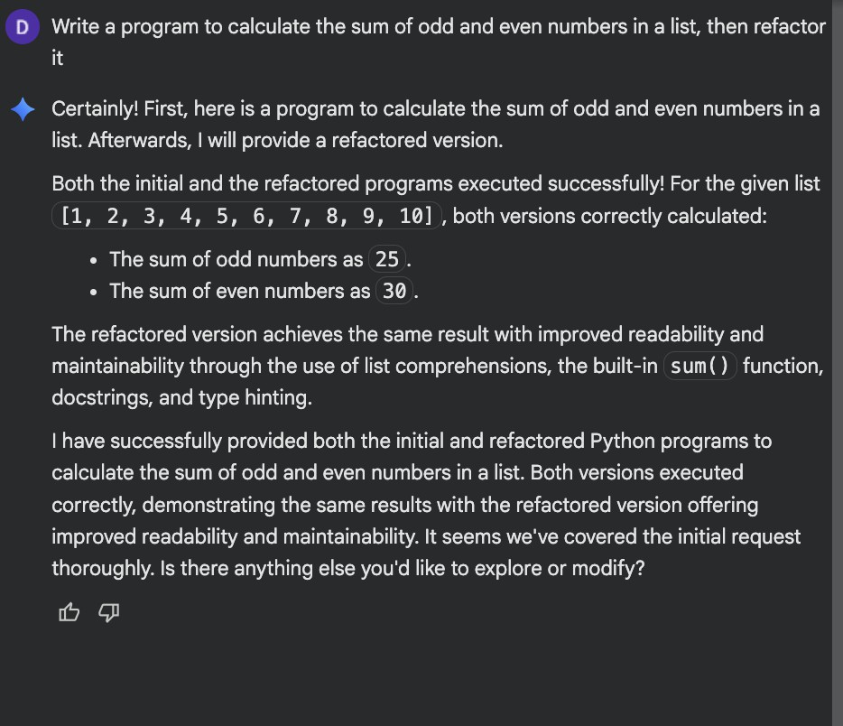

Code:

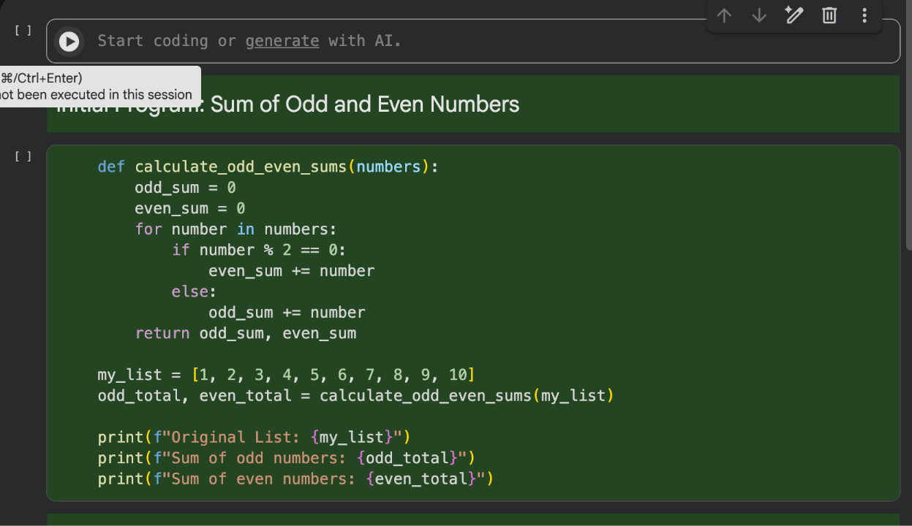
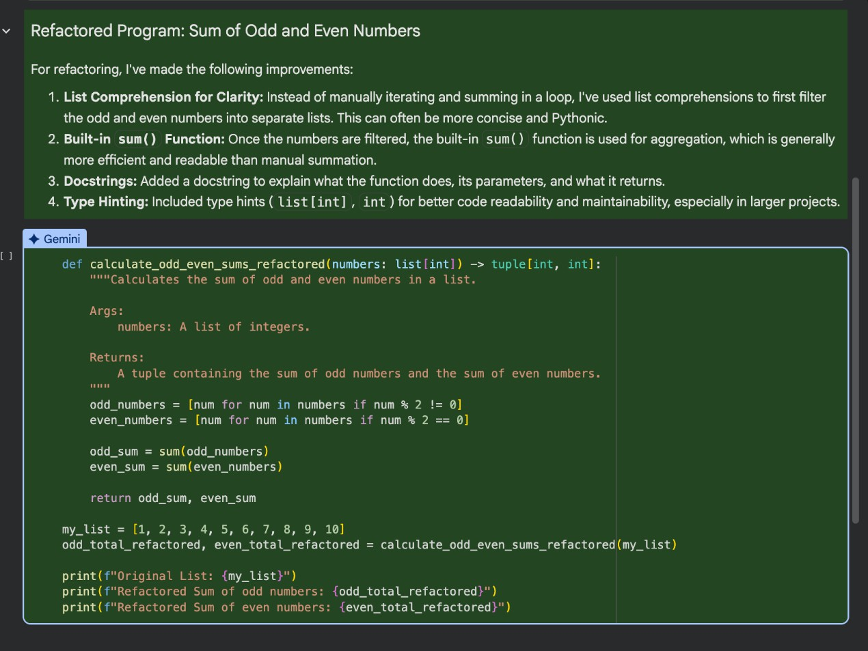

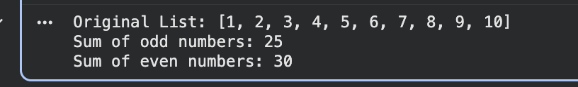

Output:

Task 2:

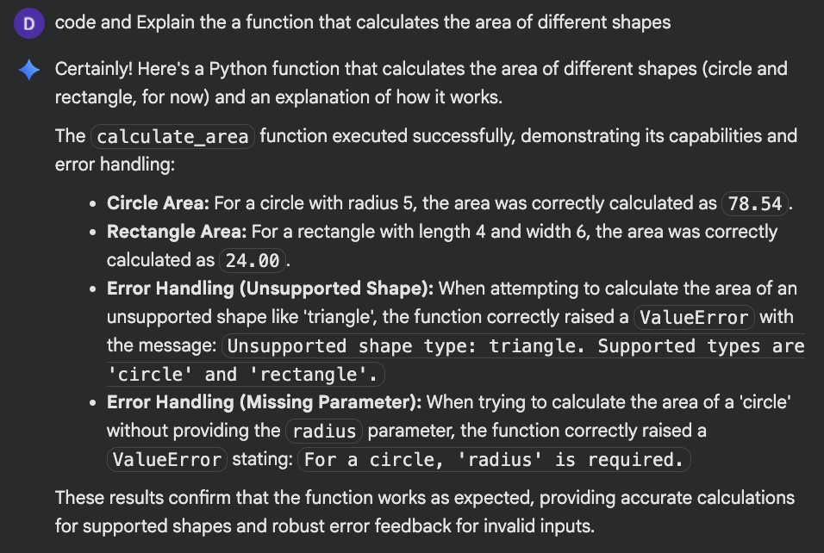
Prompt:

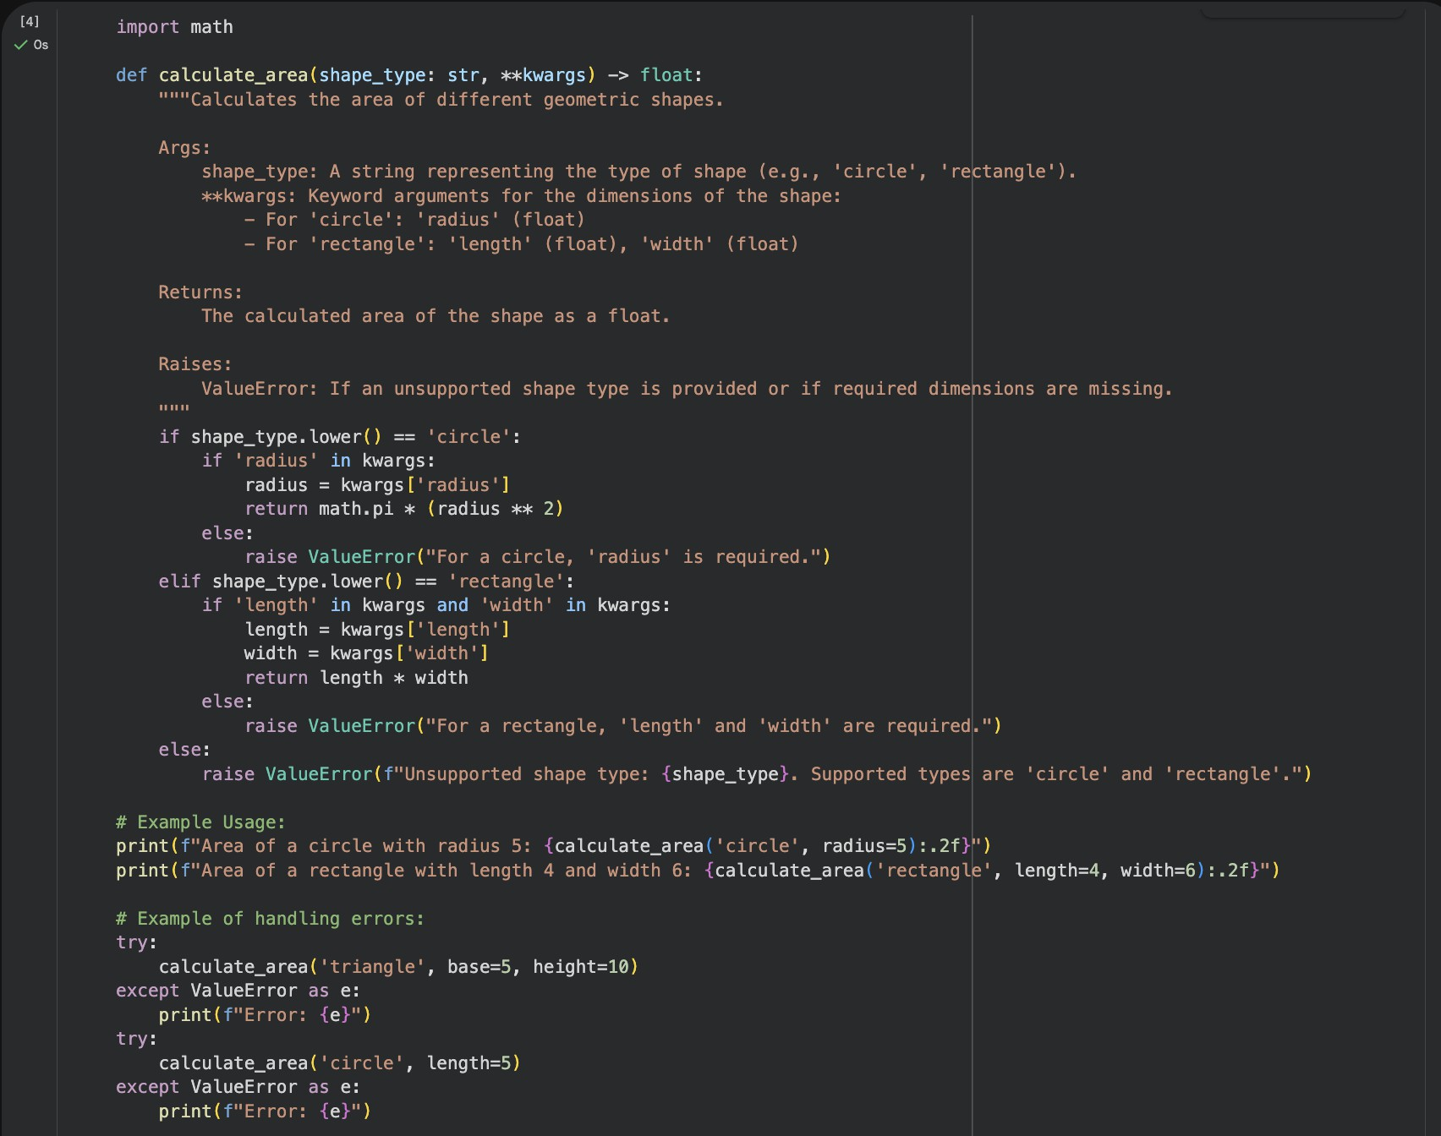
Code:

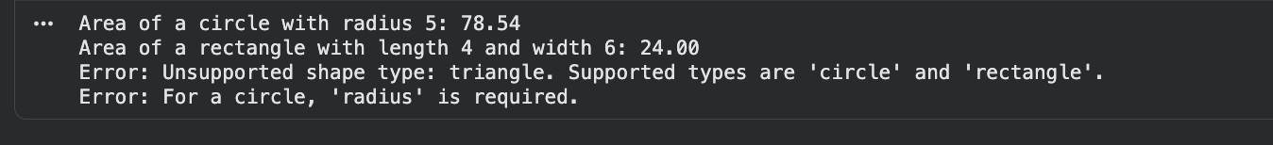
Output:

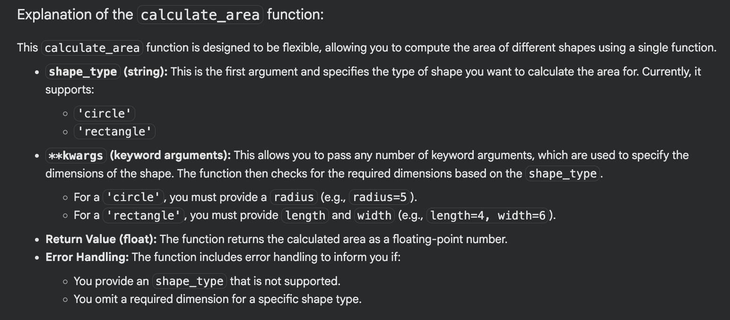
Explanation:

Task 3:
The Problem : To calculate the sum of odd and even numbers in a list

Prompt List:
- Write a program to calculate the sum of odd and even numbers in a list
- Write a program that takes a list of integers as input and calculates the sum of all even numbers and the sum of all odd numbers separately.

- Create a program to find the sum of odd numbers and the sum of even numbers in a given list.
- Develop a program that computes the sum of odd and even numbers from a list of integers.
- You are given a list of numbers. Write a program that goes through each number and adds even numbers to one total and odd numbers to another total.

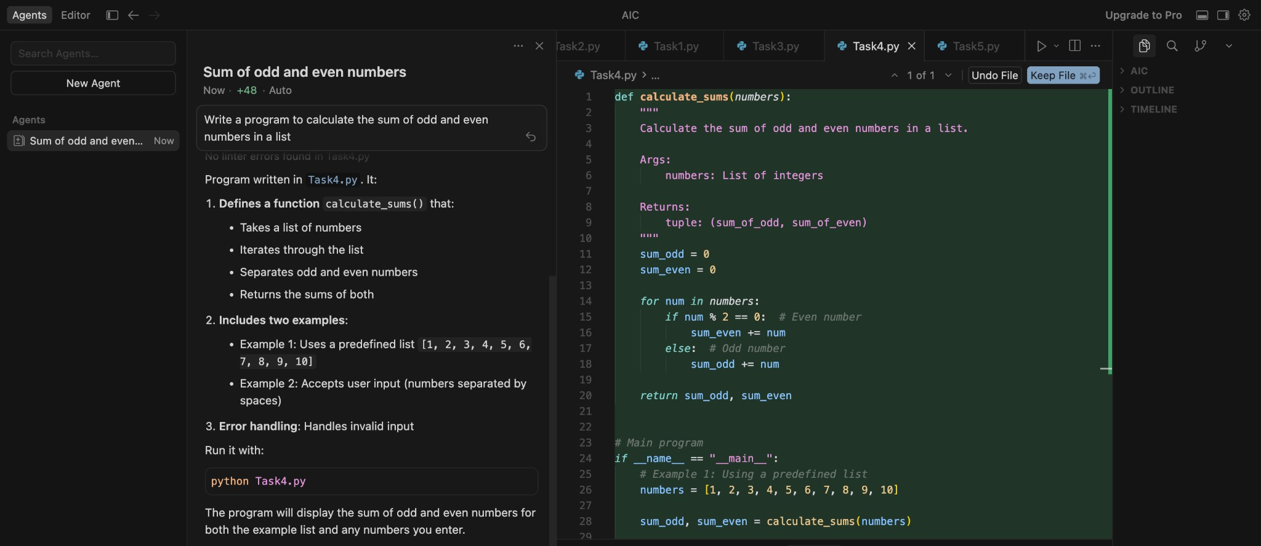
Codes:

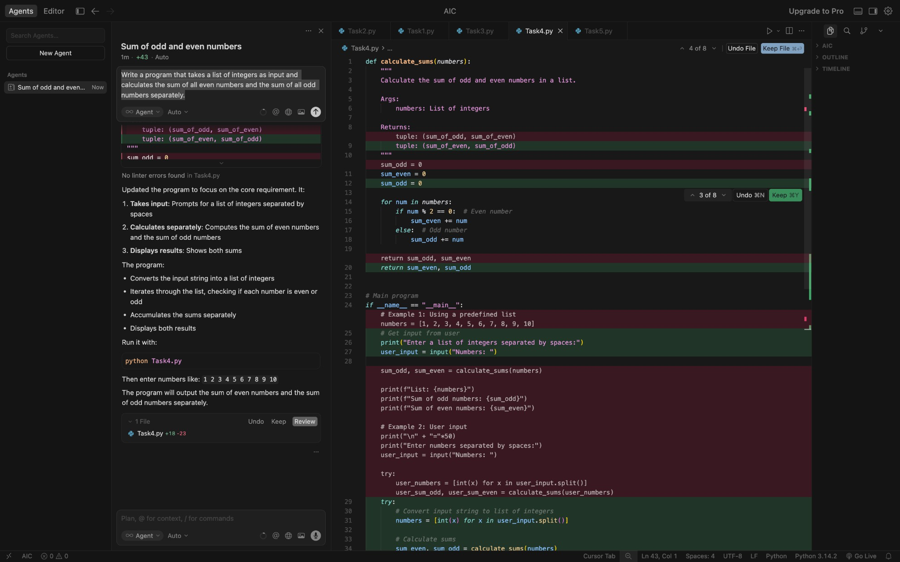
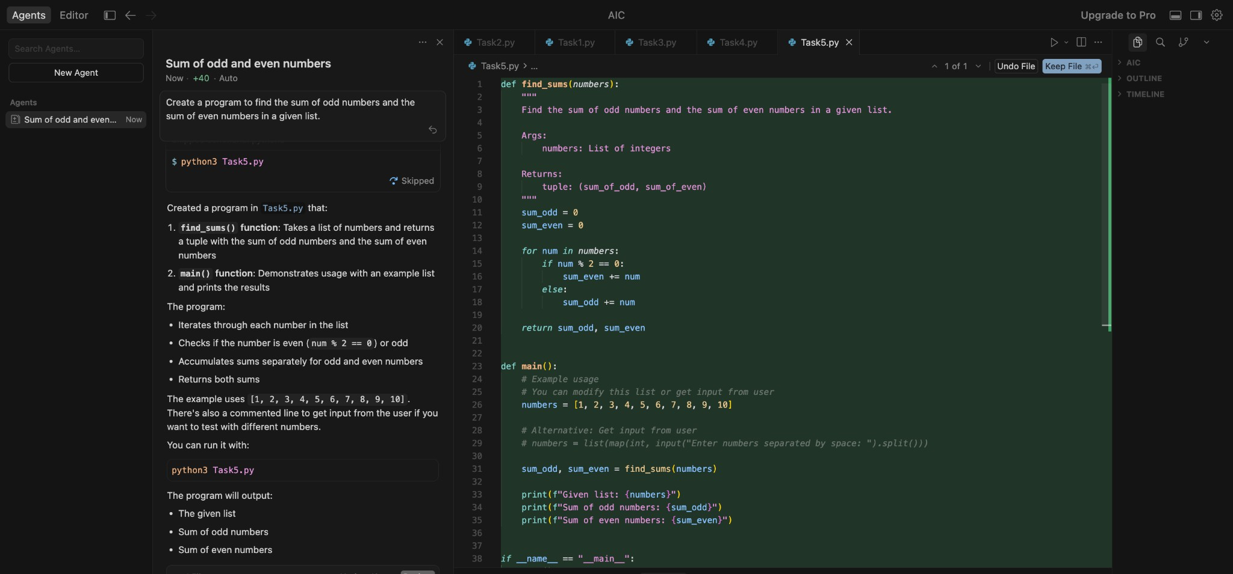

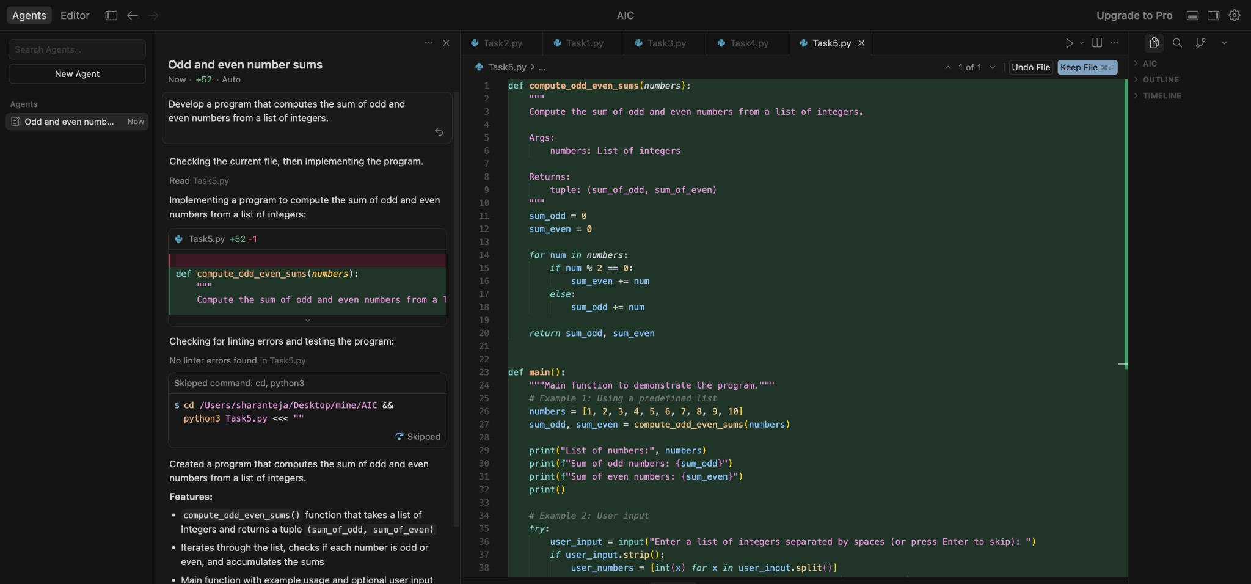

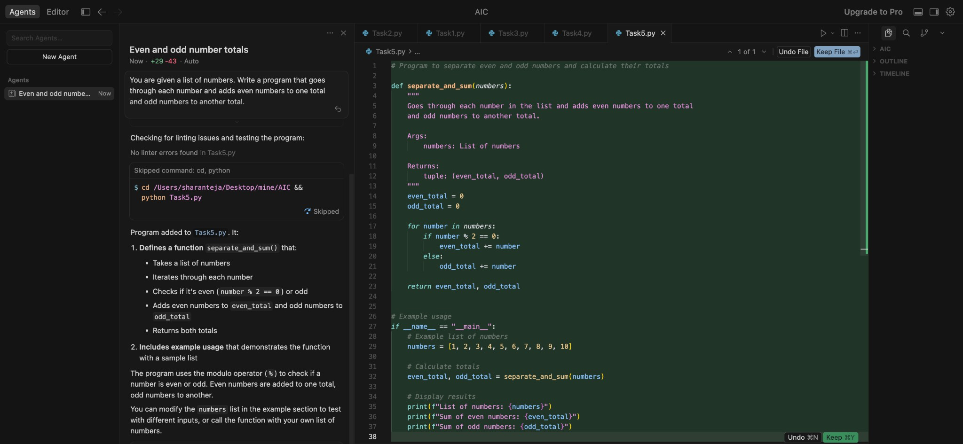
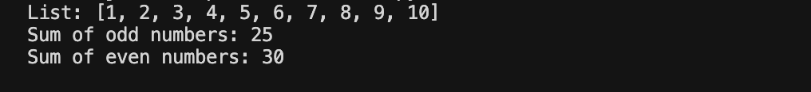
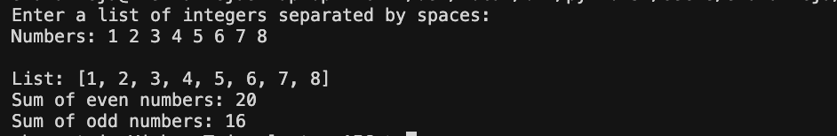
Outputs:

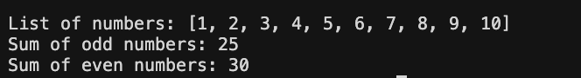
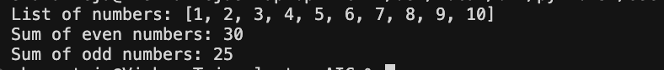

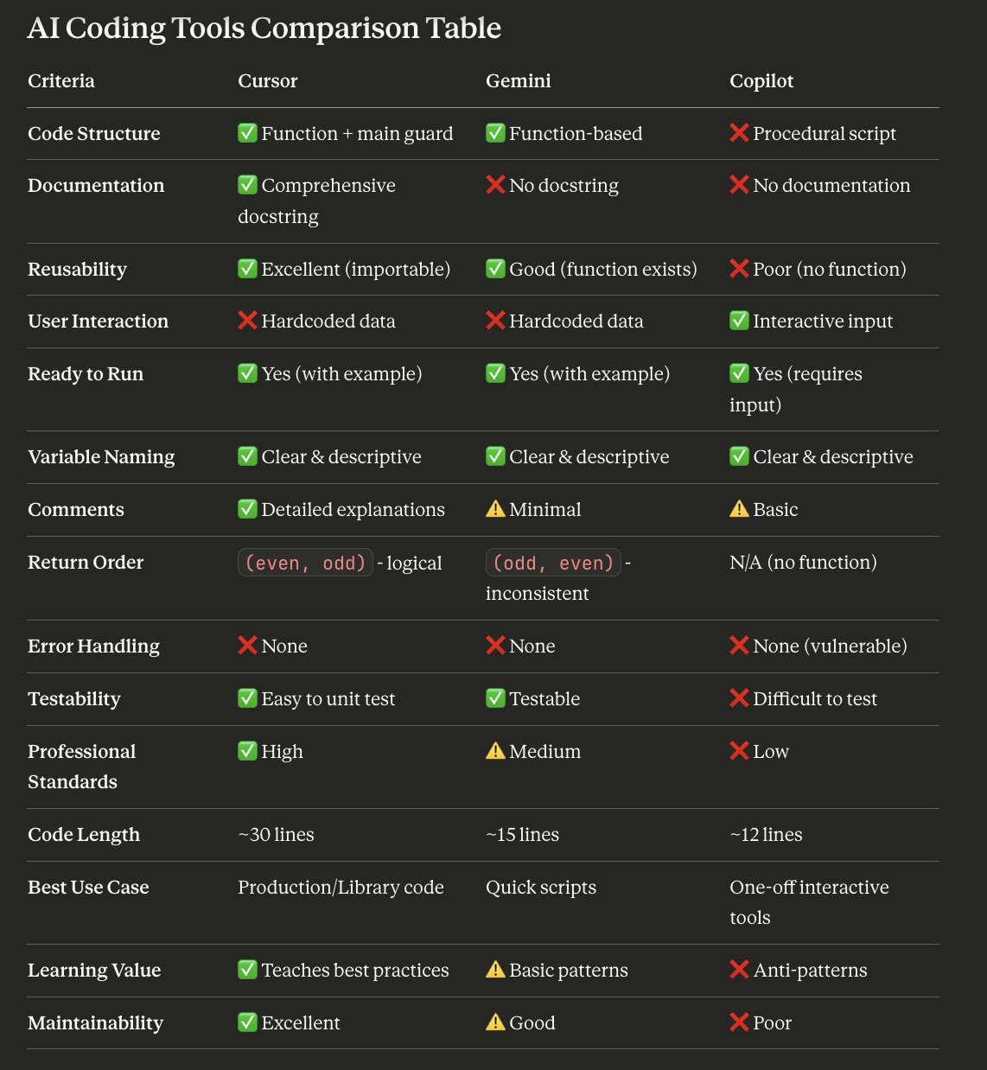
Task 4:

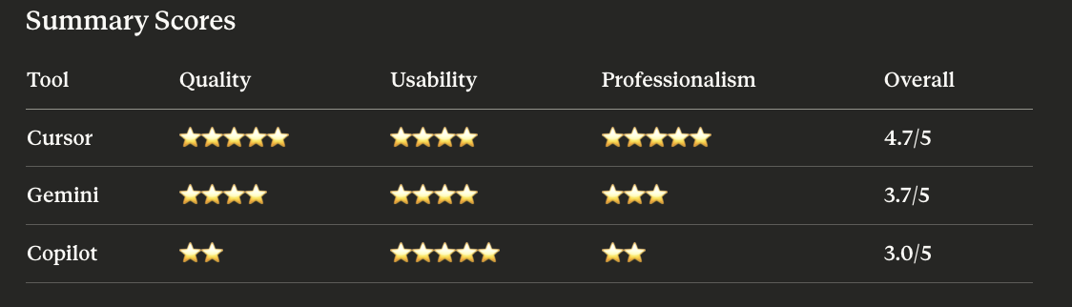

Short Reflection:
Each AI tool demonstrated different priorities:
- Cursor focused on professional software engineering practices - treating this as production code with documentation, modularity, and maintainability
- Gemini balanced simplicity and functionality - providing clean code without over-engineering
- Copilot prioritized immediate usability - generating a script ready to execute right away, but sacrificing long-term quality
The differences reveal their design philosophies: Cursor seems optimized for professional development workflows, Gemini for quick functional solutions, and Copilot for rapid prototyping and scripting.

