V.SAVANTH REDDY
BATCH – 04

LAB – 3.5

AI Assisted Coding – Lab Assignment Answers

Question 1: Zero-Shot Prompting (Leap Year Check)
Zero-shot Prompt:
"Write a Python function to check whether a given year is a leap year."
AI-Generated Code:
# Question 1: Leap Year Check
year = int(input())
if (year % 400 == 0) or (year % 4 == 0 and year % 100 != 0):
print("True")
else:
print("False")
Testing:
1900 → False
2000 → True
2024 → True
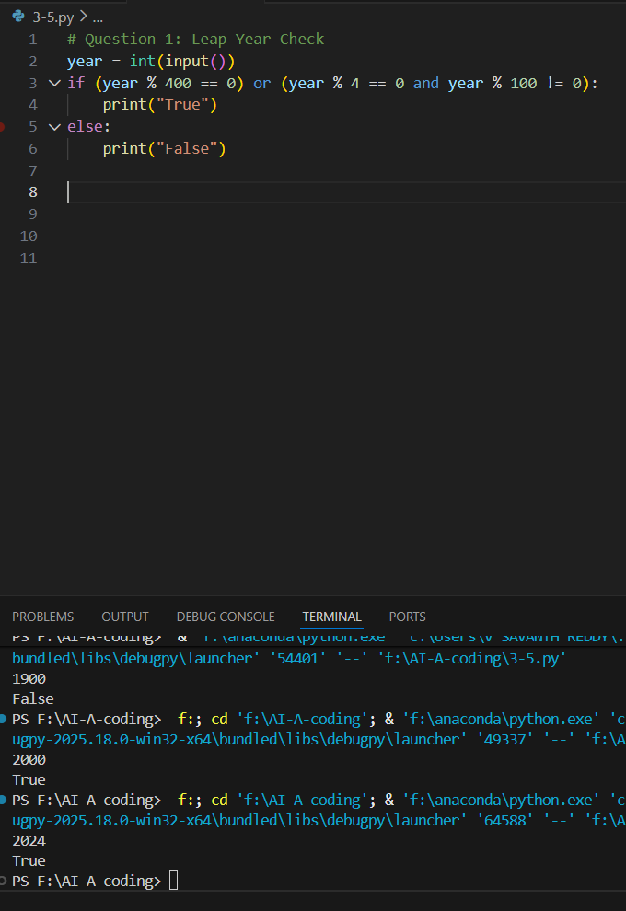
Analysis
- In zero-shot prompting, the AI is given only the task, with no examples.
- The generated solution correctly applies leap-year rules:
  - Divisible by 400 → Leap year
  - Divisible by 4 but not by 100 → Leap year
- Test Results:
  - 1900 → Not a leap year (correct)
  - 2000 → Leap year (correct)
  - 2024 → Leap year (correct)
- Logical Flaws / Missing Conditions:
  - No validation for negative or non-integer inputs.
- Overall, the zero-shot output is logically correct but lacks input validation.

Question 2: One-Shot Prompting (GCD of Two Numbers)
One-shot Prompt:
"Example: Input: 12, 18 → Output: 6.
Write a Python function to find the GCD of two numbers."
AI-Generated Code:
a, b = map(int, input().split())
while b != 0:
a, b = b, a % b
print(a)

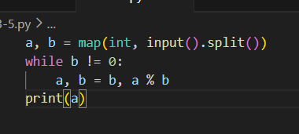
Analysis
- One-shot prompting provides one example, guiding the AI toward the expected logic.
- The AI correctly uses the Euclidean Algorithm, which is efficient.
- Comparison with Zero-Shot:
  - Zero-shot may use a brute-force method.
  - One-shot encourages a more optimal algorithm.
- Efficiency:
  - Time Complexity: O(log n) (very efficient).
- This shows that one example improves both correctness and performance

Question 3: Few-Shot Prompting (LCM Calculation)
Few-shot Prompt Examples:
4, 6 → 12
5, 10 → 10
7, 3 → 21
AI-Generated Code:
a, b = map(int, input().split())
x, y = a, b
while y != 0:
x, y = y, x % y
print(abs(a * b) // x)

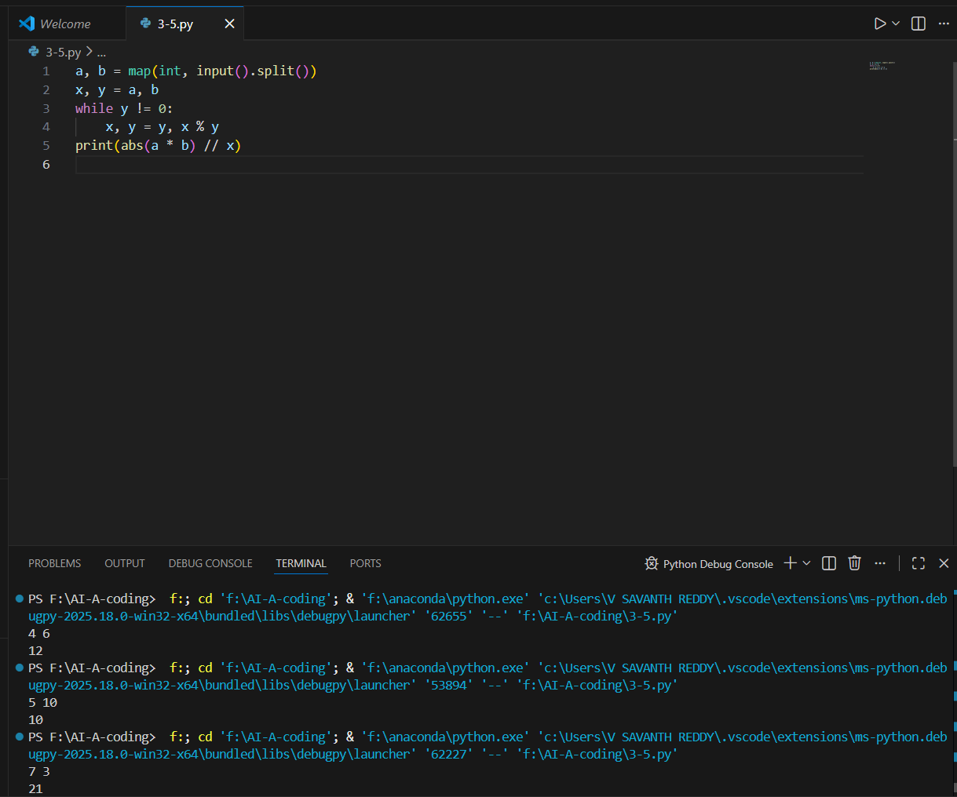
Analysis
- Few-shot prompting gives multiple examples, helping the AI infer the formula:
  - LCM(a, b) = (a × b) / GCD(a, b)
- The generated solution uses GCD internally, which is optimal.
- Role of Examples:
  - Guides the AI to choose a mathematical formula instead of iteration.
- Edge Case Testing:
  - Works correctly for prime numbers.
  - May fail if one input is zero (LCM undefined).
- Few-shot prompting leads to accurate and formula-based solutions

Question 4: Zero-Shot Prompting (Binary to Decimal Conversion)
Zero-shot Prompt:
"Write a Python function to convert binary to decimal."
AI-Generated Code:
binary = input()
decimal = 0
valid = True

for digit in binary:
if digit not in '01':
valid = False
break
decimal = decimal * 2 + int(digit)

if valid:
print(decimal)
else:
print("Error")
Testing:
1010 → 10
Invalid Input: '1021' → Error
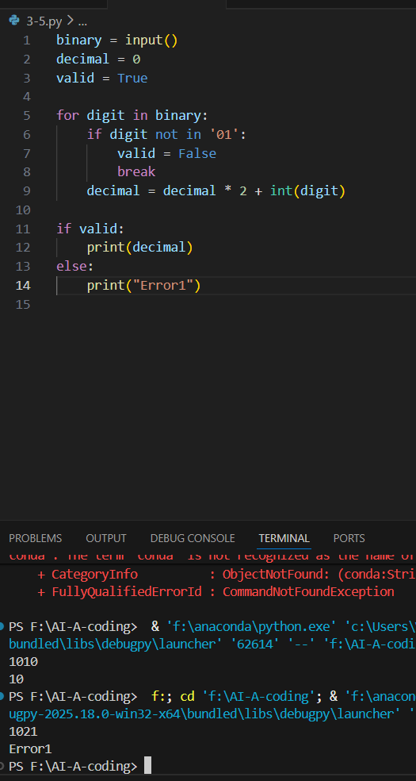
Analysis
- Zero-shot prompt produces a basic binary-to-decimal conversion.
- The logic of positional multiplication by 2 is correct.
- Validation Gaps Identified:
  - Without explicit instructions, AI may skip binary validation.
  - Manual checks for digits (0 and 1) were added.
- Test Cases:
  - Valid input (1010) → Correct output.
  - Invalid input (1021) → Handled after validation.
- Zero-shot prompting often misses validation logic unless explicitly stated.
Missing Validation:
No check to ensure only 0s and 1s are present.

Question 5: One-Shot Prompting (Decimal to Binary Conversion)
One-shot Prompt:
"Example: Input: 10 → Output: 1010.
Write a Python function to convert decimal to binary."
AI-Generated Code:
n = int(input())
if n == 0:
print(0)
elif n < 0:
print("Negative number not supported")
else:
binary = ""
while n > 0:
binary = str(n % 2) + binary
n //= 2
print(binary)

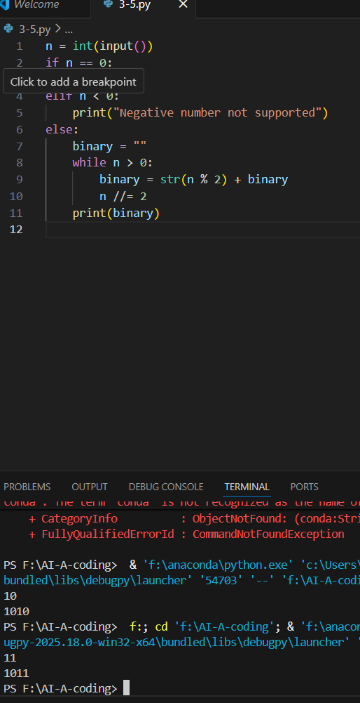
Analysis
- Providing one example makes the output clearer and structured.
- AI correctly applies repeated division by 2.
- Comparison with Zero-Shot:
  - Zero-shot may use built-in functions or unclear logic.
  - One-shot leads to step-by-step logic.
- Edge Cases:
  - Zero handled correctly.
  - Negative numbers are not converted (limitation).
- One-shot prompting improves clarity and correctness.

Question 6: Few-Shot Prompting (Harshad Number Check)
Prompt
Write a Python program to check whether a number is a Harshad (Niven) number.
Examples:
Input: 18 → Harshad Number
Input: 21 → Harshad Number
Input: 19 → Not a Harshad Number
AI-Generated Code:
n = int(input())
s = sum(int(d) for d in str(n))

if n > 0 and n % s == 0:
print("Harshad Number")
else:
print("Not a Harshad Number")
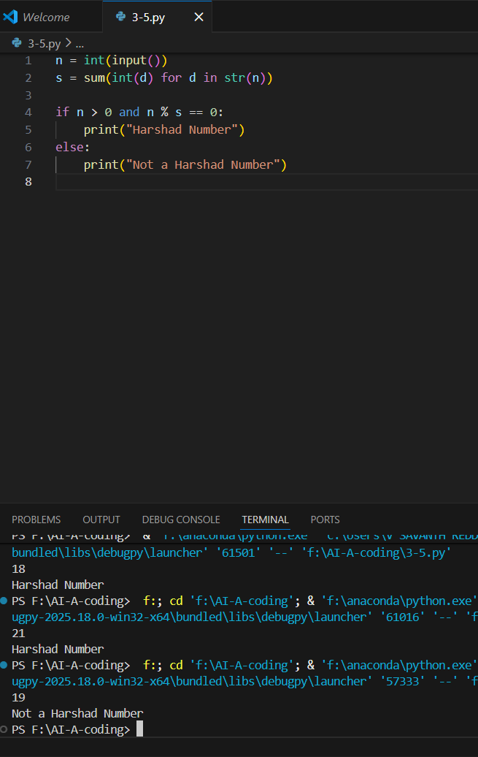
Analysis
- Multiple examples clearly define the rule:
  - Number divisible by sum of its digits.
- The AI correctly extracts digits and checks divisibility.
- Boundary Conditions:
  - Zero and negative numbers are not Harshad numbers.
- Robustness:
  - Handles multi-digit numbers correctly.
  - Simple and reliable logic.
- Few-shot prompting results in high accuracy and robustness.

Conclusion
This lab demonstrated the effectiveness of different AI prompting techniques—Zero-Shot, One-Shot, and Few-Shot Prompting—in generating Python programs. Zero-shot prompting was able to produce correct basic logic but often lacked input validation and edge case handling. One-shot prompting improved clarity and guided the AI toward more efficient algorithms by providing a single example. Few-shot prompting delivered the most accurate and robust solutions, as multiple examples helped the AI clearly understand problem patterns and apply appropriate formulas or conditions. Overall, the experiment shows that providing examples significantly enhances the correctness, efficiency, and reliability of AI-generated code.

