AI ASSISTED CODING LAB ASSIGNMENT 9.5

V. SAVANTH

2303A51226

-BATCH – 04

LAB EXPERIMENT 9.5: Documentation Generation – Automatic Documentation and Code Comments
PROBLEM 1: String Utilities Function QUESTION
Consider the function:
def reverse_string(text): return text[::-1]
Write documentation in:
- Docstring
- Inline comments
- Google-style documentation
Compare the three documentation styles and recommend the most suitable style for a utility-based string library.

PROMPT
Generate proper documentation for the given string utility function in three formats: standard docstring, inline comments, and Google-style documentation. Then compare the formats and recommend the best style.

CODE
- Docstring format
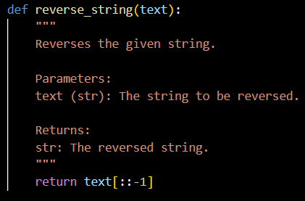
- Inline comments
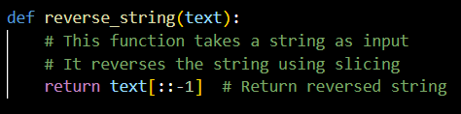
- Google-style Documentation
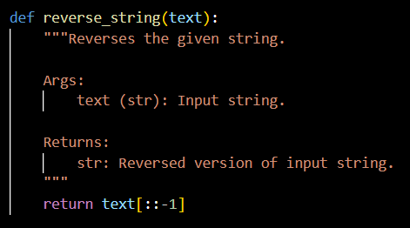

OUTPUT
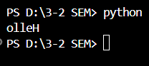
EXPLANATION
Docstrings provide structured documentation that can be accessed using help() function.

Inline comments are simple but not suitable for generating automated documentation.
Google-style documentation is structured, readable, and widely used in industry.
Recommended Style: Google-style documentation is most suitable for utility- based libraries because it is clean, standardized, and compatible with documentation tools.

Task 2: PASSWORD STRENGTH CHECKER QUESTION
def check_strength(password): return len(password) >= 8
Document the function using docstring, inline comments, and Google style. Compare the styles and recommend the best one for security-related code.

PROMPT
Generate structured documentation for a password strength checker function in three documentation formats and compare them.

CODE
- Docstring format
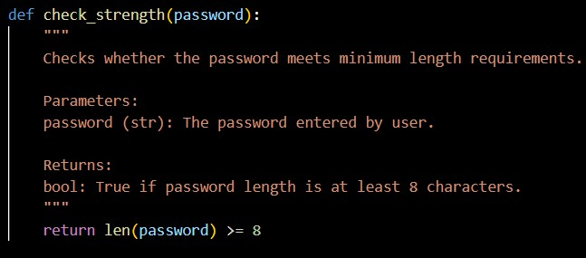

- Inline Comments
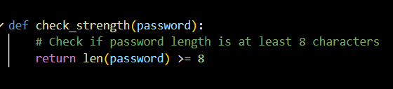
- Google-Style Documentation
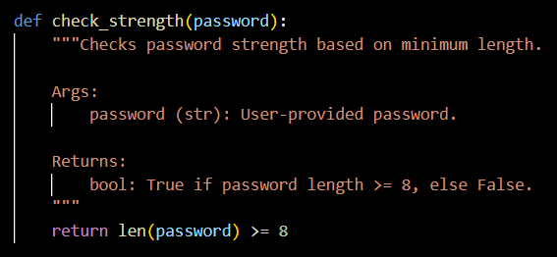
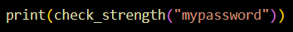

OUTPUT
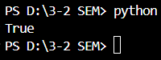
EXPLANATION
Security-related functions require clarity and precision.
Google-style documentation clearly defines arguments and return types. Inline comments are insufficient for professional security systems.
Recommended Style: Google-style documentation because security code requires clarity and maintainability.

Task 3: Math Utilities Module QUESTION
Create a module math_utils.py with:
- square(n)
- cube(n)
- factorial(n)
Generate docstrings and export documentation as HTML.

PROMPT
Create a math utilities module with proper documentation and generate HTML documentation using Python documentation tools.
CODE (math_utils.py)
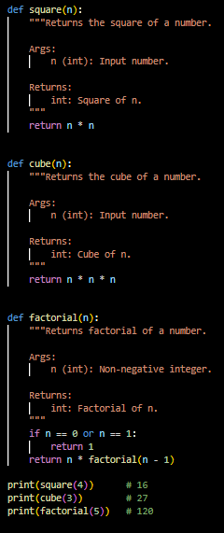

OUTPUT
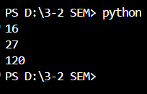
EXPLANATION
Docstrings allow automatic documentation generation using pydoc. Exporting to HTML improves usability and readability.
Structured documentation improves maintainability of reusable modules.

Task 4: Attendance Management Module QUESTION
Create attendance.py module with:
- mark_present(student)
- mark_absent(student)
- get_attendance(student)
Add proper docstrings and generate documentation.

PROMPT
Develop an attendance management module with documented functions and generate documentation viewable in terminal and browser.

CODE
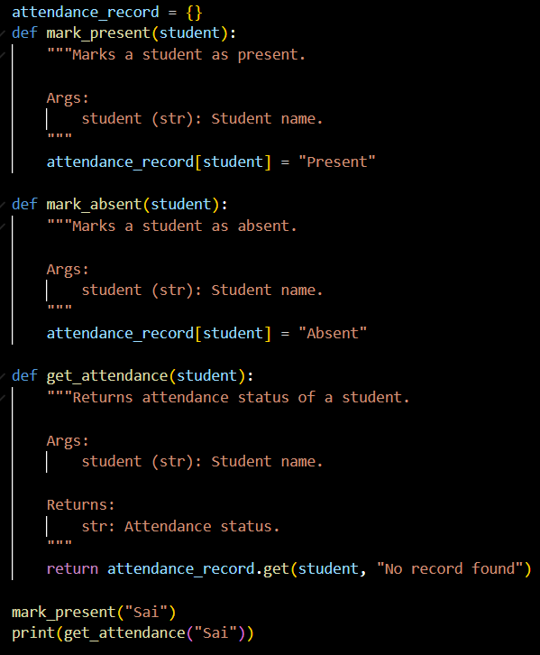
OUTPUT
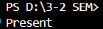
EXPLANATION
Adding docstrings makes the module self-documented.
Documentation tools allow viewing structured information directly in terminal or browser.
This improves maintainability and readability.

Task 5: File handling function QUESTION
Consider the function: def read_file(filename):
with open(filename, 'r') as f: return f.read()

Write documentation using all three formats. Identify which style best explains exception handling and justify your recommendation.

PROMPT
Generate structured documentation for a file reading function in three formats and determine which documentation style best explains exception handling.

CODE
- Docstring Format
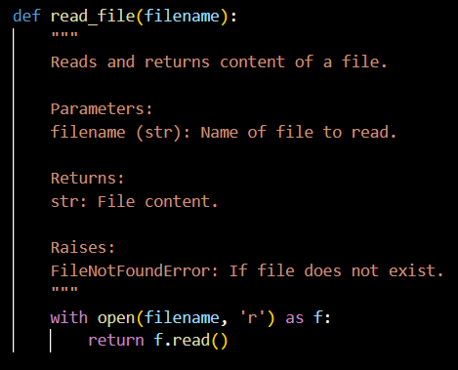

- Inline comments
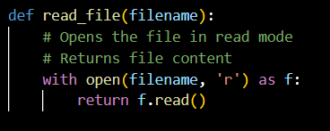

- Google-Style Documentation
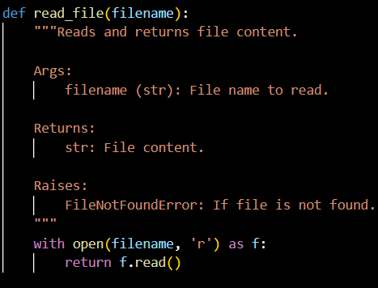
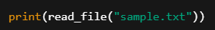

OUTPUT
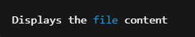
EXPLANATION
Exception handling must be clearly documented.
Inline comments do not formally describe possible errors.
Google-style documentation includes structured Raises section, making it clear and professional.
Recommendation: Google-style documentation is most suitable for explaining exception handling because it clearly defines parameters, returns, and possible errors in a structured manner.

