Assignment - 1

Name: V SAVANTH REDDY
Roll Number:2303A51226
Batch - 04
AI Assisted Coding 09-01-2026
Task 0: Environment Setup:- Task 0
- Install and configure GitHub Copilot in VS Code. Take screenshots of each step.
Expected Output
- Install and configure GitHub Copilot in VS Code. Take screenshots of each step.
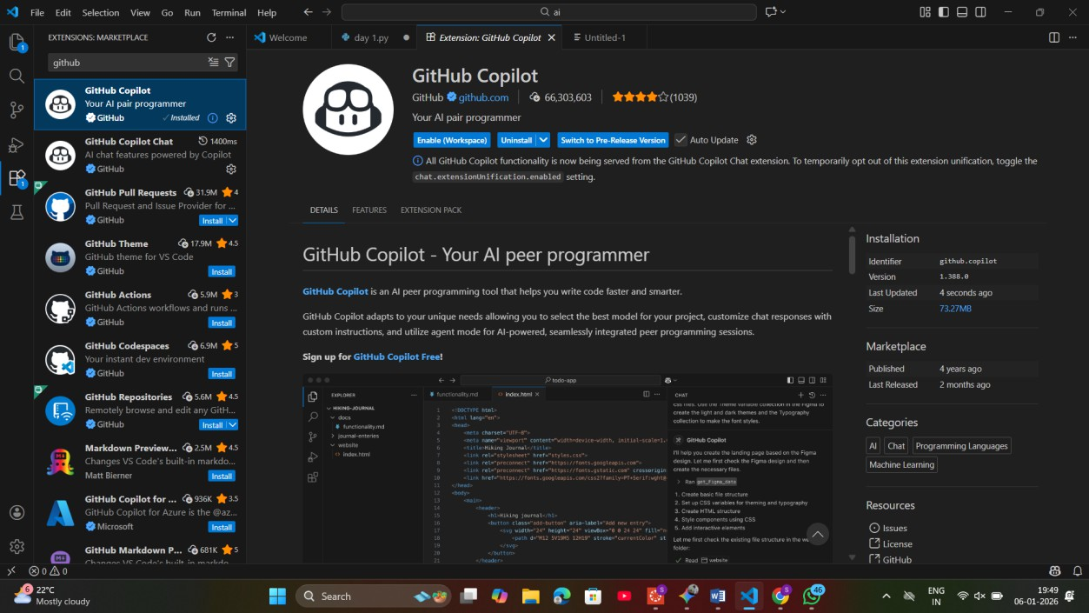

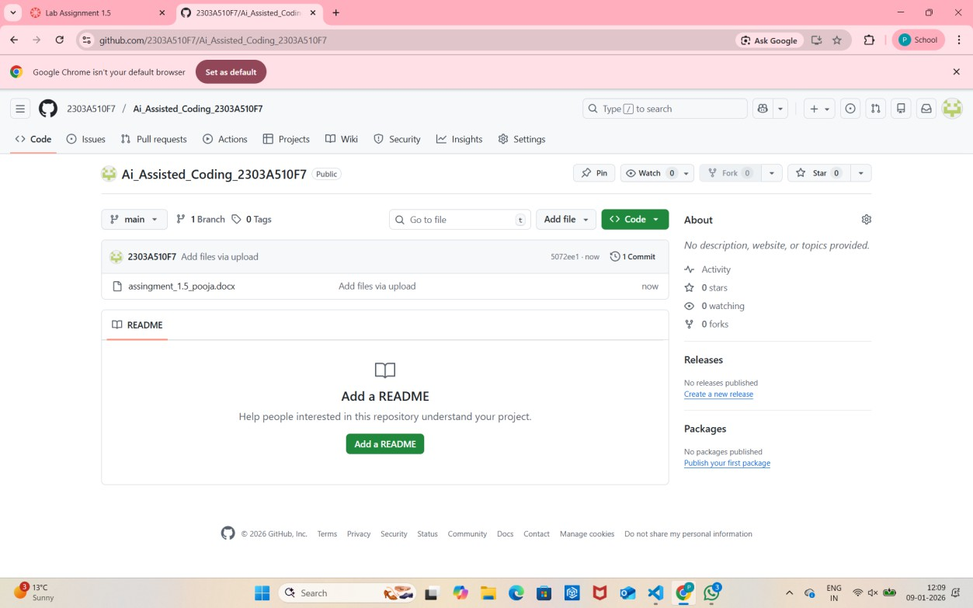
Task 1: Non-Modular Logic (Factorial):-
: AI-Generated Logic Without Modularization (String Reversal Without Functions)
- Scenario
You are developing a basic text-processing utility for a messaging application.
- Task Description
Use GitHub Copilot to generate a Python program that:
- Reverses a given string
- Accepts user input
- Implements the logic directly in the main code
- Does not use any user-defined functions
- Expected Output
- Correct reversed string
- Screenshots showing Copilot-generated code suggestions

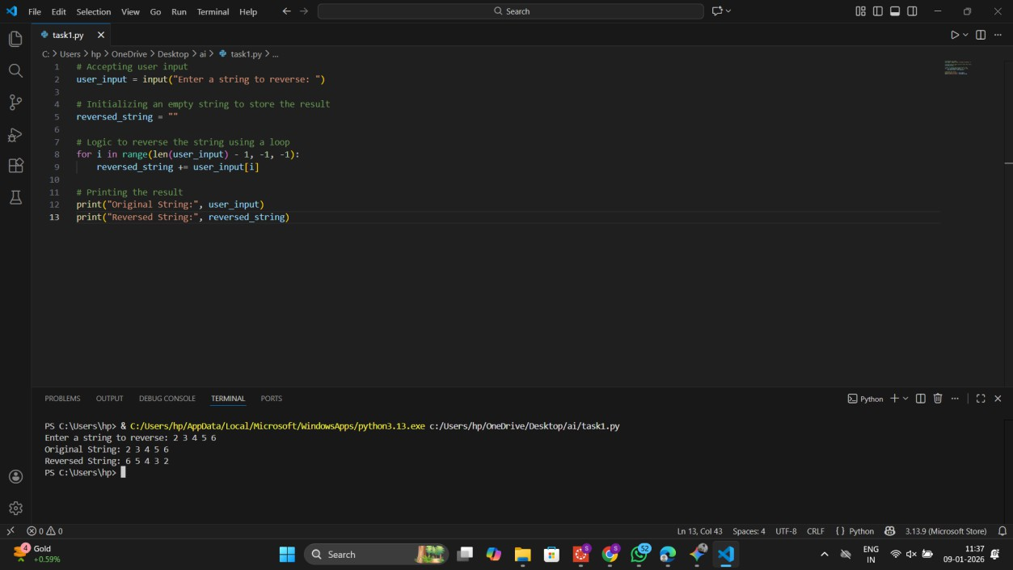
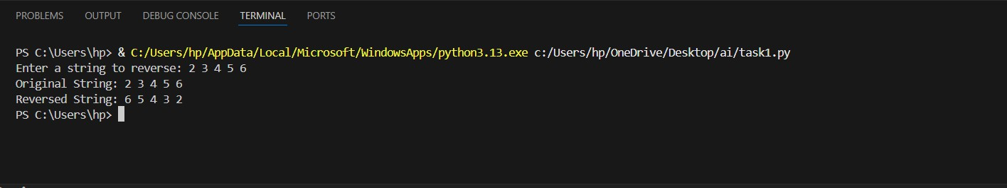
- Sample inputs and outputs

Task 2: AI Code Optimization:-
Efficiency s Logic Optimization (Readability Improvement)
- Scenario
The code will be reviewed by other developers.
- Task Description
Examine the Copilot-generated code from Task 1 and improve it by:
- Removing unnecessary variables
- Simplifying loop or indexing logic
- Improving readability
- Use Copilot prompts like:
- “Simplify this string reversal code”
- “Improve readability and efficiency”

Hint:
Prompt Copilot with phrases like
“optimize this code”, “simplify logic”, or “make it more readable”
- Expected Output
- Original and optimized code versions
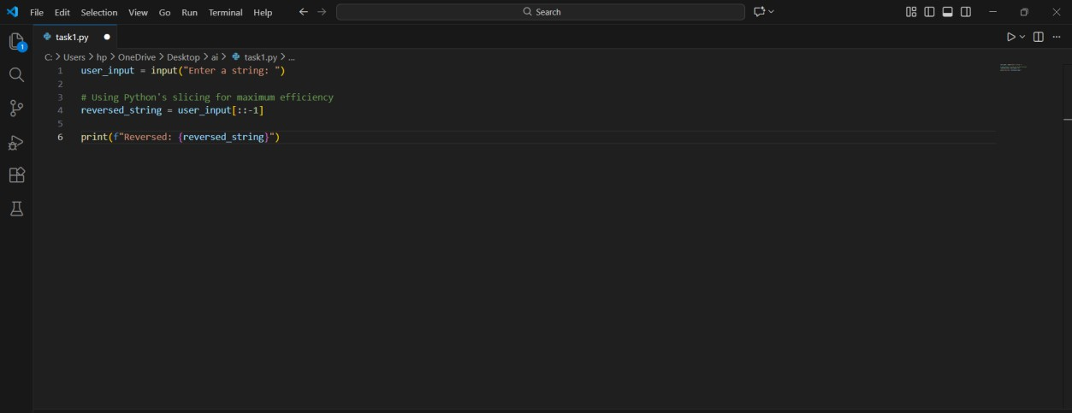
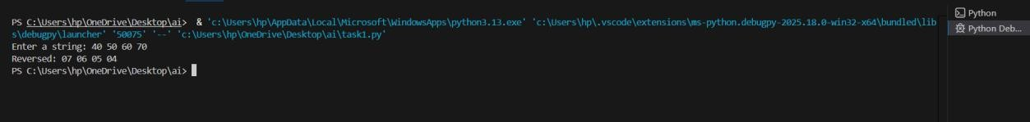
- Explanation of how the improvements reduce time complexity

Task 3: Modular Design Using AI Assistance (String Reversal Using Functions)
- Scenario
The string reversal logic is needed in multiple parts of an application.
- Task Description
Use GitHub Copilot to generate a function-based Python program that:
- Uses a user-defined function to reverse a string
- Returns the reversed string
- Includes meaningful comments (AI-assisted)
- Expected Output
- Correct function-based implementation
- Screenshots documenting Copilot’s function generation

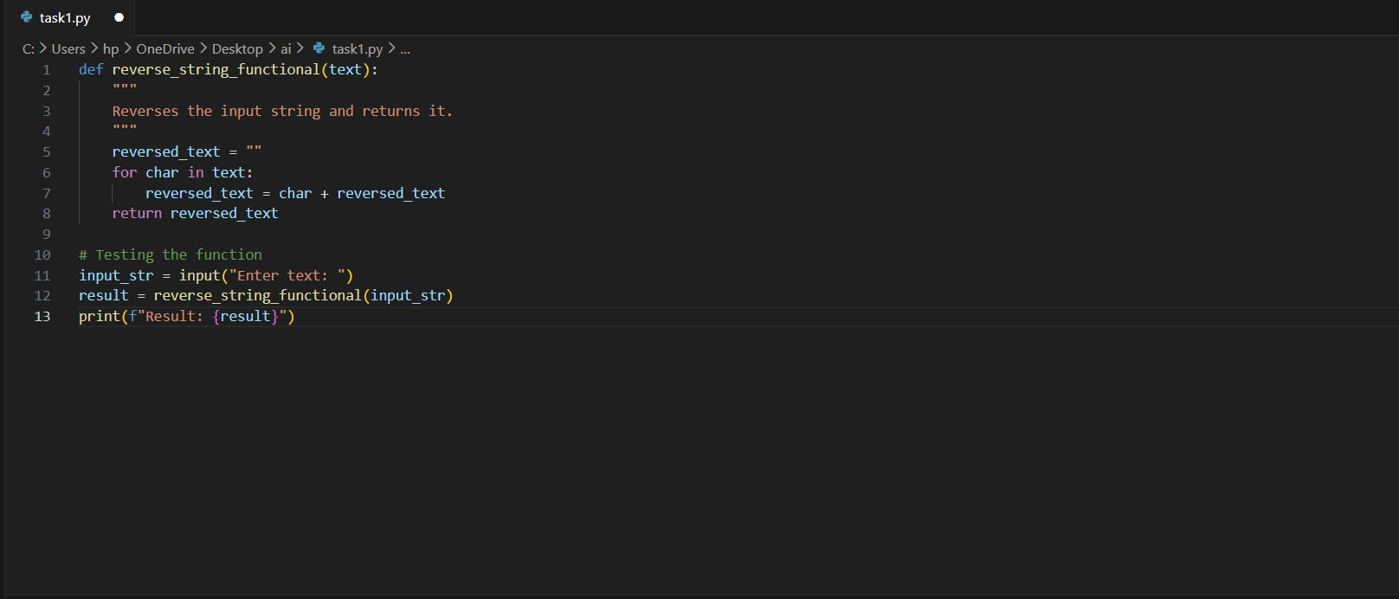
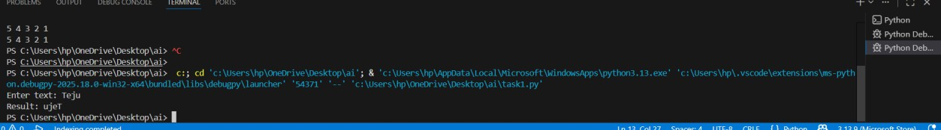
- Sample test cases and outputs

Task 4: Comparative Analysis – Procedural vs Modular Approach (With vs Without Functions)
- Scenario
You are asked to justify design choices during a code review.
- Task Description
Compare the Copilot-generated programs:
- Without functions (Task 1)
- With functions (Task 3) Analyze them based on:
- Code clarity
- Reusability
- Debugging ease
- Suitability for large-scale applications
- Expected Output
Comparison table or short analytical report

Feature | Procedural (Without Functions) | Modular (With Functions)
Code Clarity | Easy for tiny scripts; messy for large ones. | Very high; logic is isolated and named.
Reusability | Must copy-paste code to use it again. | Can be called anywhere in the app.
Debugging | Harder to isolate where an error occurs. | Easy to unit test the specific function.
Scalability | Not suitable for large applications. | Essential for professional development.

Task 5: AI-Generated Iterative vs Recursive Fibonacci Approaches (Different Algorithmic Approaches to String Reversal)
- Scenario
Your mentor wants to evaluate how AI handles alternative logic paths.
- Task Description
Prompt GitHub Copilot to generate:
- A loop-based string reversal approach
- A built-in / slicing-based string reversal approach
- Expected Output
- Two correct implementations
- Comparison discussing:
- Execution flow
- Time complexity
- Performance for large inputs
- When each approach is appropriate.

