AI ASSISTED CODING
Lab 3.2: Prompt Engineering – Improving Prompts and Context Management
Lab Title: Prompt Engineering – Improving Prompts and Context Management
Platform Used: Google Colab (Gemini AI)
V SAVANTH REDDY
2303a51226
BATCH – 04
Lab Objectives
- To understand how prompt structure and wording influence AI-generated code
- To explore how context (comments and function names) helps AI generate relevant output
- To evaluate the quality and accuracy of code based on prompt clarity
- To develop effective prompting strategies for AI-assisted programming
Lab Outcomes (LOs)
After completing this lab, students will be able to:
- Generate Python code using Google Gemini in Google Colab
- Analyze the effectiveness of code-generation suggestions by Gemini
- Set up and use Cursor AI for AI-powered coding assistance
- Evaluate and refactor code using Cursor AI features
- Compare AI tool behavior and code quality across platforms

Task Description 1 – Progressive Prompting for Calculator Design
Prompt - Create a calculator in Python.
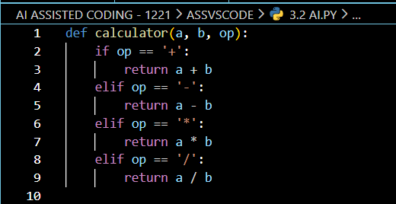
Issues Identified
- No user input
- No error handling
- Function purpose not clear
- No comments

Step 2: Improved Prompt
Create a Python calculator function named simple_calculator that takes two numbers and an operator as input.
Add comments and handle division by zero.
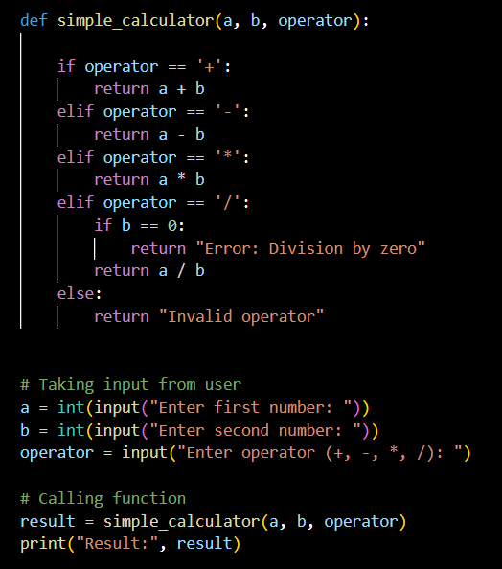
Explanation
- Function name clearly explains purpose
- Division by zero handled safely
- Docstring added for clarity
OUTPUT:
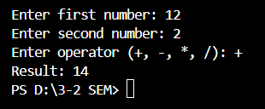

Task Description 2 – Refining Prompts for Sorting Logic
PROMPT
Refining Prompts for Sorting Logic: Start with a vague prompt for sorting student marks,
then refine it to clearly specify sorting order and constraints.
Step 1 – Sort Students marks
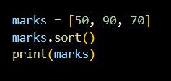
Problem
- Sorting order unclear
- No function
- No explanation

Step 2 - Write a Python function that sorts student marks in descending order using efficient logic and comments.
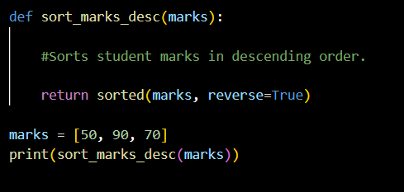
Explanation
- sorted() is efficient and readable
- reverse=True ensures descending order

OUTPUT
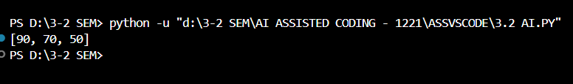
Task Description – 3
Few-Shot Prompting for Prime Number Validation
PROMPT
Example:
Input: 7 → Output: Prime
Input: 4 → Output: Not Prime
Write a Python function to check whether a given number is prime.
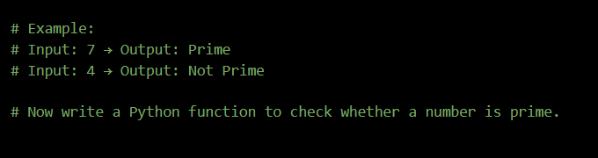

CODE
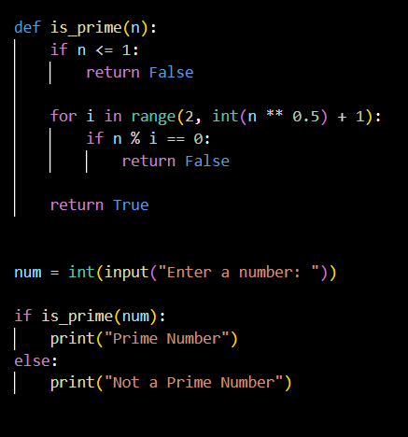
Code Explanation
- The function is_prime() takes an integer as input.
- Numbers less than or equal to 1 are immediately rejected.
- The loop checks divisibility only up to the square root of the number, improving efficiency.
- If no divisor is found, the number is declared prime.
- User input is taken and output is displayed clearly.
OUTPUT:
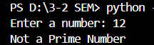
Input equals to 12 and it is not prime number
Second input 2 for proving that prime number
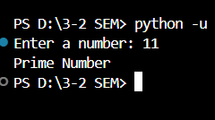
Task Description – 4
Prompt-Guided User Interface Design for Student Grading System
Prompt Used - Create a Python program that accepts student marks as input,
calculates the percentage, assigns grades, and displays the result clearly.
CODE
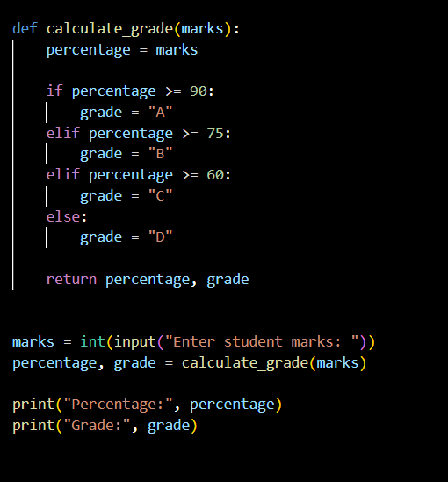

OUTPUT:
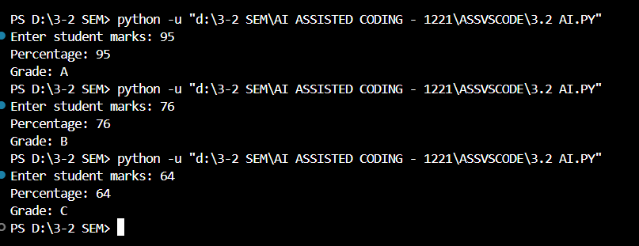

Code Explanation
- The function calculate_grade() computes the percentage and grade.
- Conditional statements are used to assign grades accurately.
- User input is taken for marks.
- Output is displayed in a clear and readable format.

Task Description – 5
Analyzing Prompt Specificity in Unit Conversion
Aim - To understand how specific and detailed prompts improve the correctness and clarity of AI-generated unit conversion functions.
PROMPT USED
Write a Python function to convert kilometers to miles.
Include comments and display clear output.

CODE:
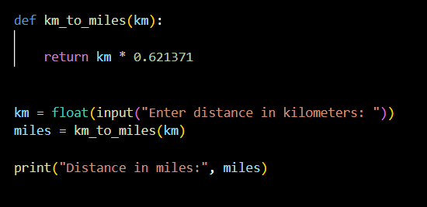
OUTPUT:
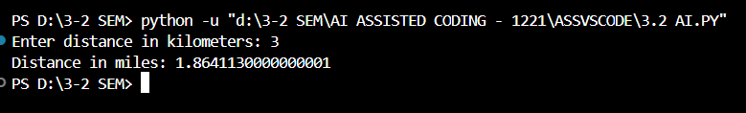
Conclusion
This lab demonstrates that prompt clarity, examples, and specificity significantly improve AI-generated code quality. Few-shot prompting enhances logical accuracy, while structured prompts lead to better user interaction, readability, and correct program flow.

