LAB 7: Error Debugging with AI
Course: AI Assisted Coding
Assignment Number: 7.5
v.savanth reddy
batch – 04
date – 06-02-25
Objective: To identify and fix syntax, logic, and runtime errors using AI-assisted debugging.

Task 1: Mutable Default Argument – Function Bug
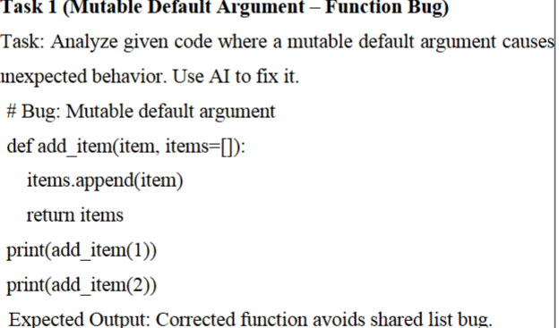
AI Prompt:
Analyze the Python function and identify why the list is shared between calls. Fix the issue.
Solution:
def add_item(item, items=None):
if items is None:
items = []
items.append(item)
return items
print(add_item(1))
print(add_item(2))
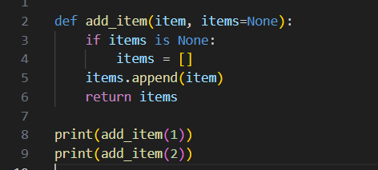
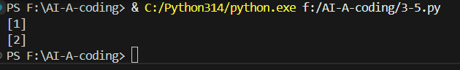
Explanation:
In Python, default arguments are evaluated only once when the function is defined. When a mutable object like a list is used as a default argument, the same list is shared across multiple function calls. This causes unexpected results. The issue is fixed by using None as the default value and creating a new list inside the function

Task 2: Floating-Point Precision Error
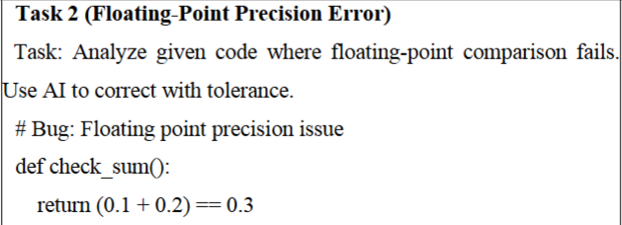
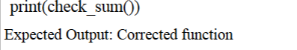

AI Prompt:
Why does floating-point comparison fail? Fix it using tolerance.
Solution:
def check_sum():
return abs((0.1 + 0.2) - 0.3) < 1e-9
print(check_sum())
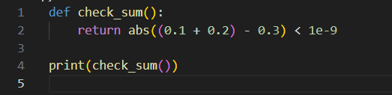
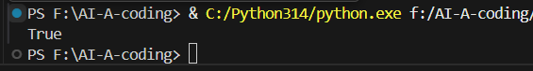
Explanation:
Floating-point numbers are stored as approximations in memory, so exact comparisons using == may fail. The sum of 0.1 and 0.2 is not exactly equal to 0.3 due to precision limitations. This issue is corrected by comparing the difference using a small tolerance value

Task 3: Recursion Error – Missing Base Case
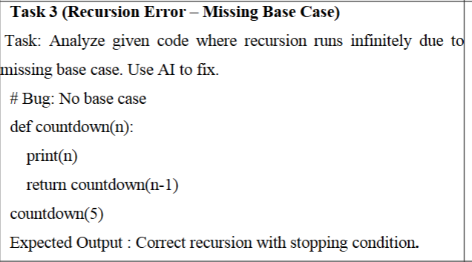
AI Prompt:
Identify the recursion error and add a proper base case.
Solution:
def countdown(n):
if n < 0:
return
print(n)
countdown(n-1)
countdown(5)
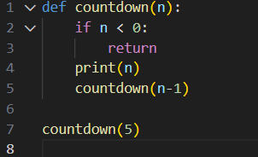
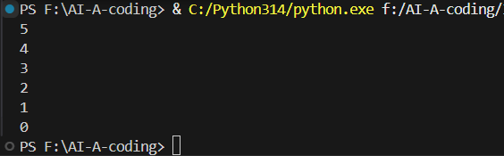
Explanation:
Recursion must always have a base case to stop further function calls. Without a base case, the function keeps calling itself indefinitely, leading to a stack overflow error. Adding a base condition ensures the recursion stops at the correct point

Task 4: Dictionary Key Error
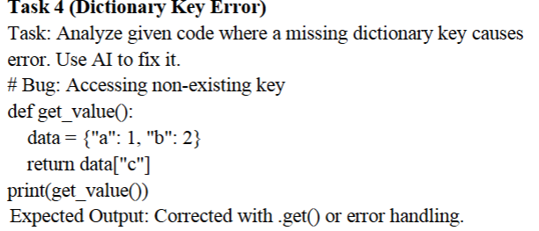
AI Prompt:
Fix the KeyError using safe dictionary access.
Solution:
def get_value():
data = {"a": 1, "b": 2}
return data.get("c", "Key not found")
print(get_value())
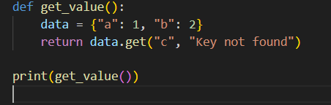
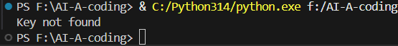
Explanation:
Accessing a dictionary key that does not exist raises a KeyError. This issue occurs when the program directly tries to access a missing key. Using the .get() method or exception handling prevents the error and allows the program to continue safely

Task 5: Infinite Loop – Wrong Condition
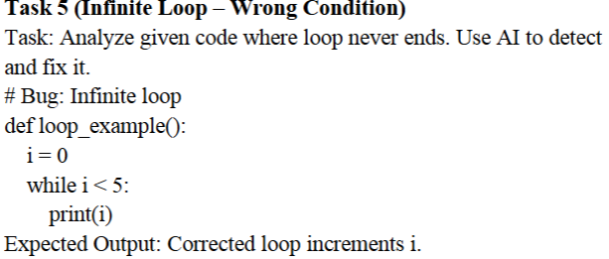
AI Prompt:
Why does the loop never stop? Fix the loop.
Solution:
def loop_example():
i = 0
while i < 5:
print(i)
i += 1
loop_example()
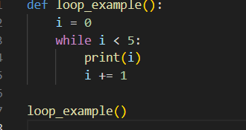
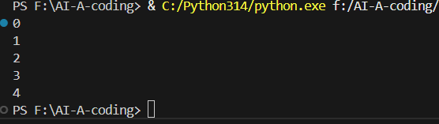
Explanation:
An infinite loop occurs when the loop condition never becomes false. In this case, the loop variable is not updated, so the condition always remains true. Incrementing the loop variable inside the loop ensures proper termination

Task 6: Unpacking Error – Wrong Variables
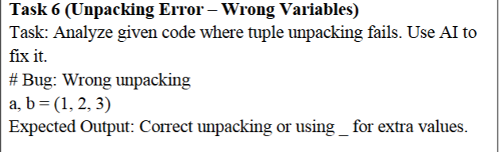
AI Prompt:
Fix the tuple unpacking error.
Solution:
a, b, _ = (1, 2, 3)
print(a, b)
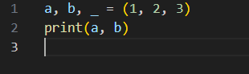
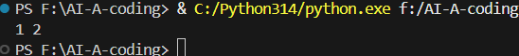
Explanation:
Tuple unpacking requires the number of variables to match the number of values. When there are extra values, Python raises an error. This issue is fixed by using an underscore (_) to ignore unwanted values during unpacking.

Task 7: Mixed Indentation – Tabs vs Spaces
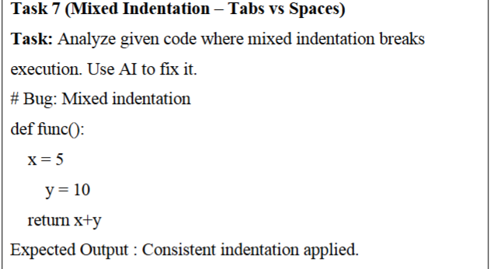
AI Prompt:
Fix the indentation error using consistent spacing.
Solution:
def func():
x = 5
y = 10
return x + y
print(func())
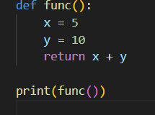
Explanation:
Python relies on indentation to define code blocks. Mixing tabs and spaces causes indentation errors and breaks execution. The problem is fixed by using consistent indentation, usually four spaces, throughout the code

Task 8: Import Error – Wrong Module Usage
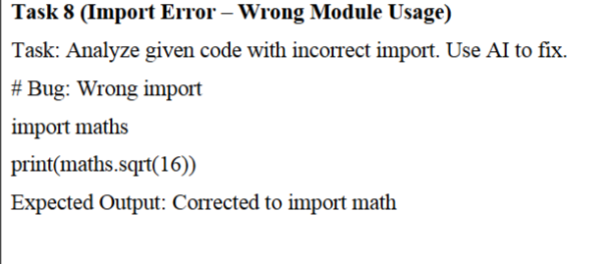
AI Prompt:
Correct the module import error.
Solution:
import math
print(math.sqrt(16))
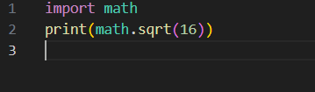
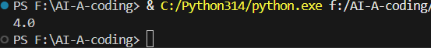
Explanation:
Import errors occur when a module name is incorrect or does not exist. In this case, the wrong module name is used. Correcting the module name ensures the required functions are imported properly

Lab Conclusion (Task 1 to Task 8)
This lab provided a comprehensive understanding of common programming errors in Python and demonstrated how AI-assisted debugging can effectively identify and resolve them. Across Tasks 1 to 8, various types of bugs were analyzed, including design flaws, logical errors, runtime exceptions, and syntax-related issues. Each task highlighted how minor mistakes in code structure, data handling, or logic can lead to incorrect results or program failure.
The lab emphasized the importance of following best coding practices such as avoiding mutable default arguments, handling floating-point precision carefully, defining proper base cases in recursive functions, and safely accessing data structures like dictionaries. It also reinforced the need for correct loop control to prevent infinite loops, proper variable matching during unpacking, consistent indentation in Python, and accurate module imports.
By using AI tools to detect errors, suggest fixes, and explain the root causes, the debugging process became more systematic and efficient. This lab enhanced problem-solving skills, improved code reliability, and built confidence in using AI as a supportive tool for debugging and refactoring Python programs. Overall, the lab successfully achieved its objectives by combining practical debugging scenarios with AI-driven insights to promote responsible and error-free programming

