Assignment 6.3
2303A51230
B. Hamsika
Batch – 18
Task Description #1: Classes (Student Class)
Scenario
You are developing a simple student information management module.
Task
- Use an AI tool (GitHub Copilot / Cursor AI / Gemini) to complete a Student class.
- The class should include attributes such as name, roll number, and branch.
- Add a method display_details() to print student information.
- Execute the code and verify the output.
- Analyze the code generated by the AI tool for correctness and clarity.
Expected Output #1
- A Python class with a constructor (__init__) and a display_details() method.
- Sample object creation and output displayed on the console.
- Brief analysis of AI-generated code.
Prompt :
#create a simple student information management system in python the class should include attributes such as name, roll number, and branch.
#and also include methods to display student details to print student information.

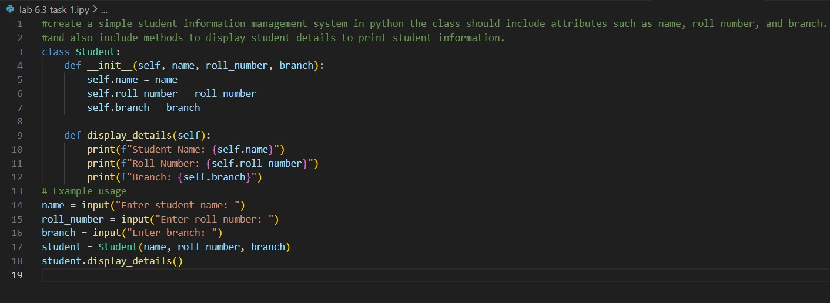
Output
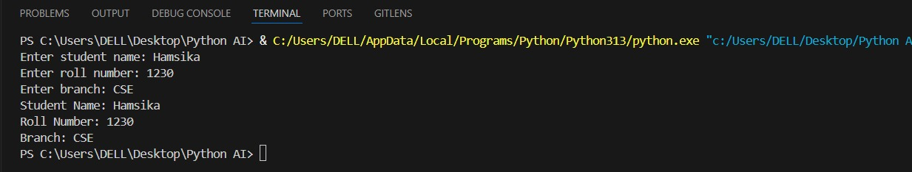
Analysis
- I gave a simple and clear prompt to the AI tool.
- The AI generated a correct class with constructor and display method.
- The code was easy to understand and executed without errors.

Task Description #2: Loops (Multiples of a Number)
Scenario
You are writing a utility function to display multiples of a given number.
Task
- Prompt the AI tool to generate a function that prints the first 10 multiples of a given number using a loop.
- Analyze the generated loop logic.
- Ask the AI to generate the same functionality using another controlled looping structure (e.g., while instead of for).
Expected Output #2
- Correct loop-based Python implementation.
- Output showing the first 10 multiples of a number.
- Comparison and analysis of different looping approaches.
Prompt :
#write a python code that prints the first 10 multiples of a give number using a loop
#Analaze the logic
#example usage

Code:
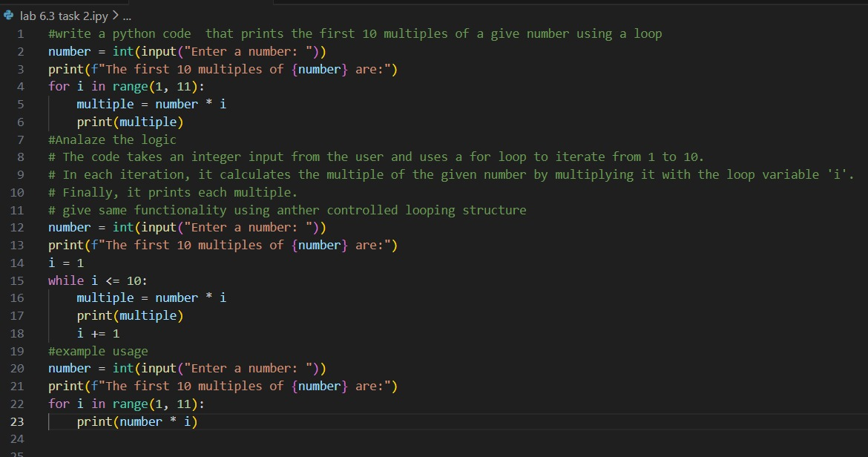
Output:
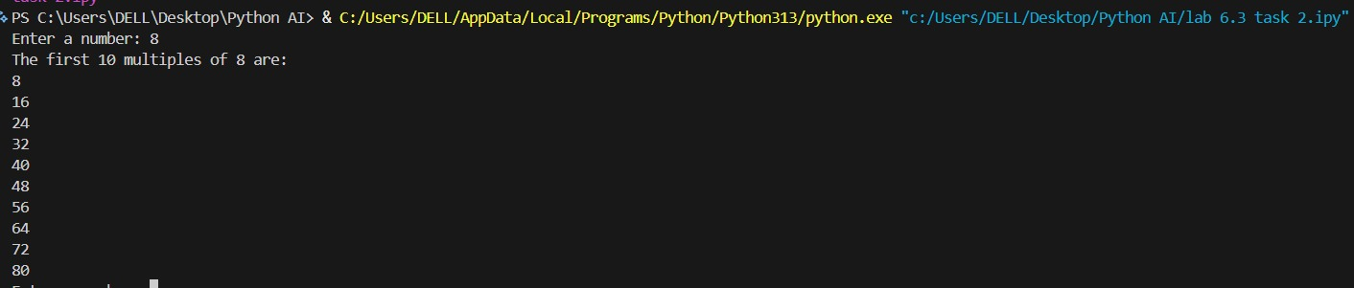
Analysis:
1.I used two different prompts to generate loop-based solutions.
2.The AI correctly used a for loop and a while loop for the same task.

Task Description #3: Conditional Statements (Age Classification)
Scenario
You are building a basic classification system based on age.
Task
- Ask the AI tool to generate nested if-elif-else conditional statements to classify age groups
(e.g., child, teenager, adult, senior).
- Analyze the generated conditions and logic.
- Ask the AI to generate the same classification using alternative conditional structures (e.g., simplified conditions or dictionary-based logic).
Expected Output #3
- A Python function that classifies age into appropriate groups.
- Clear and correct conditional logic.
- Explanation of how the conditions work.
Prompt :
#create a basic classification system based on age use nested if-elif-else conditional statements to classify age groups such as child, teenager, adult, and senior citizen.

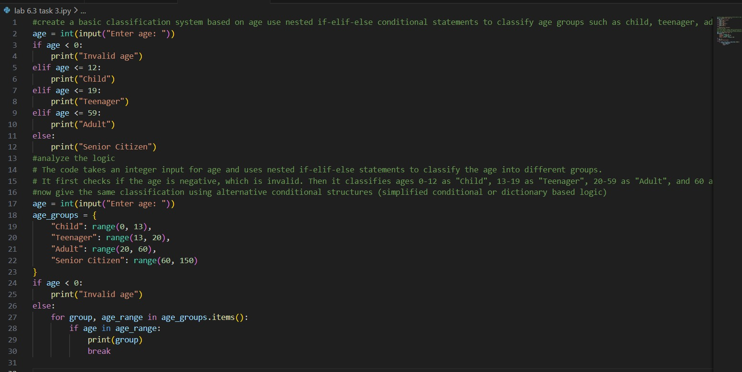
Output:
Analysis:
1.I gave a clear prompt to classify age using conditions.
2.The AI generated correct if-else logic for all age groups.
3.The output matched the expected age categories.

Task Description #4: For and While Loops (Sum of First n Numbers)
Scenario
You need to calculate the sum of the first n natural numbers.
Task
- Use AI assistance to generate a sum_to_n() function using a for loop.
- Analyze the generated code.
- Ask the AI to suggest an alternative implementation using a while loop or a mathematical
formula.
Expected Output #4
- Python function to compute the sum of first n numbers.
- Correct output for sample inputs.
- Explanation and comparison of different approaches.

Prompt :
#write a python code to calculate the sum of the first n natural numbers using a for loop
# Alternatively, using the mathematical formula n(n+1)/2
# Example usage:

Code :
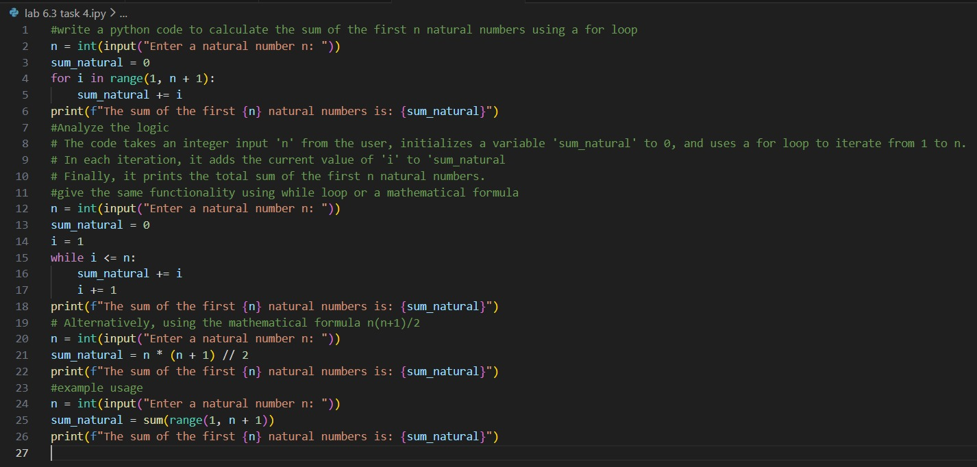

Output
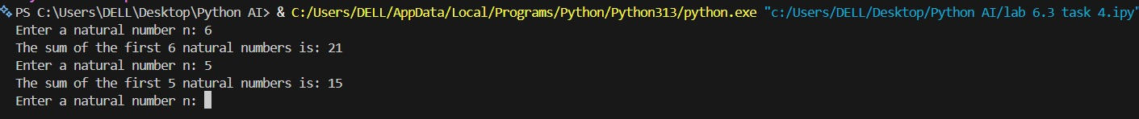
Analysis:
- I asked the AI to generate sum logic using loops.
- The AI gave correct code using both for and while loops.
Task Description #5: Classes (Bank Account Class)
Scenario
You are designing a basic banking application.
Task
- Use AI tools to generate a Bank Account class with methods such as deposit(), withdraw(), and check_balance().
- Analyze the AI-generated class structure and logic.
- Add meaningful comments and explain the working of the code.
Expected Output #5
- Complete Python Bank Account class.
- Demonstration of deposit and withdrawal operations with updated balance.
- Well-commented code with a clear explanation.
Prompt :
#create a basic banking application in python that allows users to deposit, withdraw, and check their balance. and class should with methods for each operation.

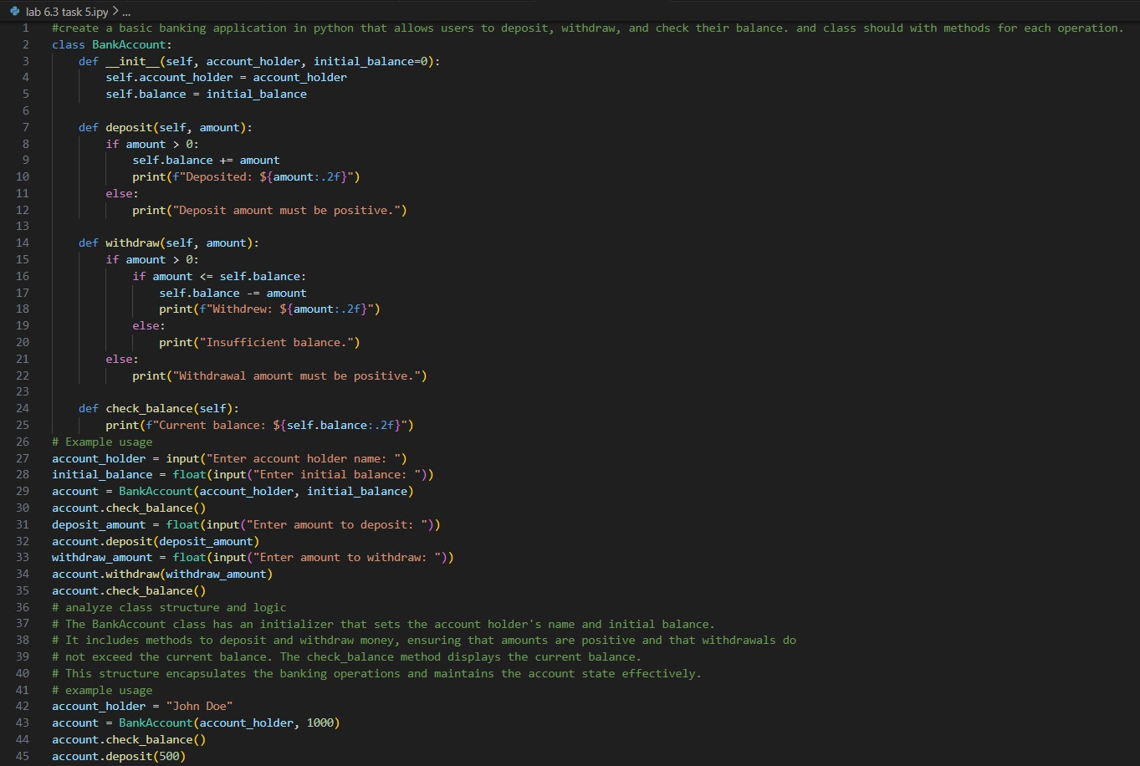

Output :
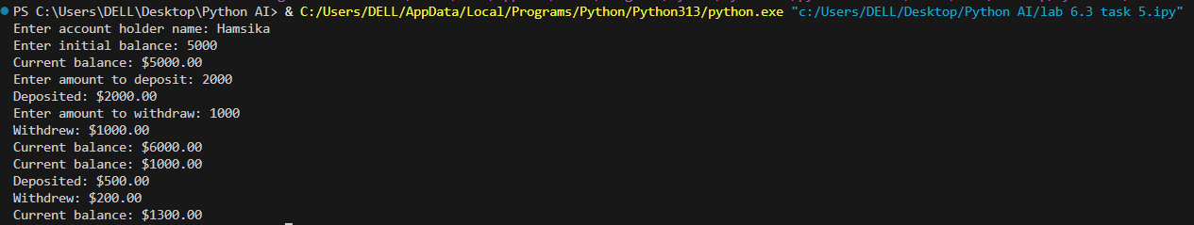

Analysis:
- I gave a clear prompt to generate a bank account class.
- The AI generated a well-structured class with correct logic.
3.Comments made the code easy to understand.

