Assignment 10.3
2303A51230
B. Hamsika
Batch – 18

Task Description #1: AI-Assisted Bug Detection
Scenario: A junior developer wrote the following Python function to calculate factorials: def factorial(n):
result = 1 for i in range(1, n): result = result * i return result
Instructions:
- Run the code and test it with factorial(5).
- Use an AI assistant to:
- Identify the logical bug in the code.
- Explain why the bug occurs (e.g., off-by-one error). o Provide a corrected version.
3. Compare the AI’s corrected code with your own manual fix. 4. Write a brief comparison: Did AI miss any edge cases (e.g., negative numbers, zero)?
Expected Output:
Corrected function should return 120 for factorial(5).
Prompt :
# def factorial(n):
# result = 1
# for i in range(1, n):
# result = result * i
# return result
# print(factorial(5))
# Identify the logical bug in this factorial function.
# Explain why the error occurs.
# Provide a corrected version.
# Also handle edge cases like zero and negative numbers.

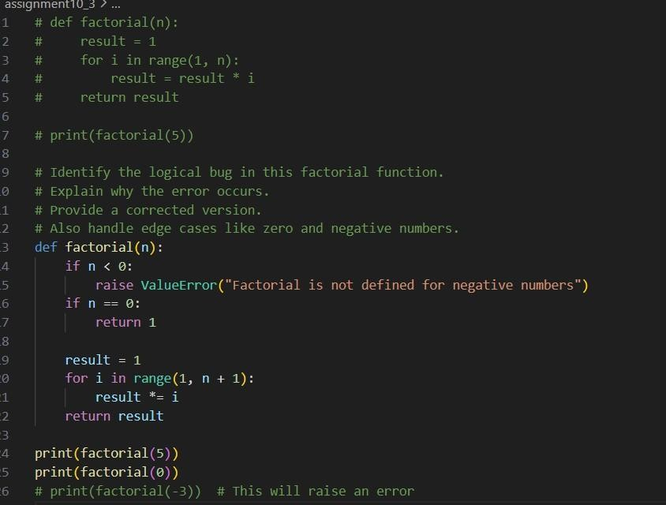
Output :

Analysis
- The original bug was an off-by-one error caused by incorrect use of range().
- AI correctly identified the logical mistake.
- AI also improved the function by adding proper exception handling.

Task Description #2: Improving Readability &
Documentation
Scenario:The following code works but is poorly written: def calc(a, b, c): if c == "add": return a + b elif c == "sub": return a - b elif
c == "mul": return a * b elif c == "div":
Instructions:
5. Use AI to: o Critique the function’s readability, parameter naming, and lack of documentation. o Rewrite the function with:
- Descriptive function and parameter names.
- A complete docstring (description, parameters, return value, examples).
- Exception handling for division by zero.
- Consideration of input validation.
- Compare the original and AI-improved versions.
- Test both with valid and invalid inputs (e.g., division by zero, non-string operation).
Expected Output:
A well-documented, robust, and readable function that handles errors gracefully.
Prompt :
##Task2:
# Original poorly written function # def calc(a, b, c): # if c == "add":
# return a + b
# elif c == "sub":
# return a - b
# elif c == "mul":
# return a * b
# elif c == "div":
# return a / b
# Critique the readability of this function.
# Improve the function by:
# - Using descriptive function and parameter names
# - Adding a complete docstring (description, parameters, return value, examples)
# - Adding exception handling for division by zero
# - Validating input types
# - Making the function more readable and professional

Code:
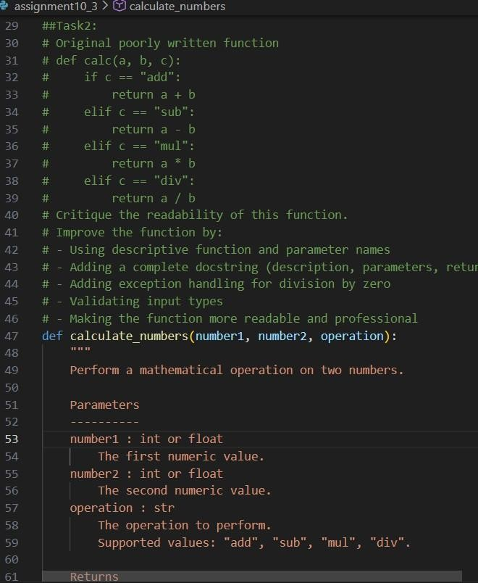
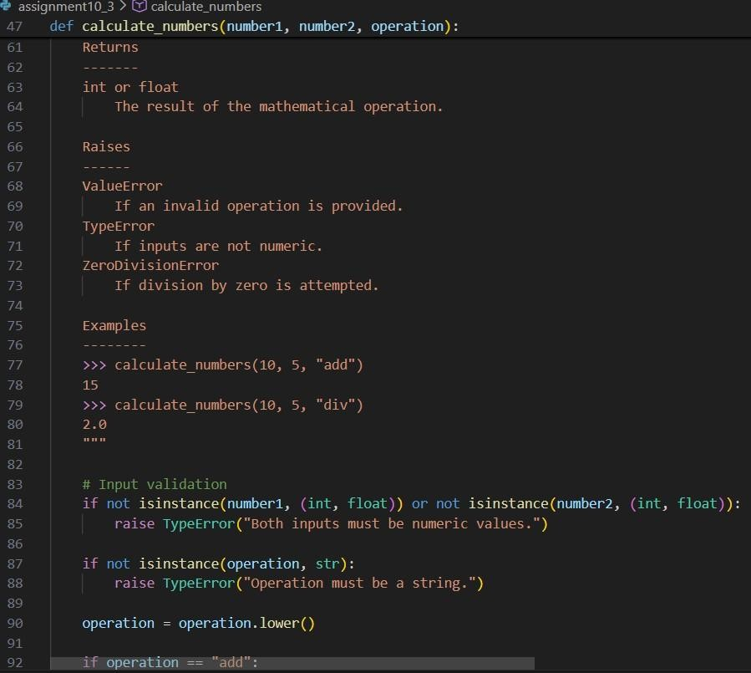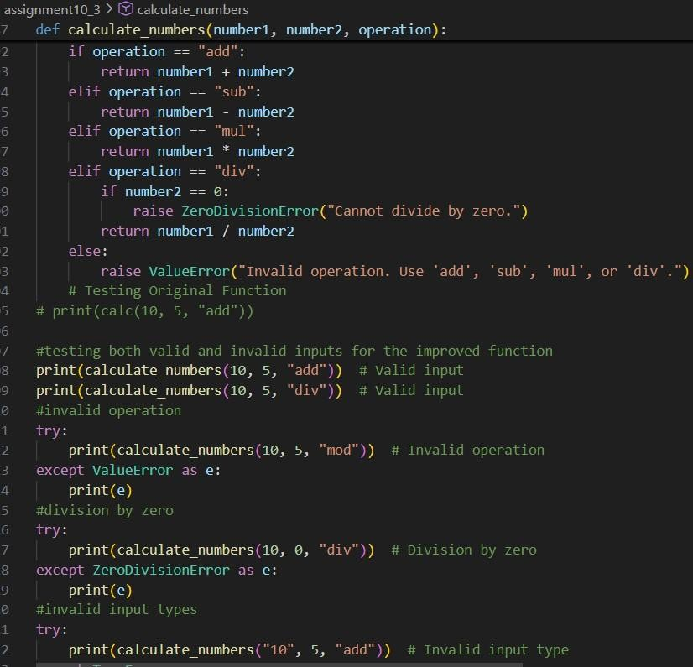

Output:
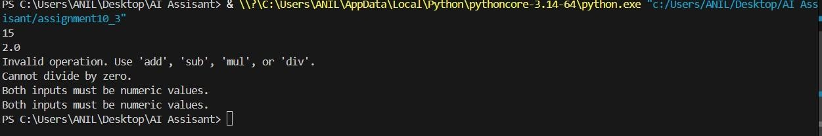
Analysis:
1. Handling division by zero.
2.Validating input types.
3.Raising meaningful exceptions.

Task Description #3: Enforcing Coding Standards
Scenario: A team project requires PEP8 compliance. A developer submits: def Checkprime(n): for i in range(2, n): if n % i == 0: return False return True
Instructions:
- Verify the function works correctly for sample inputs.
- Use an AI tool (e.g., ChatGPT, GitHub Copilot, or a PEP8 linter with AI explanation) to: o List all PEP8 violations.
o Refactor the code (function name, spacing, indentation, naming).
- Apply the AI-suggested changes and verify functionality is preserved.
- Write a short note on how automated AI reviews could streamline code reviews in large teams.
Expected Output:
A PEP8-compliant version of the function,
e.g.: def check_prime(n): for i in range(2, n):
if n % i == 0: return False return True

Prompt :
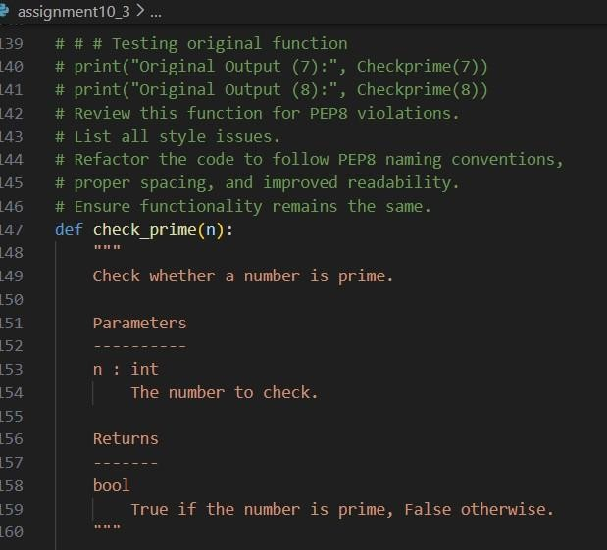
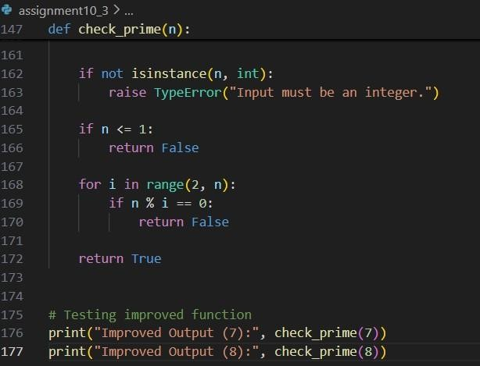

Output:
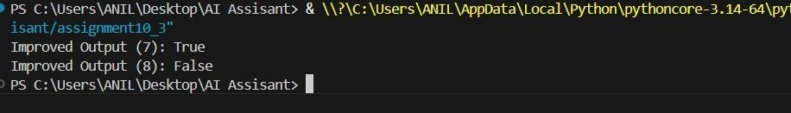
Analysis:
AI also provides quick suggestions for improvement, allowing developers to focus more on logic and performance rather than style issues
Task Description #4: AI as a Code Reviewer in Real Projects Scenario:
In a GitHub project, a teammate submits: def processData(d):
return [x * 2 for x in d if x % 2 == 0] Instructions:
1. Manually review the function for:
- Readability and naming. o Reusability and modularity.
- Edge cases (non-list input, empty list, non-integer elements).
2. Use AI to generate a code review covering:
- Better naming and function purpose clarity.
- Input validation and type hints.
- Suggestions for generalization (e.g., configurable multiplier).
- Refactor the function based on AI feedback.
- Write a short reflection on whether AI should be a standalone reviewer or an assistant.
Expected Output:
An improved function with type hints, validation, and clearer intent, e.g.:
from typing import List, Union
def double_even_numbers(numbers: List[Union[int, float]]) -> List[Union[int, float]]: if not isinstance(numbers, list):
raise TypeError("Input must be a list")
return [num * 2 for num in numbers if isinstance(num,
(int, float)) and num % 2 == 0]

Prompt :
##task4:
# def processData(d):
# return [x * 2 for x in d if x % 2 == 0]
# Review this function for readability, naming clarity, and edge cases.
# Suggest improvements including:
# - Better function name
# - Type hints
# - Input validation
# - Configurable multiplier
# - Improved documentation

Code :
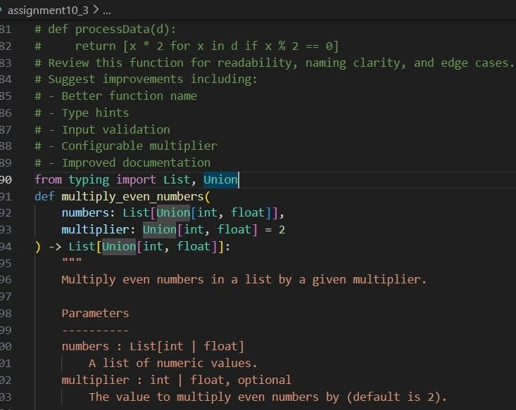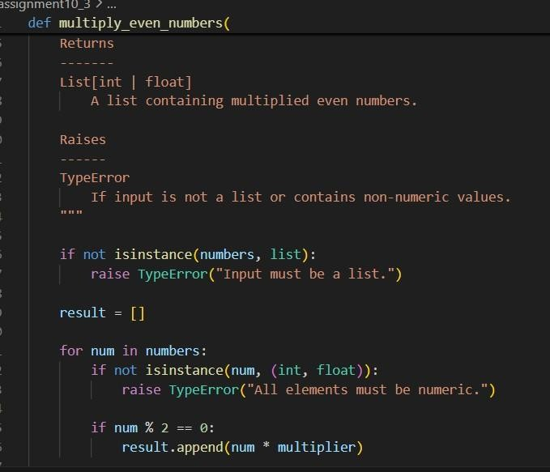

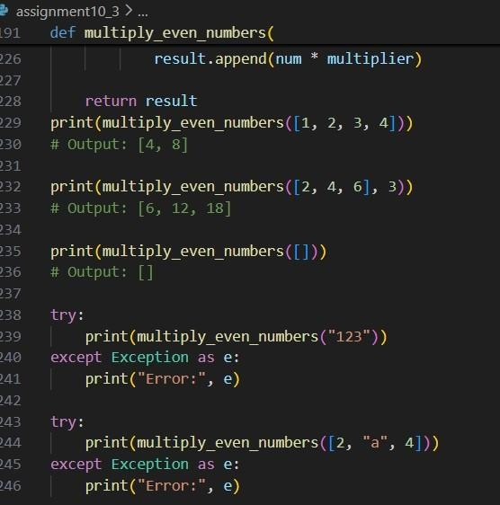

Output
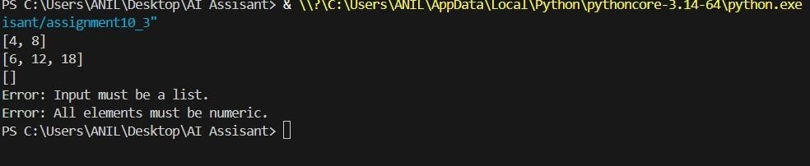
Analysis:
- Quickly identified readability and naming issues.
- Suggested better structure and documentation.

Task Description #5: AI-Assisted Performance Optimization Scenario: You are given a function that processes a list of integers, but it runs slowly on large datasets: def sum_of_squares(numbers):
total = 0 for num in numbers: total += num ** 2 return total Instructions:
- Test the function with a large list (e.g., range(1000000)).
- Use AI to:
- Analyze time complexity.
- Suggest performance improvements (e.g., using built-in functions, vectorization with NumPy if applicable). o Provide an optimized version.
- Compare execution time before and after optimization.
- Discuss trade-offs between readability and performance.
Expected Output:
An optimized function, such as: def sum_of_squares_optimized(numbers): return sum(x * x for x in numbers)
Prompt :
##task5:

# def sum_of_squares(numbers):
# total = 0
# for num in numbers:
# total += num ** 2
# return total
# Test the function with a large list (e.g., range(1000000)).
# Use AI to:
# Analyze time complexity.
# Suggest performance improvements (e.g., using built-in # functions, vectorization with NumPy if applicable).
# Provide an optimized version.
# Compare execution time before and after optimization.
# 4Discuss trade-offs between readability and performance.

Code :
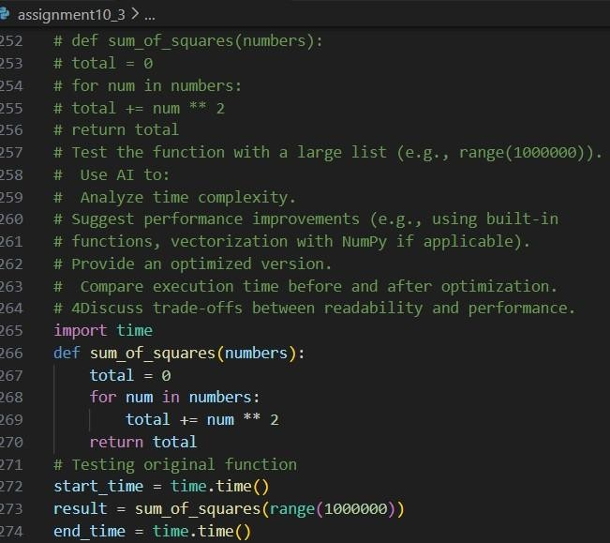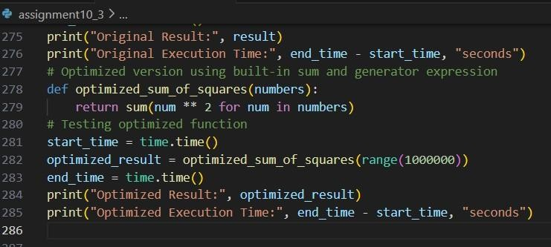

Output :
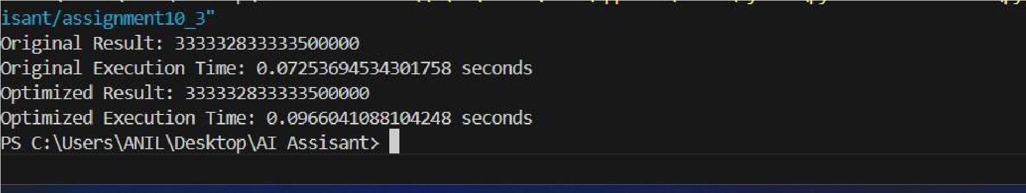
Analysis:

1.It suggested using Python’s built-in sum() with a generator expression for cleaner and slightly faster execution.
2. It also recommended NumPy vectorization for better performance on very large datasets.

