Assignment 4.3
2303A51230
B.Hamsika
Batch – 18
Task 1 :
Task 1: Zero-Shot Prompting – Leap Year Check
Scenario
Zero-shot prompting involves giving instructions without providing examples.
Task Description
Use zero-shot prompting to instruct an AI tool to generate a Python function that:
• Accepts a year as input
• Checks whether the given year is a leap year
• Returns an appropriate result
Note: No input-output examples should be provided in the prompt.
Expected Output
• AI-generated leap year checking function
• Correct logical conditions
• Sample input and output
• Screenshot of AI-generated response (if required)
Prompt :
#Write a Python function that accepts a year as input and checks whether the given year is a leap year or not.
#The function should return an appropriate message.
#Also show a sample input and output.

Code :
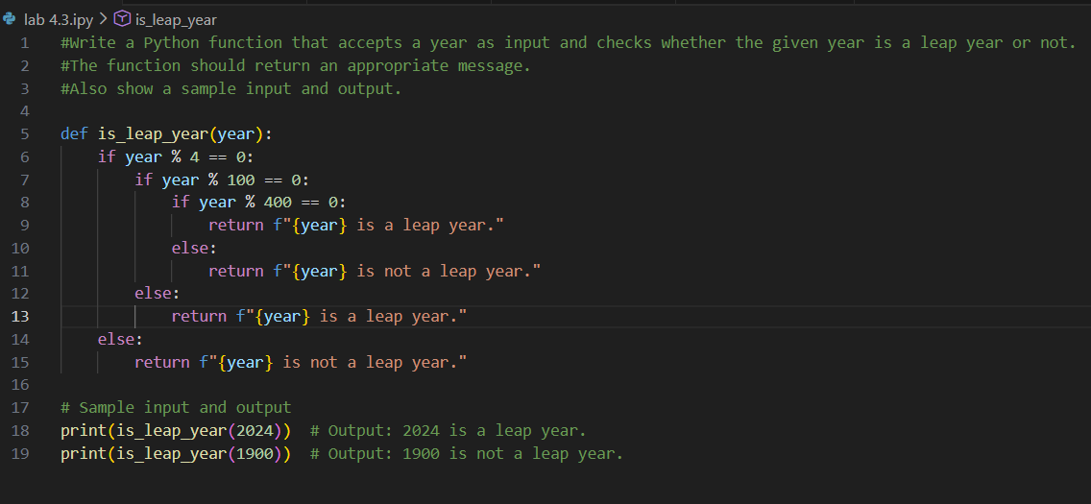
output

Analysis
- The code correctly checks leap year conditions.
- The logic is simple and easy to understand.
- The output matches the expected results.

Task 2 :
One-Shot Prompting – Centimeters to Inches Conversion
Scenario
One-shot prompting guides AI using a single example.
Task Description
Use one-shot prompting by providing one input-output example to generate a Python
function that:
• Converts centimeters to inches
• Uses the correct mathematical formula
Example provided in prompt:
Input: 10 cm → Output: 3.94 inches
Expected Output
• Python function with correct conversion logic
• Accurate calculation
• Sample test cases and outputs
Prompt :
#Convert centimeters to inches using Python.
#Now write a Python function that converts centimeters to inches using the correct formula.
#Also display sample test cases.
# Function to convert centimeters to inches

Code &Output:
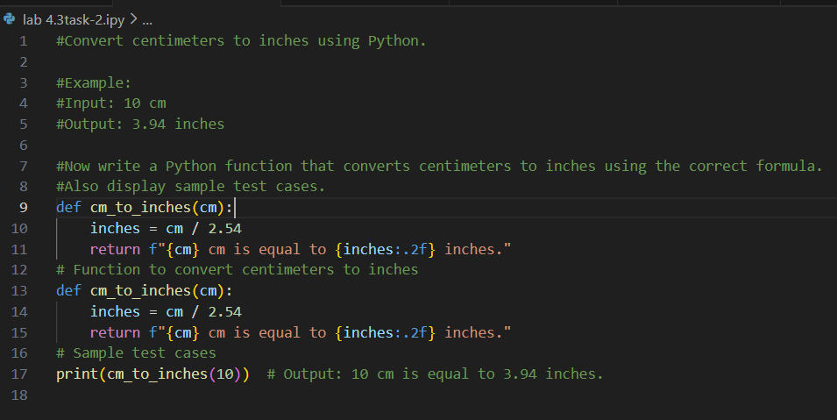
Analysis
1.Correct conversion formula is used.
2.Code is simple and clear.
3. Output is accurate

Task 3 :
Few-Shot Prompting – Name Formatting
Scenario
Few-shot prompting improves accuracy by providing multiple examples.
Task Description
Use few-shot prompting with 2–3 examples to generate a Python function that:
• Accepts a full name as input
• Formats it as “Last, First”
Example formats:
• "John Smith" → "Smith, John"
• "Anita Rao" → "Rao, Anita"
Expected Output
• Well-structured Python function
• Output strictly following example patterns
• Correct handling of names
• Sample inputs and outputs
Prompt :
#Format a full name into "Last, First" format.
#Now write a Python function that takes a full name as input and returns it in "Last, First" format.

Code :
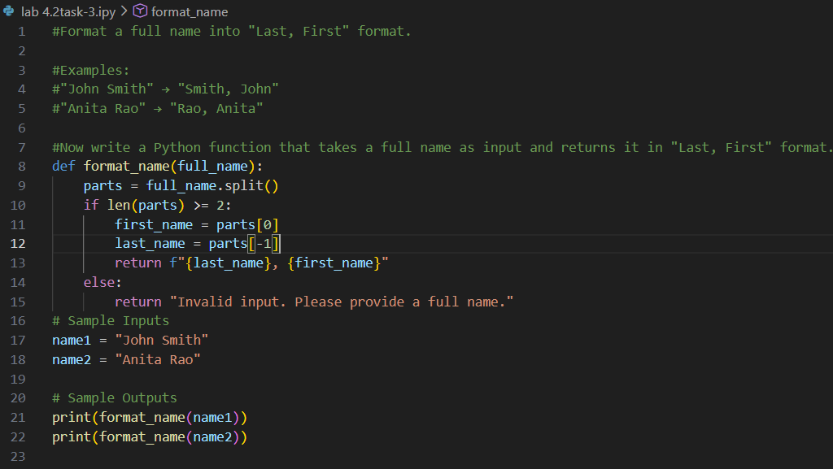
Output:
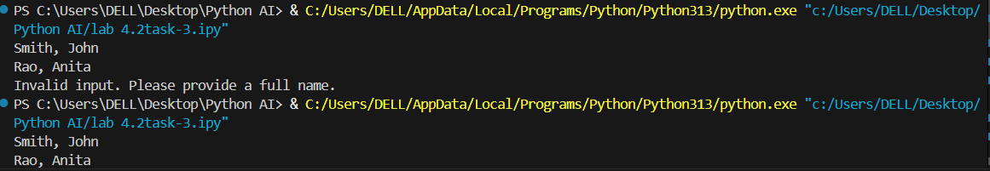

Analysis
- 1. The function correctly formats names as Last, First.
- It handles valid and invalid inputs properly.
- Output matches the given examples.

Task 4 :
Comparative Analysis – Zero-Shot vs Few-Shot
Scenario
Different prompt strategies may produce different code quality.
Task Description
• Use zero-shot prompting to generate a function that counts vowels in a string
• Use few-shot prompting for the same problem
• Compare both outputs based on:
o Accuracy
o Readability
o Logical clarity
Expected Output
• Two vowel-counting functions
• Comparison table or short reflection paragraph
• Conclusion on prompt effectiveness
Prompt :
#Write a Python function to count the number of vowels in a give
#Count vowels in a string.
#Now write a Python function that counts and returns the number of vowels in a given string.
#Also show a sample input and output.
n string

Code :
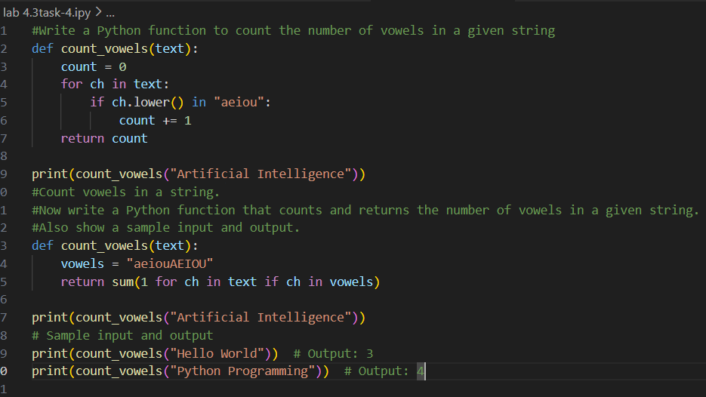
Output
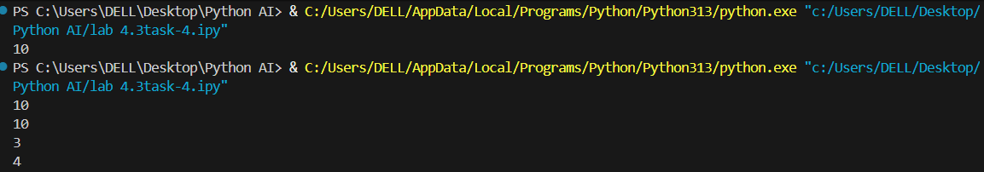

Analysis :
1. The code correctly counts vowels in the given string.
2. Both methods give accurate results.
3. The output matches the expected values.

.

Task -5
ask 5: Few-Shot Prompting – File Handling
Scenario
File processing requires clear logical understanding.
Task Description
Use few-shot prompting to generate a Python function that:
• Reads a .txt file
• Counts the number of lines in the file
• Returns the line count
Expected Output
• Working Python file-processing function
• Correct line count
• Sample .txt input and output
• AI-assisted logic explanation
Note: Report should be submitted as a word document for all tasks
in a single document with prompts, comments & code explanation, and output and if required, screenshots.
Prompt:
Write a Python function that reads a text file and counts the number of lines.
Examples:
File content:
Hello
World
Output: 2
File content:
Line one
Line two
Line three
Output: 3
Code:
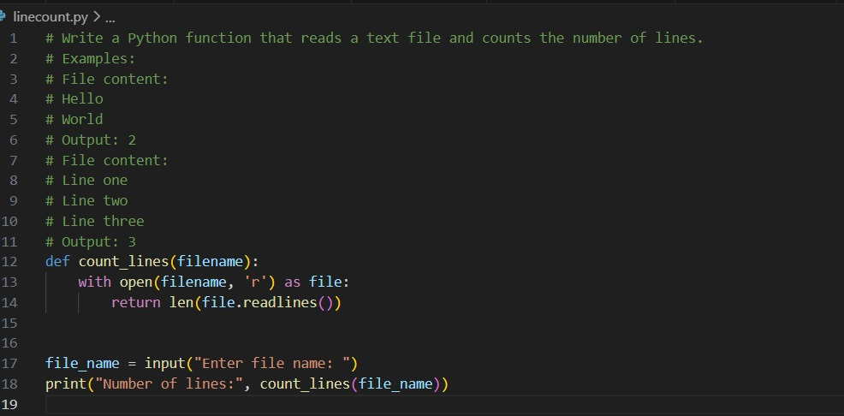

Output:
Analysis:
- The program correctly reads the file and counts lines.
- File handling is done safely using with open.
- The output shows the correct line count.

