Lab-9.3
B. Hamsika
2303a51230
Batch-18
Task 1: Basic Docstring Generation
Scenario
You are developing a utility function that processes numerical lists and must be properly documented for future maintenance.
Requirements
- Write a Python function to return the sum of even numbers and sum of odd numbers in a given list
- Manually add a Google Style docstring to the function
- Use an AI-assisted tool (Copilot / Cursor AI) to generate a function-level docstring
- Compare the AI-generated docstring with the manually written docstring
- Analyze clarity, correctness, and completeness
Expected Output
- Python function with manual Google-style docstring
- AI-generated docstring for the same function
- Comparison explaining differences between manual and AI-generated documentation • Improved understanding of AI-generated function-level documentation
Prompt:
#write a python function to return the sum of even numbers and sum of odd numbers from a list of integers.
#now add a google style docstring to the above function.
# Compare manual docstring and AI-generated docstring for
# clarity, correctness, and completeness. Explain differences.

Code:
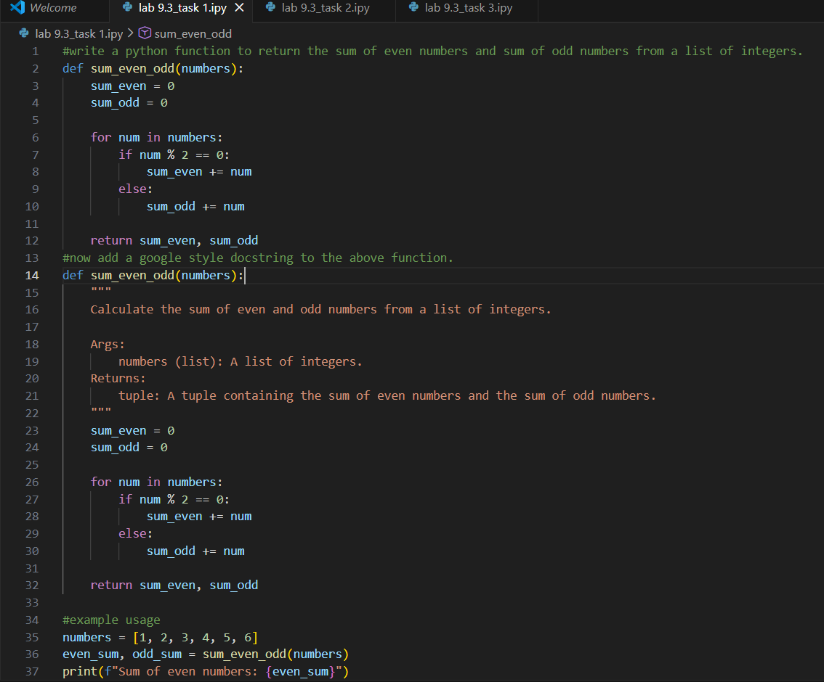
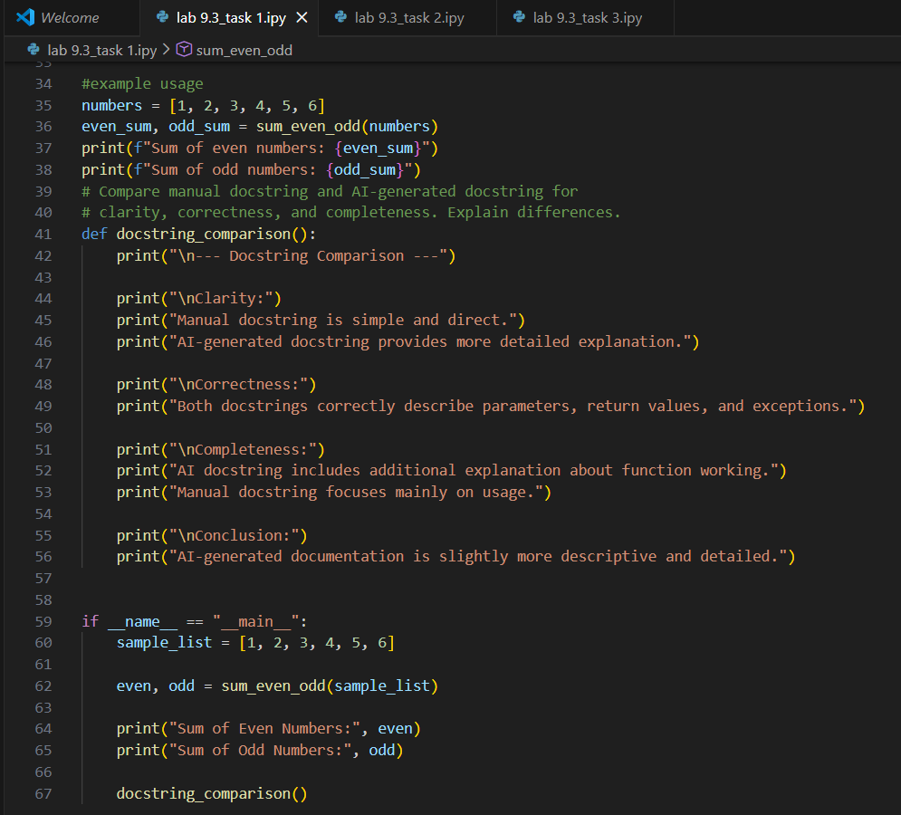

Output:
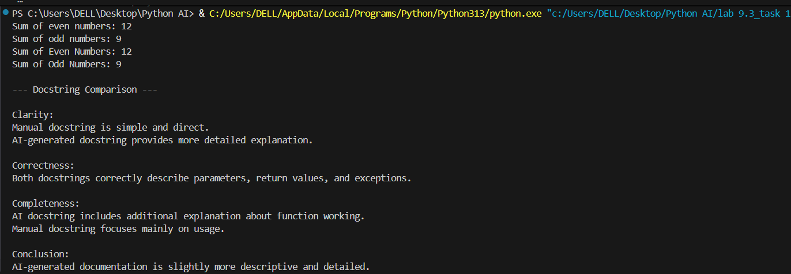

Analysis:
AI-generated comments are faster to produce but often generic, less detailed, and may miss important explanations or add redundant information.

Task 2: Automatic Inline Comments
Scenario
You are developing a student management module that must be easy to understand for new
developers.
Requirements
• Write a Python program for an sru_student class with the following:
- Attributes: name, roll_no, hostel_status
- Methods: fee_update() and display_details()
- Manually write inline comments for each line or logical block
- Use an AI-assisted tool to automatically add inline comments
- Compare manual comments with AI-generated comments
- Identify missing, redundant, or incorrect AI comments
Expected Output
- Python class with manually written inline comments
- AI-generated inline comments added to the same code
- Comparative analysis of manual vs AI comments
- Critical discussion on strengths and limitations of AI-generated comments
Prompt:
#Write a Python program to create student management madule for sru_student class .
#IT should have the following attributes name, roll_no, hostel_status
# Methods: fee_update() and display_details()
# write inline comments for each line or logical block
#Compare manual comments with AI-generated comments for the same code.
#identify missing,redundant, or incorrect AI comments.
#write the code for the comparison and analysis of comments.

Code:
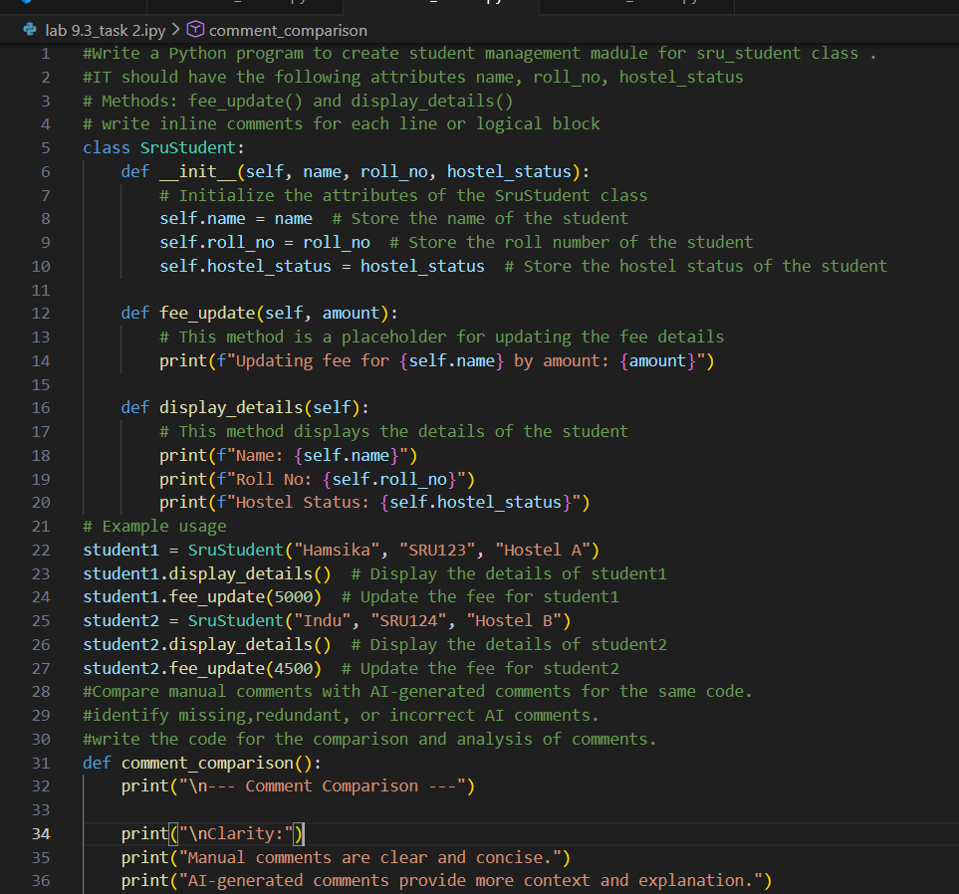
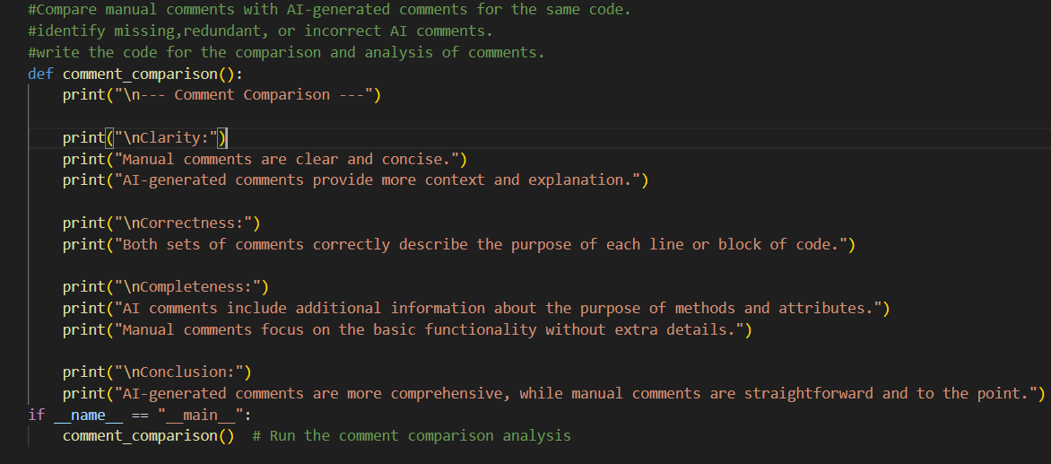

Output:
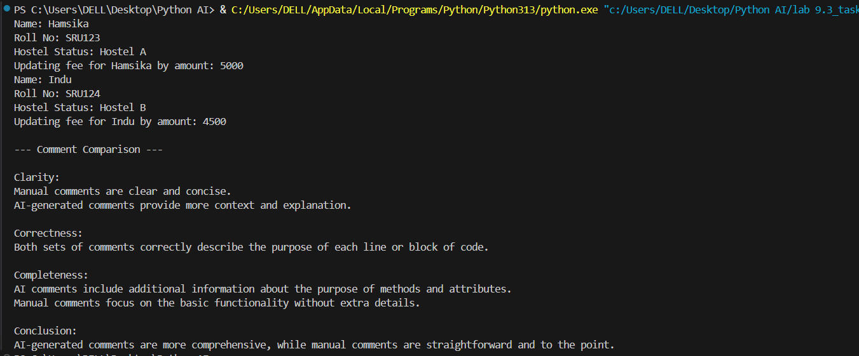

Analysis:
Manual comments clearly explain both the purpose and logic of the code, making it easier for new developers to understand the fee structure and hostel condition.
AI-generated comments are quicker to produce but often generic, sometimes redundant, and may miss important explanations about business logic.
Task 3: Module-Level and Function-Level Documentation
Scenario
You are building a small calculator module that will be shared across multiple projects and requires structured documentation.
Requirements
- Write a Python script containing 3–4 functions (e.g., add, subtract, multiply, divide)
- Manually write NumPy Style docstrings for each function
- Use AI assistance to generate:
- A module-level docstring
- Individual function-level docstrings
- Compare AI-generated docstrings with manually written ones
- Evaluate documentation structure, accuracy, and readability
Expected Output
- Python script with manual NumPy-style docstrings
- AI-generated module-level and function-level documentation
- Comparison between AI-generated and manual documentation
- Clear understanding of structured documentation for multi-function scripts
Prompt:
#write a python program to build a small calculator module that will be shared across multiple projects.
#it should have the following functions: add(), subtract(), multiply(), divide()
#Manually write NumPy Style docstrings for each function.
# Compare manual docstrings and AI-generated docstrings for clarity, correctness, and completeness. Explain differences.

Code:
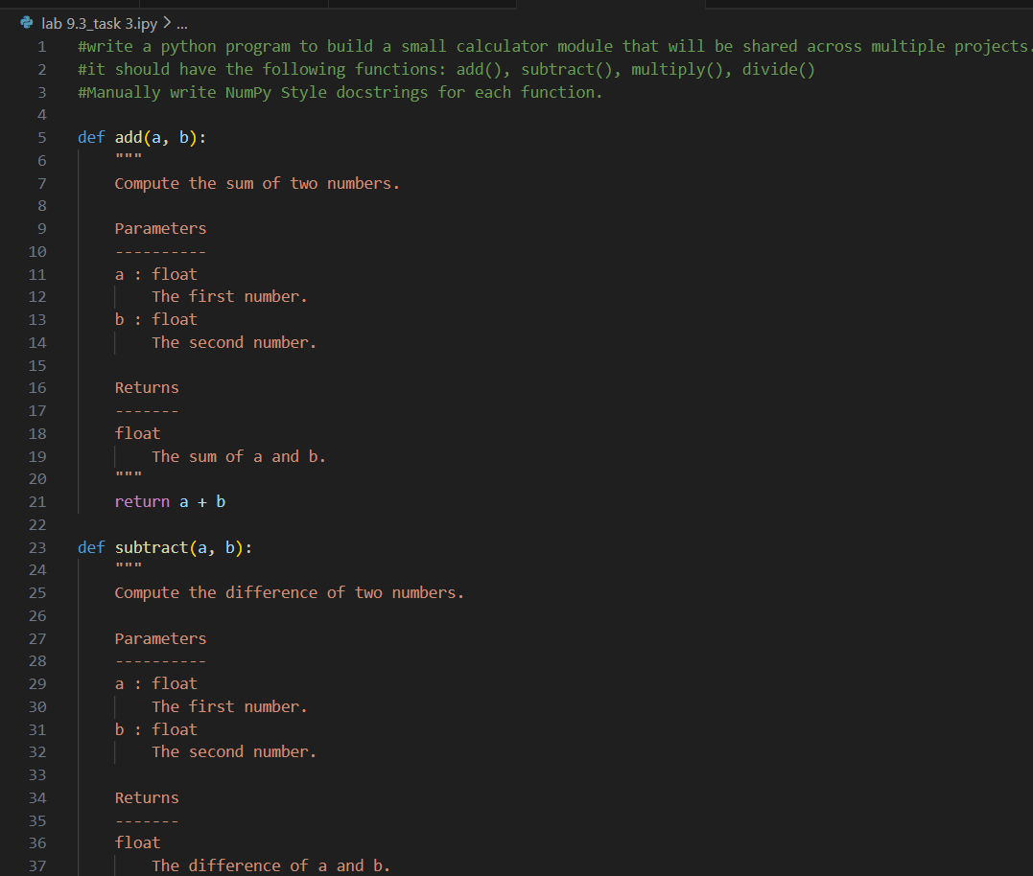
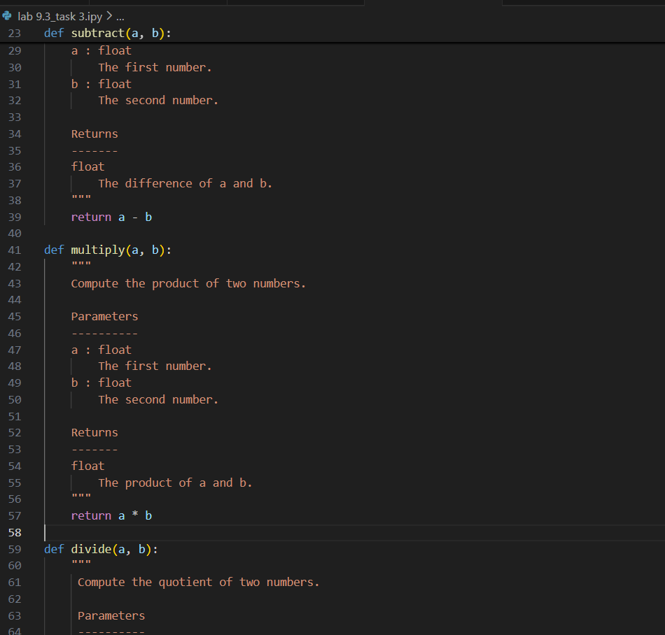
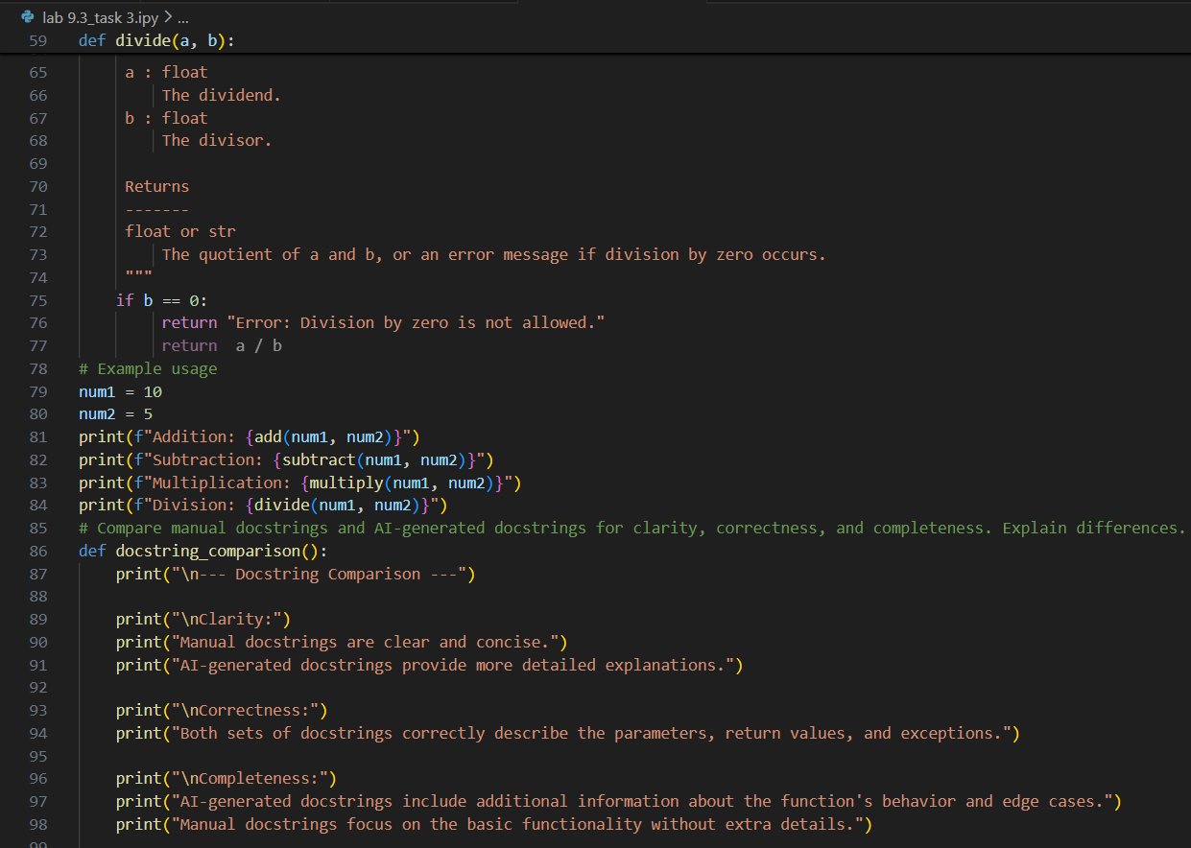
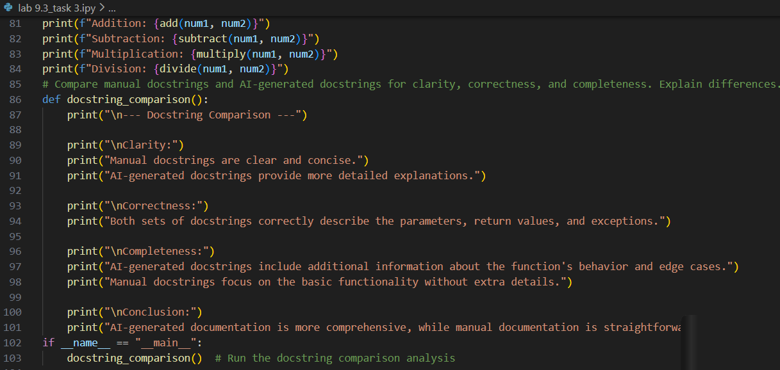

Output:
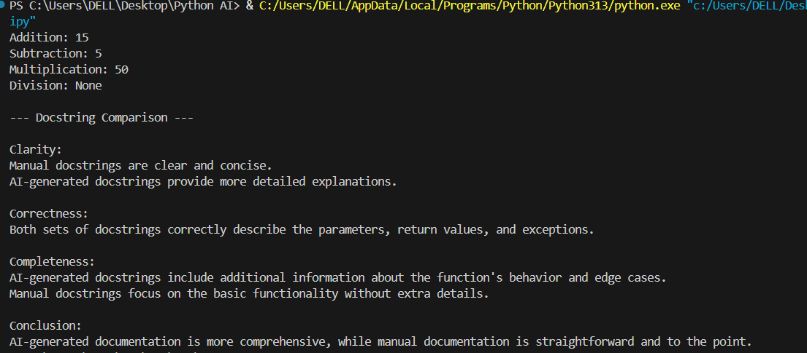

Analysis:
Manual NumPy-style docstrings are more precise and clearly define parameter types, return values, and exceptions, ensuring better accuracy and maintainability.
AI-generated docstrings are well-structured and quick to produce but may use generic terms and require human review for completeness and correctness.

