Assignment 3.1
2303A51230
Bairaboina Hamsika
Batch – 18
Question 1: Zero-Shot Prompting (Palindrome Number Program)
Write a zero-shot prompt (without providing any examples) to generate a Python function that checks whether a given number is a palindrome.
Task:
- Record the AI-generated code.
- Test the code with multiple inputs.
- Identify any logical errors or missing edge-case handling.
Prompt :
#python program to check a number is a palindrome or not Code :
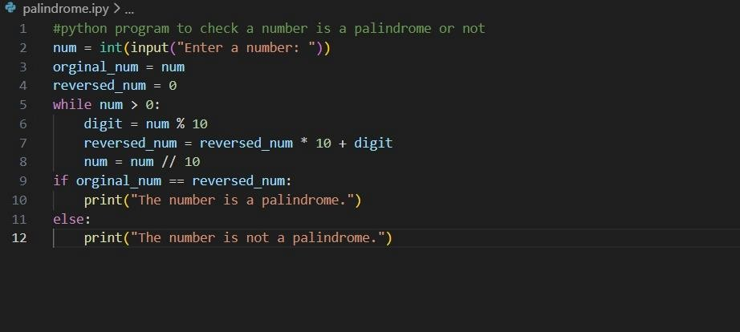
output

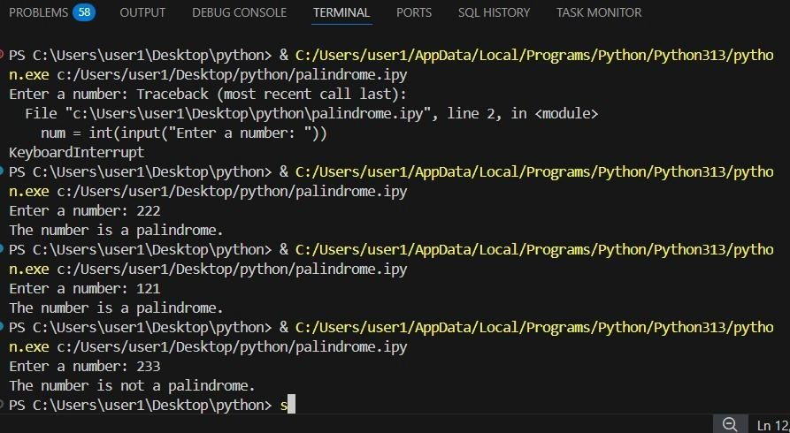

Question 2: One-Shot Prompting (Factorial Calculation) Write a one-shot prompt by providing one input-output example and ask the AI to generate a Python function to compute the factorial of a given number.
Example:
Input: 5 → Output: 120
Task:
- Compare the generated code with a zero-shot solution.
- Examine improvements in clarity and correctness.
Prompt :
#program on a python function to compute the factorial of a number
Code:
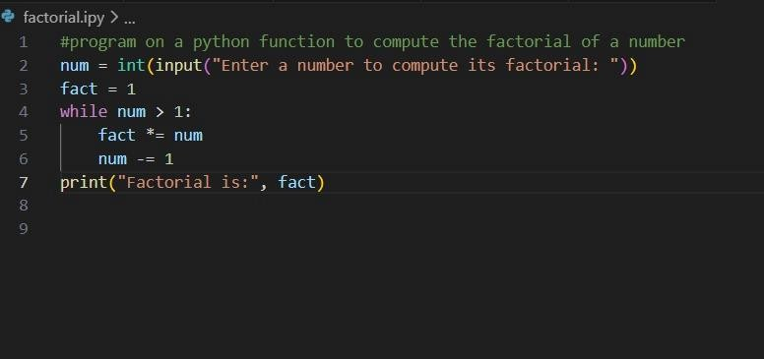
Output:
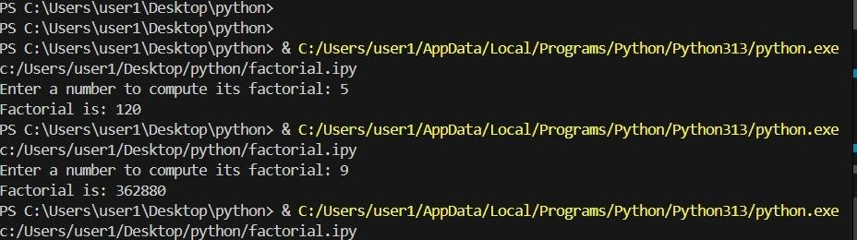

Question 3: Few-Shot Prompting (Armstrong Number Check) Write a few-shot prompt by providing multiple input-output examples to guide the AI in generating a Python function to check whether a given number is an Armstrong number.
Examples:
- Input: 153 → Output: Armstrong Number
- Input: 370 → Output: Armstrong Number • Input: 123 → Output: Not an Armstrong Number
Task:
- Analyze how multiple examples influence code structure and accuracy.
- Test the function with boundary values and invalid inputs.
(Optional Extension) Prompt :
# Write a Python function to check whether a given number is an Armstrong number.
# Examples:
# Input: 153
# Output: Armstrong Number
# Input: 370
# Output: Armstrong Number
# Input: 123
# Output: Not an Armstrong Number Code :
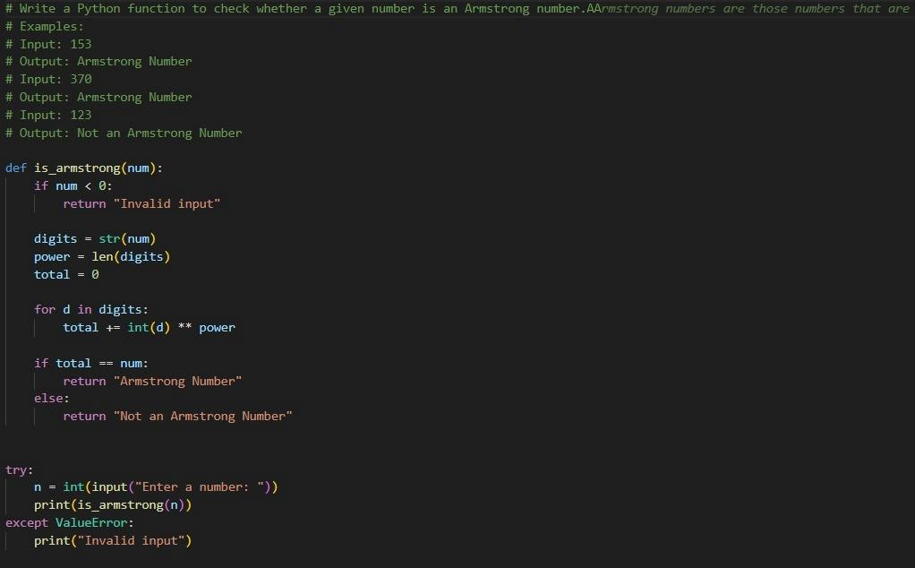
Output:
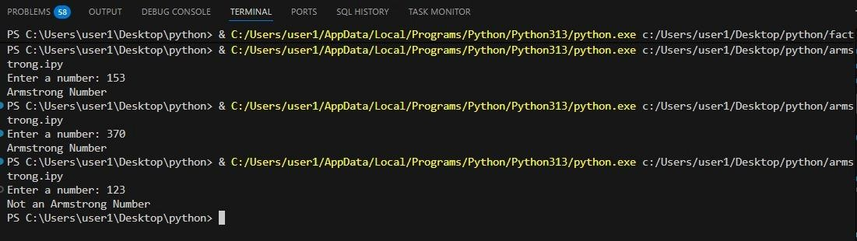
Question 4: Context-Managed Prompting (Optimized Number
Classification)
Design a context-managed prompt with clear instructions and constraints to generate an optimized Python program that classifies a number as prime, composite, or neither.
Task:
- Ensure proper input validation.
- Optimize the logic for efficiency.
- Compare the output with earlier prompting strategies.
Prompt :
# Write an optimized Python program to classify a number as # prime, composite, or neither.
# Print clear and correct output messages
# Avoid unnecessary loops
Code :
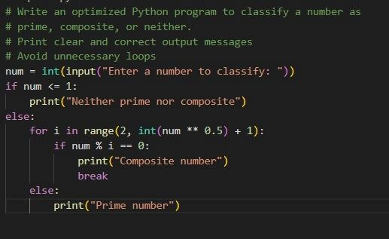
Output

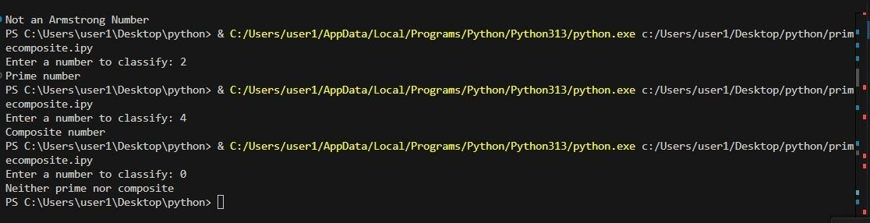
Question 5: Zero-Shot Prompting (Perfect Number Check) Write a zero-shot prompt (without providing any examples) to generate a Python function that checks whether a given number is a perfect number.
Task:
- Record the AI-generated code.
- Test the program with multiple inputs.
- Identify any missing conditions or inefficiencies in the logic.
Prompt :
# Write a Python function that checks whether a given number is a
perfect number.
Code :
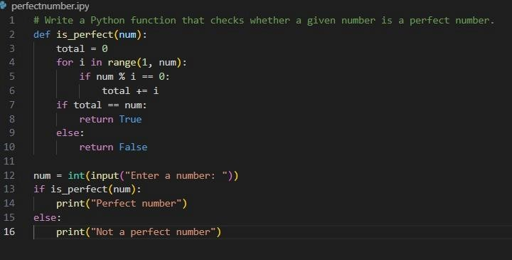
Output :
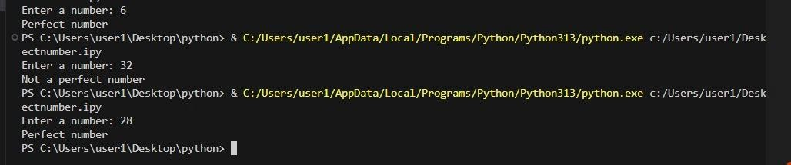
Question 6: Few-Shot Prompting (Even or Odd Classification with
Validation)
Write a few-shot prompt by providing multiple input-output examples to guide the AI in generating a Python program that determines whether a given number is even or odd, including proper input validation.
Examples:
- Input: 8 → Output: Even
- Input: 15 → Output: Odd
- Input: 0 → Output: Even Task:
- Analyze how examples improve input handling and output
clarity.
- Test the program with negative numbers and non-integer inputs.
Prompt:
# Write a Python program to determine whether a given number is even or odd. # Examples:
# Input: 8
# Output: Even
# Input: 15
# Output: Odd
# Input: 0
# Output: Even
# The program should validate input and handle non-integer values gracefully.
Code:
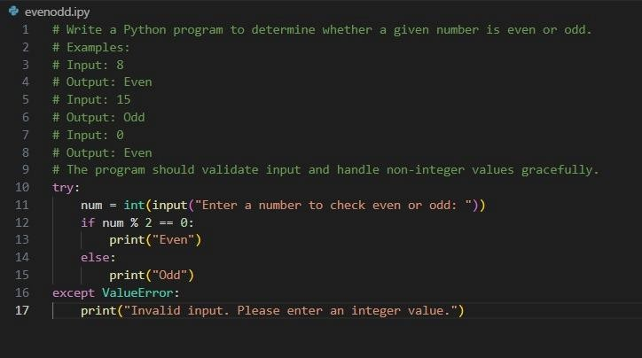
Output:
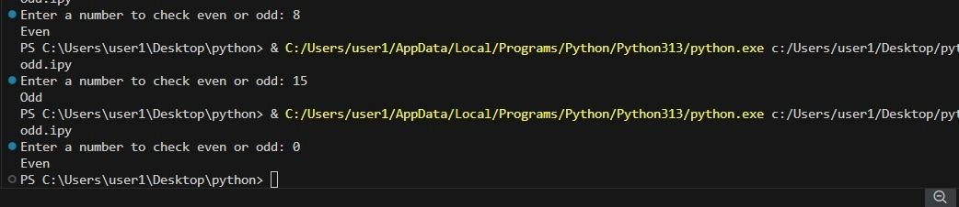

Analysis:
- I gave clear and descriptive prompts to GitHub Copilot in VS Code to generate Python programs.
- When I included examples, instructions, and validation requirements, Copilot produced more accurate and wellstructured code.
- This shows that providing proper context and clear requirements improves the quality of AI-generated code.

