Assignment 8.1
2303A51230
B. Hamsika
Batch – 18
Task Description #1: (Password Strength Validator – Apply AI in
Security Context)
- Task: Apply AI to generate at least 3 assert test cases for is_strong_password (password) and implement the validator function.
- Requirements:
- Password must have at least 8 characters.
- Must include uppercase, lowercase, digit, and special character. o Must not contain spaces. Example Assert Test Cases:
assert is_strong_password("Abcd@123") == True assert is_strong_password("abcd123") == False assert is_strong_password("ABCD@1234") == True Expected Output #1:
• Password validation logic passing all AI-generated test cases.
Prompt :
#Password Strength validator
#requeirements for a strong password:
#1. At least 8 characters long
#2. Contains at least one uppercase letter
#3. Contains at least one lowercase letter
#4. Contains at least one digit
#5. Contains at least one special character (@$!%*?&)
.
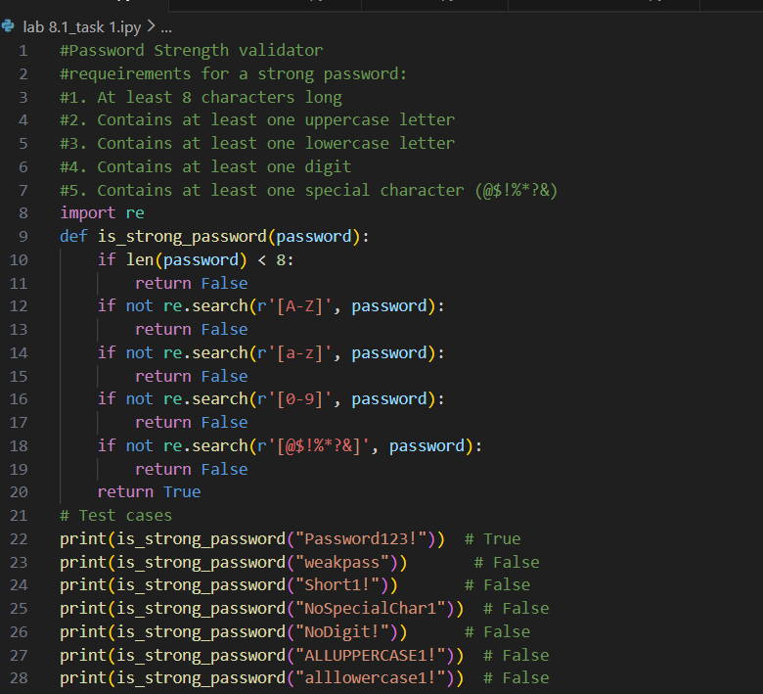

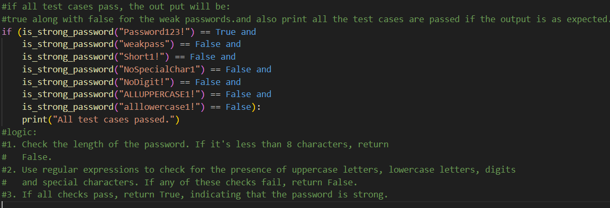

Output
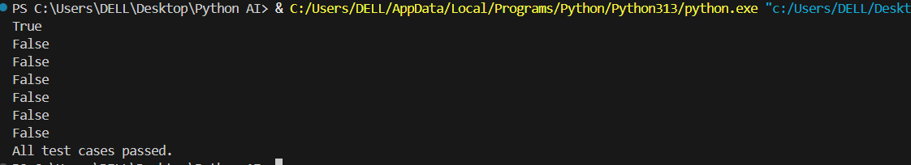

Analysis
1.The password validator checks multiple security conditions.
- The AI-generated assert test cases helped verify both valid and invalid scenarios.
- no assertion errors occurred, the function works correctly.

Task Description #2: (Number Classification with Loops – Apply
AI for Edge Case Handling)
- Task: Use AI to generate at least 3 assert test cases for a classify_number(n) function. Implement using loops.
- Requirements:
o Classify numbers as Positive, Negative, or Zero. o Handle invalid inputs like strings and None. o Include boundary conditions (-1, 0, 1).
Example Assert Test Cases:
assert classify_number(10) == "Positive" assert classify_number(-5) == "Negative" assert classify_number(0) == "Zero" Expected Output #2:
• Classification logic passing all assert tests.
Prompt :
#Number classification with loops.
#Requriements:
#The program should classify numbers as positive, negative, or zero.
#The program should handle invalid inputs like strings and None.
#It should include boundary conditions.

Code:
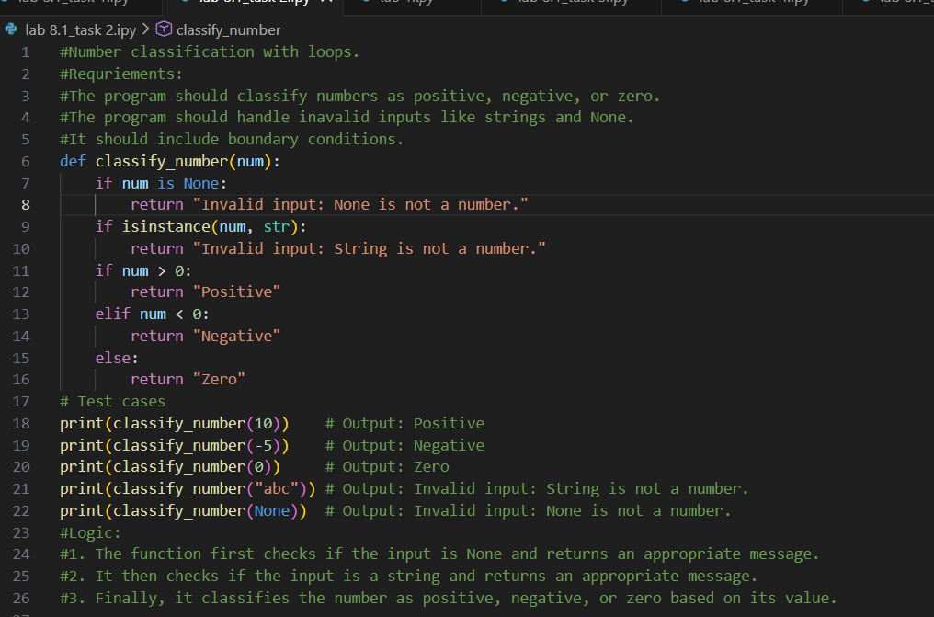

Output:
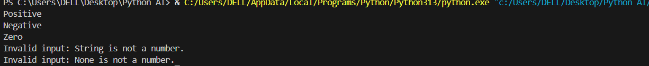

Analysis:
1. The function classifies numbers into Positive, Negative, or Zero.
2.Invalid inputs like strings and None return "Invalid Input".
3. AI-generated assert cases helped verify normal cases, edge cases, and invalid inputs.

Task Description #3: (Anagram Checker – Apply AI for String
Analysis)
- Task: Use AI to generate at least 3 assert test cases for is_anagram(str1, str2) and implement the function.
- Requirements:
o Ignore case, spaces, and punctuation. o Handle edge cases (empty strings, identical words).
Example Assert Test Cases:
assert is_anagram("listen", "silent") == True assert is_anagram("hello", "world") == False assert is_anagram("Dormitory", "Dirty Room") == True Expected Output #3:
• Function correctly identifying anagrams and passing all AI- generated tests.
Prompt :
#Anagram checker
#ignore case and spaces and punctuations
#handle edge cases like empty strings and non-string inputs identical words.

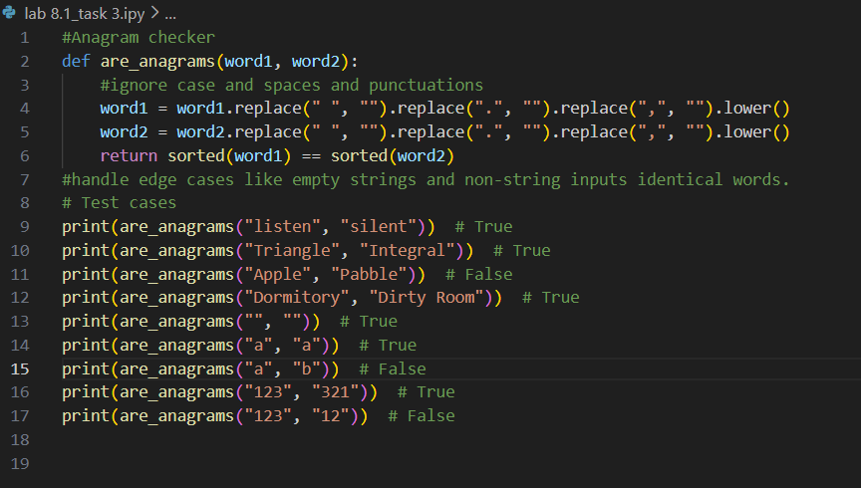

Output:
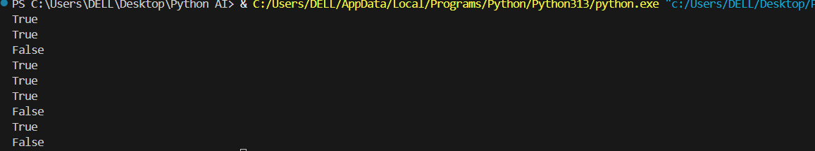

Analysis:
- The function checks if two strings are anagrams.
- AI-generated assert test cases verified both valid and invalid scenarios.
- Since no assertion errors occurred, the function works correctly.

Task Description #4:
(Inventory Class – Apply AI to Simulate Real-
World Inventory System)
- Task: Ask AI to generate at least 3 assert-based tests for an Inventory class with stock management.
- Methods:
o add_item(name, quantity) o remove_item(name, quantity) o get_stock(name) Example Assert Test Cases: inv = Inventory() inv.add_item("Pen", 10) assert inv.get_stock("Pen") == 10 inv.remove_item("Pen", 5) assert inv.get_stock("Pen") == 5 inv.add_item("Book", 3) assert inv.get_stock("Book") == 3 Expected Output #4:
• Fully functional class passing all assertions.

Prompt :
#Inventory class with stock management
#Create a class called Inventory that manages the stock of products in a store. The class should have the following methods
#1. add_product(product_name, quantity): This method should add a specified quantity of a product to the inventory. If the product already exists, it should update the quantity.
#2. remove_product(product_name, quantity): This method should remove a specified quantity of a product from the inventory. If the product does not exist or if the quantity to remove is greater than the available stock, it should display an appropriate message.
#3. check_stock(product_name): This method should return the current stock quantity of a specified product. If the product does not exist, it should display an appropriate message.

Code :
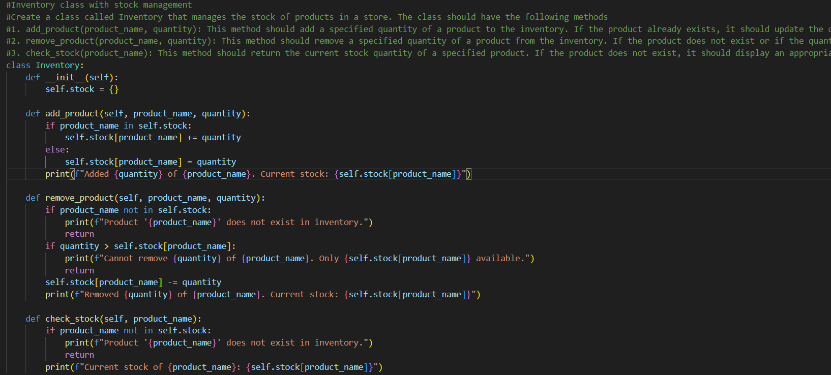

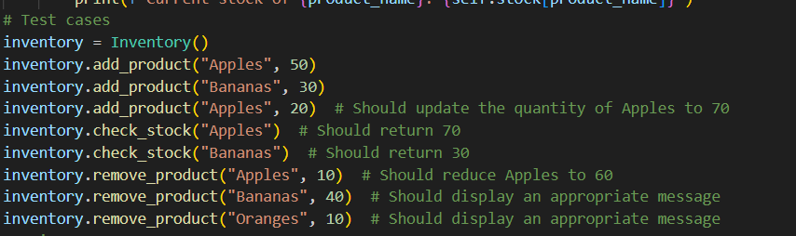

Output
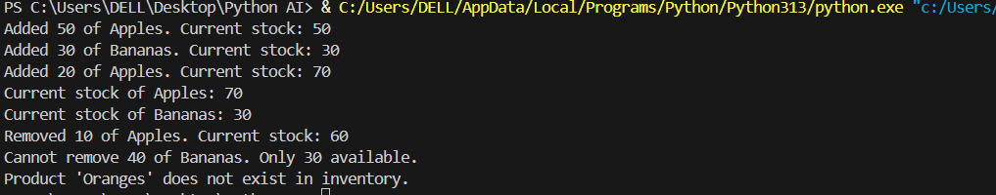
Analysis:

- AI-generated assert tests validated real-world scenarios like:
  - Adding stock
  - Removing stock
  - Checking non-existent items
  - Preventing over-removal
- Since no assertion errors occurred, the system works correctly.

Task Description #5:
(Date Validation & Formatting – Apply AI for
Data Validation)
- Task: Use AI to generate at least 3 assert test cases for validate_and_format_date(date_str) to check and convert dates.
- Requirements:
- Validate "MM/DD/YYYY" format. o Handle invalid dates.
- Convert valid dates to "YYYY-MM-DD".
Example Assert Test Cases:
assert validate_and_format_date("10/15/2023") == "2023-10-15" assert validate_and_format_date("02/30/2023") == "Invalid Date" assert validate_and_format_date("01/01/2024") == "2024-01-01" Expected Output #5:
• Function passes all AI-generated assertions and handles edge cases.
Prompt :
#Date Validation and Formattting
#Write a Python program that validates a date input by the user and formats it in a specific way. The program should:
#1. Prompt the user to enter a date in the format "DD/MM/YYYY".
#2. Validate the input to ensure it is a valid date (e.g., correct number
#3.handle invalid dates
#And the program should convert the valid date to "YYYY-MM-DD" format and display it to the user.

Code :
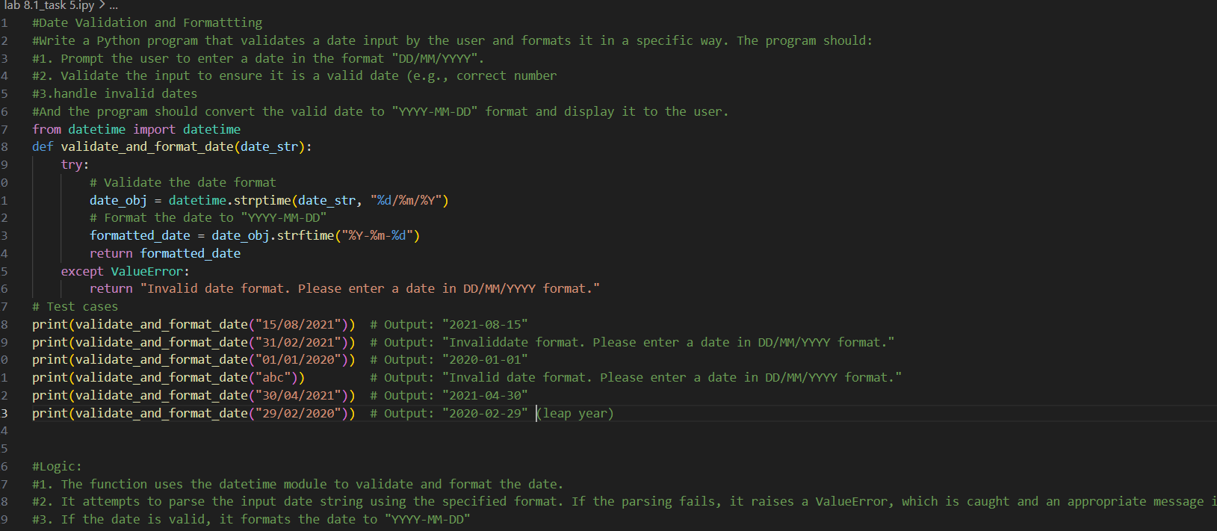

Output :
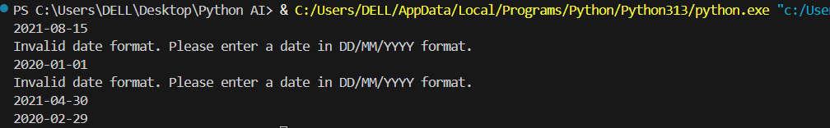
Analysis:
- The function validates dates using Python’s datetime module.
- AI-generated assert cases helped verify correct and incorrect inputs.
- Since no assertion errors occurred, the function works correctly.

