ASSIGNMENT- 9.1
Name : B.Hamsika
H.T.NO: 2303A51230
Batch : 18
Problem 1:
Consider the following Python function:
def find_max(numbers):
return max(numbers)
Task:
• Write documentation for the function in all three formats:
(a) Docstring
(b) Inline comments
(c) Google-style documentation
• Critically compare the three approaches. Discuss the
advantages, disadvantages, and suitable use cases of each
style.
• Recommend which documentation style is most effective
for a mathematical utilities library and justify your
answer
Promt :
# Write documentation for the function in three formats
# and compare them. Also recommend the best style.

# (a) Docstring Style
# (b) Inline Comment Style
# This function takes a list of numbers

# It uses Python's built-in max() function
# to return the largest number
# (c) Google-Style Documentation

INPUT:

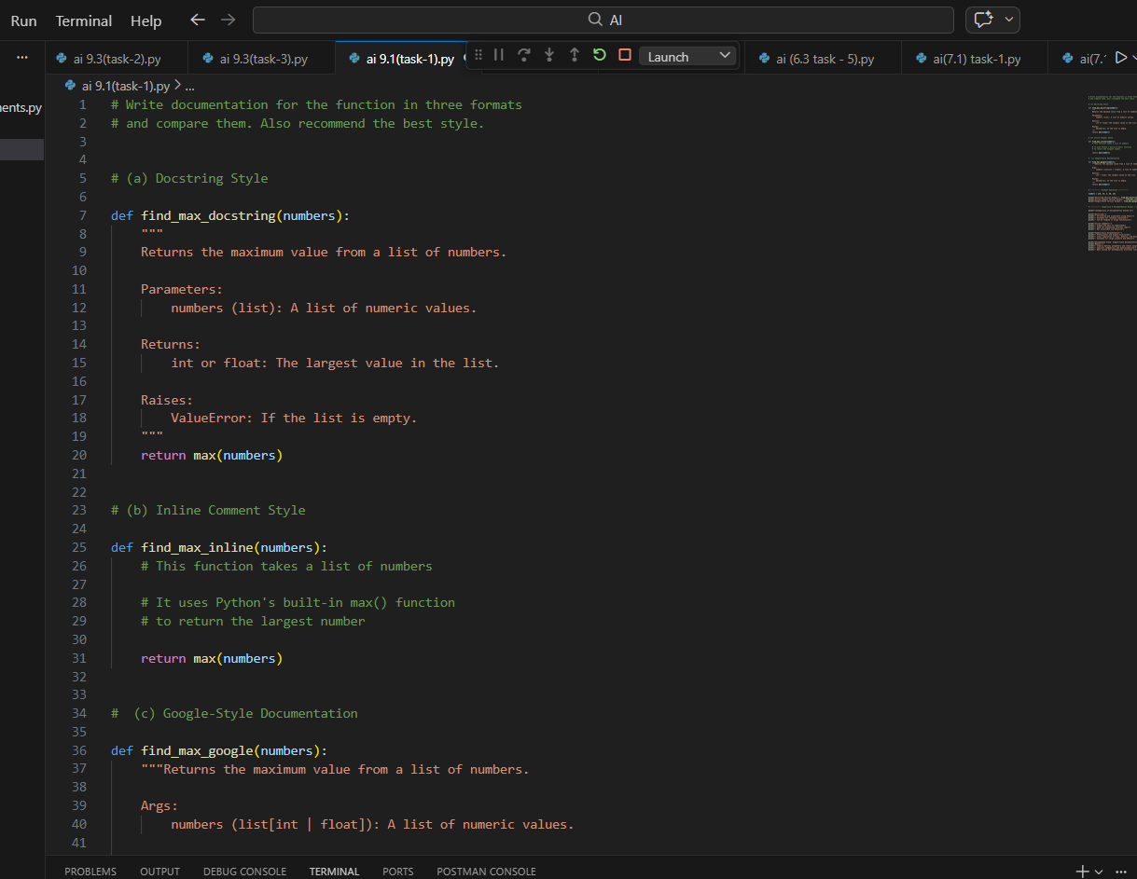
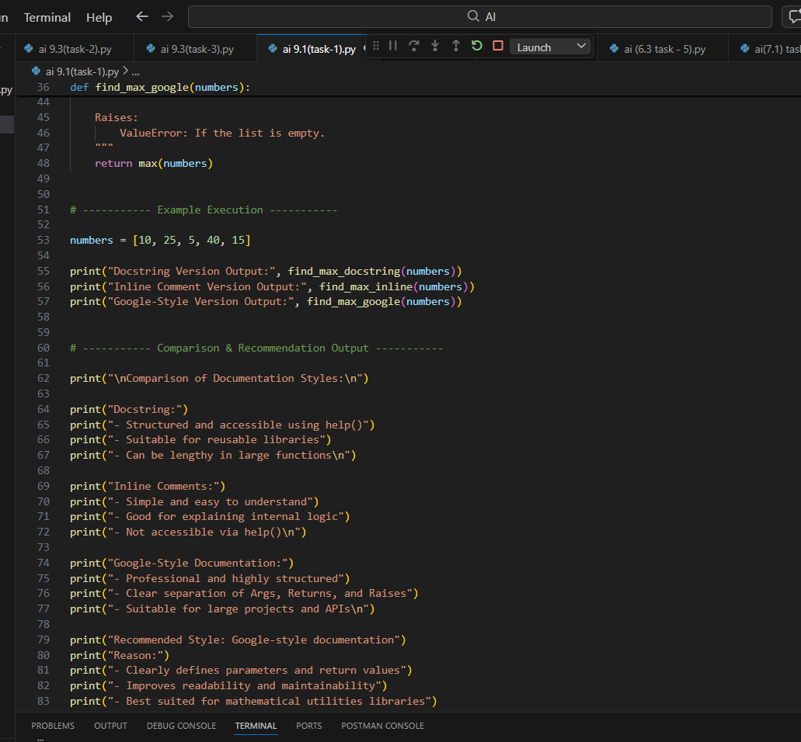
OUTPUT:
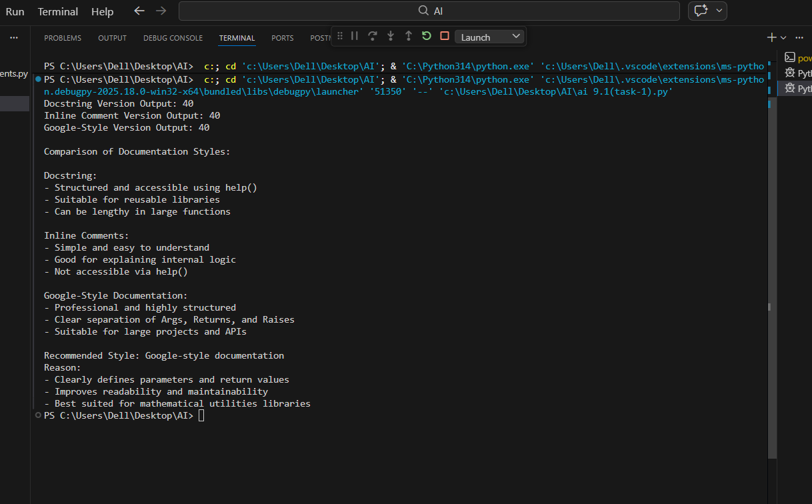
EXPLANATION:
Docstring Style – Explanation
Docstrings are written inside triple quotes below a function and provide a clear description of what the function does. They explain inputs, outputs, and possible errors in a readable format. Docstrings can be accessed using help() and are useful for documentation tools. They are good for reusable functions and structured code.
Inline Comment Style – Explanation
Inline comments are written using # inside the function body. They explain the logic of specific lines of code and improve readability. However, they are not structured documentation and cannot be accessed automatically. They are mainly useful for explaining complex steps in the code.
Google-Style Documentation – Explanation
Google-style documentation is a well-structured docstring format that clearly separates sections like Args, Returns, and Raises. It improves clarity and consistency in larger projects. This style is widely used in professional development. It is best suited for libraries and production-level code

Problem 2:
Consider the following Python function:
def login(user, password, credentials):
return credentials.get(user) == password
Task:
1. Write documentation in all three formats.
2. Critically compare the approaches.
3. Recommend which style would be most helpful for new
developers onboarding a project, and justify your choice.
PROMT:
# Write documentation for the login function using standard Python docstring format.
#Rewrite the same login function documentation using inline comments.
#Rewrite the login function using Google-style documentation format.
#Create example credentials data and test all three versions of the function.
#Compare docstring, inline comments, and Google-style documentation
# in terms of structure, clarity, and maintainability.
# Discuss advantages and disadvantages of each documentation style.
#Recommend the most suitable documentation style
# for onboarding new developers to a project.

# Justify the recommendation with clear reasoning.

INPUT:
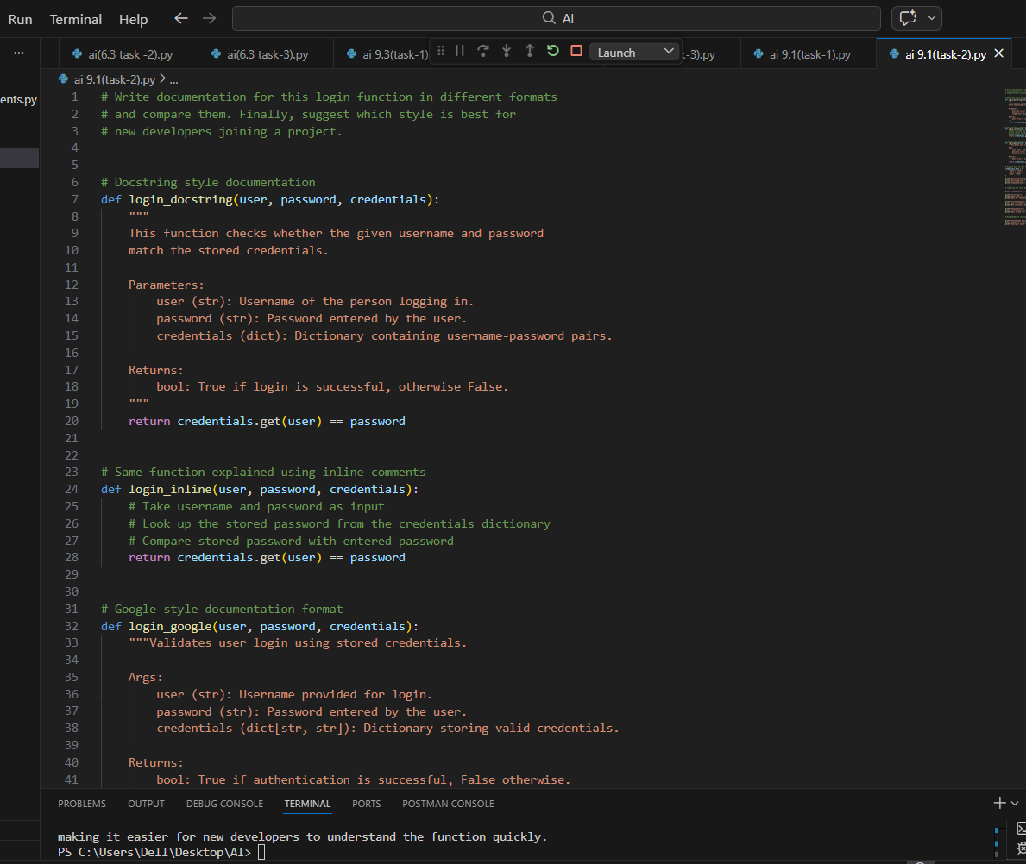
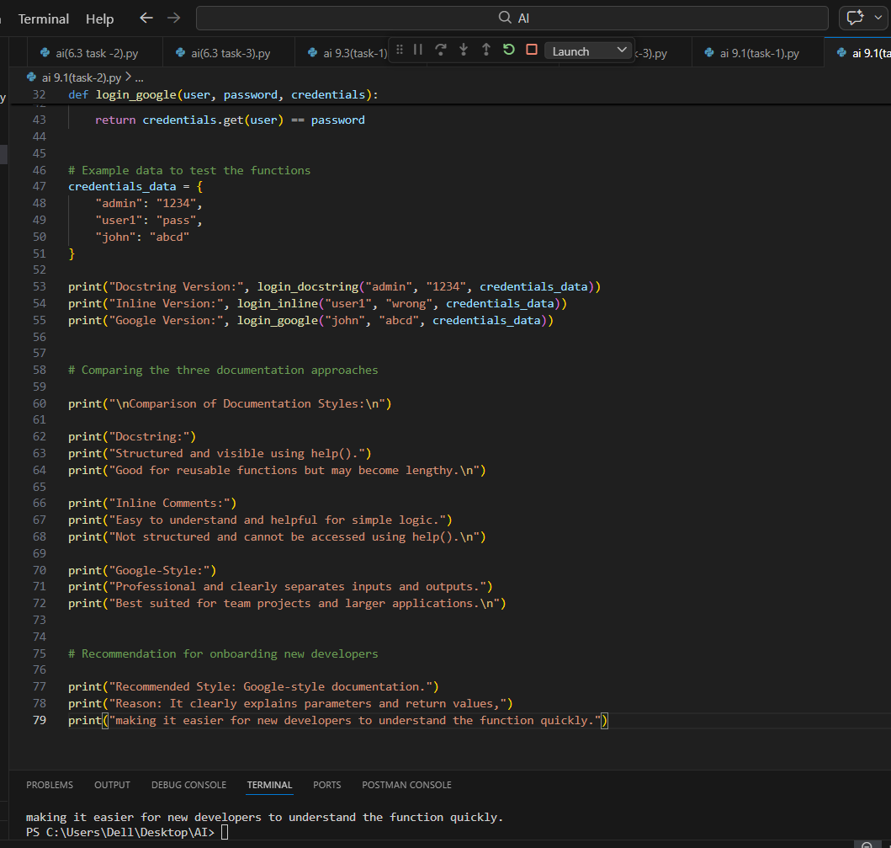
OUTPUT:
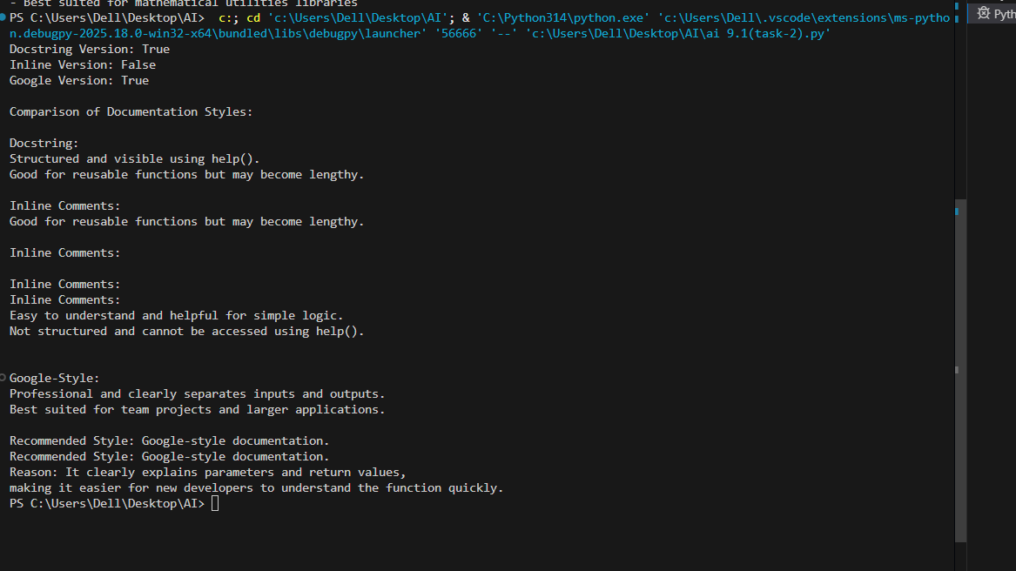
EXPLANATION:
Docstrings are written inside triple quotes below a function. They explain the purpose, parameters, and return values clearly. They can be accessed using help() and are useful for documentation tools. This style is good for reusable and well-structured code.
Inline Comment Style – Explanation
Inline comments use # to explain specific lines of code. They help understand the internal logic step-by-step. However, they are not structured and cannot be accessed as formal documentation. They are best for explaining simple or complex logic inside the function.
Google-Style Documentation – Explanation
Google-style documentation is a structured docstring format with clear sections like Args and Returns. It improves clarity and consistency in team projects. It is widely used in industry and suitable for larger applications.
Recommendation
Google-style documentation is best for new developers because it clearly explains inputs and outputs in a structured way, making the function easy to understand quickly

Problem 3: Calculator (Automatic Documentation Generation)
Task: Design a Python module named calculator.py and
demonstrate automatic documentation generation.
Instructions:
1. Create a Python module calculator.py that includes the
following functions, each written with appropriate docstrings:
o add(a, b) – returns the sum of two numbers
o subtract(a, b) – returns the difference of two numbers
o multiply(a, b) – returns the product of two numbers
o divide(a, b) – returns the quotient of two numbers
2. Display the module documentation in the terminal using
Python’s documentation tools.
3. Generate and export the module documentation in HTML
format using the pydoc utility, and open the generated HTML
file in a web browser to verify the output.
PROMT:
# Prompt: Create basic arithmetic functions (add, subtract, multiply, divide).
# Prompt: Add simple docstrings to each function for automatic documentation generation.
# Prompt: Use help() to display documentation of each function in the terminal.
# Prompt: Execute each function with sample input values.
# Prompt: Display the output of all arithmetic operations clearly.

INPUT :

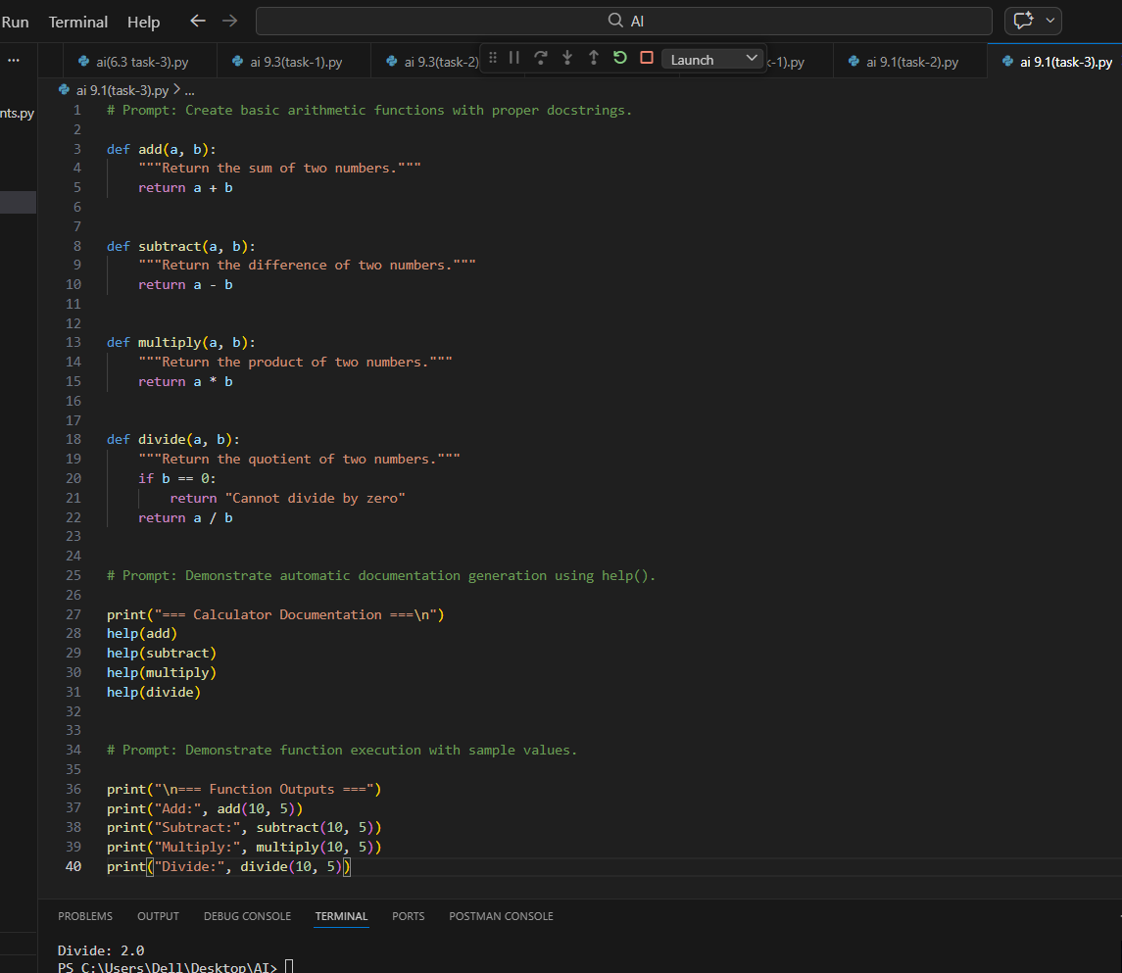
OUTPUT:
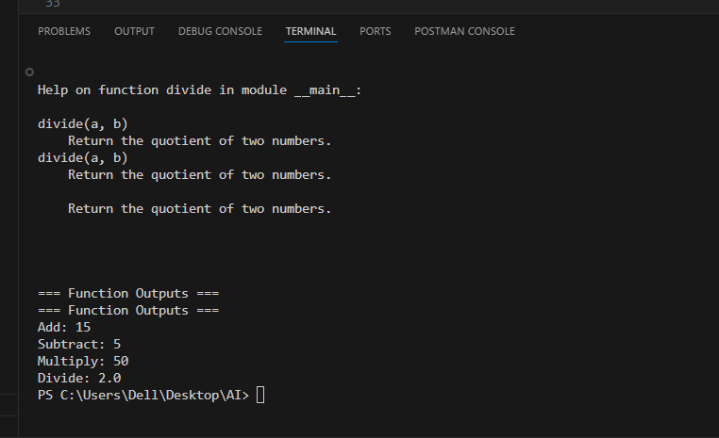
EXPLANATION:
Docstring Explanation
In this program, each arithmetic function contains a simple docstring that briefly explains its purpose. The docstring is written inside triple quotes directly below the function definition. When the help() function is called, Python automatically displays this documentation. This demonstrates how docstrings support automatic documentation generation.
Importance of Using Docstrings
Docstrings make functions self-explanatory and improve readability. They allow developers to understand what a function does without reading its implementation. Using help() is especially useful in larger projects, libraries, and team environments. This approach ensures clean, professional, and maintainable code
Problem 4: Conversion Utilities Module
Task:
1. Write a module named conversion.py with functions:
o decimal_to_binary(n)
o binary_to_decimal(b)
o decimal_to_hexadecimal(n)
2. Use Copilot for auto-generating docstrings.
3. Generate documentation in the terminal.
4. Export the documentation in HTML format and open it in a
Browser
PROMPTS:
# Create a Python module named conversion.py with number conversion functions.
# Implement decimal_to_binary(n) to convert a decimal number to binary.
# Implement binary_to_decimal(b) to convert a binary string to decimal.
# Implement decimal_to_hexadecimal(n) to convert a decimal number to hexadecimal.
# Add proper docstrings to all functions (as if generated by Copilot).
# Use help() to display function documentation in the terminal.

# Demonstrate the conversion functions using sample inputs.
# Generate module documentation in HTML format using the pydoc utility.
# Open the generated HTML file in a web browser to verify the documentation.
INPUT:
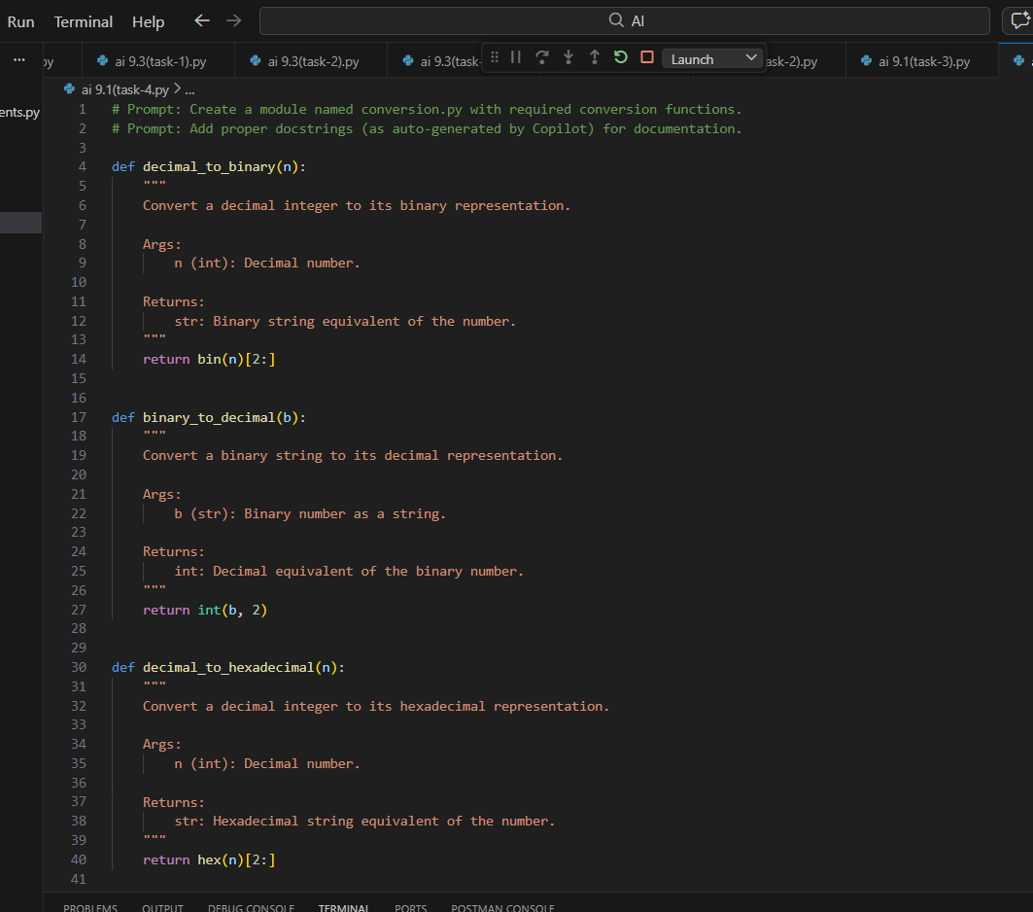
OUTPUT:
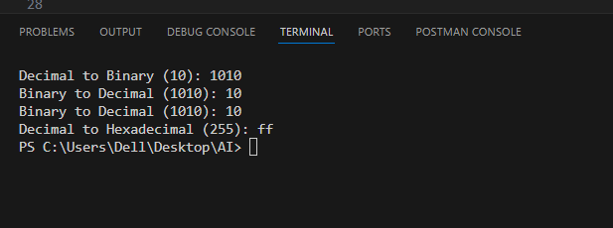
Explanation:
Each function in the module contains a structured docstring that explains its purpose, input arguments, and return values. These docstrings follow a clear format similar to professional documentation standards. When help() is used, Python automatically reads and displays these docstrings in the terminal. This makes the module self-documented and easy to understand.
Automatic Documentation Generation
The help() function demonstrates how Python can generate documentation directly from docstrings. Additionally, using the pydoc -w conversion command creates an HTML file containing the module documentation. This shows how properly written docstrings support both terminal-based and web-based documentation generation, making the code more professional and maintainable.
Problem 5 – Course Management Module
Task:
1. Create a module course.py with functions:
o add_course(course_id, name, credits)
o remove_course(course_id)
o get_course(course_id)
2. Add docstrings with Copilot.
3. Generate documentation in the terminal.
4. Export the documentation in HTML format and open it in a
browser.
PROMPTS:
COURSE MANAGEMENT MODULE
# This module should allows adding, removing, and retrieving
# course details. It also demonstrates documentation
# generation using help().

# In-memory course storage

INPUT:
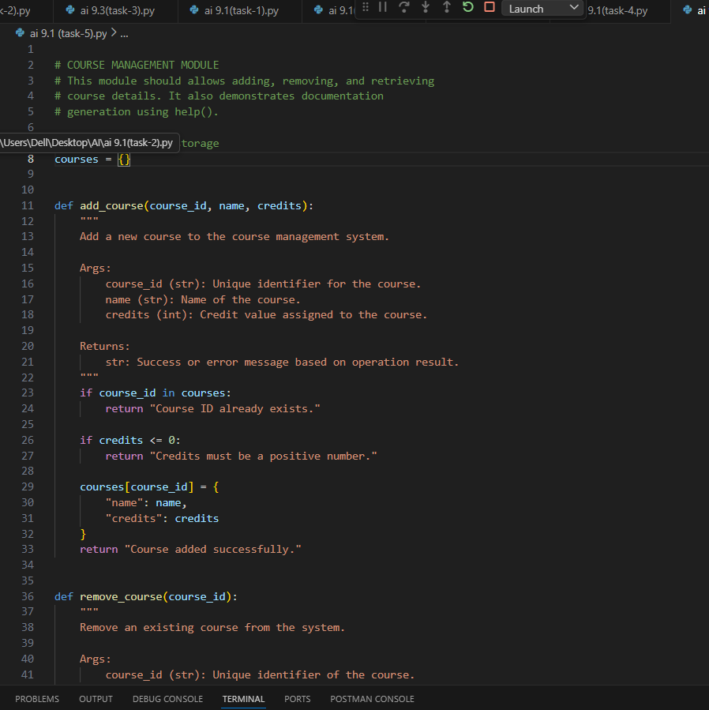
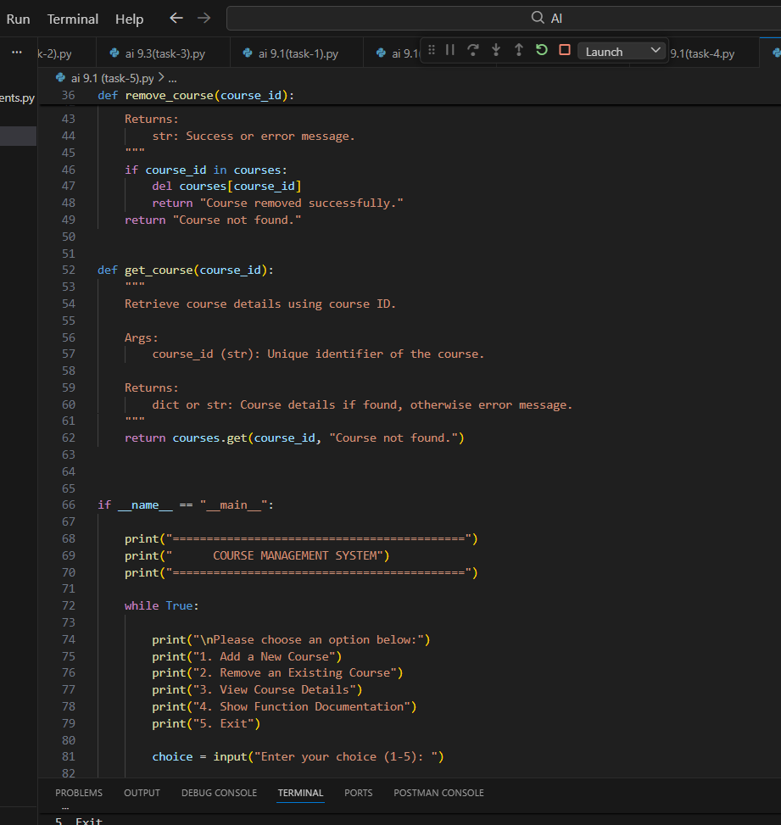

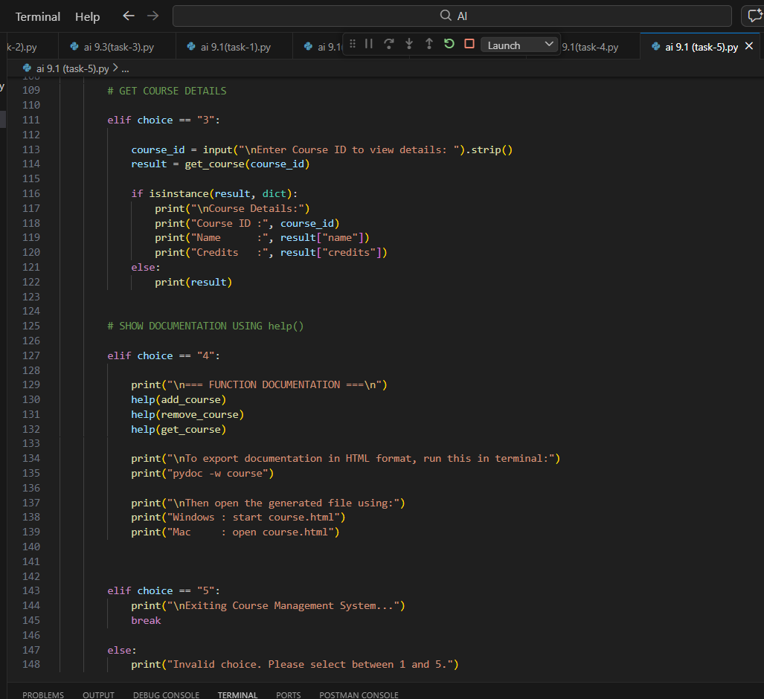OUTPUT:
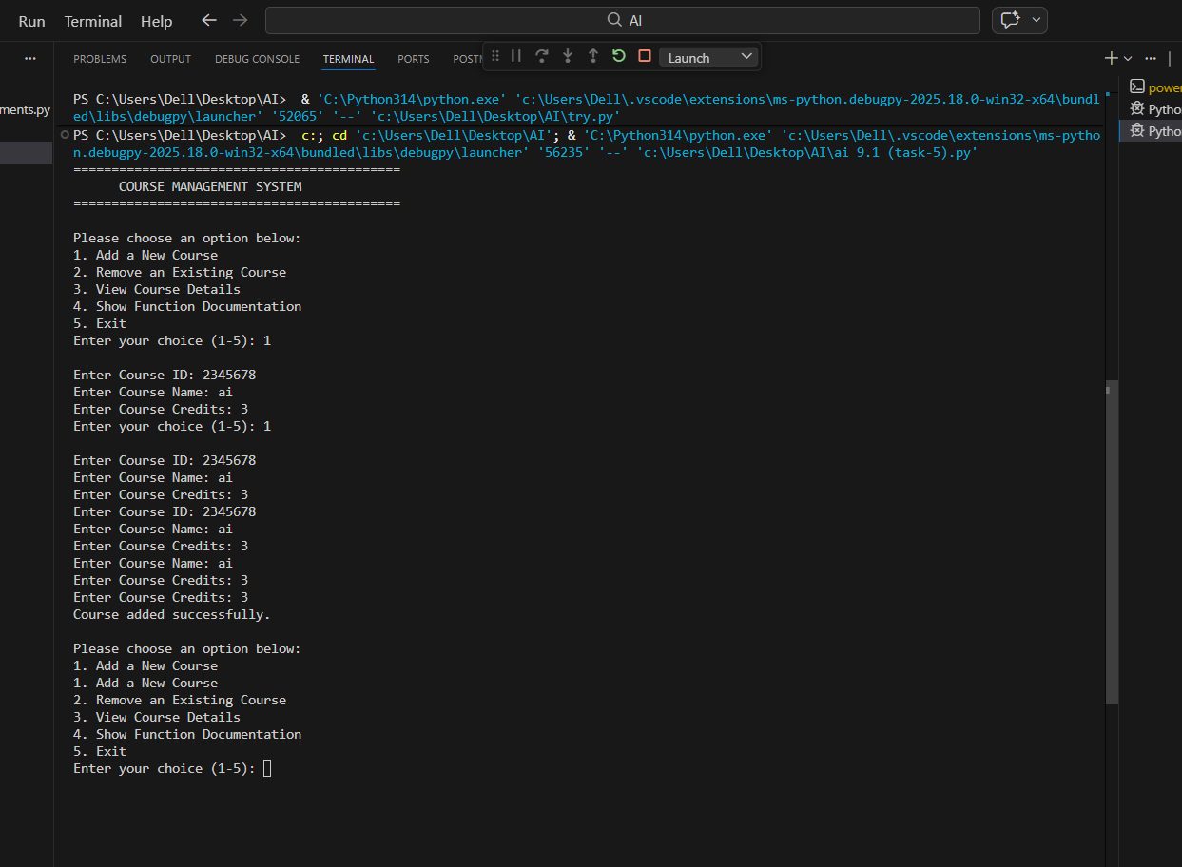
Explanation:
This program is a simple course management system that allows users to add, remove, and view course details through a menu-driven interface. It stores course information in a dictionary and performs basic validation like checking duplicate IDs and valid credits. Each function includes proper docstrings to support documentation generation. The documentation can be viewed using help() or exported to HTML format using the pydoc command.

