Assignment 4.3
2303A51232
B.Tharun
Batch – 18
Task 1: Zero-Shot Prompting – Leap Year Check
Scenario
Zero-shot prompting involves giving instructions without providing examples.
Task Description
Use zero-shot prompting to instruct an AI tool to generate a Python function that:
• Accepts a year as input
• Checks whether the given year is a leap year
• Returns an appropriate result
Note: No input-output examples should be provided in the prompt.
Prompt :
#check wheather year is leap year or not taking input from user
Code :
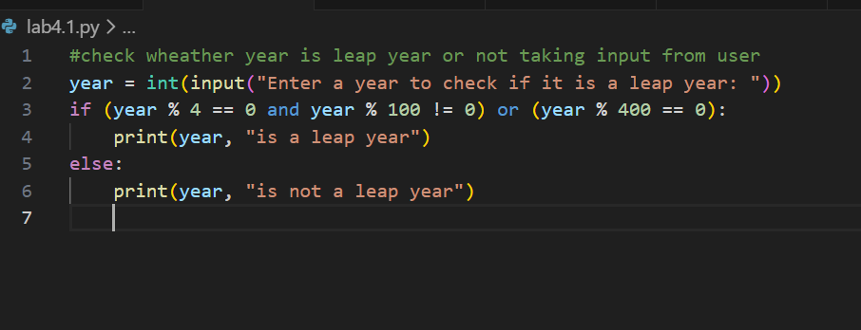
Output :
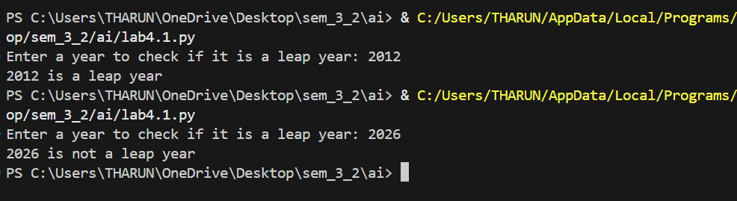
Analysis :
AI correctly understood the problem without examples.
Logical conditions were accurate (divisible by 4, 100, 400 rules).
Function structure was simple and efficient.

Task 2: One-Shot Prompting – Centimeters to Inches Conversion
Scenario
One-shot prompting guides AI using a single example.
Task Description
Use one-shot prompting by providing one input-output example to generate a Python
function that:
• Converts centimeters to inches
• Uses the correct mathematical formula
Example provided in prompt:
Input: 10 cm → Output: 3.94 inches
Prompt :
#take input from user and convert centimeter to inches
Code
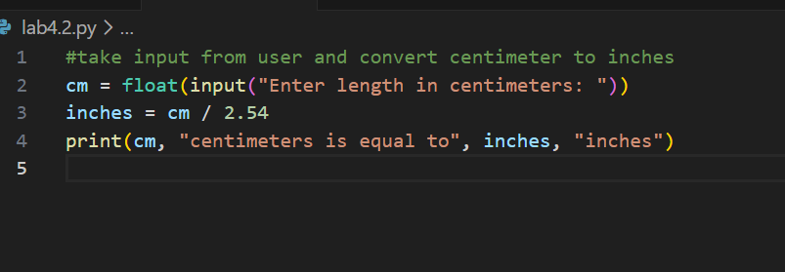
Output
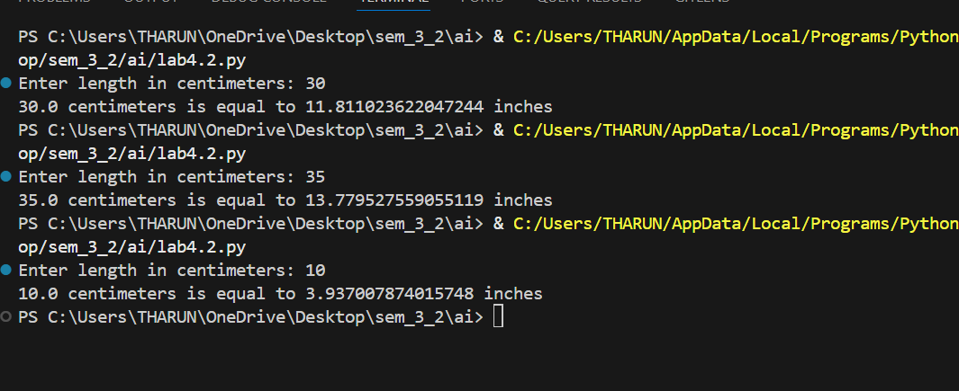
Analysis
Single example helped AI understand the formula requirement.
Conversion logic (cm ÷ 2.54) was correctly applied.
Output matched expected precision.

Task 3: Few-Shot Prompting – Name Formatting
Scenario
Few-shot prompting improves accuracy by providing multiple examples.
Task Description
Use few-shot prompting with 2–3 examples to generate a Python function that:
• Accepts a full name as input
• Formats it as “Last, First”
Example formats:
• "John Smith" → "Smith, John"
• "Anita Rao" → "Rao, Anita"
Prompt
#take input from user as string and print word reversed
#John Smith" → "Smith, John"
Code
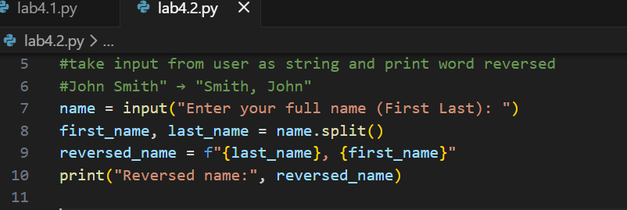
Output
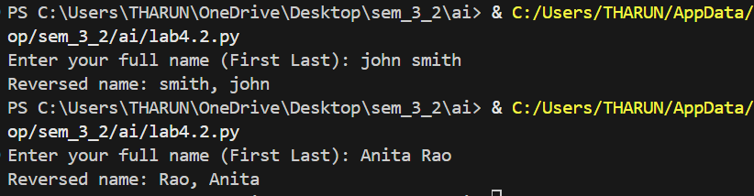
Analysis
Multiple examples improved format understanding.
Output strictly followed “Last, First” pattern.
Function handled input consistently.

Task 4: Comparative Analysis – Zero-Shot vs Few-Shot
Scenario
Different prompt strategies may produce different code quality.
Task Description
• Use zero-shot prompting to generate a function that counts vowels in a string
• Use few-shot prompting for the same problem
• Compare both outputs based on:
o Accuracy
o Readability
o Logical clarity
prompt
#count vowels from a sentence
Code
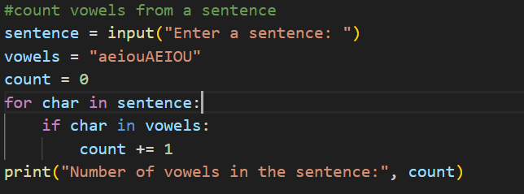
Output
Analysis
Zero-shot version was logically correct but longer.
Few-shot version was more concise and readable.
Few-shot prompting improved code quality.

Task 5: Few-Shot Prompting – File Handling
Scenario
File processing requires clear logical understanding.
Task Description
Use few-shot prompting to generate a Python function that:
• Reads a .txt file
• Counts the number of lines in the file
• Returns the line count
Expected Output
• Working Python file-processing function
• Correct line count
• Sample .txt input and output
• AI-assisted logic explanation
Prompt
#read a .txt file and count number of lines in file and return file count
Code 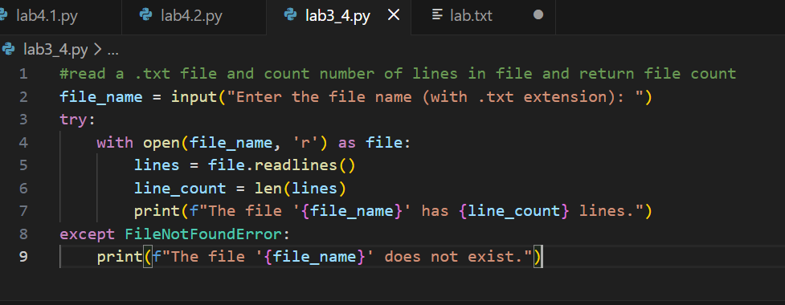
Output
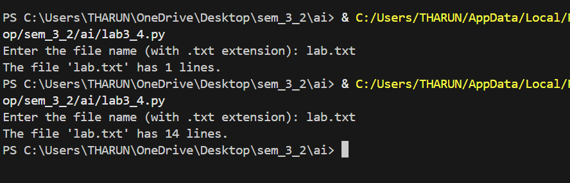

Analysis
Few-shot prompting improved understanding of file operations.
Function correctly read file and counted lines.
Proper use of file handling methods.
Logic was clear and structured.

