Assignment 2.1
2303A51232
B.Tharun
Batch – 18
Task 1 :
Statistical Summary for Survey Data
❖ Scenario:
You are a data analyst intern working with survey responses stored as
numerical lists.
❖ Task:
Use Google Gemini in Colab to generate a Python function that reads a list
of numbers and calculates the mean, minimum, and maximum values.
❖ Expected Output:
➢ Correct Python function
➢ Output shown in Colab
➢ Screenshot of Gemini prompt and result
Prompt :
#read a list of numbers
#calculates the mean, minimum, and maximum values.
Code :
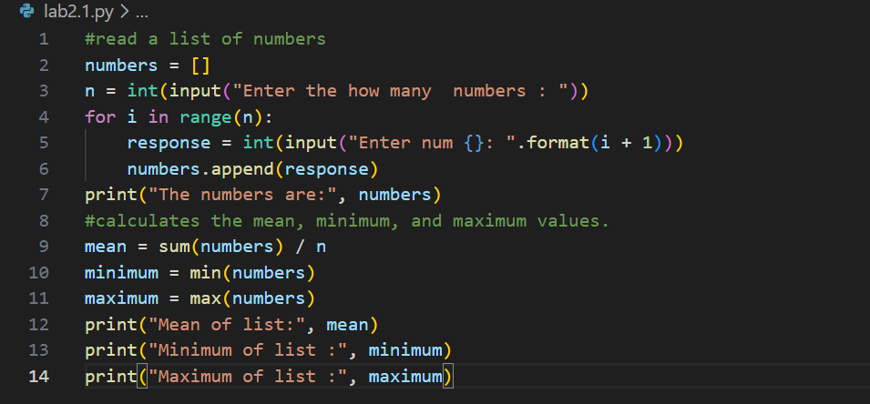
output
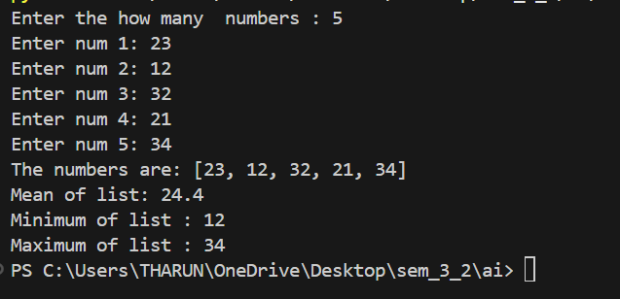
Analysis
1.Gemini generated correct code.
2.Output was accurate.
3. Easy to use in vs.

Task 2 :
Scenario:
You are evaluating AI tools for numeric validation logic.
❖ Task:
Generate an Armstrong number checker using Gemini and GitHub
Copilot.
Compare their outputs, logic style, and clarity.
❖ Expected Output:
➢ Side-by-side comparison table
➢ Screenshots of prompts and generated code
Prompt :
#take input from user and check if it is armstrong number
Code :
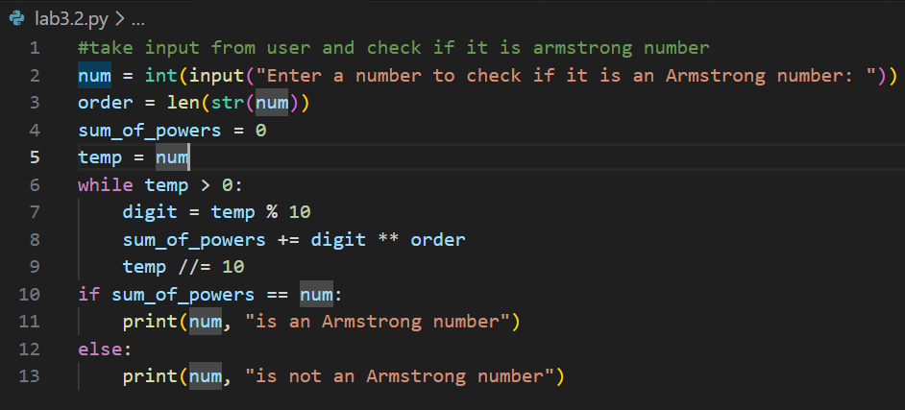
Output:
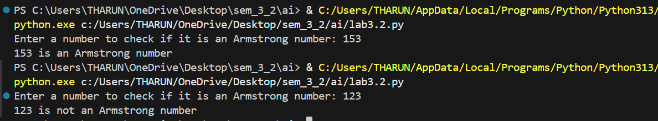
Analysis
1.Both tools gave correct logic.
2.Gemini was easy to understand.
3.Copilot was faster.

Task 3 :
Leap Year Validation Using Cursor AI
❖ Scenario:
You are validating a calendar module for a backend system.
❖ Task:
Use Cursor AI to generate a Python program that checks whether a given
year is a leap year.
Use at least two different prompts and observe changes in code.
❖ Expected Output:
➢ Two versions of code
➢ Sample inputs/outputs
➢ Brief comparison
Prompt :
#take input from user and check if it is leap year
Code :
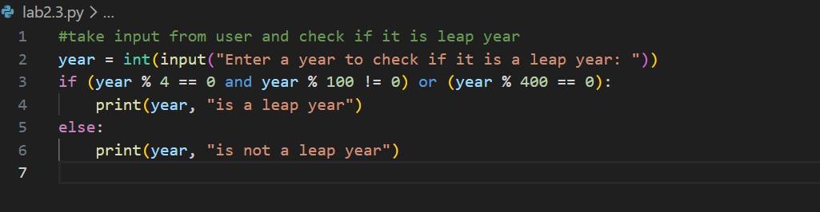
Output:
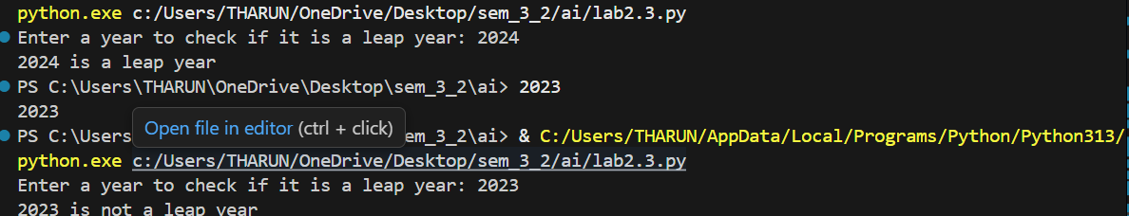
Analysis
1.Cursor AI used with VS Code.
2. Different prompts gave different code.
3. Logic was correct.

Task 4 :
Student Logic + AI Refactoring (Odd/Even Sum)
❖ Scenario:
Company policy requires developers to write logic before using AI.
❖ Task:
Write a Python program that calculates the sum of odd and even numbers
in a tuple, then refactor it using any AI tool.
❖ Expected Output:
➢ Original code
➢ Refactored code
➢ Explanation of improvements
Prompt :
#read tuple from user and print sum of even numbers in it
#print sum sum odd numbers in it
Code :
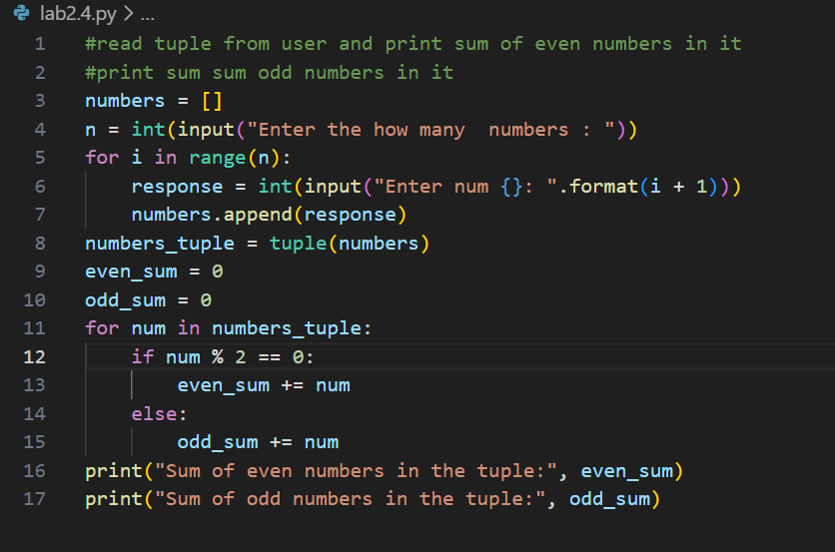
Output
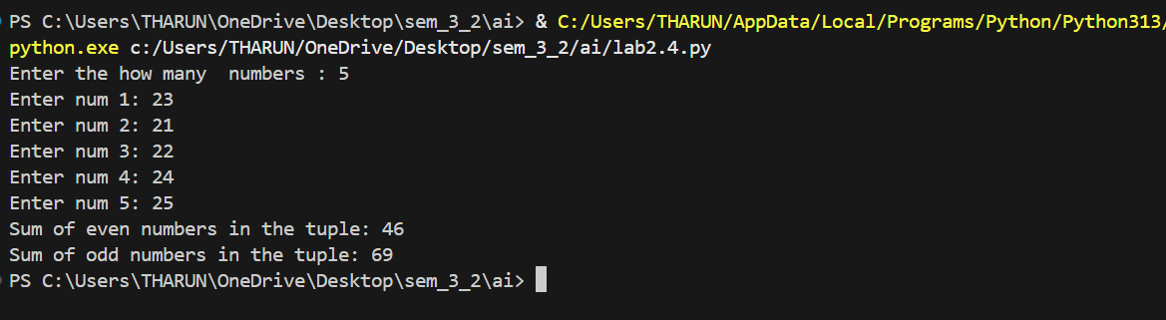
Analysis :
1. Code written manually in VS Code.
2. AI refactored the code.
3. Code became clean and readable.

