Assignment – 6.3
2303A51232 Wednesday
B.Tharun lab assignment
Batch 18 04-02-2026
Task Description #1: Classes (Student Class)
Scenario
You are developing a simple student information management module.
Task
• Use an AI tool (GitHub Copilot / Cursor AI / Gemini) to complete a Student class.
• The class should include attributes such as name, roll number, and branch.
• Add a method display_details() to print student information.
• Execute the code and verify the output.
• Analyze the code generated by the AI tool for correctness and clarity.
Expected Output #1
• A Python class with a constructor (__init__) and a display_details() method.
• Sample object creation and output displayed on the console.
• Brief analysis of AI-generated code.
Prompt
#simple student information management module.
#class should include attributes such as name, roll number, and branch.
#Add a method display_details() to print student information
#take input from the user
#print all students id name age grade and branch

Code
#simple student information management module.
def add_student(students, student_id, name, age, grade):
students[student_id] = {
'name': name,
'age': age,
'grade': grade
}
#class should include attributes such as name, roll number, and branch.
def display_students(students):
print("\nStudent Information:")
for student_id, info in students.items():
print(f"ID: {student_id}, Name: {info['name']}, Age: {info['age']}, Grade: {info['grade']}, branch: {info.get('branch', 'N/A')}")
#Add a method display_details() to print student information
students = {}

display_students(students)
#take input from the user
student_id = int(input("Enter Student ID: "))
name = input("Enter Student Name: ")
age = int(input("Enter Student Age: "))
grade = input("Enter Student Grade: ")
branch = input("Enter Student Branch: ")
add_student(students, student_id, name, age, grade)
display_students(students)
#print all students id name age grade and branch
display_students(students)

Output
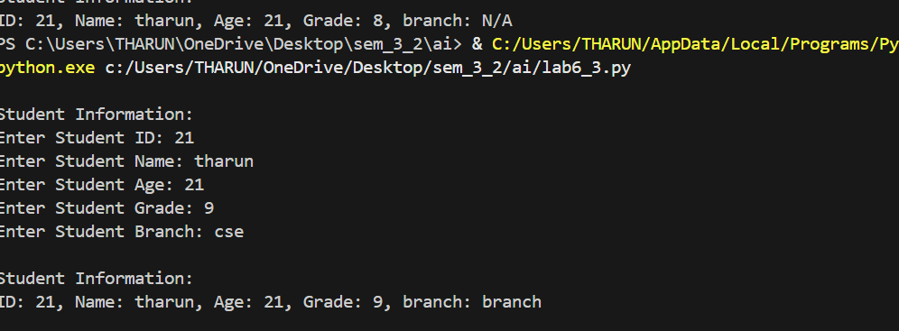
Task Description #2: Loops (Multiples of a Number)
Scenario
You are writing a utility function to display multiples of a given number.
Task
• Prompt the AI tool to generate a function that prints the first 10 multiples of a given number
using a loop.
• Analyze the generated loop logic.
• Ask the AI to generate the same functionality using another controlled looping structure (e.g.,
while instead of for).
Expected Output #2
• Correct loop-based Python implementation.
• Output showing the first 10 multiples of a number.
• Comparison and analysis of different looping approaches
Prompt
# write a utility function to display multiples of a given number.

Code
def display_multiples(number, limit):
print(f"Multiples of {number} up to {limit}:")
for i in range(1, limit + 1):
print(number * i, end=' ')
print()
num = int(input("Enter a number to find its multiples: "))
limit = int(input("Enter the limit up to which multiples are to be displayed: "))
display_multiples(num, limit)

Output
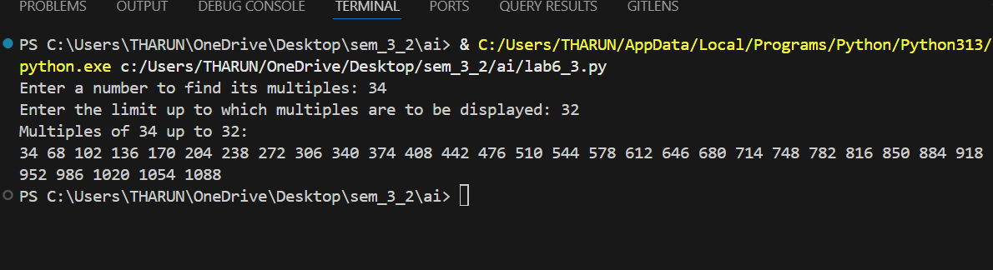

Task Description #3: Conditional Statements (Age Classification)
Scenario
You are building a basic classification system based on age.
Task
• Ask the AI tool to generate nested if-elif-else conditional statements to classify age groups
(e.g., child, teenager, adult, senior).
• Analyze the generated conditions and logic.
• Ask the AI to generate the same classification using alternative conditional structures (e.g.,
simplified conditions or dictionary-based logic).
Expected Output #3
• A Python function that classifies age into appropriate groups.
• Clear and correct conditional logic.
• Explanation of how the conditions work.
Prompt
#take input as age of person
#determine whether the person is a minor, adult, or senior citizen

Code
age = int(input("Enter your age: "))
if age < 0:
print("Invalid age. Age cannot be negative.")
elif age < 18:
print("You are a minor.")
elif age < 65:
print("You are an adult.")
else:
print("You are a senior citizen.")

Output
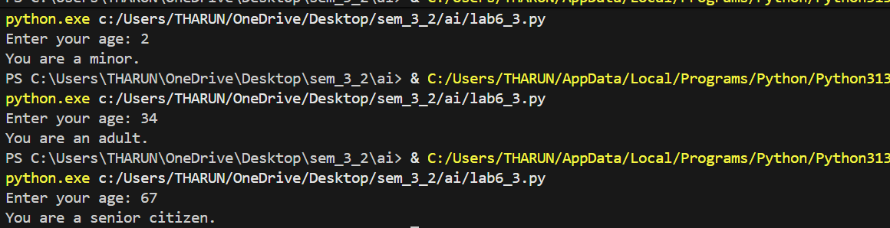

Task Description #4: For and While Loops (Sum of First n Numbers)
Scenario
You need to calculate the sum of the first n natural numbers.
Task
• Use AI assistance to generate a sum_to_n() function using a for loop.
• Analyze the generated code.
• Ask the AI to suggest an alternative implementation using a while loop or a mathematical
formula.
Expected Output #4
• Python function to compute the sum of first n numbers.
• Correct output for sample inputs.
• Explanation and comparison of different approaches.
Prompt
#take input from user and find sum of n natural numbers

Code
#take input from user and find sum of n natural numbers
n = int(input("Enter a positive integer: "))
if n < 1:
print("Please enter a positive integer greater than 0.")
else:
total_sum = 0
for i in range(1, n + 1):
total_sum += i
print(f"The sum of the first {n} natural numbers is: {total_sum}")

Output
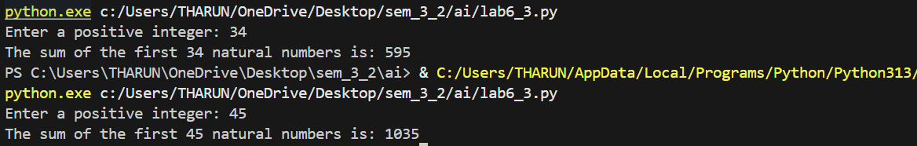

Task Description #5: Classes (Bank Account Class)
Scenario
You are designing a basic banking application.
Task
• Use AI tools to generate a Bank Account class with methods such as deposit(), withdraw(),
and check_balance().
• Analyze the AI-generated class structure and logic.
• Add meaningful comments and explain the working of the code.
Expected Output #5
• Complete Python Bank Account class.
• Demonstration of deposit and withdrawal operations with updated balance.
• Well-commented code with a clear explanation.
Prompt
#design a basic banking application.allow users to create an account, deposit money, withdraw money, and check their balance.

#enter amount to depiste and withdraw by user

Code
#design a basic banking application.allow users to create an account, deposit money, withdraw money, and check their balance.
class BankAccount:
def __init__(self, account_holder, initial_balance=0):
self.account_holder = account_holder
self.balance = initial_balance

def deposit(self, amount):
if amount > 0:
self.balance += amount
print(f"Deposited: {amount}. New balance: {self.balance}")
else:
print("Deposit amount must be positive.")

def withdraw(self, amount):
if 0 < amount <= self.balance:
self.balance -= amount
print(f"Withdrew: {amount}. New balance: {self.balance}")
else:
print("Insufficient balance or invalid withdrawal amount.")

def check_balance(self):
print(f"Account Holder: {self.account_holder}, Balance: {self.balance}")
# Example usage
account_holder = input("Enter account holder name: ")
account = BankAccount(account_holder)
account.check_balance()
#enter amount to depiste and withdraw by user
deposit_amount = int(input("Enter amount to deposit: "))
account.deposit(deposit_amount)
withdraw_amount = int(input("Enter amount to withdraw: "))
account.withdraw(withdraw_amount)
account.check_balance()

Output
