ASSIGNMENT 6.3

2303A51237

Task Description #1: Classes (Student Class)
Scenario
You are developing a simple student information management module.
Task
• Use an AI tool (GitHub Copilot / Cursor AI / Gemini) to complete a Student class.
• The class should include attributes such as name, roll number, and branch.
• Add a method display_details() to print student information.
• Execute the code and verify the output.
• Analyze the code generated by the AI tool for correctness and clarity.
Expected Output #1
• A Python class with a constructor (__init__) and a display_details() method.
• Sample object creation and output displayed on the console.
• Brief analysis of AI-generated code.

#PROMPT: #write code for a student module information using _init_ method and display method to display the student information

CODE:
class Student:
def __init__(self, name, age, student_id, major):
self.name = name
self.age = age
self.student_id = student_id
self.major = major

def display_info(self):
print(f"Student Name: {self.name}")
print(f"Age: {self.age}")
print(f"Student ID: {self.student_id}")
print(f"Major: {self.major}")
# Example usage
student_name = input("Enter student name: ")
student_age = int(input("Enter student age: "))
student_id = input("Enter student ID: ")
student_major = input("Enter student major: ")
student = Student(student_name, student_age, student_id, student_major)
student.display_info()

OUTPUT:
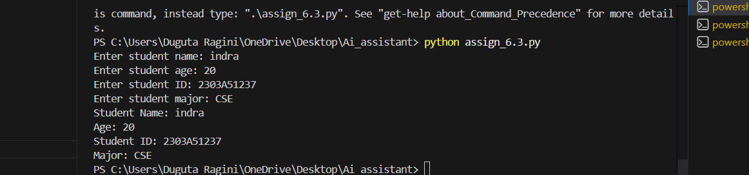

Task Description #2: Loops (Multiples of a Number)
Scenario
You are writing a utility function to display multiples of a given number.
Task
• Prompt the AI tool to generate a function that prints the first 10 multiples of a given number
using a loop.
• Analyze the generated loop logic.
• Ask the AI to generate the same functionality using another controlled looping structure (e.g.,
while instead of for).
Expected Output #2
• Correct loop-based Python implementation.
• Output showing the first 10 multiples of a number.
• Comparison and analysis of different looping approaches.

#PROMPT: #WRITE A PROGRAM TO PRIINT MULTIPLICATION TABLE OF A NUMBER USING FUNCTION

CODE:
def multiplication_table(number, upto=10):
print(f"Multiplication Table for {number}:")
for i in range(1, upto + 1):
print(f"{number} x {i} = {number * i}")
num = int(input("Enter a number to generate its multiplication table: "))
multiplication_table(num)

OUTPUT:
def multiplication_table(number, upto=10):
print(f"Multiplication Table for {number}:")
for i in range(1, upto + 1):
print(f"{number} x {i} = {number * i}")
num = int(input("Enter a number to generate its multiplication table: "))
multiplication_table(num)

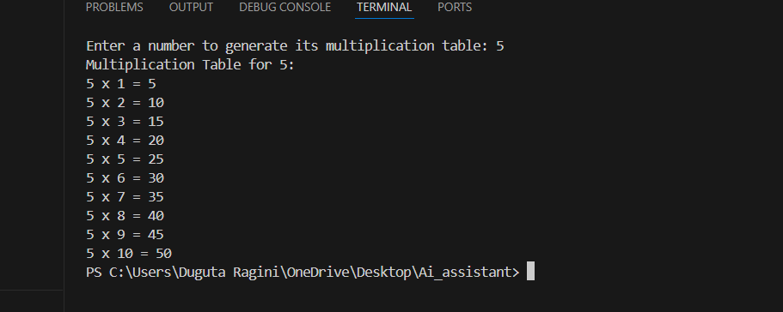

Task Description #3: Conditional Statements (Age Classification)
Scenario
You are building a basic classification system based on age.
Task
• Ask the AI tool to generate nested if-elif-else conditional statements to classify age groups
(e.g., child, teenager, adult, senior).
• Analyze the generated conditions and logic.
• Ask the AI to generate the same classification using alternative conditional structures (e.g.,
simplified conditions or dictionary-based logic).
Expected Output #3
• A Python function that classifies age into appropriate groups.
• Clear and correct conditional logic.
• Explanation of how the conditions work.

#PROMPT: #WRITE A PROGRAM TO CLASSIFT CHILD,TEENAGER,ADULT,SENIOR CITIZEN BASED ON AGE USING IF ELSE LADDER
CODE:
age = int(input("Enter your age: "))
if age < 13:
print("You are a Child.")
elif 13 <= age < 20:
print("You are a Teenager.")
elif 20 <= age < 60:
print("You are an Adult.")
else:
print("You are a Senior Citizen.")

OUTPUT:

Task Description #4: For and While Loops (Sum of First n Numbers)
Scenario
You need to calculate the sum of the first n natural numbers.
Task
• Use AI assistance to generate a sum_to_n() function using a for loop.
• Analyze the generated code.
• Ask the AI to suggest an alternative implementation using a while loop or a mathematical
formula.
Expected Output #4
• Python function to compute the sum of first n numbers.
• Correct output for sample inputs.
• Explanation and comparison of different approaches.

#PROMPT: #Write aprogram to calculate the sum of first n natural numbers using while loop
CODE:
n = int(input("Enter a positive integer: "))
total_sum = 0
i = 1
while i <= n:
total_sum += i
i += 1
print(f"The sum of the first {n} natural numbers is: {total_sum}")

OUTPUT:
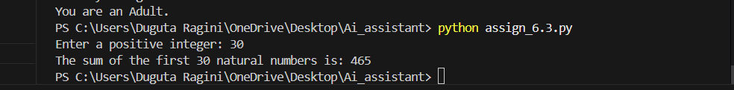

Task Description #5: Classes (Bank Account Class)
Scenario
You are designing a basic banking application.
Task
• Use AI tools to generate a Bank Account class with methods such as deposit(), withdraw(),
and check_balance().
• Analyze the AI-generated class structure and logic.
• Add meaningful comments and explain the working of the code.
Expected Output #5
• Complete Python Bank Account class.
• Demonstration of deposit and withdrawal operations with updated balance.
• Well-commented code with a clear explanation

#PROMPT: #WRITE CODE FOR A SIMPLE BANK ACCOUNT METHOD TO DEPOSIT,WITHDRAW AND CHECK BALANCE

CODE:
class BankAccount:
def __init__(self, account_holder, initial_balance=0):
self.account_holder = account_holder
self.balance = initial_balance

def deposit(self, amount):
if amount > 0:
self.balance += amount
print(f"Deposited: ${amount:.2f}")
else:
print("Deposit amount must be positive.")

def withdraw(self, amount):
if 0 < amount <= self.balance:
self.balance -= amount
print(f"Withdrew: ${amount:.2f}")
else:
print("Insufficient funds or invalid withdrawal amount.")

def check_balance(self):
print(f"Current balance: ${self.balance:.2f}")
# Example usage
account_holder = input("Enter account holder name: ")
account = BankAccount(account_holder)
account.deposit(500)
account.withdraw(200)
account.check_balance()
OUTPUT:
