Assignment 6.1
2303A51237

Task Description #1 (AI-Based Code Completion for Loops)
Task: Use an AI code completion tool to generate a loop-based
program.
Prompt:
“Generate Python code to print all even numbers between 1 and N
using a loop.”
Expected Output:
• AI-generated loop logic.
• Identification of loop type used (for or while).
• Validation with sample inputs.

#Prompt: #write a code to print all even numbers from 1 to n

CODE:
n = int(input("Enter a number n: "))
even_numbers = []
for i in range(1, n+1):
if i % 2 == 0:
even_numbers.append(i)
print("Even numbers from 1 to", n, "are:", even_numbers)
output:

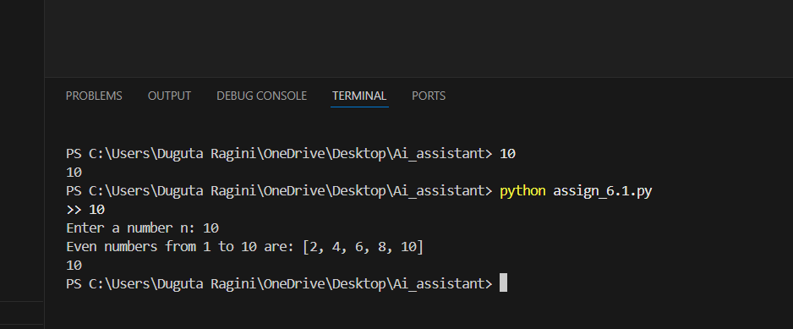

Task Description #2 (AI-Based Code Completion for Loop with
Conditionals)
Task: Use an AI code completion tool to combine loops and
conditionals.
Prompt:
“Generate Python code to count how many numbers in a list are even
and odd.”
Expected Output:
• AI-generated code using loop and if condition.
• Correct count validation.
• Explanation of logic flow.

#prompt: #generate a python code to count how many even and odd numbers in a list

CODE:
numbers_list = [10, 23, 45, 66, 78, 89, 90, 12, 34, 57]
even_count = 0
odd_count = 0
for number in numbers_list:
if number % 2 == 0:
even_count += 1
else:
odd_count += 1
print("Even numbers count:", even_count)
print("Odd numbers count:", odd_count)

OUTPUT:
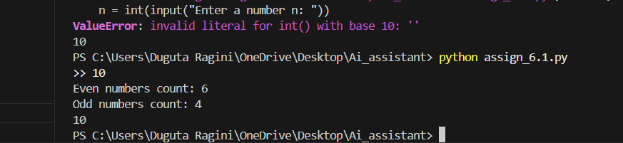

Task Description #3 (AI-Based Code Completion for Class
Attributes Validation)
Task: Use an AI tool to complete a Python class that validates user
input.
Prompt:
“Generate a Python class User that validates age and email using
conditional statements.”
Expected Output:
• AI-generated class with validation logic.
• Verification of condition handling.
• Test cases for valid and invalid inputs.
#prompt: #create a class user that validates age and email using conditionals statements

CODE:
class User:
def __init__(self, age, email):
self.age = age
self.email = email

def validate_age(self):
if 0 < self.age < 120:
return True
else:
return False

def validate_email(self):
if "@" in self.email and "." in self.email.split("@")[-1]:
return True
else:
return False
# Example usage
user1 = User(25, "user@example.com")
print("Age valid:", user1.validate_age())
print("Email valid:", user1.validate_email())

OUTPUT:
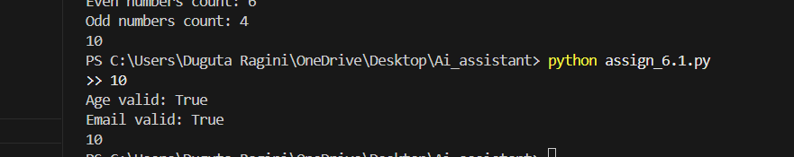

Task Description #4 (AI-Based Code Completion for Classes)
Task: Use an AI code completion tool to generate a Python class for
managing student details.
Prompt:
“Generate a Python class Student with attributes (name, roll number,
marks) and methods to calculate total and average marks.”
Expected Output:
• AI-generated class code.
• Verification of correctness and completeness of class
structure.
• Minor manual improvements (if needed) with justification.

#Prompt: #create a python class named student include all student attributes and methods like (name,roll number,marks )and methods to calculate total and average marks
CODE:
class Student:
def __init__(self, name, roll_number, marks):
self.name = name
self.roll_number = roll_number
self.marks = marks # marks should be a list of integers

def calculate_total(self):
return sum(self.marks)

def calculate_average(self):
if len(self.marks) == 0:
return 0
return sum(self.marks) / len(self.marks)
# Example usage
student1 = Student("Alice", 101, [85, 90, 78, 92])
print("Student Name:", student1.name)
print("Roll Number:", student1.roll_number)
print("Total Marks:", student1.calculate_total())
print("Average Marks:", student1.calculate_average())

OUTPUT:
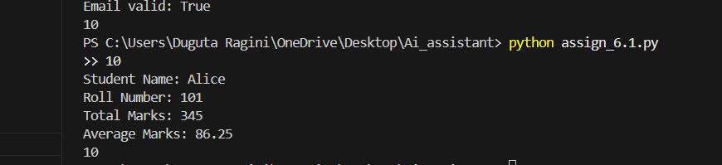

Task Description 5 (AI-Assisted Code Completion Review)
Task: Use an AI tool to generate a complete Python program using
classes, loops, and conditionals together.
Prompt:
“Generate a Python program for a simple bank account system using
class, loops, and conditional statements.”

#Prompt:
#create a simple bank application using classes and conditionals with methods like deposit,withdraw and check balance ,display balance

CODE:
class BankAccount:
def __init__(self, account_holder, balance=0):
self.account_holder = account_holder
self.balance = balance

def deposit(self, amount):
if amount > 0:
self.balance += amount
print(f"Deposited: {amount}. New balance: {self.balance}")
else:
print("Deposit amount must be positive.")

def withdraw(self, amount):
if amount > 0:
if amount <= self.balance:
self.balance -= amount
print(f"Withdrew: {amount}. New balance: {self.balance}")
else:
print("Insufficient funds.")
else:
print("Withdrawal amount must be positive.")

def check_balance(self):
print(f"Current balance: {self.balance}")
def display_balance(self):
print(f"Account Holder: {self.account_holder}, Balance: {self.balance}")
# Example usage
account = BankAccount("John Doe", 1000)
account.check_balance()
account.deposit(500)
account.withdraw(200)
account.check_balance()
account.withdraw(2000) # Attempt to withdraw more than the balance
account.display_balance()

OUTPUT:
