Assignment-12.1(AI)

Task Description #1 (Sorting – Merge Sort Implementation)
- Task: Use AI to generate a Python program that implements the Merge Sort algorithm.
- Instructions:
  - Prompt AI to create a function merge_sort(arr) that sorts a list in ascending order.
  - Ask AI to include time complexity and space complexity in the function docstring.
  - Verify the generated code with test cases.
- Expected Output:
  - A functional Python script implementing Merge Sort with proper documentation.
  - 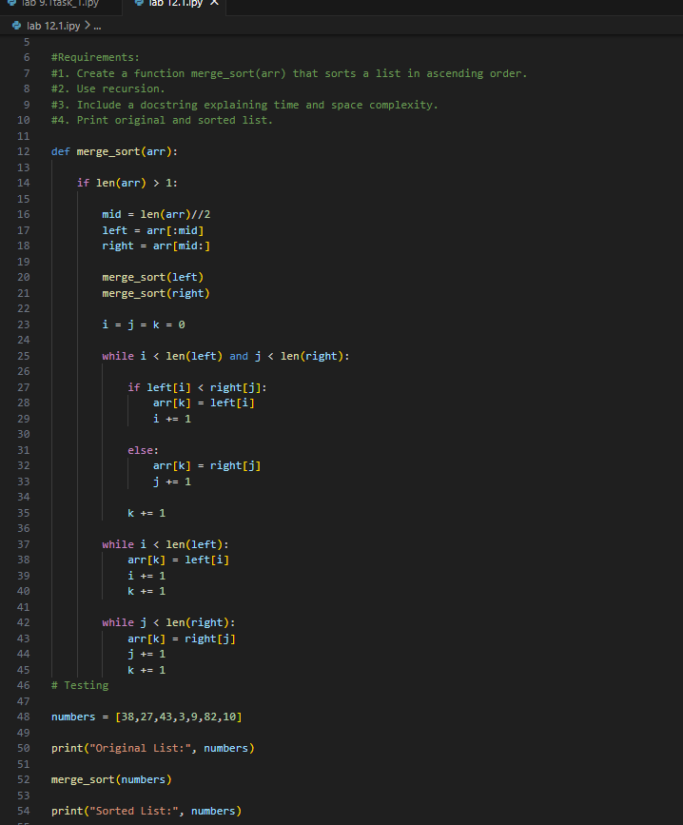

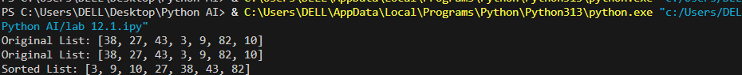

Task Description #2 (Searching – Binary Search with AI Optimization)
- Task: Use AI to create a binary search function that finds a target element in a sorted list.
- Instructions:
  - Prompt AI to create a function binary_search(arr, target) returning the index of the target or -1 if not found.
  - Include docstrings explaining best, average, and worst-case complexities.
  - Test with various inputs.
- Expected Output:
  - Python code implementing binary search with AI-generated comments and docstrings.
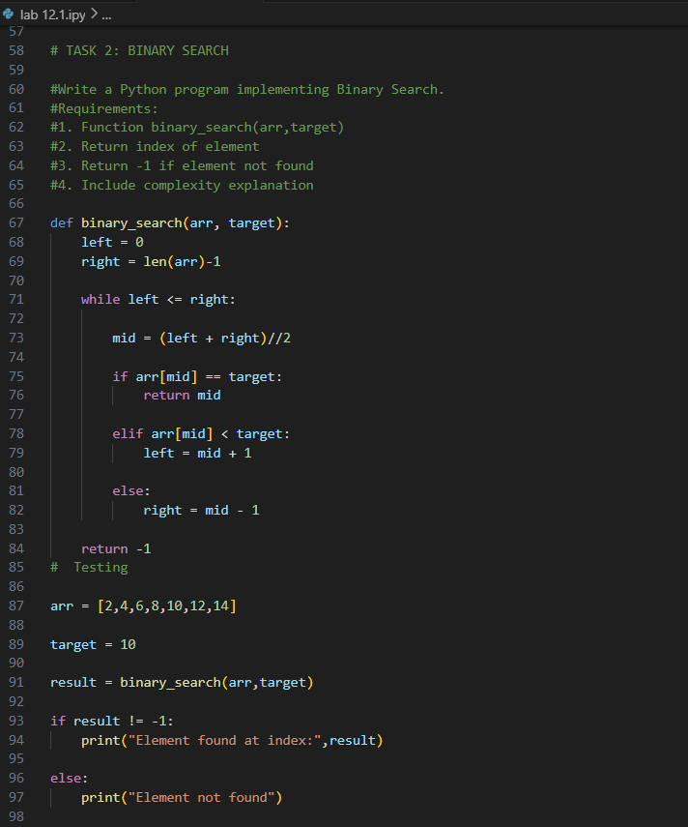
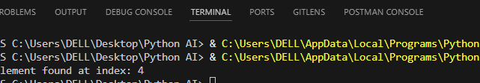
Task Description #3 (Real-Time Application – Inventory Management System)
- Scenario: A retail store’s inventory system contains thousands of products, each with attributes like product ID, name, price, and stock quantity. Store staff need to:
  - Quickly search for a product by ID or name.
  - Sort products by price or quantity for stock analysis.
- Task:
  - Use AI to suggest the most efficient search and sort algorithms for this use case.
  - Implement the recommended algorithms in Python.
  - Justify the choice based on dataset size, update frequency, and performance requirements.
- Expected Output:
  - A table mapping operation → recommended algorithm → justification.
  - Working Python functions for searching and sorting the inventory.
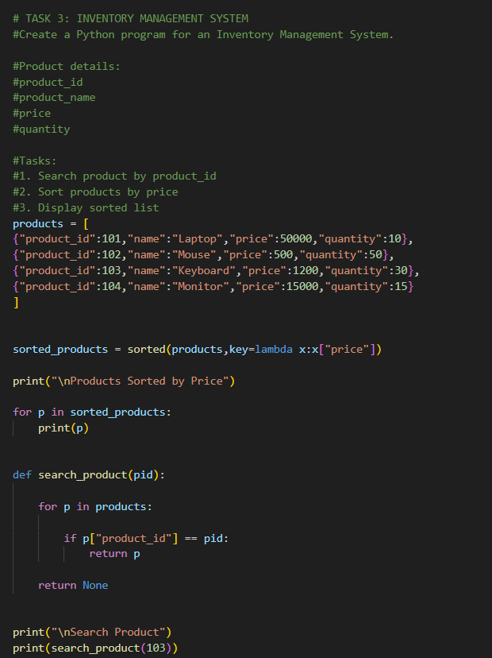

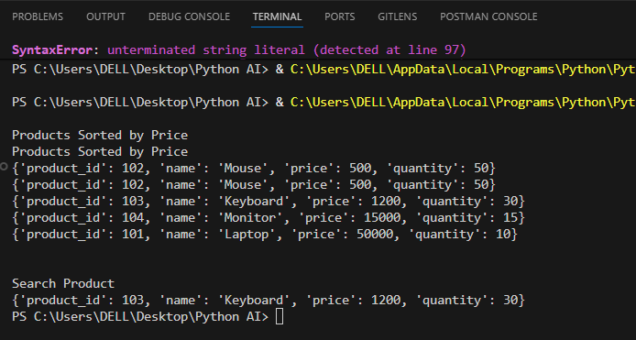

Task description #4: Smart Hospital Patient Management System
A hospital maintains records of thousands of patients with details such as patient ID, name, severity level, admission date, and bill amount. Doctors and staff need to:
- Quickly search patient records using patient ID or name.
- Sort patients based on severity level or bill amount for prioritization and billing.
Student Task
- Use AI to recommend suitable searching and sorting algorithms.
- Justify the selected algorithms in terms of efficiency and suitability.
- Implement the recommended algorithms in Python.
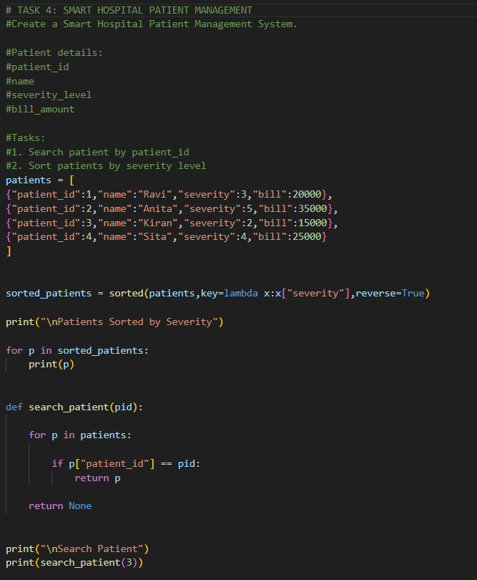

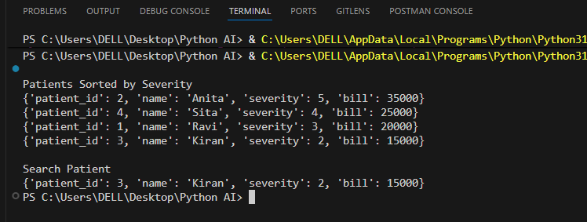

Task Description #5: University Examination Result Processing System
A university processes examination results for thousands of students containing roll number, name, subject, and marks. The system must:
- Search student results using roll number.
- Sort students based on marks to generate rank lists.
Student Task
- Identify efficient searching and sorting algorithms using AI assistance.
- Justify the choice of algorithms.
- Implement the algorithms in Python.
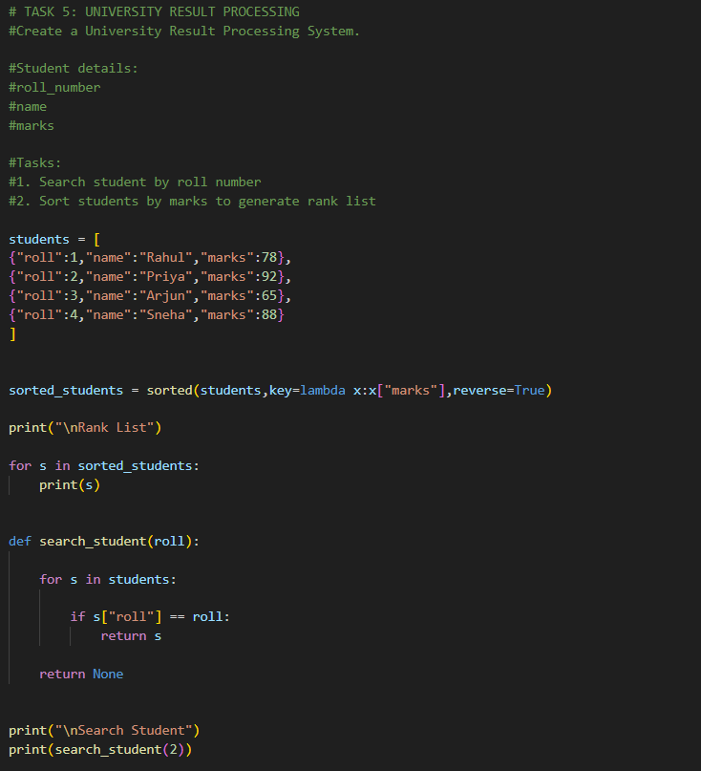

.
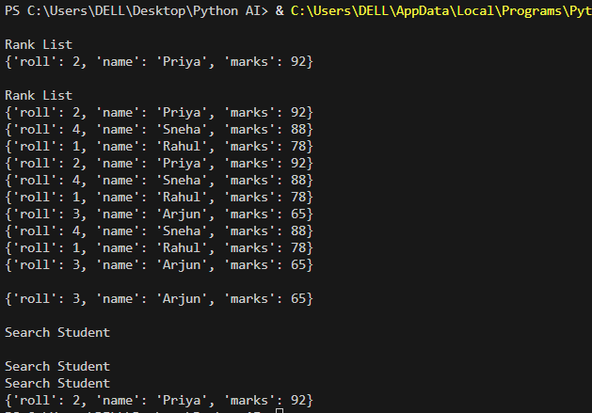

Task Description #6: Online Food Delivery Platform
An online food delivery application stores thousands of orders with order ID, restaurant name, delivery time, price, and order status. The platform needs to:
- Quickly find an order using order ID.
- Sort orders based on delivery time or price.
Student Task
- Use AI to suggest optimized algorithms.
- Justify the algorithm selection.
- Implement searching and sorting modules in Python.
