ASSIGNMENT-6.3

Narendra
2303A51248

Task Description #1: Classes (Student Class)
Scenario
You are developing a simple student information management module.
Task
• Use an AI tool (GitHub Copilot / Cursor AI / Gemini) to complete a Student class.
• The class should include attributes such as name, roll number, and branch.
• Add a method display_details() to print student information.
• Execute the code and verify the output.
• Analyze the code generated by the AI tool for correctness and clarity.
Expected Output #1
• A Python class with a constructor (__init__) and a display_details() method.
• Sample object creation and output displayed on the console.
• Brief analysis of AI-generated code.

PROMOT:
#write a python pogram for a simple student information management system using class and methods
class Student:
def __init__(self, name, age, grade):
self.name = name
self.age = age
self.grade = grade

def display_info(self):
print(f"Name: {self.name}, Age: {self.age}, Grade: {self.grade}")
def calculate_average_grade(students):
if not students:
return 0
return sum(student.grade for student in students) / len(students)
if __name__ == "__main__":
students = []
num_students = int(input("Enter number of students: "))

for i in range(num_students):
print(f"\nStudent {i + 1}")
name = input("Enter name: ")
age = int(input("Enter age: "))
grade = float(input("Enter grade: "))
student = Student(name, age, grade)
students.append(student)

print("\nStudent Information:")
for student in students:
student.display_info()

average_grade = calculate_average_grade(students)
print(f"\nAverage Grade: {average_grade:.2f}")

OUTPUT:
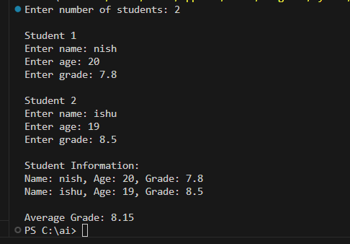

Task Description #2: Loops (Multiples of a Number)
Scenario
You are writing a utility function to display multiples of a given number.
Task
• Prompt the AI tool to generate a function that prints the first 10 multiples of a given number
using a loop.
• Analyze the generated loop logic.
• Ask the AI to generate the same functionality using another controlled looping structure (e.g.,
while instead of for).
Expected Output #2
• Correct loop-based Python implementation.
• Output showing the first 10 multiples of a number.
• Comparison and analysis of different looping approaches
CODE:
#write a python program to write the first 10 multiples of the number entered by the user using loops.
def print_multiples(number, count=10):
for i in range(1, count + 1):
print(f"{number} x {i} = {number * i}")
if __name__ == "__main__":
num = int(input("Enter a number to see its first 10 multiples: "))
print_multiples(num)

OUTPUT:
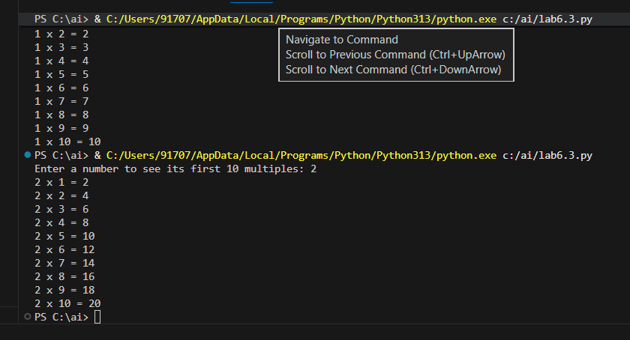

Task Description #3: Conditional Statements (Age Classification)
Scenario
You are building a basic classification system based on age.
Task
• Ask the AI tool to generate nested if-elif-else conditional statements to classify age groups
(e.g., child, teenager, adult, senior).
• Analyze the generated conditions and logic.
• Ask the AI to generate the same classification using alternative conditional structures (e.g.,
simplified conditions or dictionary-based logic).
Expected Output #3
• A Python function that classifies age into appropriate groups.
• Clear and correct conditional logic.
• Explanation of how the conditions work.

CODE:
#write a python program of basic classification system based on age
def classify_age(age):
if age < 0:
return "Invalid age"
elif age <= 12:
return "Child"
elif age <= 19:
return "Teenager"
elif age <= 59:
return "Adult"
else:
return "Senior"
if __name__ == "__main__":
age = int(input("Enter your age: "))
category = classify_age(age)
print(f"You are classified as: {category}")

OUTPUT:
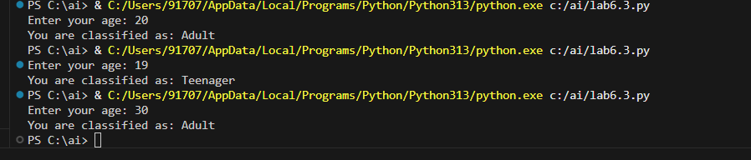

Task Description #4: For and While Loops (Sum of First n Numbers)
Scenario
You need to calculate the sum of the first n natural numbers.
Task
• Use AI assistance to generate a sum_to_n() function using a for loop.
• Analyze the generated code.
• Ask the AI to suggest an alternative implementation using a while loop or a mathematical
formula.
Expected Output #4
• Python function to compute the sum of first n numbers.
• Correct output for sample inputs.
• Explanation and comparison of different approaches.

CODE:
#write a python program to calculate the sum of the first N numers entered by the user using loops.
def sum_of_numbers(N):
total = 0
for i in range(1, N + 1):
total += i
return total
if __name__ == "__main__":
N = int(input("Enter a positive integer N: "))
total_sum = sum_of_numbers(N)
print(f"The sum of the first {N} numbers is: {total_sum}")
OUTPUT:
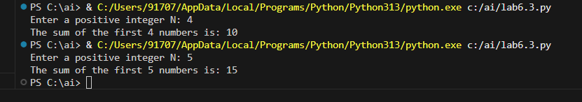

Task Description #5: Classes (Bank Account Class)
Scenario
You are designing a basic banking application.
Task
• Use AI tools to generate a Bank Account class with methods such as deposit(), withdraw(),
and check_balance().
• Analyze the AI-generated class structure and logic.
• Add meaningful comments and explain the working of the code.
Expected Output #5
• Complete Python Bank Account class.
• Demonstration of deposit and withdrawal operations with updated balance.
• Well-commented code with a clear explanation.

CODE:
#Write a python program for a bank account with methods to deposit, withdraw, and check balance using classes loops and conditional statements.
class BankAccount:
def __init__(self, initial_balance=0):
self.balance = initial_balance

def deposit(self, amount):
if amount > 0:
self.balance += amount
print(f"Deposited: ${amount:.2f}")
else:
print("Deposit amount must be positive.")

def withdraw(self, amount):
if 0 < amount <= self.balance:
self.balance -= amount
print(f"Withdrew: ${amount:.2f}")
else:
print("Insufficient funds or invalid withdrawal amount.")

def check_balance(self):
print(f"Current balance: ${self.balance:.2f}")
if __name__ == "__main__":

account = BankAccount()
while True:
print("\nBank Account Menu:")
print("1. Deposit")
print("2. Withdraw")
print("3. Check Balance")
print("4. Exit")
choice = input("Choose an option (1-4): ")

if choice == '1':
amount = float(input("Enter amount to deposit: "))
account.deposit(amount)
elif choice == '2':
amount = float(input("Enter amount to withdraw: "))
account.withdraw(amount)
elif choice == '3':
account.check_balance()
elif choice == '4':
print("Exiting the program.")
break
else:
print("Invalid choice. Please try again.")

OUTPUT:
