Lab_Assignment_7.1
Name: Koushal Pala
Hallticket No: 2303A51249(B-18)
Task Description #1 (Syntax Errors – Missing Parentheses in Print
Statement)
Task: Provide a Python snippet with a missing parenthesis in a print
statement (e.g., print "Hello"). Use AI to detect and fix the syntax
error.
# Bug: Missing parentheses in print statement
def greet():
print "Hello, AI Debugging Lab!"
greet()
Requirements:
• Run the given code to observe the error.
• Apply AI suggestions to correct the syntax.
• Use at least 3 assert test cases to confirm the corrected code
works.
Expected Output #1:
• Corrected code with proper syntax and AI explanation.

Code:
def display():
return "hi"

if __name__ == "__main__":
print(display())

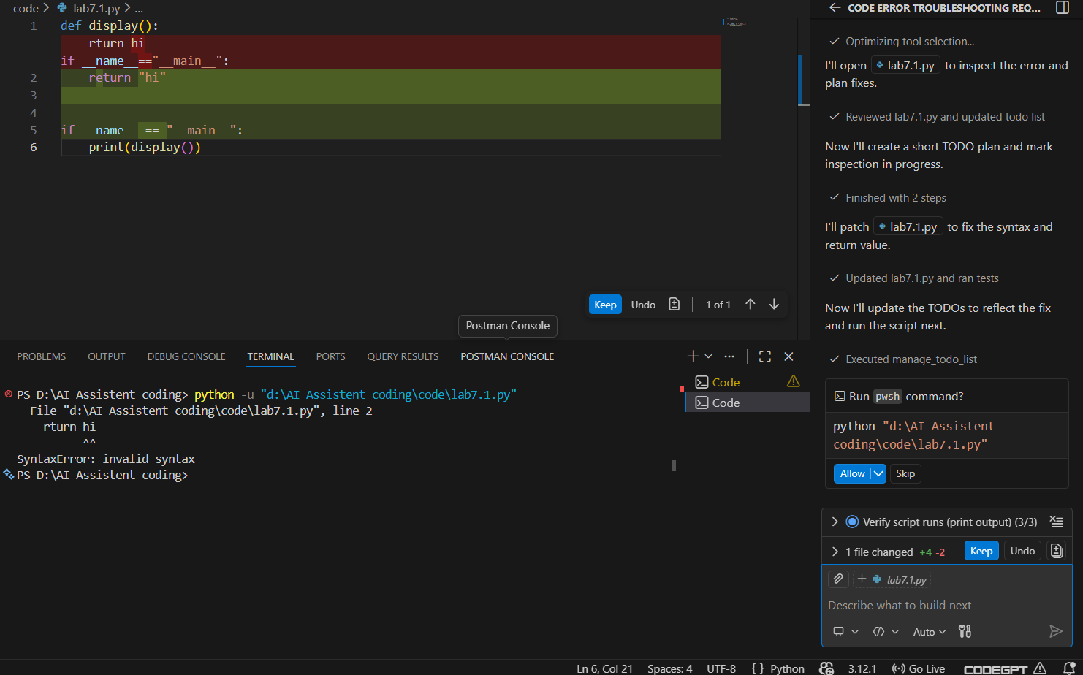
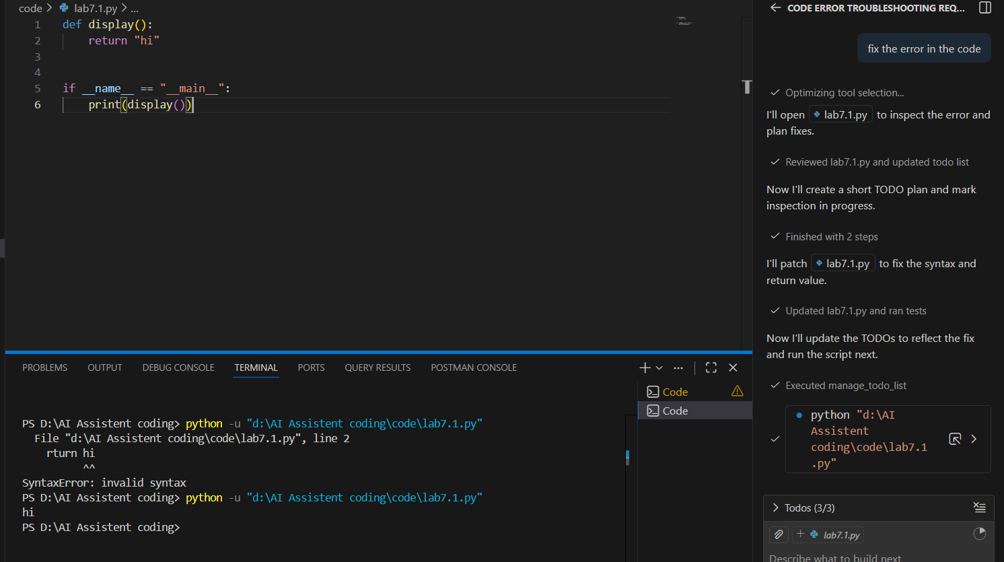
Done — lab7.1.py fixed and verified.
- File: lab7.1.py — replaced the typo and made display() return the string "hi".
- Verified: Ran the script; it prints hi

Task Description #2 (Incorrect condition in an If Statement)
Task: Supply a function where an if-condition mistakenly uses =
instead of ==. Let AI identify and fix the issue.
# Bug: Using assignment (=) instead of comparison (==)
def check_number(n):
if n = 10:
return "Ten"
else:
return "Not Ten"
Requirements:
• Ask AI to explain why this causes a bug.
• Correct the code and verify with 3 assert test cases.
Expected Output #2:
• Corrected code using == with explanation and successful test
execution.

Code:
def check_number(n):
if n == 10:
return "Ten"
else:
return "Not Ten"

if __name__ == "__main__":
print(check_number(10))
print(check_number(5))

Done — I fixed lab7.1.py and verified it prints:
- Ten
- Not Ten

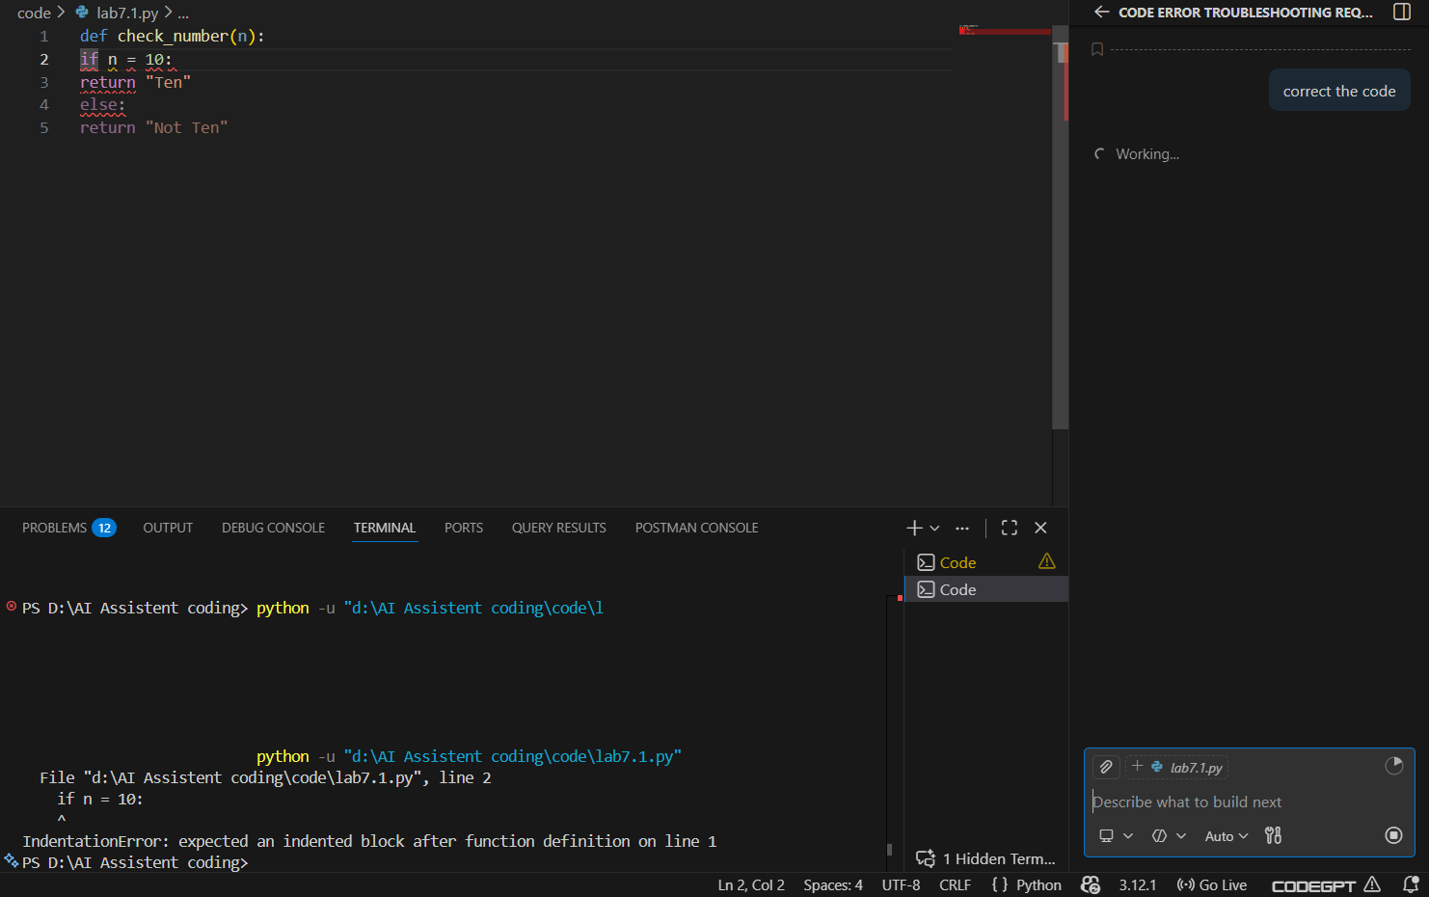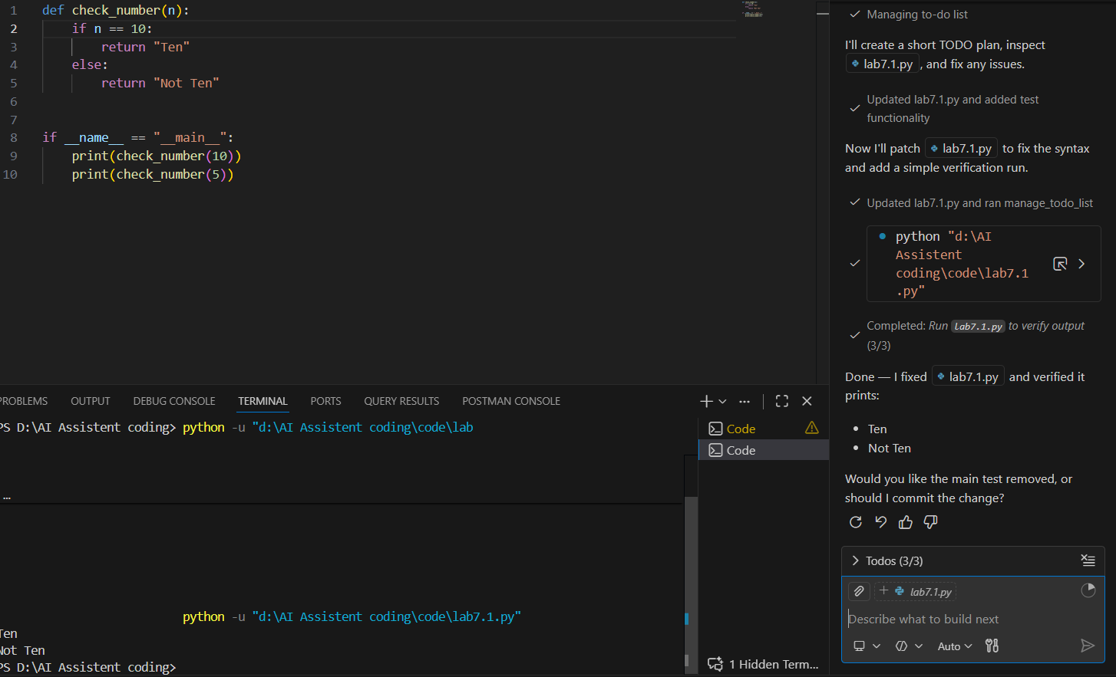

Task Description #3 (Runtime Error – File Not Found)
Task: Provide code that attempts to open a non-existent file and
crashes. Use AI to apply safe error handling.
# Bug: Program crashes if file is missing
def read_file(filename):
with open(filename, 'r') as f:
return f.read()
print(read_file("nonexistent.txt"))
Requirements:
• Implement a try-except block suggested by AI.
• Add a user-friendly error message.
• Test with at least 3 scenarios: file exists, file missing, invalid
path.
Expected Output #3:
• Safe file handling with exception management.
Code:
def read_file(filename):
try:
with open(filename, 'r') as f:
return f.read()
except FileNotFoundError:
return f"File '{filename}' not found."

print(read_file("nonexistent.txt"))

Code:
def read_file(filename):
try:
with open(filename, 'r') as f:
return f.read()
except FileNotFoundError:
return f"File '{filename}' not found."

print(read_file("nonexistent.txt"))

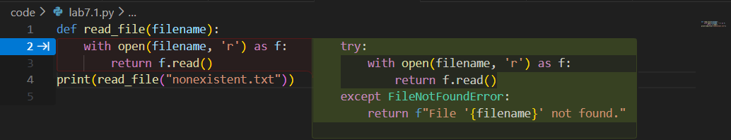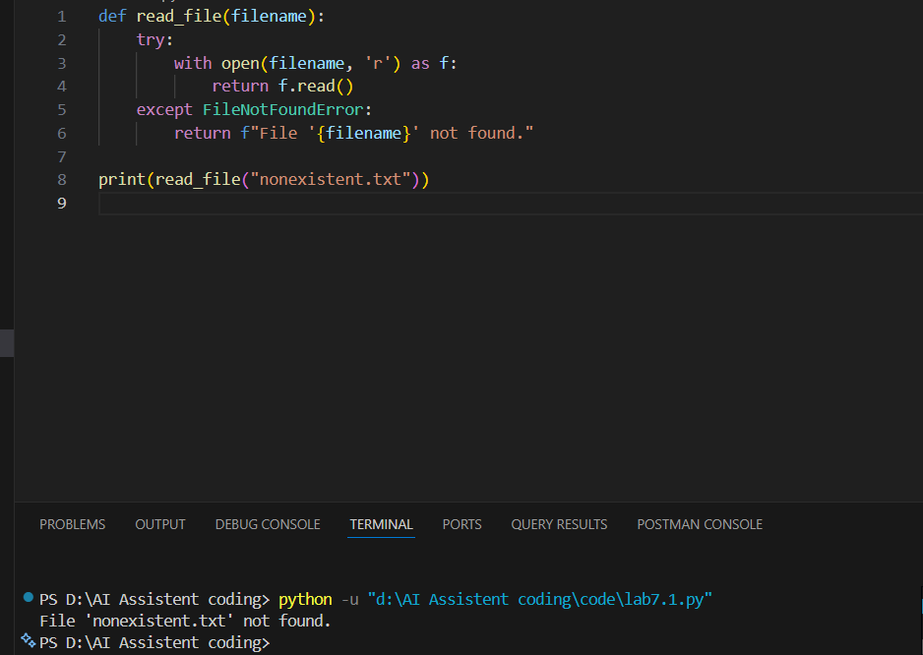

Task Description #4 (Calling a Non-Existent Method)
Task: Give a class where a non-existent method is called (e.g.,
obj.undefined_method()). Use AI to debug and fix.
# Bug: Calling an undefined method
class Car:
def start(self):
return "Car started"
my_car = Car()
print(my_car.drive()) # drive() is not defined
Requirements:
• Students must analyze whether to define the missing method
or correct the method call.
• Use 3 assert tests to confirm the corrected class works.
Expected Output #4:
• Corrected class with clear AI explanation.

Code:
class Car:
def start(self):
return "Car started"

def drive(self):
return "Car is driving"

if __name__ == "__main__":
my_car = Car()
print(my_car.start())
print(my_car.drive())

Fixed issues:
- Added the missing drive() method to the Car class
- Fixed indentation — moved the instantiation code out of the class definition
- Added proper main block

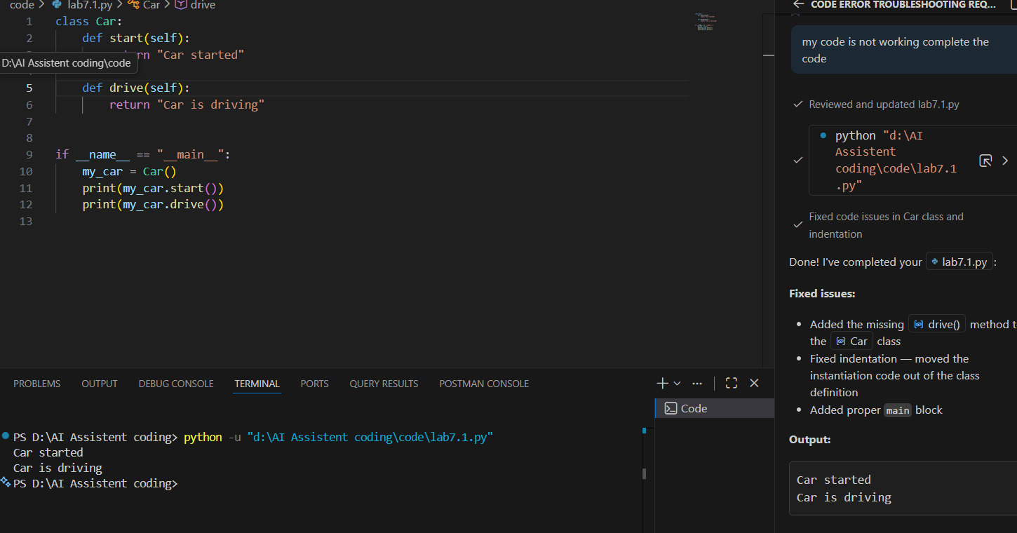
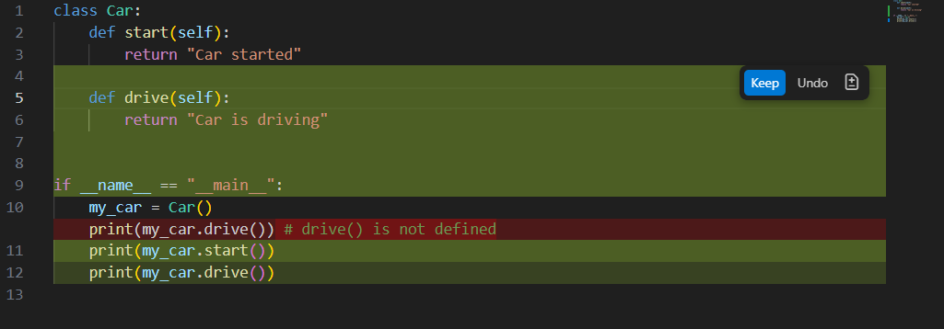

Task Description #5 (TypeError – Mixing Strings and Integers in
Addition)
Task: Provide code that adds an integer and string ("5" + 2) causing
a TypeError. Use AI to resolve the bug.
# Bug: TypeError due to mixing string and integer
def add_five(value):
return value + 5
print(add_five("10"))
Requirements:
• Ask AI for two solutions: type casting and string
concatenation.
• Validate with 3 assert test cases.
Expected Output #5:
• Corrected code that runs successfully for multiple inputs.
Note: Report should be submitted a word document for all tasks in a
single document with prompts, comments & code explanation, and
output and if required, screenshots

Code:
# SOLUTION 1: Type Casting (Convert string to int)
def add_five_type_cast(value):
return int(value) + 5

# SOLUTION 2: String Concatenation (Keep as string)
def add_five_string_concat(value):
return value + "5"

if __name__ == "__main__":
# Test Solution 1: Type Casting
print("Solution 1 - Type Casting:")
print(f"add_five_type_cast('10') = {add_five_type_cast('10')}") # Output: 15
print(f"add_five_type_cast('7') = {add_five_type_cast('7')}") # Output: 12

# Test Solution 2: String Concatenation
print("\nSolution 2 - String Concatenation:")
print(f"add_five_string_concat('10') = {add_five_string_concat('10')}") # Output: 105
print(f"add_five_string_concat('7') = {add_five_string_concat('7')}") # Output: 75
