Lab_Assignment_6.1
Name: Koushal Pala
Hallticket No: 2303A51249(B-18)

Task Description #1 (AI-Based Code Completion for Loops)
Task: Use an AI code completion tool to generate a loop-based
program.
Prompt:
“Generate Python code to print all even numbers between 1 and N
using a loop.”
Expected Output:
• AI-generated loop logic.
• Identification of loop type used (for or while).
• Validation with sample inputs

Prompt: write a python program to take input N from the user and print all even numbers from 1 to N using a loop
Code:
N = int(input("Enter a number N: "))
for i in range(1, N + 1):
if i % 2 == 0:
print(i)
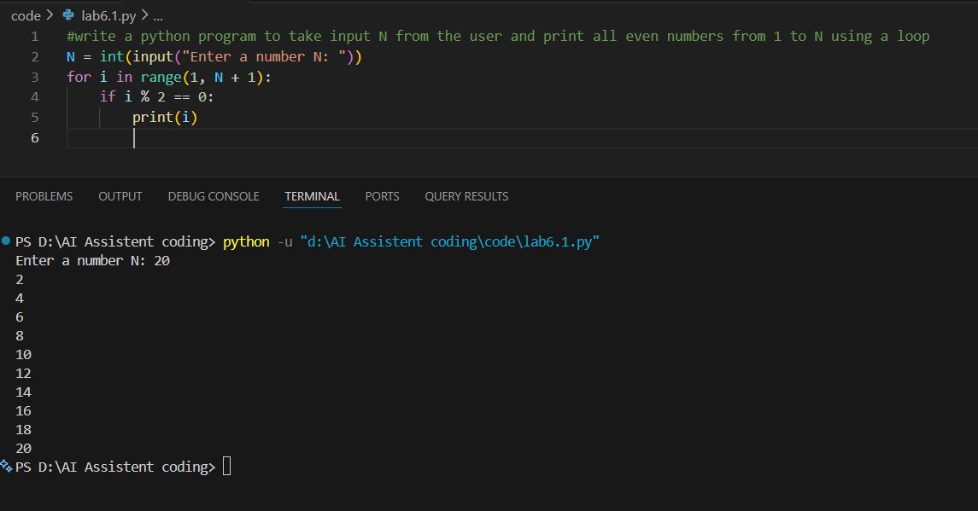
Task Description #2 (AI-Based Code Completion for Loop with
Conditionals)
Task: Use an AI code completion tool to combine loops and
conditionals.
Prompt:
“Generate Python code to count how many numbers in a list are even
and odd.”
Expected Output:
• AI-generated code using loop and if condition.
• Correct count validation.
• Explanation of logic flow

Prompt: write a python program to take list as input from user and count the number of even and odd numbers in the list
Code:
numbers = list(map(int, input("Enter numbers separated by space: ").split()))
even_count = 0
odd_count = 0
for num in numbers:
if num % 2 == 0:
even_count += 1
else:
odd_count += 1
print("Even numbers count:", even_count)
print("Odd numbers count:", odd_count)
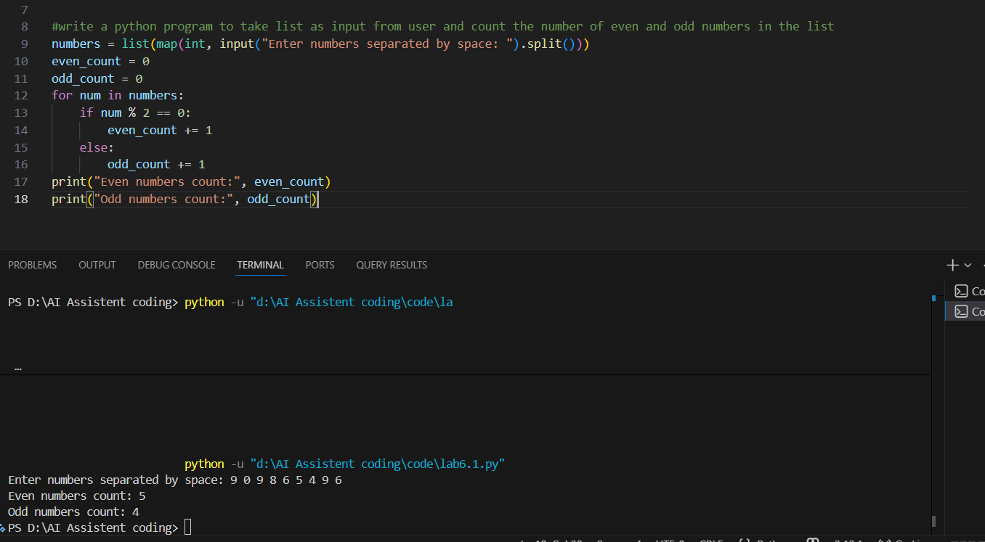
Task Description #3 (AI-Based Code Completion for Class
Attributes Validation)
Task: Use an AI tool to complete a Python class that validates user
input.
Prompt:
“Generate a Python class User that validates age and email using
conditional statements.”
Expected Output:
• AI-generated class with validation logic.
• Verification of condition handling.
• Test cases for valid and invalid inputs.

Prompt: write a python program that takes age and email from the user and checks if the user is eligible to register on a website (age should be greater than 18 and email should contain '@' symbol) with n test cases
Code:
test_cases = int(input("Enter number of test cases: "))
for _ in range(test_cases):
age = int(input("Enter your age: "))
email = input("Enter your email: ")
if age > 18 and '@' in email:
print("Eligible to register")
else:
print("Not eligible to register")

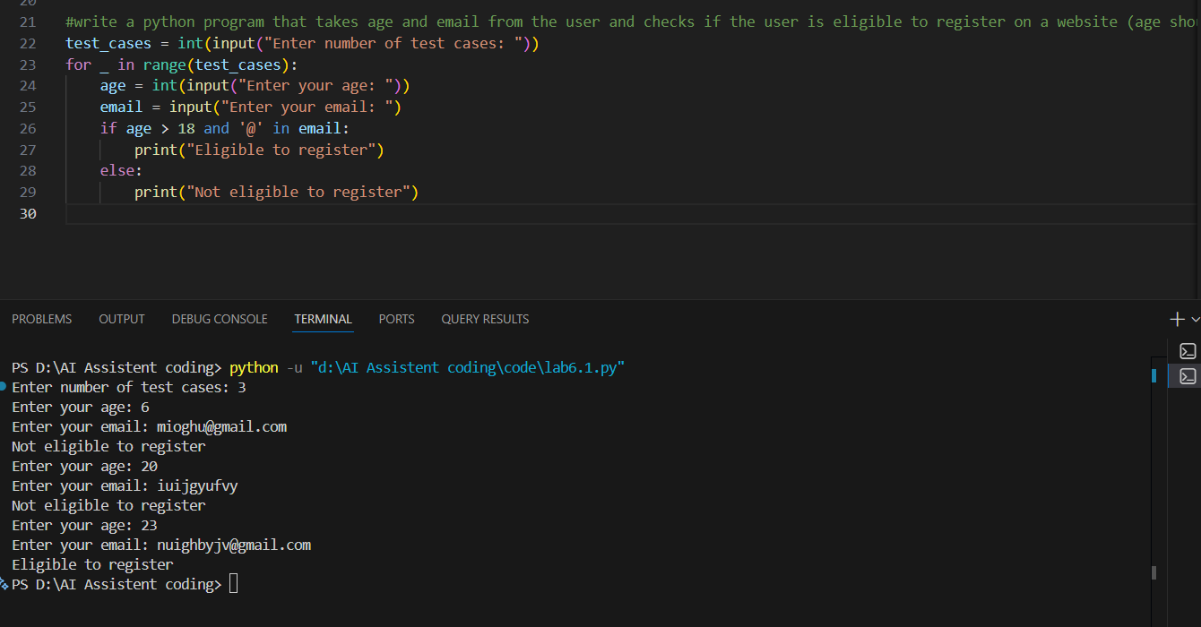

Task Description #4 (AI-Based Code Completion for Classes)
Task: Use an AI code completion tool to generate a Python class for
managing student details.
Prompt:
“Generate a Python class Student with attributes (name, roll number,
marks) and methods to calculate total and average marks.”
Expected Output:
• AI-generated class code.
• Verification of correctness and completeness of class
structure.
• Minor manual improvements (if needed) with justification.

Prompt: write a python program that takes student details (name, age, marks) from the user write functions to compute average total,average,marks with n test cases

Code:
def compute_total(marks_list):
return sum(marks_list)

def compute_average(marks_list):
if not marks_list:
return 0
return sum(marks_list) / len(marks_list)

test_cases = int(input("Enter number of test cases: "))
for _ in range(test_cases):
name = input("Enter student name: ")
age = int(input("Enter student age: "))
marks = list(map(int, input("Enter marks separated by space: ").split()))
total = compute_total(marks)
average = compute_average(marks)
print(f"Student Name: {name}")
print(f"Age: {age}")
print(f"Total Marks: {total}")
print(f"Average Marks: {average}")
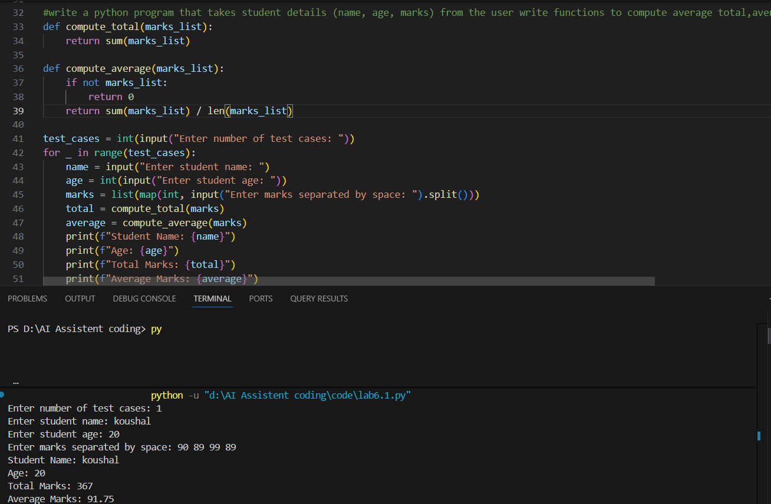

Task Description 5 (AI-Assisted Code Completion Review)
Task: Use an AI tool to generate a complete Python program using
classes, loops, and conditionals together.
Prompt:
“Generate a Python program for a simple bank account system using
class, loops, and conditional statements.”
Expected Output:
• Complete AI-generated program.
• Identification of strengths and limitations of AI suggestions.
• Reflection on how AI assisted coding productivity.

Prompt: write a python program for a banking appllication using loops,classes and conditional statements
Code:
class BankAccount:
def __init__(self, account_holder, balance=0):
self.account_holder = account_holder
self.balance = balance

def deposit(self, amount):
if amount > 0:
self.balance += amount
print(f"Deposited: {amount}. New balance: {self.balance}")
else:
print("Deposit amount must be positive.")

def withdraw(self, amount):
if amount > 0:
if amount <= self.balance:
self.balance -= amount
print(f"Withdrew: {amount}. New balance: {self.balance}")
else:
print("Insufficient funds.")
else:
print("Withdrawal amount must be positive.")

def display_balance(self):
print(f"Account Holder: {self.account_holder}, Balance: {self.balance}")
def main():
account_holder = input("Enter account holder name: ")
account = BankAccount(account_holder)

while True:
print("\nOptions:")
print("1. Deposit")
print("2. Withdraw")
print("3. Display Balance")
print("4. Exit")
choice = input("Choose an option (1-4): ")

if choice == '1':
amount = float(input("Enter amount to deposit: "))
account.deposit(amount)
elif choice == '2':
amount = float(input("Enter amount to withdraw: "))
account.withdraw(amount)
elif choice == '3':
account.display_balance()
elif choice == '4':
print("Exiting the banking application.")
break
else:
print("Invalid choice. Please try again.")
if __name__ == "__main__":
main()

